AI ACADEMY · TEACHER · ai-7/11

Sampling variability
Project: Reproducible AI Research Study

01. Prepare the purpose, prerequisites and materials

Teach the learning cycle
Primary target: Explain the mechanism and terminology of sampling variability
Session | Sequence and minutes | Resources
Session 1 · Understand · 45 min | 0–7: recall and prerequisite; 7–15: inspect the concrete case and predict; 15–30: teacher models the worked trace; 30–40: learners explain a step using the text and visual; 40–45: check the core idea. | Sections 1–6; record the brief recall in the workbook.
Session 2 · Practise · 45 min | 0–5: retrieve the procedure; 5–15: W2 completion practice; 15–23: explain and check with a partner; 23–30: each learner answers the misconception check; 30–40: targeted reteaching or a harder variation; 40–45: prepare the investigation. | Sections 7–10; use the matching workbook W2 and misconception check.
Session 3 · Investigate and transfer · 45 min | 0–5: retrieve the decision rule; 5–20: investigate or trace; 20–30: start the independent case; 30–38: connect the project; 38–43: act on feedback; 43–45: plan the return check. | Sections 9 and 11–14. Give extra time to finish the full task set; use Section 15 when the week includes a coding lab.
This is a starting allocation of 135 minutes, not a validated duration. Preserve all named topics. Schedule extra time for connected examples, the full investigation, independent cases and project building. Repeated copies of a case share one recorded attempt; they are not new evidence.

Retrieval answer guidance

Confounders and controls
Without opening the old lesson, explain one key idea from Confounders and controls. Give an example and a mistake that the idea helps you avoid.
Look for: Explain the mechanism and terminology of confounders and controls
Reference example, not the only acceptable wording: Teacher explanation: A confounder changes alongside the intended factor and can offer another explanation. Controls aim to isolate the proposed mechanism. For a toy comparison vary only retrieval method while holding corpus, queries, cutoff and relevance rubric fixed. Randomise or counterbalance order when order effects matter.

Baselines and fair comparisons
Without opening the old lesson, explain one key idea from Baselines and fair comparisons. Give an example and a mistake that the idea helps you avoid.
Look for: Explain the mechanism and terminology of baselines and fair comparisons
Reference example, not the only acceptable wording: Teacher explanation: Fair baselines use credible procedures on matched evidence and resource conditions. A weak arbitrary reference can exaggerate improvement. For a room-reporting study use manual authoritative lookup or a deterministic same-room rule, not random room names. Match cases, available sources and scoring.

Replication and reproduction
Without opening the old lesson, explain one key idea from Replication and reproduction. Give an example and a mistake that the idea helps you avoid.
Look for: Explain the mechanism and terminology of replication and reproduction
Reference example, not the only acceptable wording: Teacher explanation: Reproducing a computation uses recorded artifacts; replication collects new evidence under a comparable question. Naming conventions vary, so define the terms in the project. Here replay means same artifacts/procedure; new-data replication means newly collected eligible cases under the same plan. Preserve environment, data versions and raw results.
Two 45-minute sessions. Sampling variability means different eligible samples can give different estimates even under the same population. Separate this from procedure changes. Use the supplied constructed scenarios to make the mechanism inspectable. Collect W4 before sharing solutions. Students should name intermediate evidence and limitations; classroom pacing and learning effectiveness remain unvalidated.

Outcomes
Explain the mechanism and terminology of sampling variability
Apply the stated procedure to a new case with a traceable result
Identify an assumption or limitation and design a revealing follow-up

Preparation
Lesson and workbook; paper and pencil
Calculator and optional local Python 3 for arithmetic; no live API or private data
Prepare the fresh retry separately and withhold its solution until after collection

Prerequisite answer
A result depends on the inputs, procedure and conditions that produced it. Preserve data roles and distinguish observed outcomes from predictions or unmeasured conditions. If the prior concept cannot be explained, use a short retrieval activity before this chapter.

End goal for the pictorial case
Explain sampling variability using the records and boundaries of this fictional investigation.
This added worked case illustrates the week’s main idea. Retain all original and connected topics; schedule its practice within the teaching cycle.

02. Explain and model the mechanism
Sampling variability means different eligible samples can give different estimates even under the same population. Separate this from procedure changes.
Begin by writing the question the procedure is intended to answer. Identify the information already supplied, the information it will produce and the information still missing. These are constructed classroom examples; they do not require live accounts, private records or an external service. Do not treat a plausible explanation as a measured outcome.
Consider finite population values1, 1, 3, 3 with distinct IDs. Enumerate the six unordered samples of size2 without replacement. Their means are1, 2, 2, 2, 2, 3.
Before applying the procedure, write its units, denominator or decision boundary where relevant. A partner should be able to repeat each step using the same inputs. If a required input is absent or violates the stated contract, record that condition explicitly instead of quietly replacing it with a convenient value.
Term | Meaning
Sampling variability | Changes in estimates across eligible samples
Sampling distribution | The distribution of an estimate under a sampling procedure
Without replacement | Selecting distinct units within a sample

Sampling variability — evidence trace
Input and scope | Check or calculation | Conclusion and limit
Find the mean of sample means and the chance of mean2 under uniform selection of those six samples. | Consider finite population values1, 1, 3, 3 with distinct IDs. Enumerate the six unordered samples of size2 without replacement. | Mean=(1+2+2+2+2+3)/6=2; mean2 occurs4/6=2/3. The population mean is2, while individual samples differ.
The figure connects this chapter's worked input, declared procedure and result. Read the complete worked reasoning for qualifiers and intermediate steps; the abbreviated labels do not replace that reasoning.
Guided: Mean=(1+2+2+2+2+3)/6=2; mean2 occurs4/6=2/3. The population mean is2, while individual samples differ. Qualification: This finite example is not a general normality guarantee or a model of a biased convenience sample. Exit: accept a concrete variation with its predicted outcome and a stated condition that would challenge the mechanism; reject a claim resting on unmeasured evidence.

Model the reasoning aloud
Use the complete worked example below before asking learners to complete W2. Reveal a small part, invite a prediction, then explain the deciding step. These teacher notes contain solutions; do not reveal the independent case answer during modelling.
Find the mean of sample means and the chance of mean2 under uniform selection of those six samples.
Mean=(1+2+2+2+2+3)/6=2; mean2 occurs4/6=2/3. The population mean is2, while individual samples differ.
Compare the intermediate evidence with the final statement. Explain why each number or decision follows from the stated inputs. The conclusion belongs to this scenario and procedure; changing the inputs, evaluation population or authority can change what it establishes. Retain the raw record so a later revision can be compared honestly.
Optional local lab: predict the printed result before running this standalone Python 3 example. Change one relevant boundary input, record the outcome and state the contract or statistical assumptions. The program uses fictional values and the Python standard library; it performs no external operations.
from itertools import combinations
def sample_means(population, size):
if type(size) is not int or not 1 <= size <= len(population):
raise ValueError('sample size')
return [sum((population[i] for i in indices)) / size for indices in combinations(range(len(population)), size)]
print(sample_means([1, 1, 3, 3], 2))
Thinking move | Teacher prompt
Plan | What is given? What is the question? Which procedure fits these facts?
Do | Point to each input and intermediate step in the worked trace. Name the rule that allows the next step.
Check | Does the output answer the question? Which assumption or limitation prevents a larger claim?
Use the diagram and verbal explanation together. Ask learners to match a sentence to a specific visual step; do not assign learners fixed visual or auditory learning styles.

A pictorial worked case: Sampling variability
Two small samples can differ. A fixed classifier is scored on two distinct four-case samples from a declared collection.

The facts we will use
Sample A has 3 correct of 4; sample B has 2 correct of 4. The model and rubric are unchanged.
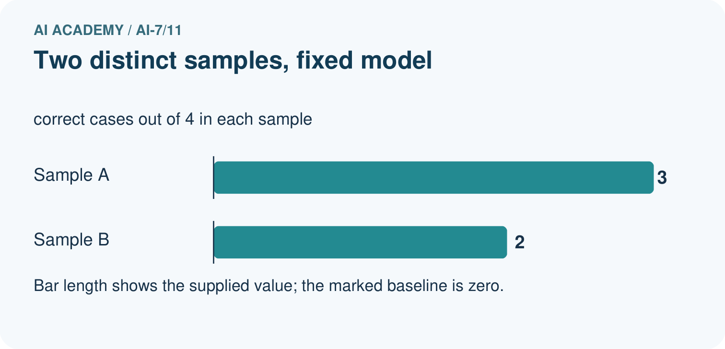
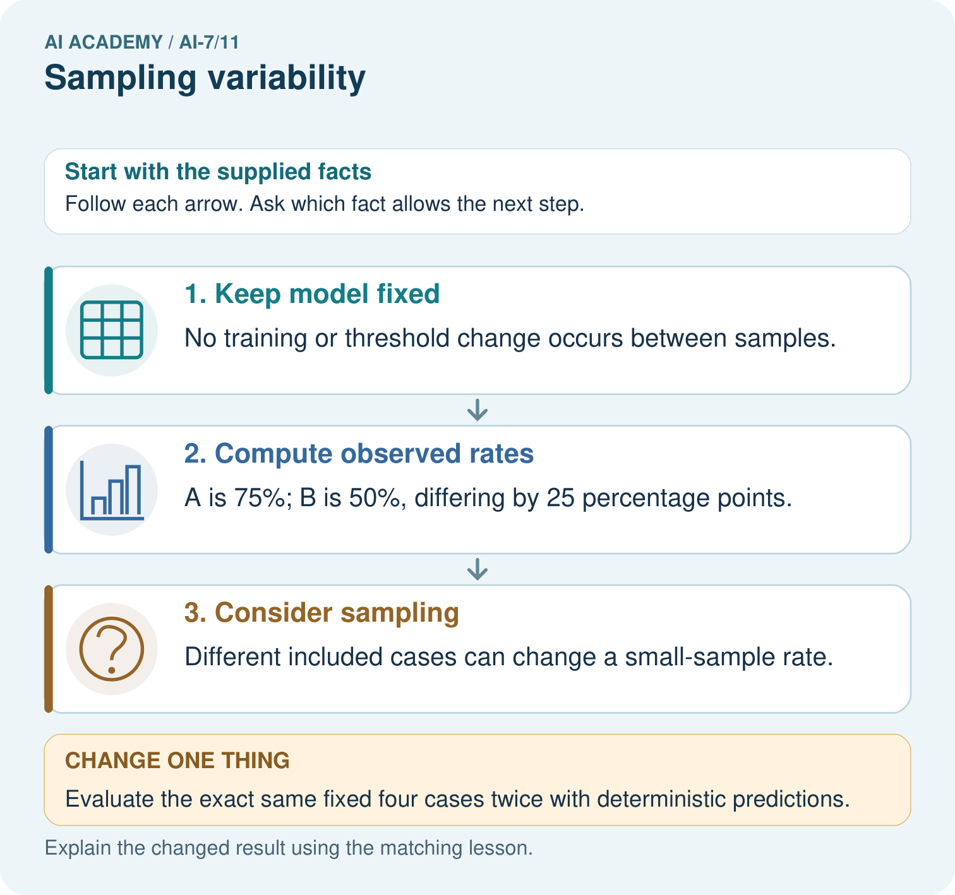

Read the picture one step at a time
Step | What happens and why
1. Keep model fixed | No training or threshold change occurs between samples.
2. Compute observed rates | A is 75%; B is 50%, differing by 25 percentage points.
3. Consider sampling | Different included cases can change a small-sample rate.
Match each pictured step to the supplied facts. This is a worked teaching case, not an independent assessment.

Why this result follows
Sampling variability means a statistic can vary because different units were observed. Do not automatically attribute every rate change to a model improvement or deterioration.

What this example does not establish
These two samples do not supply a probability model or confidence interval; none is invented.

Change one thing in the pictured case
Change: Evaluate the exact same fixed four cases twice with deterministic predictions.
Prediction: The counts should agree unless some condition, data or scoring changed.
Reason: The sampling explanation no longer applies when the records are identical.

Ask while showing the picture
Cover the result. Ask learners to name the inputs and predict the next step. Uncover one step, connect the icon to the actual procedure, and explain its evidence. Then change the supplied condition and compare. The picture is a representation; it does not document execution of a real AI model.

03. Demonstrate and guide practice
Time or stage | Teacher action
Session 1: 0–7 minutes | Retrieve the prerequisite; identify the input, procedure and evidence source.
7–18 minutes | Explain section 1 and vocabulary. Complete W1 with a mechanism-based explanation.
18–32 minutes | Trace the declared procedure and worked case. Complete W2, recording intermediate steps.
32–45 minutes | Discuss the diagram with the worked input; use W3 to distinguish measured claims and limitations.
Session 2: 0–8 minutes | Retrieve the worked reasoning and collect the guided response before discussing it.
8–20 minutes | Compare a proposed boundary variant with the original case; identify what remains fixed.
20–35 minutes | Collect W4 independently. Require the procedure trace and the bounded conclusion.
35–45 minutes | Use W5 and exit responses for feedback. Administer the fresh retry after feedback and preserve both attempts.
Use the worked example in Sections 3 and 6. Collect a prediction before revealing its result; ask the learner to point to each intermediate fact.
Provide an input/procedure/result/limit frame and a calculator when needed. Ask students to identify the first step before completing the whole trace. Extension: compare two concrete variants of this mechanism while holding unrelated conditions fixed; report both successful and unsuccessful outcomes.

Reduce help deliberately
Completion task: Find the mean of sample means and the chance of mean2 under uniform selection of those six samples. Show the intermediate steps and give the conclusion with its scope.
Teacher check: Teacher explanation: Mean=(1+2+2+2+2+3)/6=2; mean2 occurs4/6=2/3. The population mean is2, while individual samples differ.
Start by identifying the given inputs together. Leave the intermediate steps blank. If needed, model one step, then withdraw that help on the next step. Move to a full trace only when the partial trace is understood. For partners, alternate explainer and checker; collect a response from every learner before discussion.

Individual reasoning check
Use the worked case for Sampling variability. Proposed explanation: “The worked result establishes every future case”. Decide whether this explanation is supported. Point to the step or supplied fact that decides; explain your repair if needed.
Expected correction: This finite example is not a general normality guarantee or a model of a biased convenience sample.
Collect explanations, not only yes/no votes. If a misunderstanding is common, re-model the relevant step for the class. If it affects a few learners, give a short targeted group explanation while others solve a more demanding variation.

Pictorial practice question
Calculate the two four-case rates and their difference. Explain how changed included cases can affect a fixed model, and why identical deterministic records should not differ on a rerun.

Reasoned teacher answer
No training or threshold change occurs between samples. A is 75%; B is 50%, differing by 25 percentage points. Different included cases can change a small-sample rate. Changed case: The counts should agree unless some condition, data or scoring changed. The sampling explanation no longer applies when the records are identical.
Changed-case reasoning: The counts should agree unless some condition, data or scoring changed. The sampling explanation no longer applies when the records are identical.
Collect each learner’s explanation before discussion. Use the first missing connection between input, deciding step and result to choose support. This question is worked-case practice, not fresh mastery evidence.

04. Run the investigation and diagnose misconceptions
The worked result establishes every future case: This finite example is not a general normality guarantee or a model of a biased convenience sample.
A missing input may be replaced without recording the change: A replacement changes the evidence or contract. Record the change and its justification; do not silently turn unknown into a measured value.
Repeating an assessed case is new independent evidence: A replay checks consistency. An example used for feedback or revision cannot later be described as untouched final evaluation.
Use Section 9 for the evidence ledger. Add a boundary or missing-input case and record the expected response before checking. More successful repeats of one case do not establish wider coverage.

Match the support to the first error
What the response shows | Next teaching action
Missing or misread facts | Read the case aloud, mark supplied versus unknown facts, and let the learner restate it.
Wrong procedure | Return to the deciding step in the worked case. Contrast it with the proposed incorrect explanation.
Arithmetic or implementation error | Trace intermediate values or lines; preserve the first mismatch and retry that step.
Correct result without a reason | Ask for a trace and a changed case before marking independent understanding.
An unsupported wider claim | Ask which supplied evidence supports the claim and which further observation would be needed.
Offer an oral explanation, drawing, enlarged visual or fewer examples when that removes a reading/writing barrier. Keep the same reasoning goal. Stretch secure learners by changing a boundary or assumption and asking them to defend the effect, not simply by assigning more of the same questions.

05. Assess and explain the answers

Guided and exit questions
Guided: Mean=(1+2+2+2+2+3)/6=2; mean2 occurs4/6=2/3. The population mean is2, while individual samples differ. Qualification: This finite example is not a general normality guarantee or a model of a biased convenience sample. Exit: accept a concrete variation with its predicted outcome and a stated condition that would challenge the mechanism; reject a claim resting on unmeasured evidence.

W1 Explain the mechanism
Explain the weekly mechanism in your own words. Use the worked scenario to name its input, decision rule and output.
Teacher explanation: Sampling variability means different eligible samples can give different estimates even under the same population. Separate this from procedure changes. Consider finite population values1, 1, 3, 3 with distinct IDs. Enumerate the six unordered samples of size2 without replacement. Their means are1, 2, 2, 2, 2, 3.

W2 Trace the worked case
Find the mean of sample means and the chance of mean2 under uniform selection of those six samples. Show the intermediate steps and give the conclusion with its scope.
Teacher explanation: Mean=(1+2+2+2+2+3)/6=2; mean2 occurs4/6=2/3. The population mean is2, while individual samples differ.

W3 Audit the limit
A report omits this qualification: This finite example is not a general normality guarantee or a model of a biased convenience sample. Explain how omitting it could change a reader's interpretation, and write an accurate replacement.
Teacher explanation: This finite example is not a general normality guarantee or a model of a biased convenience sample. State the observed result separately from the unverified or out-of-scope claim; preserve the original evidence rather than inventing a missing fact.

W4 Apply a new case independently
Population0, 0, 4, 4 with distinct IDs; enumerate size2 sample means and their average.
Teacher explanation: Means0, 2, 2, 2, 2, 4; average2; mean2 occurs4/6. Equal values have distinct IDs and count as separate eligible units.

W5 Design a revealing follow-up
For the worked scenario, propose one additional case that could reveal a failure, describe its expected outcome before running it, and explain what would need to remain fixed for a fair comparison. Do not reuse W4 as a new final test after receiving feedback.
Teacher explanation: Accept a concrete variant of the worked input or a missing/conflicting/boundary condition, with an expectation derived from the declared procedure. Require preserved settings, original outputs and data roles. This finite example is not a general normality guarantee or a model of a biased convenience sample. The new case should test this particular mechanism rather than merely restate the original result.

Independent assessment and fresh retry
W4: Means0, 2, 2, 2, 2, 4; average2; mean2 occurs4/6. Equal values have distinct IDs and count as separate eligible units. Require intermediate reasoning and the stated scope. Fresh retry: Population2, 2, 6, 6 under same sampling. Expected reasoning: Means2, 4, 4, 4, 4, 6; average4; mean4 probability2/3. If students need support, record it and reassess with another new case rather than awarding independence to a copied answer.

Assess independent transfer
Selected case: Population0, 0, 4, 4 with distinct IDs; enumerate size2 sample means and their average.

Selected case answer
Teacher explanation: Means0, 2, 2, 2, 2, 4; average2; mean2 occurs4/6. Equal values have distinct IDs and count as separate eligible units.
Dimension | Evidence required
Explanation | Names the applicable idea or procedure and ties it to the supplied facts.
Trace and result | Preserves the given inputs and shows the relevant intermediate steps; distinguishes a prediction from an observed execution.
Limits | States the assumptions, missing evidence or conditions under which the result would change.
Record each dimension as not yet, with support, or independent. Accept a valid alternative procedure with a defensible trace. Do not penalise an honestly recorded model failure if the learner correctly explains its evidence and limits.

Feedback that the learner uses
Name the earliest unsupported step and give one action to repair it. Have the learner make that repair now and explain why. Then assess the relevant skill on a fresh, fully specified case. Confirm it was not previously practised with feedback; solve and check the new case before assigning it. A follow-up design prompt is a starting brief, not automatically an equivalent test.

06. Connect the project, support and next lesson
Add a labelled sampling variability evidence sheet to Reproducible AI Research Study. Show how you can explain the mechanism and terminology of sampling variability. Use the supplied fictional case and keep its inputs, intermediate steps, calculation or prediction, and limitation. Connect this record to last week’s record; a matching answer without a trace is insufficient.
Provide an input/procedure/result/limit frame and a calculator when needed. Ask students to identify the first step before completing the whole trace. Extension: compare two concrete variants of this mechanism while holding unrelated conditions fixed; report both successful and unsuccessful outcomes.
Next connection: Uncertainty intervals. Preserve the current case record and retrieve its evidence boundary before moving on.
Retain the project ledger and assess a changed case after support. Check the relevant prerequisite before carrying this component forward.

Plan the delayed return
Suggested return points in this level: ai-7/12, ai-7/14, ai-7/17. Use actual classroom dates, adjusting for holidays and gaps. One, three and six teaching weeks are scheduling choices, not a claimed optimal spacing.
At a delayed check, ask for the idea from memory and a changed application. Compare with the earlier independent response and record support used. For a new level, revisit the previous capstone before checking the new prerequisites.
Record | Teacher evidence
Learner code and date
Concept and case used; prior exposure
Explanation / trace / limits
Support and first repair
Changed case and delayed outcome
Next teaching action
Use the evidence to choose reteaching or the next step. A completed page, confidence rating or attractive project does not by itself demonstrate understanding.

Project evidence from this case
For the Reproducible AI Research Study, retain an annotated worked trace and the changed-case reasoning. Connect the claim to its records, units and assumptions so another investigator can challenge or reproduce it.

07. Prepare, teach and assess
Teaching target: Explain the mechanism and terminology of sampling variability
Prepare the labelled worked-case picture, the matching workbook, fictional input cards and a place for individual responses. Check a local Python 3 environment before class; have a paper-trace version ready.
Session | Plan | Resources
Session 1 · Understand · 45 min | 0–7: recall and prerequisite; 7–15: inspect the concrete case and predict; 15–30: teacher models the worked trace; 30–40: learners explain a step using the text and visual; 40–45: check the core idea. | Sections 1–6; record the brief recall in the workbook.
Session 2 · Practise · 45 min | 0–5: retrieve the procedure; 5–15: W2 completion practice; 15–23: explain and check with a partner; 23–30: each learner answers the misconception check; 30–40: targeted reteaching or a harder variation; 40–45: prepare the investigation. | Sections 7–10; use the matching workbook W2 and misconception check.
Session 3 · Investigate and transfer · 45 min | 0–5: retrieve the decision rule; 5–20: investigate or trace; 20–30: start the independent case; 30–38: connect the project; 38–43: act on feedback; 43–45: plan the return check. | Sections 9 and 11–14. Give extra time to finish the full task set; use Section 15 when the week includes a coding lab.
Before class, solve the supported practice: Find the mean of sample means and the chance of mean2 under uniform selection of those six samples. Show the intermediate steps and give the conclusion with its scope.
Reasoned practice answer: Teacher explanation: Mean=(1+2+2+2+2+3)/6=2; mean2 occurs4/6=2/3. The population mean is2, while individual samples differ.
Check every learner before discussion: Use the worked case for Sampling variability. Proposed explanation: “The worked result establishes every future case”. Decide whether this explanation is supported. Point to the step or supplied fact that decides; explain your repair if needed.
Misconception repair: This finite example is not a general normality guarantee or a model of a biased convenience sample.
Support: read the exact case aloud, enlarge the labelled picture, supply input cards and model only the first deciding step. Accept a spoken explanation or drawing; retain the reasoning goal.
Extension: Evaluate the exact same fixed four cases twice with deterministic predictions. Require a prediction and a reason before comparing. Expected result: The counts should agree unless some condition, data or scoring changed. Reason: The sampling explanation no longer applies when the records are identical.
Independent assessment: withhold the reserved answer until the learner has attempted the new case. Record support separately from correctness.
Criterion | Not yet | With support | Independent
Explanation | Names an answer without a deciding fact | Uses a hint to link fact and decision | Explains the deciding fact in own words
Trace or test | Cannot connect input and result | Completes steps with prompts | Traces or tests a changed case accurately
Limits and revision | Claims more than evidence supports | Names a limit after a prompt | States a defensible limit and useful next test
Project checkpoint: Make a transparent first version. Keep a trace of how one input becomes an output; explain the rule or learned component.
Use the weekly teacher answer for topic-specific reasoning. A saved progress tick is an activity record; judge mastery from the learner’s explanation and evidence.

08. Use feedback, labs and repair paths
Use the two formative questions as supported practice, not as independent mastery scores. Discuss the deciding evidence rather than accepting a guessed selection.
The feedback comes from the reviewed public worked case. Do not reveal the separately reserved independent teacher answer until the learner has attempted that case.
Ask students to predict before running code. Preserve errors and actual outputs; collect a changed test and an explanation. The branch-boundary and indexing lessons deliberately include failure cases.
Use the earlier worked-explanation links to address a specific missing building block, then return to the current question. Adapt this suggestion after observing the learner; it is not an automatic diagnosis.
Collect the completed-work portfolio as evidence. Record support separately from correctness, and assess explanation, trace/test and limitations. Progress ticks and quiz selections alone do not establish mastery.

