AI ACADEMY · TEACHER · python-bridge/2

Values variables and types
Project: Python readiness portfolio

01. Prepare the purpose, prerequisites and materials

Teach the learning cycle
Primary target: Distinguish integer, floating-point, text and Boolean values
Session | Sequence and minutes | Resources
Session 1 · Understand · 45 min | 0–7: recall and prerequisite; 7–15: inspect the concrete case and predict; 15–30: teacher models the worked trace; 30–40: learners explain a step using the text and visual; 40–45: check the core idea. | Sections 1–6; record the brief recall in the workbook.
Session 2 · Practise · 45 min | 0–5: retrieve the procedure; 5–15: W2 completion practice; 15–23: explain and check with a partner; 23–30: each learner answers the misconception check; 30–40: targeted reteaching or a harder variation; 40–45: prepare the investigation. | Sections 7–10; use the matching workbook W2 and misconception check.
Session 3 · Investigate and transfer · 45 min | 0–5: retrieve the decision rule; 5–20: investigate or trace; 20–30: start the independent case; 30–38: connect the project; 38–43: act on feedback; 43–45: plan the return check. | Sections 9 and 11–14. Give extra time to finish the full task set; use Section 15 when the week includes a coding lab.
This is a starting allocation of 135 minutes, not a validated duration. Preserve all named topics. Schedule extra time for connected examples, the full investigation, independent cases and project building. Repeated copies of a case share one recorded attempt; they are not new evidence.

Retrieval answer guidance

From a paper algorithm to Python
Without opening the old lesson, explain one key idea from From a paper algorithm to Python. Give an example and a mistake that the idea helps you avoid.
Look for: Translate a short paper calculation into a Python script
Reference example, not the only acceptable wording: packs = 4; per_pack = 6; total = packs * per_pack; print(total), each on its own line. The first two bind quantities, the third computes 24 and the fourth displays 24. Assignment alone produces no displayed output in this script.
Focus on scalar values and rebinding; lists and mutation come later. Avoid saying every assignment makes a deep copy. For the integers used here, rebinding one name leaves the other bound to its prior value. Reference: Python tutorial introduction, https://docs.python.org/3/tutorial/introduction.html, and built-in types, https://docs.python.org/3/library/stdtypes.html.

Outcomes
Distinguish integer, floating-point, text and Boolean values
Trace reassignment without treating a name as a live formula
Choose a suitable representation for a count and an identifier

Preparation
Python 3 editor prepared in Week 1 and fresh values.py script
Name cards and value cards marked with int, float, str or bool
Fictional shelf labels and a blank trace table

Prerequisite answer
It displays the current value 24. Assignment and display are separate operations.

End goal for the pictorial case
Trace values variables and types and explain the changed program before running it.
This added worked case illustrates the week’s main idea. Retain all original and connected topics; schedule its practice within the teaching cycle.

02. Explain and model the mechanism
A count and a shelf label can look similar while needing different operations. The integer 8 is a number; "08" is text that preserves a leading zero. You can count eight objects, but adding two shelf labels is usually meaningless. This week you will examine values, trace changes to names and explain which representation a task needs.
Use the saved Python 3 script workflow from Week 1. Make a new file values.py, predict before running and keep actual output separately. Use fictional labels only. Four useful types are int for whole numbers, float for floating-point numbers, str for text, and bool for True or False. A type describes a value, not whether its meaning is sensible for the task.
type(count) produces the type of the value bound to count. These print lines display <class 'int'> and <class 'str'>. The quotes in "08" mark text; they are not displayed by print(shelf). True and False have capital initials and no quotes. "False" is text, not a Boolean.
Term | Meaning
Value | A piece of data such as 8 or a text label
Variable | A name bound to a value during execution
Type | A category of value that determines available operations
String | A sequence of text characters
Reassignment | Binding an existing name to a new value

A saved value is not a live link
Instruction | count now | saved now
count = 8 | 8 | Not assigned
saved = count | 8 | 8
count = count + 2 | 10 | 8
Evaluate the right side using the current value, then bind the left-hand name. The saved integer does not update when count is reassigned.
The new saved = count binds saved to the current 10, so print(saved) displays 10. Without that assignment it stays 8. Exit: turning "08" into 8 loses the leading zero; identifier addition has no defined meaning in the stated task. -3 is an integer but cannot be a nonnegative count.

Model the reasoning aloud
Use the complete worked example below before asking learners to complete W2. Reveal a small part, invite a prediction, then explain the deciding step. These teacher notes contain solutions; do not reveal the independent case answer during modelling.

A saved value is not a live link
Instruction | count now | saved now
count = 8 | 8 | Not assigned
saved = count | 8 | 8
count = count + 2 | 10 | 8
Evaluate the right side using the current value, then bind the left-hand name. The saved integer does not update when count is reassigned.
count = 8
saved = count
count = count + 2
print(count)
print(saved)
The outputs are 10 and 8 on separate lines. saved = count uses the value available at that moment. It does not store a formula that keeps following count. count = count + 2 is valid assignment: read the old 8, calculate 10, then rebind count. It is not a claim that 8 equals 10.

After count becomes 10, add saved = count and print(saved). Predict the new output and explain why this is different from expecting saved to change automatically.
________________________________________________________________
________________________________________________________________
________________________________________________________________
________________________________________________________________
________________________________________________________________
Thinking move | Teacher prompt
Plan | What is given? What is the question? Which procedure fits these facts?
Do | Point to each input and intermediate step in the worked trace. Name the rule that allows the next step.
Check | Does the output answer the question? Which assumption or limitation prevents a larger claim?
Use the diagram and verbal explanation together. Ask learners to match a sentence to a specific visual step; do not assign learners fixed visual or auditory learning styles.

A pictorial worked case: Values variables and types
A number and its printed-looking text. A program stores a numeric badge count and a string that looks like that count.

The facts we will use
Python 3: count=8; tag="8"; print(count+2); print(tag+"2").
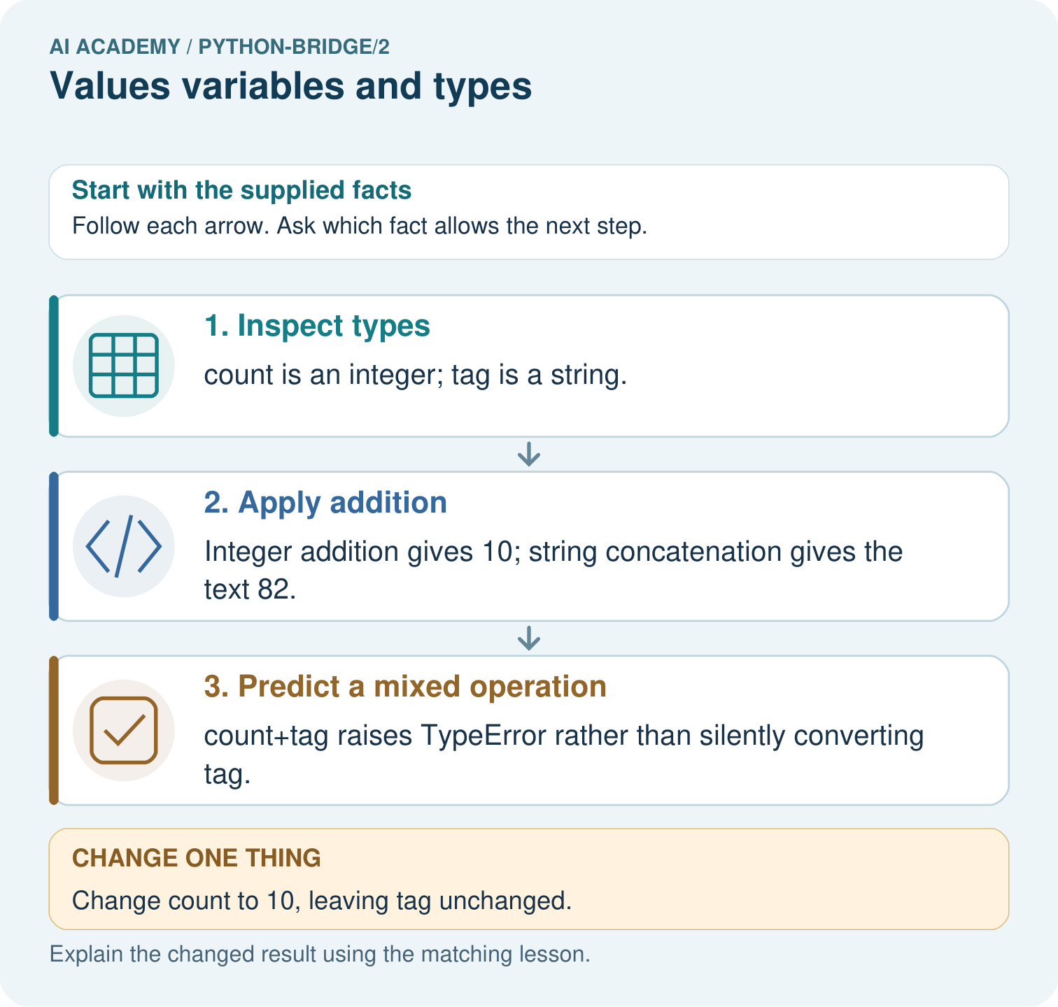

Read the picture one step at a time
Step | What happens and why
1. Inspect types | count is an integer; tag is a string.
2. Apply addition | Integer addition gives 10; string concatenation gives the text 82.
3. Predict a mixed operation | count+tag raises TypeError rather than silently converting tag.
Match each pictured step to the supplied facts. This is a worked teaching case, not an independent assessment.

Why this result follows
Values carry types, not merely appearances. The plus operator performs numeric addition for these integers and concatenation for these strings; the mixed operation is invalid here.

What this example does not establish
These examples use built-in integers and strings; operator behaviour depends on types and is not proof of general model reasoning.

Change one thing in the pictured case
Change: Change count to 10, leaving tag unchanged.
Prediction: The two valid outputs become 12 and 82.
Reason: Only the integer variable changes; the string still contains the character 8.

Ask while showing the picture
Cover the result. Ask learners to name the inputs and predict the next step. Uncover one step, connect the icon to the actual procedure, and explain its evidence. Then change the supplied condition and compare. The picture is a representation; it does not document execution of a real AI model.

03. Demonstrate and guide practice
Time or stage | Teacher action
Session 1 start to 7 minutes | Retrieve assignment versus print and collect the prerequisite.
7 to 20 minutes | Compare count and shelf label; model type output and complete W1.
20 to 33 minutes | Use the diagram and move name cards while tracing the count program.
33 to 45 minutes | Complete W2 with predicted and actual outputs in separate columns.
Session 2 start to 8 minutes | Retrieve the two saved values and explain the extra assignment in the guided task.
8 to 20 minutes | Run the numeric and text operations; use W3 to diagnose a TypeError.
20 to 35 minutes | Collect W4 independently before support, including the seat-label choice.
35 to 45 minutes | Complete W5 and the exit; separate type from permitted value.
Use the worked example in Sections 3 and 6. Collect a prediction before revealing its result; ask the learner to point to each intermediate fact.
Use movable name cards and immutable number cards. Keep quotations visible on text cards and show source beside output. Offer an oral trace but record assistance. Extension: explain why a type-correct number such as -3 is not acceptable as the number of seats.

Reduce help deliberately
Completion task: Trace the five-line count and saved program. Record both printed outputs, then predict the result of assigning saved = count after the change. Check with a run or label a paper trace.
Teacher check: Original outputs 10 then 8. After the new assignment, saved becomes 10. Keep actual observations separate. Reading an integer value earlier does not create a live link to another name.
Start by identifying the given inputs together. Leave the intermediate steps blank. If needed, model one step, then withdraw that help on the next step. Move to a full trace only when the partial trace is understood. For partners, alternate explainer and checker; collect a response from every learner before discussion.

Individual reasoning check
Use the worked case for Values variables and types. Proposed explanation: “Digits always mean a number”. Decide whether this explanation is supported. Point to the step or supplied fact that decides; explain your repair if needed.
Expected correction: Quotes make a string, even when every character is a digit.
Collect explanations, not only yes/no votes. If a misunderstanding is common, re-model the relevant step for the class. If it affects a few learners, give a short targeted group explanation while others solve a more demanding variation.

Pictorial practice question
Predict both print outputs and explain why they differ. Does count+tag work, and what happens to each valid output after count becomes ten?

Reasoned teacher answer
The outputs are 10 and 82. The first adds integers; the second joins strings. count+tag raises TypeError. Changing count to 10 yields 12, while tag+"2" remains 82.
Changed-case reasoning: The two valid outputs become 12 and 82. Only the integer variable changes; the string still contains the character 8.
Collect each learner’s explanation before discussion. Use the first missing connection between input, deciding step and result to choose support. This question is worked-case practice, not fresh mastery evidence.

04. Run the investigation and diagnose misconceptions
Digits always mean a number: Quotes make a string, even when every character is a digit.
Changing one scalar name updates every earlier assignment: Trace the value bound at each assignment; no formula link is stored.
The right type guarantees valid data: A negative integer can be an invalid object count.
Lowercase false is Python’s Boolean false value: The literal is False; lowercase false is a name and is undefined in a fresh script.
Use Section 9 for the evidence ledger. Add a boundary or missing-input case and record the expected response before checking. More successful repeats of one case do not establish wider coverage.

Match the support to the first error
What the response shows | Next teaching action
Missing or misread facts | Read the case aloud, mark supplied versus unknown facts, and let the learner restate it.
Wrong procedure | Return to the deciding step in the worked case. Contrast it with the proposed incorrect explanation.
Arithmetic or implementation error | Trace intermediate values or lines; preserve the first mismatch and retry that step.
Correct result without a reason | Ask for a trace and a changed case before marking independent understanding.
An unsupported wider claim | Ask which supplied evidence supports the claim and which further observation would be needed.
Offer an oral explanation, drawing, enlarged visual or fewer examples when that removes a reading/writing barrier. Keep the same reasoning goal. Stretch secure learners by changing a boundary or assumption and asking them to defend the effect, not simply by assigning more of the same questions.

05. Assess and explain the answers

Guided and exit questions
The new saved = count binds saved to the current 10, so print(saved) displays 10. Without that assignment it stays 8. Exit: turning "08" into 8 loses the leading zero; identifier addition has no defined meaning in the stated task. -3 is an integer but cannot be a nonnegative count.

W1 Identify the value and its type
Classify 12, 1.5, "12", False and "False". Explain why the last two are different.
12 is int; 1.5 is float; "12" is str; False is bool; "False" is str. Quotes mark text even when the characters spell a Boolean name.

W2 Trace a saved value
Trace the five-line count and saved program. Record both printed outputs, then predict the result of assigning saved = count after the change. Check with a run or label a paper trace.
Original outputs 10 then 8. After the new assignment, saved becomes 10. Keep actual observations separate. Reading an integer value earlier does not create a live link to another name.

W3 Diagnose the operation
Predict 6 + 3, "6" + "3" and "6" * 3. Explain what happens for "6" + 3. Which expression counts six groups of three?
9, text 63, text 666, and TypeError respectively. Six groups of three needs numeric multiplication 6 * 3, giving 18; none of the listed successful expressions calculates that total.

W4 Trace a new pair of names independently
A fresh script runs seats = 12; booked = seats; seats = seats - 5; print(seats); print(booked), with each statement on a separate line. Predict both outputs. Then add booked = seats + 1 and print(booked). Explain the evaluation order and choose a type for a seat label "07".
The outputs are 7 and 12, then 8 after the added assignment. The right side reads the current seats value 7 before binding booked to 8. The seat label remains str to preserve its leading zero.

W5 Separate type from validity
Give a suitable type for a counter count, a length of 2.5 metres, a shelf ID with a leading zero, and a yes-or-no availability flag. Give a count value with the right type that should still be rejected.
Use int, float, str and bool respectively. A negative integer such as -3 has type int but is invalid for a nonnegative physical count. Type checking and checking the task’s permitted values are different.

Independent assessment and fresh retry
W4 needs outputs 7, 12 and 8 with a right-side-first explanation and str for "07". After support, retry with stock = 9, spare = stock, stock = stock - 4: printing stock and spare gives 5 and 9; spare = stock + 2 then gives 7. Record independent reasoning before giving the retry.

Assess independent transfer
Selected case: Predict both output lines and explain why estimate stays unchanged when count is reassigned. Repeat the trace with initial count=0. Explain why note is text even though its printed characters look like a number.
count = 4
note = "4"
estimate = count / 2
fits = count <= 5
count = count + 3
print(count, note, estimate, fits)
print(type(count).__name__, type(note).__name__, type(estimate).__name__, type(fits).__name__)

Selected case answer
Original outputs: 7 4 2.0 True, then int str float bool. Estimate was calculated as 2.0 before reassignment; it is not a live formula. With initial count=0: 3 4 0.0 True, with the same types. Note is the quoted string "4", independent of the integer count.
Dimension | Evidence required
Explanation | Names the applicable idea or procedure and ties it to the supplied facts.
Trace and result | Preserves the given inputs and shows the relevant intermediate steps; distinguishes a prediction from an observed execution.
Limits | States the assumptions, missing evidence or conditions under which the result would change.
Record each dimension as not yet, with support, or independent. Accept a valid alternative procedure with a defensible trace. Do not penalise an honestly recorded model failure if the learner correctly explains its evidence and limits.

Feedback that the learner uses
Name the earliest unsupported step and give one action to repair it. Have the learner make that repair now and explain why. Then assess the relevant skill on a fresh, fully specified case. Confirm it was not previously practised with feedback; solve and check the new case before assigning it. A follow-up design prompt is a starting brief, not automatically an equivalent test.

06. Connect the project, support and next lesson
Add a labelled values variables and types evidence sheet to Python readiness portfolio. Show how you can distinguish integer, floating-point, text and boolean values. Use the supplied fictional case and keep its inputs, intermediate steps, calculation or prediction, and limitation. Connect this record to last week’s record; a matching answer without a trace is insufficient.
Use movable name cards and immutable number cards. Keep quotations visible on text cards and show source beside output. Offer an oral trace but record assistance. Extension: explain why a type-correct number such as -3 is not acceptable as the number of seats.
Week 3 combines numeric values in expressions and uses parentheses to make grouping explicit.
Retain the project ledger and assess a changed case after support. Check the relevant prerequisite before carrying this component forward.

Plan the delayed return
Suggested return points in this level: python-bridge/3, python-bridge/5, python-bridge/8. Use actual classroom dates, adjusting for holidays and gaps. One, three and six teaching weeks are scheduling choices, not a claimed optimal spacing.
At a delayed check, ask for the idea from memory and a changed application. Compare with the earlier independent response and record support used. For a new level, revisit the previous capstone before checking the new prerequisites.
Record | Teacher evidence
Learner code and date
Concept and case used; prior exposure
Explanation / trace / limits
Support and first repair
Changed case and delayed outcome
Next teaching action
Use the evidence to choose reteaching or the next step. A completed page, confidence rating or attractive project does not by itself demonstrate understanding.

Project evidence from this case
For Python readiness before the Responsible Plant Classifier, retain a trace of the values, the predicted outputs and the changed-case explanation. Use actual Python 3 results to check the prediction after reasoning first.

07. Prepare, teach and assess
Teaching target: Distinguish integer, floating-point, text and Boolean values
Prepare the labelled worked-case picture, the matching workbook, fictional input cards and a place for individual responses. Check a local Python 3 environment before class; have a paper-trace version ready.
Session | Plan | Resources
Session 1 · Understand · 45 min | 0–7: recall and prerequisite; 7–15: inspect the concrete case and predict; 15–30: teacher models the worked trace; 30–40: learners explain a step using the text and visual; 40–45: check the core idea. | Sections 1–6; record the brief recall in the workbook.
Session 2 · Practise · 45 min | 0–5: retrieve the procedure; 5–15: W2 completion practice; 15–23: explain and check with a partner; 23–30: each learner answers the misconception check; 30–40: targeted reteaching or a harder variation; 40–45: prepare the investigation. | Sections 7–10; use the matching workbook W2 and misconception check.
Session 3 · Investigate and transfer · 45 min | 0–5: retrieve the decision rule; 5–20: investigate or trace; 20–30: start the independent case; 30–38: connect the project; 38–43: act on feedback; 43–45: plan the return check. | Sections 9 and 11–14. Give extra time to finish the full task set; use Section 15 when the week includes a coding lab.
Before class, solve the supported practice: Trace the five-line count and saved program. Record both printed outputs, then predict the result of assigning saved = count after the change. Check with a run or label a paper trace.
Reasoned practice answer: Original outputs 10 then 8. After the new assignment, saved becomes 10. Keep actual observations separate. Reading an integer value earlier does not create a live link to another name.
Check every learner before discussion: Use the worked case for Values variables and types. Proposed explanation: “Digits always mean a number”. Decide whether this explanation is supported. Point to the step or supplied fact that decides; explain your repair if needed.
Misconception repair: Quotes make a string, even when every character is a digit.
Support: read the exact case aloud, enlarge the labelled picture, supply input cards and model only the first deciding step. Accept a spoken explanation or drawing; retain the reasoning goal.
Extension: Change count to 10, leaving tag unchanged. Require a prediction and a reason before comparing. Expected result: The two valid outputs become 12 and 82. Reason: Only the integer variable changes; the string still contains the character 8.
Independent assessment: withhold the reserved answer until the learner has attempted the new case. Record support separately from correctness.
Criterion | Not yet | With support | Independent
Explanation | Names an answer without a deciding fact | Uses a hint to link fact and decision | Explains the deciding fact in own words
Trace or test | Cannot connect input and result | Completes steps with prompts | Traces or tests a changed case accurately
Limits and revision | Claims more than evidence supports | Names a limit after a prompt | States a defensible limit and useful next test
Project checkpoint: Python readiness portfolio. Keep runnable code, predictions, actual outputs, one repaired error and an explanation of a function on changed inputs.
Use the weekly teacher answer for topic-specific reasoning. A saved progress tick is an activity record; judge mastery from the learner’s explanation and evidence.

08. Use feedback, labs and repair paths
Use the two formative questions as supported practice, not as independent mastery scores. Discuss the deciding evidence rather than accepting a guessed selection.
The feedback comes from the reviewed public worked case. Do not reveal the separately reserved independent teacher answer until the learner has attempted that case.
Ask students to predict before running code. Preserve errors and actual outputs; collect a changed test and an explanation. The branch-boundary and indexing lessons deliberately include failure cases.
Use the earlier worked-explanation links to address a specific missing building block, then return to the current question. Adapt this suggestion after observing the learner; it is not an automatic diagnosis.
Collect the completed-work portfolio as evidence. Record support separately from correctness, and assess explanation, trace/test and limitations. Progress ticks and quiz selections alone do not establish mastery.

