AI ACADEMY · TEACHER · python-bridge/6

Loops and trace tables
Project: Python readiness portfolio

01. Prepare the purpose, prerequisites and materials

Teach the learning cycle
Primary target: Trace variable values before and after each loop iteration
Session | Sequence and minutes | Resources
Session 1 · Understand · 45 min | 0–7: recall and prerequisite; 7–15: inspect the concrete case and predict; 15–30: teacher models the worked trace; 30–40: learners explain a step using the text and visual; 40–45: check the core idea. | Sections 1–6; record the brief recall in the workbook.
Session 2 · Practise · 45 min | 0–5: retrieve the procedure; 5–15: W2 completion practice; 15–23: explain and check with a partner; 23–30: each learner answers the misconception check; 30–40: targeted reteaching or a harder variation; 40–45: prepare the investigation. | Sections 7–10; use the matching workbook W2 and misconception check.
Session 3 · Investigate and transfer · 45 min | 0–5: retrieve the decision rule; 5–20: investigate or trace; 20–30: start the independent case; 30–38: connect the project; 38–43: act on feedback; 43–45: plan the return check. | Sections 9 and 11–14. Give extra time to finish the full task set; use Section 15 when the week includes a coding lab.
This is a starting allocation of 135 minutes, not a validated duration. Preserve all named topics. Schedule extra time for connected examples, the full investigation, independent cases and project building. Repeated copies of a case share one recorded attempt; they are not new evidence.
Case exposure check: this source example appears in ai-2/4, ai-2/5, python-bridge/6. Reuse a familiar case for recall or modelling; verify that the case used to assess transfer has not already received feedback.

Retrieval answer guidance

Branching and boundary tests
Without opening the old lesson, explain one key idea from Branching and boundary tests. Give an example and a mistake that the idea helps you avoid.
Look for: Trace the selected branch in an if elif else chain
Reference example, not the only acceptable wording: if tests negative first; elif checks <= 12 only after that fails; else handles the rest. Unindented print runs after any selected branch, whose assignment gives label a value.

Expressions and operator order
Without opening the old lesson, explain one key idea from Expressions and operator order. Give an example and a mistake that the idea helps you avoid.
Look for: Evaluate numeric expressions using Python’s grouping rules
Reference example, not the only acceptable wording: 3 * 8 + 2 or (3 * 8) + 2 gives 26. 3 * (8 + 2) gives 30 and adds two to each of three packs, not two once.
Teach for loops with finite integer ranges before adding more loop forms. Keep range values, body executions and output events separate. Reference: https://docs.python.org/3/tutorial/controlflow.html#the-range-function. The examples use a positive default step and do not require lists or while loops.

Outcomes
Trace variable values before and after each loop iteration
Use the excluded stop value in range correctly
Explain initialization and test zero one and several iterations

Preparation
Python 3 editor and loops.py
Counters or numbered paper cards
Blank trace table with turn total before and total after columns

Prerequisite answer
It reads the old 2, adds 3 and stores 5. Assignment updates a value; it is not an algebraic equality.

End goal for the pictorial case
Trace loops and trace tables and explain the changed program before running it.
This added worked case illustrates the week’s main idea. Retain all original and connected topics; schedule its practice within the teaching cycle.

02. Explain and model the mechanism
Imagine adding numbered counters: first 1, then 2, then 3. A loop can repeat the same addition with a different number each time. This week you will predict each change before running a short Python script. Tracing repeated calculations prepares you to inspect the data processing used in larger AI applications.
In for turn in range(1, 4), Python supplies 1, 2 and 3 in order. The start is included and the stop is excluded. The indented body runs once for each supplied value. The colon and four-space indentation mark that body. This lesson uses integer range values with the default positive step of 1.
The output is 6. Before the first iteration, total is 0. Each assignment reads the previous total and adds the current turn. After turn 3, the range is exhausted, so execution continues after the loop. The table records state; it does not create extra instructions.
Term | Meaning
Loop | A block of instructions that can run repeatedly
Iteration | One execution of a loop body
Accumulator | A variable that keeps a running result
Initialization | Giving a variable its starting value
Trace table | A record of variable values as instructions execute

State after each addition
turn | total before | total after
1 | 0 | 1
2 | 1 | 3
3 | 3 | 6
Initialize total to 0 before the loop. The unindented print runs once afterward.
range(1, 3) supplies 1 and 2, giving total 3. Stop 4 includes 3. Exit: the reset bug agrees for one iteration because there are no earlier additions to lose. range(1, 4) should give 6; the faulty version gives 3.

Model the reasoning aloud
Use the complete worked example below before asking learners to complete W2. Reveal a small part, invite a prediction, then explain the deciding step. These teacher notes contain solutions; do not reveal the independent case answer during modelling.
range(1, 4) | 1, 2, 3 | 3
range(1, 2) | 1 | 1
range(1, 1) | No values | 0
range(4) | 0, 1, 2, 3 | 4
With one argument, range starts at zero. range(4) supplies four values but none is 4. If the worked script uses range(1, 1), the body never runs and the initialized total remains 0. Do not rely on a variable first assigned inside a loop: a zero-iteration run might never assign it.

Replace range(1, 4) with range(1, 3) in the worked script. Predict the supplied values and final total. What stop value is needed to include 3?
________________________________________________________________
________________________________________________________________
________________________________________________________________
________________________________________________________________
________________________________________________________________
Thinking move | Teacher prompt
Plan | What is given? What is the question? Which procedure fits these facts?
Do | Point to each input and intermediate step in the worked trace. Name the rule that allows the next step.
Check | Does the output answer the question? Which assumption or limitation prevents a larger claim?
Use the diagram and verbal explanation together. Ask learners to match a sentence to a specific visual step; do not assign learners fixed visual or auditory learning styles.

A pictorial worked case: Loops and trace tables
Accumulate a short range. A running total adds the integers visited by range(1,5).

The facts we will use
Python 3: total=0; for value in range(1,5): total+=value; print(total). The print is after the loop.
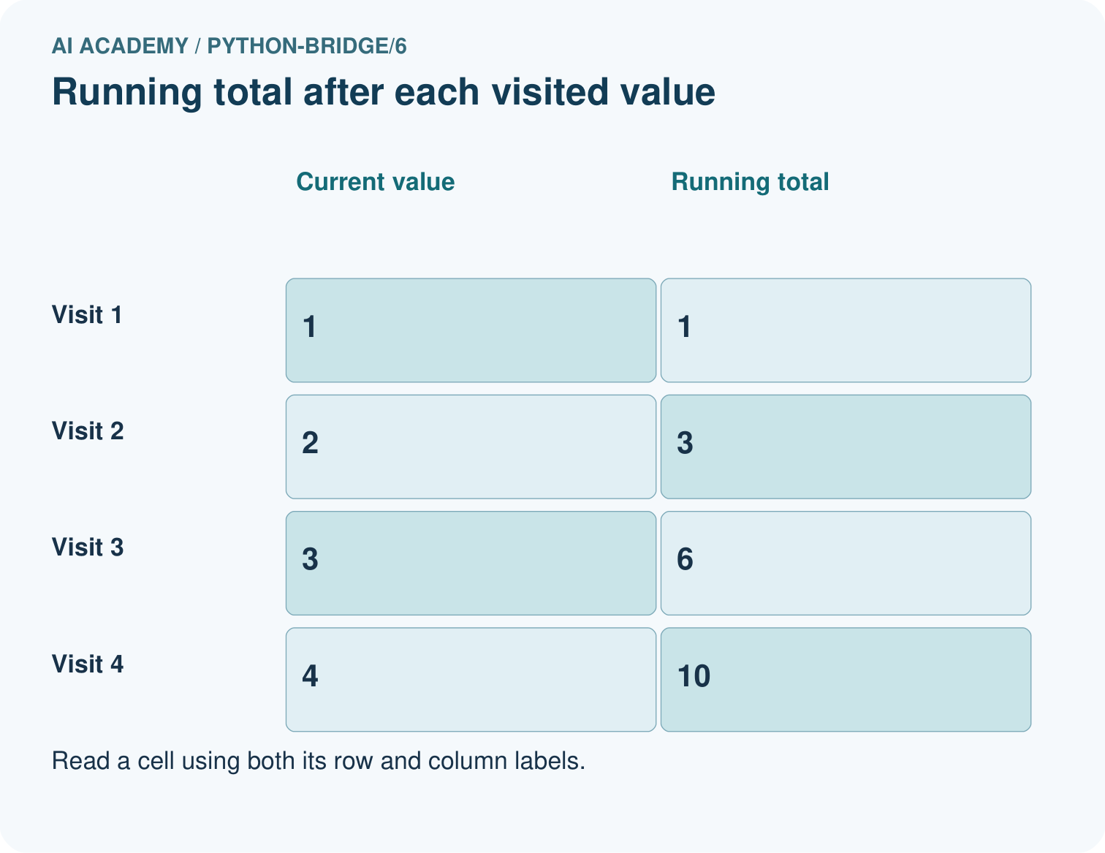
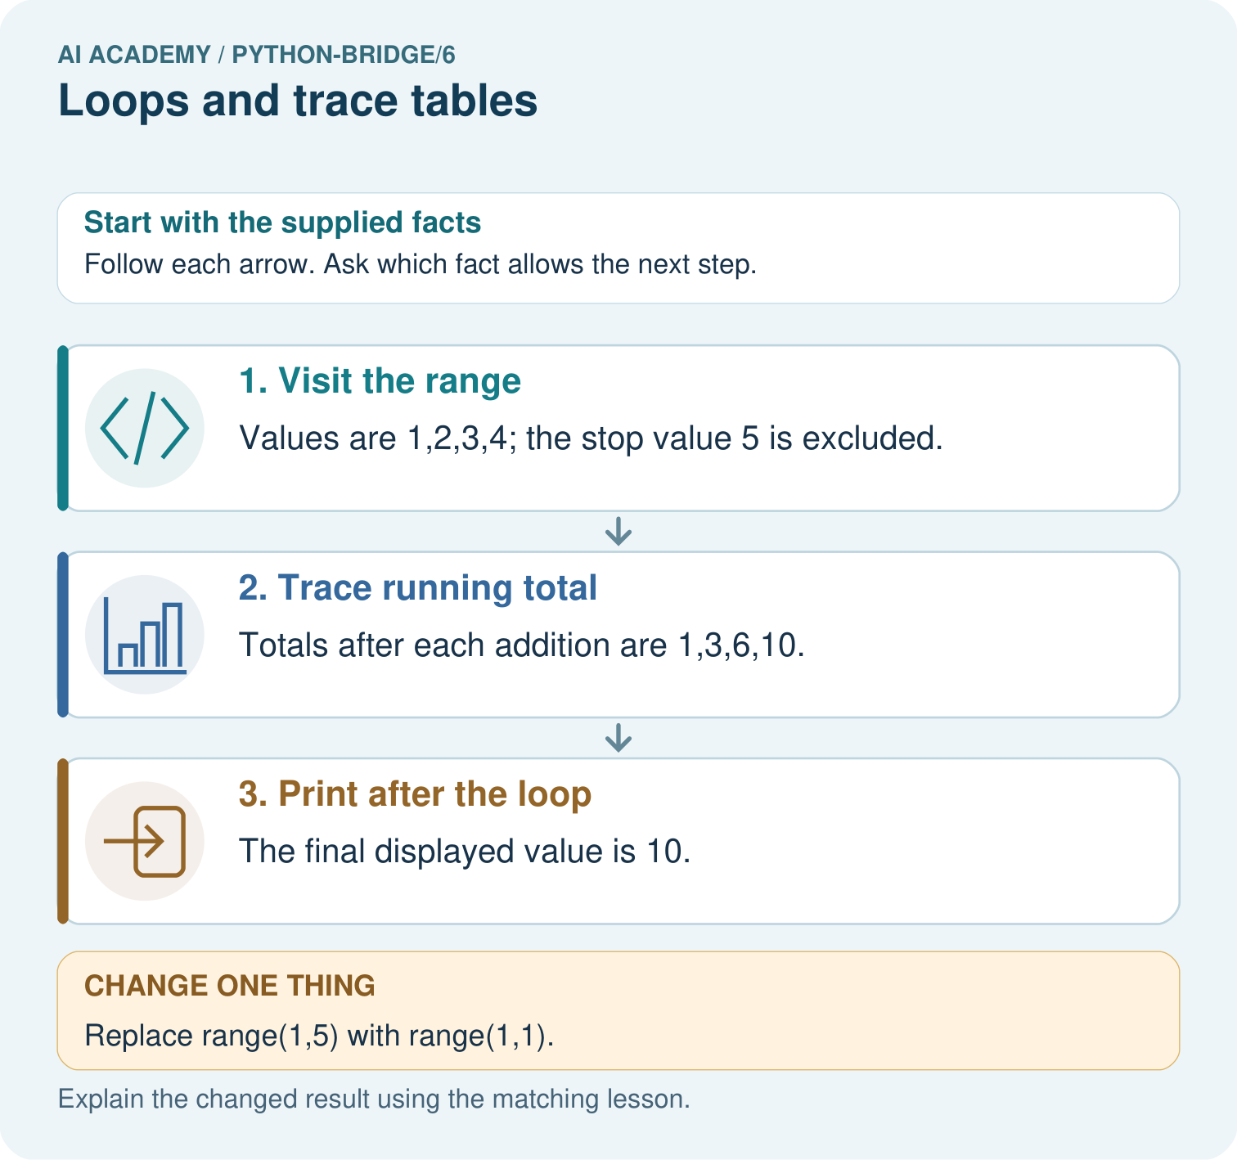

Read the picture one step at a time
Step | What happens and why
1. Visit the range | Values are 1,2,3,4; the stop value 5 is excluded.
2. Trace running total | Totals after each addition are 1,3,6,10.
3. Print after the loop | The final displayed value is 10.
Match each pictured step to the supplied facts. This is a worked teaching case, not an independent assessment.

Why this result follows
A loop repeats an operation for each visited value. A trace table distinguishes the current value from the accumulator; the range stop is not included.

What this example does not establish
This bounded loop does not train an AI model; other loop conditions may require separate termination checks.

Change one thing in the pictured case
Change: Replace range(1,5) with range(1,1).
Prediction: No values are visited and the final output is 0.
Reason: The accumulator starts at zero and an empty loop never changes it.

Ask while showing the picture
Cover the result. Ask learners to name the inputs and predict the next step. Uncover one step, connect the icon to the actual procedure, and explain its evidence. Then change the supplied condition and compare. The picture is a representation; it does not document execution of a real AI model.

03. Demonstrate and guide practice
Time or stage | Teacher action
Session 1 start to 7 minutes | Retrieve assignment using the prerequisite.
7 to 20 minutes | Model range with numbered cards and complete W1.
20 to 33 minutes | Trace each row of the worked addition and predict output.
33 to 45 minutes | Complete W2 and compare predicted and observed values.
Session 2 start to 8 minutes | Retrieve included start and excluded stop.
8 to 20 minutes | Trace the reset bug, complete W3 and discuss the guided response.
20 to 35 minutes | Collect independent W4 code and zero one and several iteration traces.
35 to 45 minutes | Use W5 and the exit to examine assumptions and revealing tests.
Use the worked example in Sections 3 and 6. Collect a prediction before revealing its result; ask the learner to point to each intermediate fact.
Use counters and let the learner move a pointer through one instruction at a time. Offer a blank trace grid and permit oral explanation. Extension: put print inside the correct loop and explain why zero rounds produces no output while an outside print still does.

Reduce help deliberately
Completion task: Copy the worked script. Change the range to range(2, 5). Record turn, total before and total after each iteration. Predict the single output, then run and compare.
Teacher check: Rows are 2 / 0 / 2, 3 / 2 / 5, 4 / 5 / 9. Final output 9. Keep the observed result distinct from the prediction.
Start by identifying the given inputs together. Leave the intermediate steps blank. If needed, model one step, then withdraw that help on the next step. Move to a full trace only when the partial trace is understood. For partners, alternate explainer and checker; collect a response from every learner before discussion.

Individual reasoning check
Use the worked case for Loops and trace tables. Proposed explanation: “The stop value is included”. Decide whether this explanation is supported. Point to the step or supplied fact that decides; explain your repair if needed.
Expected correction: List the supplied values before tracing; range(1, 4) excludes 4.
Collect explanations, not only yes/no votes. If a misunderstanding is common, re-model the relevant step for the class. If it affects a few learners, give a short targeted group explanation while others solve a more demanding variation.

Pictorial practice question
List the four visited values and their running totals. Explain why 5 is absent and what prints for range(1,1).

Reasoned teacher answer
The visits are 1,2,3,4 and totals are 1,3,6,10. The stop is exclusive. An empty range leaves total at its initial 0.
Changed-case reasoning: No values are visited and the final output is 0. The accumulator starts at zero and an empty loop never changes it.
Collect each learner’s explanation before discussion. Use the first missing connection between input, deciding step and result to choose support. This question is worked-case practice, not fresh mastery evidence.

04. Run the investigation and diagnose misconceptions
The stop value is included: List the supplied values before tracing; range(1, 4) excludes 4.
Initialization belongs inside every iteration: Resetting the accumulator loses earlier work.
An unindented print repeats with the body: Indentation determines which statements repeat.
Zero iterations mean the entire program does nothing: Initialization and statements after the loop still execute.
Use Section 9 for the evidence ledger. Add a boundary or missing-input case and record the expected response before checking. More successful repeats of one case do not establish wider coverage.

Match the support to the first error
What the response shows | Next teaching action
Missing or misread facts | Read the case aloud, mark supplied versus unknown facts, and let the learner restate it.
Wrong procedure | Return to the deciding step in the worked case. Contrast it with the proposed incorrect explanation.
Arithmetic or implementation error | Trace intermediate values or lines; preserve the first mismatch and retry that step.
Correct result without a reason | Ask for a trace and a changed case before marking independent understanding.
An unsupported wider claim | Ask which supplied evidence supports the claim and which further observation would be needed.
Offer an oral explanation, drawing, enlarged visual or fewer examples when that removes a reading/writing barrier. Keep the same reasoning goal. Stretch secure learners by changing a boundary or assumption and asking them to defend the effect, not simply by assigning more of the same questions.

05. Assess and explain the answers

Guided and exit questions
range(1, 3) supplies 1 and 2, giving total 3. Stop 4 includes 3. Exit: the reset bug agrees for one iteration because there are no earlier additions to lose. range(1, 4) should give 6; the faulty version gives 3.

W1 Explain the range
List the values supplied by range(2, 5) and explain why 5 is absent. How many times does its body run?
2, 3 and 4; the stop value is excluded. The body runs three times.

W2 Trace before running
Copy the worked script. Change the range to range(2, 5). Record turn, total before and total after each iteration. Predict the single output, then run and compare.
Rows are 2 / 0 / 2, 3 / 2 / 5, 4 / 5 / 9. Final output 9. Keep the observed result distinct from the prediction.

W3 Repair the reset
For the faulty script with range(1, 4), record total after each addition. Explain the wrong final output and remove only the faulty reset.
Faulty after-addition values are 1, 2, 3 because each starts from zero. Remove the indented total = 0. Correct after-addition values are 1, 3, 6; final output 6.

W4 Build a repeated addition independently
A box starts with 5 counters. Each round adds 2 counters. Use rounds = 3, an initialized total and for turn in range(rounds). Print the final total once after the loop. Trace the totals and predict fresh runs with rounds 0, 1 and 3. Assume rounds is a nonnegative integer.
Initialize total = 5 before the loop; add 2 inside it. For three rounds, turn values 0, 1, 2 give totals 7, 9, 11. Final outputs for 0, 1, 3 rounds are 5, 7, 11. Print is unindented.

W5 Check a contract limitation
In your counter script, range(-2) performs no iterations. Does returning the initial 5 make negative rounds valid? Explain what the script checks and what it assumes.
No. The written contract requires a nonnegative integer. The script assumes this and does not reject negative values. Empty range behavior does not validate the input; report the limitation or add an explicit check.

Independent assessment and fresh retry
W4 must preserve the initial 5, update by 2, trace three iterations and print once. Require outputs 5, 7, 11 for zero one and three rounds. After support, retry with an initial 4 and additions of 3 for zero one and two rounds: outputs 4, 7, 10. Record assistance before judging independence.

Assess independent transfer
Selected case: List every value visited and each running total. Then predict the result for range(2,2).
total = 0
for value in range(2, 6):
total = total + value
print(total)

Selected case answer
Values 2,3,4,5 give totals 2,5,9,14. Range(2,2) is empty, so total remains 0. The upper endpoint is excluded.
Dimension | Evidence required
Explanation | Names the applicable idea or procedure and ties it to the supplied facts.
Trace and result | Preserves the given inputs and shows the relevant intermediate steps; distinguishes a prediction from an observed execution.
Limits | States the assumptions, missing evidence or conditions under which the result would change.
Record each dimension as not yet, with support, or independent. Accept a valid alternative procedure with a defensible trace. Do not penalise an honestly recorded model failure if the learner correctly explains its evidence and limits.

Feedback that the learner uses
Name the earliest unsupported step and give one action to repair it. Have the learner make that repair now and explain why. Then assess the relevant skill on a fresh, fully specified case. Confirm it was not previously practised with feedback; solve and check the new case before assigning it. A follow-up design prompt is a starting brief, not automatically an equivalent test.

06. Connect the project, support and next lesson
Add a labelled loops and trace tables evidence sheet to Python readiness portfolio. Show how you can trace variable values before and after each loop iteration. Use the supplied fictional case and keep its inputs, intermediate steps, calculation or prediction, and limitation. Connect this record to last week’s record; a matching answer without a trace is insufficient.
Use counters and let the learner move a pointer through one instruction at a time. Offer a blank trace grid and permit oral explanation. Extension: put print inside the correct loop and explain why zero rounds produces no output while an outside print still does.
Week 7 stores several values in a list and distinguishes an index from the value at that position.
Retain the project ledger and assess a changed case after support. Check the relevant prerequisite before carrying this component forward.

Plan the delayed return
Suggested return points in this level: python-bridge/7, python-bridge/9, python-bridge/12. Use actual classroom dates, adjusting for holidays and gaps. One, three and six teaching weeks are scheduling choices, not a claimed optimal spacing.
At a delayed check, ask for the idea from memory and a changed application. Compare with the earlier independent response and record support used. For a new level, revisit the previous capstone before checking the new prerequisites.
Record | Teacher evidence
Learner code and date
Concept and case used; prior exposure
Explanation / trace / limits
Support and first repair
Changed case and delayed outcome
Next teaching action
Use the evidence to choose reteaching or the next step. A completed page, confidence rating or attractive project does not by itself demonstrate understanding.

Project evidence from this case
For Python readiness before the Responsible Plant Classifier, retain a trace of the values, the predicted outputs and the changed-case explanation. Use actual Python 3 results to check the prediction after reasoning first.

07. Prepare, teach and assess
Teaching target: Trace variable values before and after each loop iteration
Prepare the labelled worked-case picture, the matching workbook, fictional input cards and a place for individual responses. Check a local Python 3 environment before class; have a paper-trace version ready.
Session | Plan | Resources
Session 1 · Understand · 45 min | 0–7: recall and prerequisite; 7–15: inspect the concrete case and predict; 15–30: teacher models the worked trace; 30–40: learners explain a step using the text and visual; 40–45: check the core idea. | Sections 1–6; record the brief recall in the workbook.
Session 2 · Practise · 45 min | 0–5: retrieve the procedure; 5–15: W2 completion practice; 15–23: explain and check with a partner; 23–30: each learner answers the misconception check; 30–40: targeted reteaching or a harder variation; 40–45: prepare the investigation. | Sections 7–10; use the matching workbook W2 and misconception check.
Session 3 · Investigate and transfer · 45 min | 0–5: retrieve the decision rule; 5–20: investigate or trace; 20–30: start the independent case; 30–38: connect the project; 38–43: act on feedback; 43–45: plan the return check. | Sections 9 and 11–14. Give extra time to finish the full task set; use Section 15 when the week includes a coding lab.
Before class, solve the supported practice: Copy the worked script. Change the range to range(2, 5). Record turn, total before and total after each iteration. Predict the single output, then run and compare.
Reasoned practice answer: Rows are 2 / 0 / 2, 3 / 2 / 5, 4 / 5 / 9. Final output 9. Keep the observed result distinct from the prediction.
Check every learner before discussion: Use the worked case for Loops and trace tables. Proposed explanation: “The stop value is included”. Decide whether this explanation is supported. Point to the step or supplied fact that decides; explain your repair if needed.
Misconception repair: List the supplied values before tracing; range(1, 4) excludes 4.
Support: read the exact case aloud, enlarge the labelled picture, supply input cards and model only the first deciding step. Accept a spoken explanation or drawing; retain the reasoning goal.
Extension: Replace range(1,5) with range(1,1). Require a prediction and a reason before comparing. Expected result: No values are visited and the final output is 0. Reason: The accumulator starts at zero and an empty loop never changes it.
Independent assessment: withhold the reserved answer until the learner has attempted the new case. Record support separately from correctness.
Criterion | Not yet | With support | Independent
Explanation | Names an answer without a deciding fact | Uses a hint to link fact and decision | Explains the deciding fact in own words
Trace or test | Cannot connect input and result | Completes steps with prompts | Traces or tests a changed case accurately
Limits and revision | Claims more than evidence supports | Names a limit after a prompt | States a defensible limit and useful next test
Project checkpoint: Python readiness portfolio. Keep runnable code, predictions, actual outputs, one repaired error and an explanation of a function on changed inputs.
Use the weekly teacher answer for topic-specific reasoning. A saved progress tick is an activity record; judge mastery from the learner’s explanation and evidence.

08. Use feedback, labs and repair paths
Use the two formative questions as supported practice, not as independent mastery scores. Discuss the deciding evidence rather than accepting a guessed selection.
The feedback comes from the reviewed public worked case. Do not reveal the separately reserved independent teacher answer until the learner has attempted that case.
Ask students to predict before running code. Preserve errors and actual outputs; collect a changed test and an explanation. The branch-boundary and indexing lessons deliberately include failure cases.
Use the earlier worked-explanation links to address a specific missing building block, then return to the current question. Adapt this suggestion after observing the learner; it is not an automatic diagnosis.
Collect the completed-work portfolio as evidence. Record support separately from correctness, and assess explanation, trace/test and limitations. Progress ticks and quiz selections alone do not establish mastery.

