AI ACADEMY · TEACHER · python-bridge/7

Lists and indexing
Project: Python readiness portfolio

01. Prepare the purpose, prerequisites and materials

Teach the learning cycle
Primary target: Distinguish a list index from the value stored at that position
Session | Sequence and minutes | Resources
Session 1 · Understand · 45 min | 0–7: recall and prerequisite; 7–15: inspect the concrete case and predict; 15–30: teacher models the worked trace; 30–40: learners explain a step using the text and visual; 40–45: check the core idea. | Sections 1–6; record the brief recall in the workbook.
Session 2 · Practise · 45 min | 0–5: retrieve the procedure; 5–15: W2 completion practice; 15–23: explain and check with a partner; 23–30: each learner answers the misconception check; 30–40: targeted reteaching or a harder variation; 40–45: prepare the investigation. | Sections 7–10; use the matching workbook W2 and misconception check.
Session 3 · Investigate and transfer · 45 min | 0–5: retrieve the decision rule; 5–20: investigate or trace; 20–30: start the independent case; 30–38: connect the project; 38–43: act on feedback; 43–45: plan the return check. | Sections 9 and 11–14. Give extra time to finish the full task set; use Section 15 when the week includes a coding lab.
This is a starting allocation of 135 minutes, not a validated duration. Preserve all named topics. Schedule extra time for connected examples, the full investigation, independent cases and project building. Repeated copies of a case share one recorded attempt; they are not new evidence.

Retrieval answer guidance

Loops and trace tables
Without opening the old lesson, explain one key idea from Loops and trace tables. Give an example and a mistake that the idea helps you avoid.
Look for: Trace variable values before and after each loop iteration
Reference example, not the only acceptable wording: 2, 3 and 4; the stop value is excluded. The body runs three times.

Boolean conditions
Without opening the old lesson, explain one key idea from Boolean conditions. Give an example and a mistake that the idea helps you avoid.
Look for: Translate stated requirements into comparisons
Reference example, not the only acceptable wording: (minutes <= 12) and quiet. At most includes equality, so <= is required; the nonnegative integer and Boolean input contract still applies.

From a paper algorithm to Python
Without opening the old lesson, explain one key idea from From a paper algorithm to Python. Give an example and a mistake that the idea helps you avoid.
Look for: Translate a short paper calculation into a Python script
Reference example, not the only acceptable wording: packs = 4; per_pack = 6; total = packs * per_pack; print(total), each on its own line. The first two bind quantities, the third computes 24 and the fourth displays 24. Assignment alone produces no displayed output in this script.
Teach lists as ordered collections, with index and value kept distinct. The first exercises use nonnegative indices, although Python also permits negative indexing. Reference: https://docs.python.org/3/tutorial/introduction.html#lists. Do not imply that updating a record changes or verifies the physical object represented.

Outcomes
Distinguish a list index from the value stored at that position
Read and update an item using a valid index
Trace a loop through list values and test an empty list

Preparation
Python 3 editor and lists.py
Four position cards numbered 0 through 3 and movable value cards
Blank trace table and separate predicted and observed output columns

Prerequisite answer
0, 1 and 2; three iterations. The stop value 3 is excluded.

End goal for the pictorial case
Trace lists and indexing and explain the changed program before running it.
This added worked case illustrates the week’s main idea. Retain all original and connected topics; schedule its practice within the teaching cycle.

02. Explain and model the mechanism
A fictional supply shelf has three trays with counts 4, 7 and 4 in that order. Store them as counts = [4, 7, 4]. Square brackets enclose the list and commas separate its items. The order matters: the first and third trays contain equal values but occupy different positions.
Python counts positions from zero. counts[0] reads the first item, counts[1] the second and counts[2] the third. len(counts) is 3 because there are three items. It is a count, not the last nonnegative index. This lesson uses integer counts and nonnegative indices; Python also supports negative indices, which are outside our current indexing convention.
The printed lines are 3, 4, 7 and [4, 9, 4]. The assignment counts[1] = 9 replaces the item at index 1; it does not add a fourth item or change the two other values. The length stays 3. A recorded count can be changed by code without proving that the physical tray really contains that many objects.
Term | Meaning
List | An ordered collection of items
Index | An integer position used to access an item
Length | The number of items in a collection
Item | One value stored in a collection
IndexError | An error raised when an index is outside a sequence

Positions and stored counts
Tray position | Index | Value
First | 0 | 4
Second | 1 | 7
Third | 2 | 4
Equal stored values do not imply equal positions. There is no item at index 3.
For [2, 0, 5], totals become 2, 2, 7. Output is 7. Zero is still an item and its iteration still executes. Exit: len([8, 3]) is 2, but index 2 is outside the list. Last nonnegative index is 1, whose value is 3. An empty list has no last item, so a length check is required before access.

Model the reasoning aloud
Use the complete worked example below before asking learners to complete W2. Reveal a small part, invite a prediction, then explain the deciding step. These teacher notes contain solutions; do not reveal the independent case answer during modelling.
counts = [4, 7, 4]
total = 0
for count in counts:
total = total + count
print(total)
4 | 0 | 4
7 | 4 | 11
4 | 11 | 15
This fresh script prints 15. for count in counts supplies the stored values, not the indices. Both copies of 4 are processed because both are items. For an empty list written [], the body runs zero times and total stays 0. For [7], it runs once and prints 7.

Change only the list to [2, 0, 5]. Trace the three additions and state the final output. Explain why the middle item is processed even though its value is zero.
________________________________________________________________
________________________________________________________________
________________________________________________________________
________________________________________________________________
________________________________________________________________
Thinking move | Teacher prompt
Plan | What is given? What is the question? Which procedure fits these facts?
Do | Point to each input and intermediate step in the worked trace. Name the rule that allows the next step.
Check | Does the output answer the question? Which assumption or limitation prevents a larger claim?
Use the diagram and verbal explanation together. Ask learners to match a sentence to a specific visual step; do not assign learners fixed visual or auditory learning styles.

A pictorial worked case: Lists and indexing
Indexes are positions, not values. A list of shelf counts is read by position.

The facts we will use
Python 3: counts=[6,1,8]; print(counts[0]); print(counts[-1]); print(len(counts)).
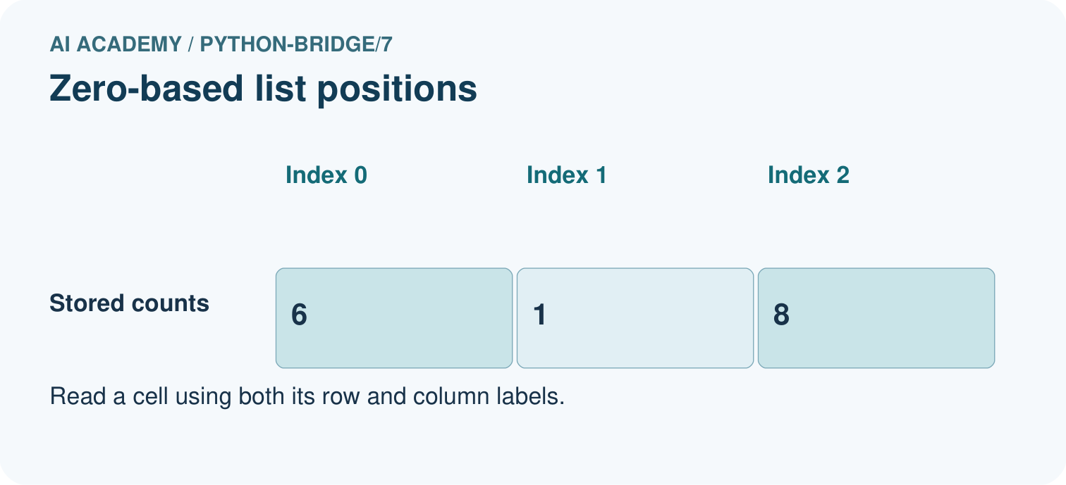
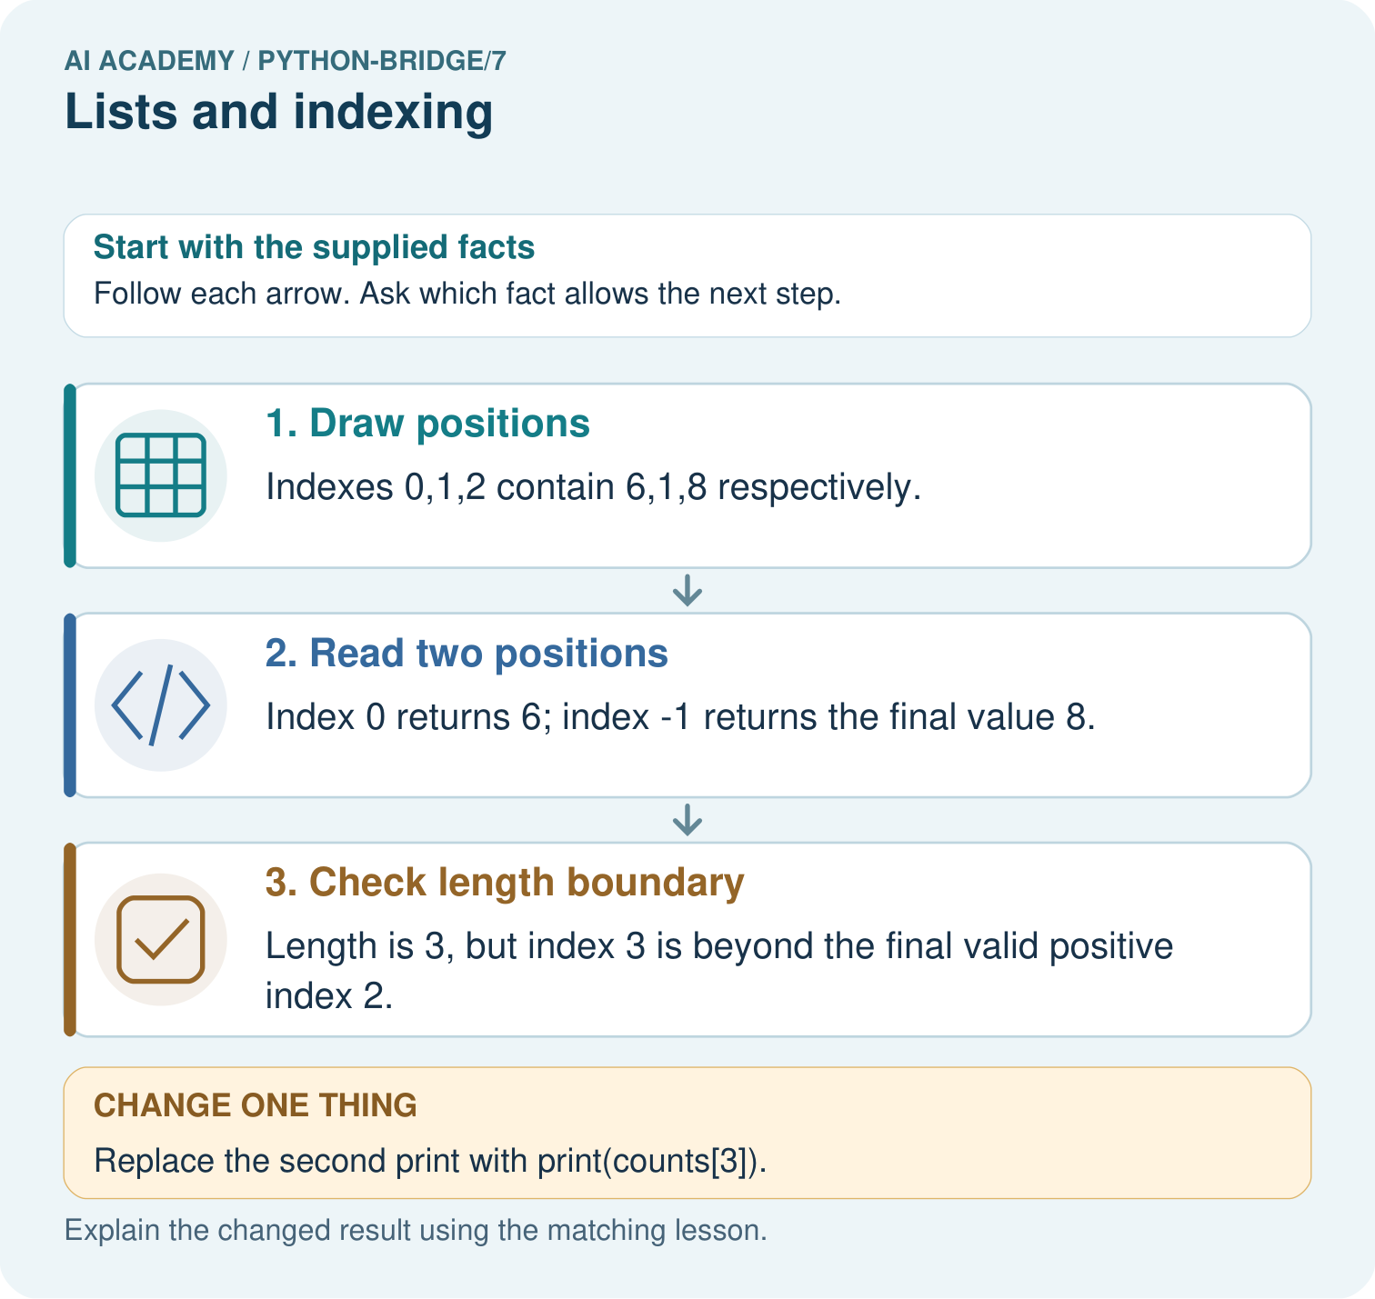

Read the picture one step at a time
Step | What happens and why
1. Draw positions | Indexes 0,1,2 contain 6,1,8 respectively.
2. Read two positions | Index 0 returns 6; index -1 returns the final value 8.
3. Check length boundary | Length is 3, but index 3 is beyond the final valid positive index 2.
Match each pictured step to the supplied facts. This is a worked teaching case, not an independent assessment.

Why this result follows
List positions begin at zero. A negative index counts from the end; the list length counts entries and is not itself a valid positive index for the final entry.

What this example does not establish
A valid position does not establish that the stored count is accurate; empty lists also have no final element to read.

Change one thing in the pictured case
Change: Replace the second print with print(counts[3]).
Prediction: The first print shows 6, then IndexError stops the script before the length print.
Reason: The attempted position does not exist.

Ask while showing the picture
Cover the result. Ask learners to name the inputs and predict the next step. Uncover one step, connect the icon to the actual procedure, and explain its evidence. Then change the supplied condition and compare. The picture is a representation; it does not document execution of a real AI model.

03. Demonstrate and guide practice
Time or stage | Teacher action
Session 1 start to 7 minutes | Retrieve range(3) and its excluded stop.
7 to 20 minutes | Place value cards under position cards and complete W1.
20 to 33 minutes | Run the worked read and update script, then complete W2.
33 to 45 minutes | Trace the value loop and answer the guided question.
Session 2 start to 8 minutes | Retrieve the distinction between length and final index.
8 to 20 minutes | Predict the faulty access before running; use W3 to repair value versus index confusion.
20 to 35 minutes | Collect W4 independently, keeping the replacement step separate from empty-list summation.
35 to 45 minutes | Discuss W5 and use the exit to diagnose indexing assumptions.
Use the worked example in Sections 3 and 6. Collect a prediction before revealing its result; ask the learner to point to each intermediate fact.
Keep position cards fixed while moving value cards. Permit an oral trace and provide a blank grid. Extension: write a guarded final-item reader that prints Empty when len(readings) == 0, otherwise prints readings[len(readings) - 1]. Test [] and [6].

Reduce help deliberately
Completion task: Start with counts = [4, 7, 4]. Run counts[0] = 6. Write the resulting list, its length and the value at index 2. Predict before running.
Teacher check: The result is [6, 7, 4]; length remains 3; index 2 still holds 4. Only the first item was replaced.
Start by identifying the given inputs together. Leave the intermediate steps blank. If needed, model one step, then withdraw that help on the next step. Move to a full trace only when the partial trace is understood. For partners, alternate explainer and checker; collect a response from every learner before discussion.

Individual reasoning check
Use the worked case for Lists and indexing. Proposed explanation: “Length is the last nonnegative index”. Decide whether this explanation is supported. Point to the step or supplied fact that decides; explain your repair if needed.
Expected correction: Length counts items; the last nonnegative index of a nonempty list is one less.
Collect explanations, not only yes/no votes. If a misunderstanding is common, re-model the relevant step for the class. If it affects a few learners, give a short targeted group explanation while others solve a more demanding variation.

Pictorial practice question
Label the three index positions. Predict all original outputs, then name the first output and stopping point after using index 3.

Reasoned teacher answer
Original outputs are 6,8,3. After the change, 6 prints first, counts[3] raises IndexError, and the third print does not execute.
Changed-case reasoning: The first print shows 6, then IndexError stops the script before the length print. The attempted position does not exist.
Collect each learner’s explanation before discussion. Use the first missing connection between input, deciding step and result to choose support. This question is worked-case practice, not fresh mastery evidence.

04. Run the investigation and diagnose misconceptions
Length is the last nonnegative index: Length counts items; the last nonnegative index of a nonempty list is one less.
A loop variable always contains an index: A direct list loop supplies stored values.
Updating one item grows the list: Assignment at an existing index replaces that item; length is unchanged.
Repeated values are processed only once: Each position contributes one item, even when values repeat.
Use Section 9 for the evidence ledger. Add a boundary or missing-input case and record the expected response before checking. More successful repeats of one case do not establish wider coverage.

Match the support to the first error
What the response shows | Next teaching action
Missing or misread facts | Read the case aloud, mark supplied versus unknown facts, and let the learner restate it.
Wrong procedure | Return to the deciding step in the worked case. Contrast it with the proposed incorrect explanation.
Arithmetic or implementation error | Trace intermediate values or lines; preserve the first mismatch and retry that step.
Correct result without a reason | Ask for a trace and a changed case before marking independent understanding.
An unsupported wider claim | Ask which supplied evidence supports the claim and which further observation would be needed.
Offer an oral explanation, drawing, enlarged visual or fewer examples when that removes a reading/writing barrier. Keep the same reasoning goal. Stretch secure learners by changing a boundary or assumption and asking them to defend the effect, not simply by assigning more of the same questions.

05. Assess and explain the answers

Guided and exit questions
For [2, 0, 5], totals become 2, 2, 7. Output is 7. Zero is still an item and its iteration still executes. Exit: len([8, 3]) is 2, but index 2 is outside the list. Last nonnegative index is 1, whose value is 3. An empty list has no last item, so a length check is required before access.

W1 Separate index and value
For counts = [4, 7, 4], give the length, valid nonnegative indices and value at index 1. Explain how the two items with value 4 differ.
Length 3; indices 0, 1, 2; counts[1] is 7. The equal values occupy different positions, indices 0 and 2.

W2 Trace an update
Start with counts = [4, 7, 4]. Run counts[0] = 6. Write the resulting list, its length and the value at index 2. Predict before running.
The result is [6, 7, 4]; length remains 3; index 2 still holds 4. Only the first item was replaced.

W3 Repair a position mistake
A learner loops with for count in counts and tries to read counts[count] for counts = [4, 7, 4]. Identify the first attempted index and error. Explain how to print each value directly.
The first count is 4, so counts[4] raises IndexError. The loop variable already holds each value. Use an indented print(count) to print 4, 7 and 4 on separate lines.

W4 Process new data independently
Start with readings = [3, 0, 3, 2]. Replace the second item with 5 using its index. Write a loop that adds all updated readings and prints one final total. Trace every update of the total. Then test the summing part alone on [] and [6].
Use readings[1] = 5, giving [3, 5, 3, 2]. Initialize total = 0 before for reading in readings, add reading inside, and print outside. Running totals are 3, 8, 11, 13; final 13. Summing [] gives 0 and [6] gives 6. The replacement line itself requires at least two items.

W5 Keep the information you need
Compare [1, 5, 2] and [5, 1, 2]. State their totals and first items. Would storing only the total answer which first item was larger? Explain.
Both total 8. Their first items are 1 and 5, so the second list has the larger first item. A total alone discards the order and cannot answer this question.

Independent assessment and fresh retry
W4 must use index 1 for the second item, retain all four items, produce the full trace and output 13, and obtain 0 and 6 when testing only summation. After support, retry [2, 2, 1], replace the first item with 4, and sum: updated list [4, 2, 1], totals 4, 6, 7. Then sum [] and [5] for outputs 0 and 5. Record support before judging independence.

Assess independent transfer
Selected case: Predict the three outputs. If the second print uses values[3] instead, where does execution stop and which later output is not produced?
values = [4, 9, 2]
print(values[1])
print(values[-1])
print(len(values))

Selected case answer
Outputs are 9,2,3. With values[3], the first print produces 9, then IndexError occurs; the final length print is not reached. Positive valid indices are 0,1,2.
Dimension | Evidence required
Explanation | Names the applicable idea or procedure and ties it to the supplied facts.
Trace and result | Preserves the given inputs and shows the relevant intermediate steps; distinguishes a prediction from an observed execution.
Limits | States the assumptions, missing evidence or conditions under which the result would change.
Record each dimension as not yet, with support, or independent. Accept a valid alternative procedure with a defensible trace. Do not penalise an honestly recorded model failure if the learner correctly explains its evidence and limits.

Feedback that the learner uses
Name the earliest unsupported step and give one action to repair it. Have the learner make that repair now and explain why. Then assess the relevant skill on a fresh, fully specified case. Confirm it was not previously practised with feedback; solve and check the new case before assigning it. A follow-up design prompt is a starting brief, not automatically an equivalent test.

06. Connect the project, support and next lesson
Add a labelled lists and indexing evidence sheet to Python readiness portfolio. Show how you can distinguish a list index from the value stored at that position. Use the supplied fictional case and keep its inputs, intermediate steps, calculation or prediction, and limitation. Connect this record to last week’s record; a matching answer without a trace is insufficient.
Keep position cards fixed while moving value cards. Permit an oral trace and provide a blank grid. Extension: write a guarded final-item reader that prints Empty when len(readings) == 0, otherwise prints readings[len(readings) - 1]. Test [] and [6].
Week 8 groups reusable instructions in functions and supplies values through arguments.
Retain the project ledger and assess a changed case after support. Check the relevant prerequisite before carrying this component forward.

Plan the delayed return
Suggested return points in this level: python-bridge/8, python-bridge/10. Use actual classroom dates, adjusting for holidays and gaps. One, three and six teaching weeks are scheduling choices, not a claimed optimal spacing.
At a delayed check, ask for the idea from memory and a changed application. Compare with the earlier independent response and record support used. For a new level, revisit the previous capstone before checking the new prerequisites.
Record | Teacher evidence
Learner code and date
Concept and case used; prior exposure
Explanation / trace / limits
Support and first repair
Changed case and delayed outcome
Next teaching action
Use the evidence to choose reteaching or the next step. A completed page, confidence rating or attractive project does not by itself demonstrate understanding.

Project evidence from this case
For Python readiness before the Responsible Plant Classifier, retain a trace of the values, the predicted outputs and the changed-case explanation. Use actual Python 3 results to check the prediction after reasoning first.

07. Prepare, teach and assess
Teaching target: Distinguish a list index from the value stored at that position
Prepare the labelled worked-case picture, the matching workbook, fictional input cards and a place for individual responses. Check a local Python 3 environment before class; have a paper-trace version ready.
Session | Plan | Resources
Session 1 · Understand · 45 min | 0–7: recall and prerequisite; 7–15: inspect the concrete case and predict; 15–30: teacher models the worked trace; 30–40: learners explain a step using the text and visual; 40–45: check the core idea. | Sections 1–6; record the brief recall in the workbook.
Session 2 · Practise · 45 min | 0–5: retrieve the procedure; 5–15: W2 completion practice; 15–23: explain and check with a partner; 23–30: each learner answers the misconception check; 30–40: targeted reteaching or a harder variation; 40–45: prepare the investigation. | Sections 7–10; use the matching workbook W2 and misconception check.
Session 3 · Investigate and transfer · 45 min | 0–5: retrieve the decision rule; 5–20: investigate or trace; 20–30: start the independent case; 30–38: connect the project; 38–43: act on feedback; 43–45: plan the return check. | Sections 9 and 11–14. Give extra time to finish the full task set; use Section 15 when the week includes a coding lab.
Before class, solve the supported practice: Start with counts = [4, 7, 4]. Run counts[0] = 6. Write the resulting list, its length and the value at index 2. Predict before running.
Reasoned practice answer: The result is [6, 7, 4]; length remains 3; index 2 still holds 4. Only the first item was replaced.
Check every learner before discussion: Use the worked case for Lists and indexing. Proposed explanation: “Length is the last nonnegative index”. Decide whether this explanation is supported. Point to the step or supplied fact that decides; explain your repair if needed.
Misconception repair: Length counts items; the last nonnegative index of a nonempty list is one less.
Support: read the exact case aloud, enlarge the labelled picture, supply input cards and model only the first deciding step. Accept a spoken explanation or drawing; retain the reasoning goal.
Extension: Replace the second print with print(counts[3]). Require a prediction and a reason before comparing. Expected result: The first print shows 6, then IndexError stops the script before the length print. Reason: The attempted position does not exist.
Independent assessment: withhold the reserved answer until the learner has attempted the new case. Record support separately from correctness.
Criterion | Not yet | With support | Independent
Explanation | Names an answer without a deciding fact | Uses a hint to link fact and decision | Explains the deciding fact in own words
Trace or test | Cannot connect input and result | Completes steps with prompts | Traces or tests a changed case accurately
Limits and revision | Claims more than evidence supports | Names a limit after a prompt | States a defensible limit and useful next test
Project checkpoint: Python readiness portfolio. Keep runnable code, predictions, actual outputs, one repaired error and an explanation of a function on changed inputs.
Use the weekly teacher answer for topic-specific reasoning. A saved progress tick is an activity record; judge mastery from the learner’s explanation and evidence.

08. Use feedback, labs and repair paths
Use the two formative questions as supported practice, not as independent mastery scores. Discuss the deciding evidence rather than accepting a guessed selection.
The feedback comes from the reviewed public worked case. Do not reveal the separately reserved independent teacher answer until the learner has attempted that case.
Ask students to predict before running code. Preserve errors and actual outputs; collect a changed test and an explanation. The branch-boundary and indexing lessons deliberately include failure cases.
Use the earlier worked-explanation links to address a specific missing building block, then return to the current question. Adapt this suggestion after observing the learner; it is not an automatic diagnosis.
Collect the completed-work portfolio as evidence. Record support separately from correctness, and assess explanation, trace/test and limitations. Progress ticks and quiz selections alone do not establish mastery.

