AI ACADEMY · TEACHER · python-bridge/10

Dictionaries and records
Project: Python readiness portfolio

01. Prepare the purpose, prerequisites and materials

Teach the learning cycle
Primary target: Read and update named dictionary fields
Session | Sequence and minutes | Resources
Session 1 · Understand · 45 min | 0–7: recall and prerequisite; 7–15: inspect the concrete case and predict; 15–30: teacher models the worked trace; 30–40: learners explain a step using the text and visual; 40–45: check the core idea. | Sections 1–6; record the brief recall in the workbook.
Session 2 · Practise · 45 min | 0–5: retrieve the procedure; 5–15: W2 completion practice; 15–23: explain and check with a partner; 23–30: each learner answers the misconception check; 30–40: targeted reteaching or a harder variation; 40–45: prepare the investigation. | Sections 7–10; use the matching workbook W2 and misconception check.
Session 3 · Investigate and transfer · 45 min | 0–5: retrieve the decision rule; 5–20: investigate or trace; 20–30: start the independent case; 30–38: connect the project; 38–43: act on feedback; 43–45: plan the return check. | Sections 9 and 11–14. Give extra time to finish the full task set; use Section 15 when the week includes a coding lab.
This is a starting allocation of 135 minutes, not a validated duration. Preserve all named topics. Schedule extra time for connected examples, the full investigation, independent cases and project building. Repeated copies of a case share one recorded attempt; they are not new evidence.

Retrieval answer guidance

Return values and local state
Without opening the old lesson, explain one key idea from Return values and local state. Give an example and a mistake that the idea helps you avoid.
Look for: Use a returned value in a later calculation
Reference example, not the only acceptable wording: result is 9 and doubled is 18. Nothing is displayed by these assignments or the returning function. print(doubled) would display 18.

Lists and indexing
Without opening the old lesson, explain one key idea from Lists and indexing. Give an example and a mistake that the idea helps you avoid.
Look for: Distinguish a list index from the value stored at that position
Reference example, not the only acceptable wording: Length 3; indices 0, 1, 2; counts[1] is 7. The equal values occupy different positions, indices 0 and 2.

Boolean conditions
Without opening the old lesson, explain one key idea from Boolean conditions. Give an example and a mistake that the idea helps you avoid.
Look for: Translate stated requirements into comparisons
Reference example, not the only acceptable wording: (minutes <= 12) and quiet. At most includes equality, so <= is required; the nonnegative integer and Boolean input contract still applies.
Teach Week 10 as a two-session investigation using fictional data. A fictional cupboard record has a name, capacity and used count. A list asks us to remember positions. Named fields make the intended meaning visible. Our schema requires name as text and capacity and used as nonnegative integers, with used no greater than capacity. Assess the three stated outcomes through the independent task, not by copying the worked result.

Outcomes
Read and update named dictionary fields
Connect a record to a function call
Distinguish missing fields from zero values

Preparation
Python 3 editor with a fresh local practice file
Paper trace table and the student workbook
Fictional input records from this lesson; no real student identifiers

Prerequisite answer
5; the caller may store or print it.

End goal for the pictorial case
Trace dictionaries and records and explain the changed program before running it.
This added worked case illustrates the week’s main idea. Retain all original and connected topics; schedule its practice within the teaching cycle.

02. Explain and model the mechanism
A fictional cupboard record has a name, capacity and used count. A list asks us to remember positions. Named fields make the intended meaning visible. Our schema requires name as text and capacity and used as nonnegative integers, with used no greater than capacity.
Square brackets look up the value for a key. The quoted key "used" is text; its value is an integer. Assigning to an existing key replaces that field. Other fields remain the same. Dictionary syntax does not enforce our schema: the programmer must check it.
Term | Meaning
Dictionary | A mapping from unique keys to values
Key | A name used to look up a value
Record | Related fields describing one item
KeyError | The error from looking up an absent dictionary key

Follow the evidence
Step or case | Evidence | Meaning
Read used | 4 | 12 - 4 = 8
Update used | 6 | 12 - 6 = 6
Read each row from left to right and connect the evidence to the stated rule.
Spaces are 0. A present used field with value 0 is different from an absent field. Exit: No. The used count exceeds capacity. Successful arithmetic does not validate the record.

Model the reasoning aloud
Use the complete worked example below before asking learners to complete W2. Reveal a small part, invite a prediction, then explain the deciding step. These teacher notes contain solutions; do not reveal the independent case answer during modelling.

Set used to 12. Predict the returned spaces. Does a used value of 0 mean the field is missing?
________________________________________________________________
________________________________________________________________
________________________________________________________________
________________________________________________________________
________________________________________________________________
________________________________________________________________
Thinking move | Teacher prompt
Plan | What is given? What is the question? Which procedure fits these facts?
Do | Point to each input and intermediate step in the worked trace. Name the rule that allows the next step.
Check | Does the output answer the question? Which assumption or limitation prevents a larger claim?
Use the diagram and verbal explanation together. Ask learners to match a sentence to a specific visual step; do not assign learners fixed visual or auditory learning styles.

A pictorial worked case: Dictionaries and records
A zero field is still present. A dictionary record describes a shelf. The program distinguishes missing data from an actual zero.

The facts we will use
Python 3: shelf={"count":0,"name":"Atlas"}; print(shelf["count"]); print(shelf.get("price")); print("count" in shelf).
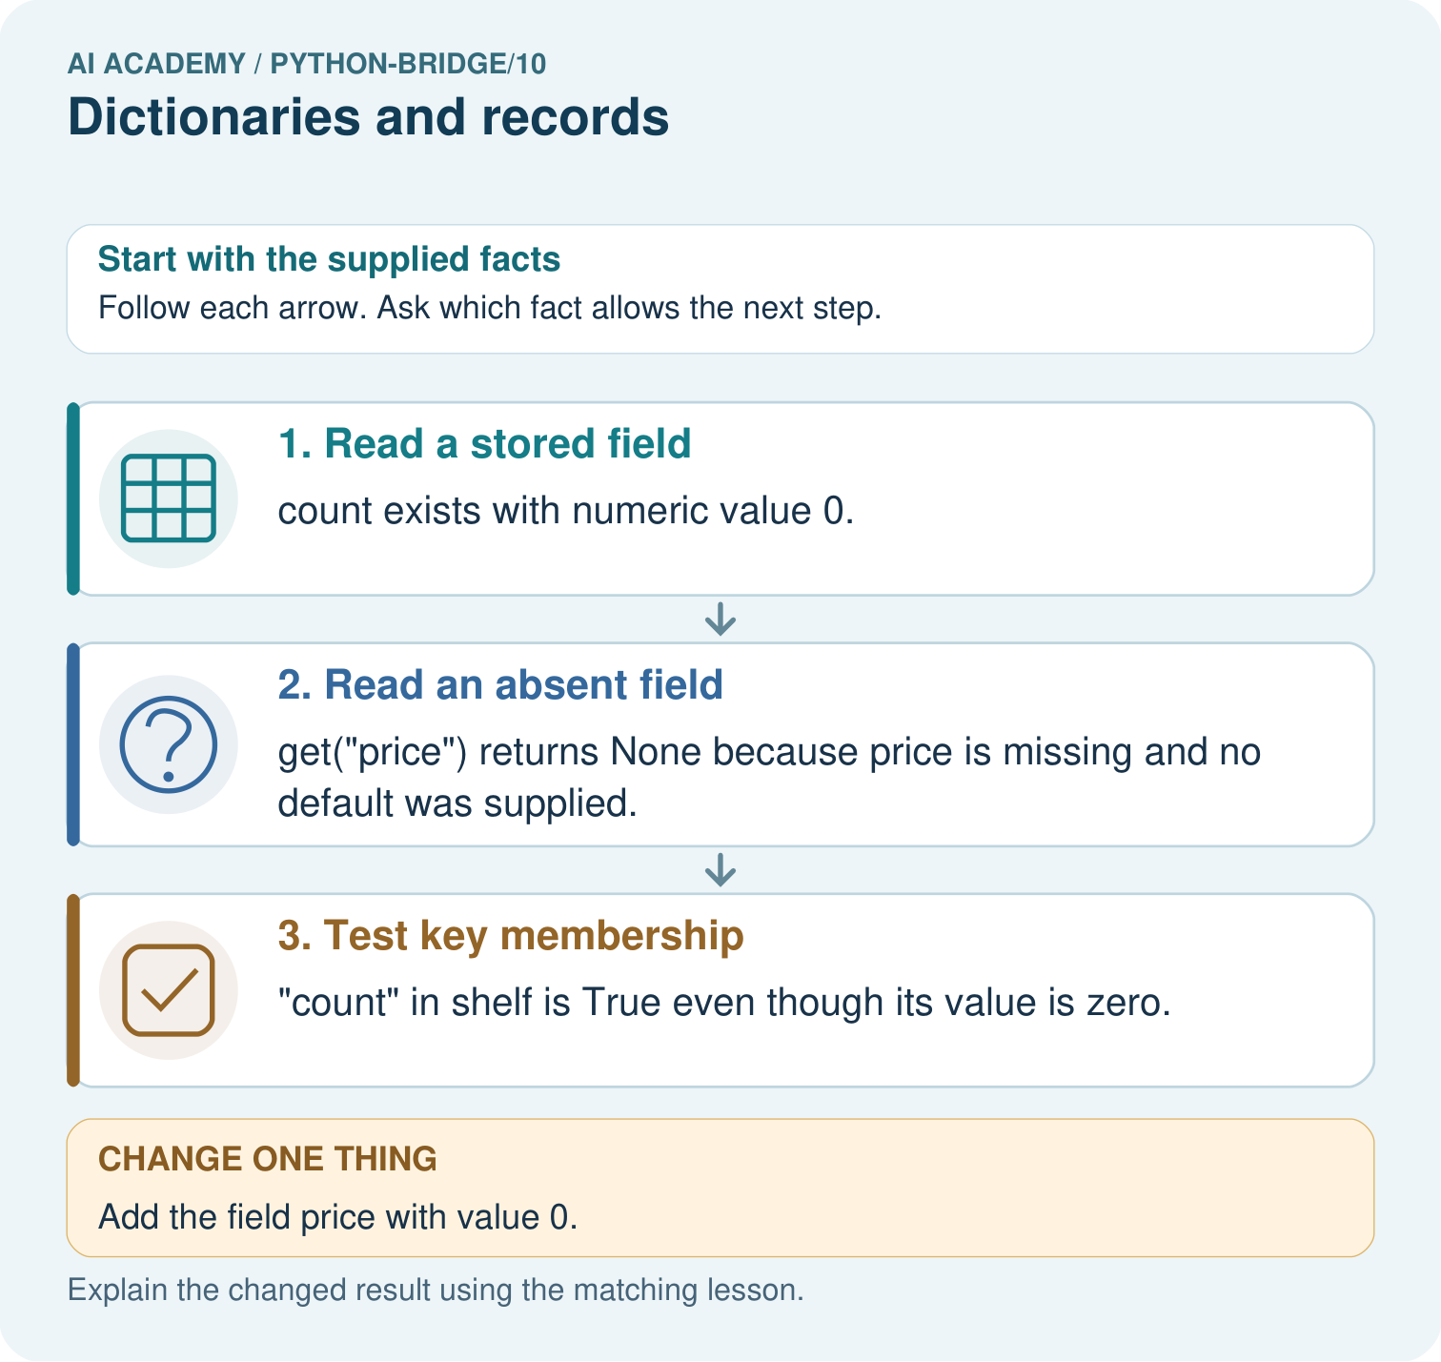

Read the picture one step at a time
Step | What happens and why
1. Read a stored field | count exists with numeric value 0.
2. Read an absent field | get("price") returns None because price is missing and no default was supplied.
3. Test key membership | "count" in shelf is True even though its value is zero.
Match each pictured step to the supplied facts. This is a worked teaching case, not an independent assessment.

Why this result follows
Dictionary keys name fields. Presence is different from truthiness of a value; a measured zero should not be discarded as if the field were absent.

What this example does not establish
None is also a possible explicitly stored value; real record contracts must define how missing and null values are represented.

Change one thing in the pictured case
Change: Add the field price with value 0.
Prediction: The price lookup now returns 0 instead of None.
Reason: A recorded zero is a present value, whereas the earlier lookup had no field.

Ask while showing the picture
Cover the result. Ask learners to name the inputs and predict the next step. Uncover one step, connect the icon to the actual procedure, and explain its evidence. Then change the supplied condition and compare. The picture is a representation; it does not document execution of a real AI model.

03. Demonstrate and guide practice
Time or stage | Teacher action
Session 1 start to 7 minutes | Retrieve the prerequisite and explain the purpose in the opening section.
7 to 20 minutes | Read the worked example and diagram; ask learners to trace each step aloud.
20 to 33 minutes | Complete W1 and W2, then compare predictions with observed results.
33 to 45 minutes | Collect the guided prediction before running; discuss a mismatch and its cause.
Session 2 start to 8 minutes | Retrieve the main rule without showing the previous answer.
8 to 20 minutes | Use W3 to diagnose and repair the stated failure; rerun an earlier case.
20 to 35 minutes | Collect W4 independently, including code or plan, predictions and explanations, before hints.
35 to 45 minutes | Discuss W5 and the exit; use the fresh retry when support was needed.
Use the worked example in Sections 3 and 6. Collect a prediction before revealing its result; ask the learner to point to each intermediate fact.
Use key cards and value cards. Extension: add a location text field and show why it does not change the remaining calculation.

Reduce help deliberately
Completion task: Change the Red record used to 9. State remaining spaces and whether capacity changes.
Teacher check: Spaces 0; capacity remains 9.
Start by identifying the given inputs together. Leave the intermediate steps blank. If needed, model one step, then withdraw that help on the next step. Move to a full trace only when the partial trace is understood. For partners, alternate explainer and checker; collect a response from every learner before discussion.

Individual reasoning check
Use the worked case for Dictionaries and records. Proposed explanation: “A successful run proves the conclusion”. Decide whether this explanation is supported. Point to the step or supplied fact that decides; explain your repair if needed.
Expected correction: Named fields reduce position mistakes but do not prove that a record is accurate. A capacity of 2 with used of 5 is representable in a dictionary and violates this schema.
Collect explanations, not only yes/no votes. If a misunderstanding is common, re-model the relevant step for the class. If it affects a few learners, give a short targeted group explanation while others solve a more demanding variation.

Pictorial practice question
Predict all three original outputs. Explain the difference between count=0 and missing price, then predict the lookup after price=0 is added.

Reasoned teacher answer
Outputs are 0, None, True. count is present with zero; price is absent. Adding price=0 makes get("price") return 0 without changing count membership.
Changed-case reasoning: The price lookup now returns 0 instead of None. A recorded zero is a present value, whereas the earlier lookup had no field.
Collect each learner’s explanation before discussion. Use the first missing connection between input, deciding step and result to choose support. This question is worked-case practice, not fresh mastery evidence.

04. Run the investigation and diagnose misconceptions
A successful run proves the conclusion: Named fields reduce position mistakes but do not prove that a record is accurate. A capacity of 2 with used of 5 is representable in a dictionary and violates this schema.
Matching the example is enough: Require the new W4 case, explicit predictions and an explanation. Fresh retry: create a Gold record with capacity 11 and used 3; return 8, update used to 11 and return 0. Require field lookups rather than copied literal arguments.
A convenient shortcut preserves meaning: cupboard["Used"] raises KeyError here because keys are case sensitive. Correct it to "used". Adding a new field called "Used" would create a second key and leave the original unchanged; it would not repair the intended lookup.
Use Section 9 for the evidence ledger. Add a boundary or missing-input case and record the expected response before checking. More successful repeats of one case do not establish wider coverage.

Match the support to the first error
What the response shows | Next teaching action
Missing or misread facts | Read the case aloud, mark supplied versus unknown facts, and let the learner restate it.
Wrong procedure | Return to the deciding step in the worked case. Contrast it with the proposed incorrect explanation.
Arithmetic or implementation error | Trace intermediate values or lines; preserve the first mismatch and retry that step.
Correct result without a reason | Ask for a trace and a changed case before marking independent understanding.
An unsupported wider claim | Ask which supplied evidence supports the claim and which further observation would be needed.
Offer an oral explanation, drawing, enlarged visual or fewer examples when that removes a reading/writing barrier. Keep the same reasoning goal. Stretch secure learners by changing a boundary or assumption and asking them to defend the effect, not simply by assigning more of the same questions.

05. Assess and explain the answers

Guided and exit questions
Spaces are 0. A present used field with value 0 is different from an absent field. Exit: No. The used count exceeds capacity. Successful arithmetic does not validate the record.

W1 Identify fields
For {"name": "Red", "capacity": 9, "used": 2}, state the keys, value of used and remaining spaces.
Keys name, capacity, used; used is 2; remaining spaces 7.

W2 Trace an update
Change the Red record used to 9. State remaining spaces and whether capacity changes.
Spaces 0; capacity remains 9.

W3 Repair a lookup
The code reads record["Used"] from the Red record. Explain the error and repair it without adding a field.
KeyError because Used is absent. Use record["used"].

W4 Build a record independently
Create a Green record with capacity 15 and used 6. Pass its fields to remaining and store the result. Update used to 10 and repeat. Predict both results.
Use a dictionary with name Green, capacity 15, used 6; results are 9 and then 5. The second call must read the updated field.

W5 Check the contract
A record has capacity 3 and used 4. It gives -1 spaces without an error. Should it be accepted? Explain.
No. The used count exceeds capacity. Successful arithmetic does not validate the record.

Independent assessment and fresh retry
Independent W4 evidence: Use a dictionary with name Green, capacity 15, used 6; results are 9 and then 5. The second call must read the updated field. Record whether the learner needed no help, a hint or explanation. Fresh retry: create a Gold record with capacity 11 and used 3; return 8, update used to 11 and return 0. Require field lookups rather than copied literal arguments.

Assess independent transfer
Selected case: Predict the three outputs and trace the named-field update. Explain why zero and a missing count produce different results. If the condition becomes if not count, which supplied record is first handled incorrectly?
def describe(record):
count = record.get("count")
if count is None:
return "missing"
return count
record = {"count": 0}
print(describe(record))
record["count"] = 3
print(describe(record))
print(describe({}))

Selected case answer
Outputs are0,3,missing. A stored0 is a supplied value; an absent field returns None under get here. The update replaces count with3 before the second call. Using if not count would incorrectly return missing for the original count0 because zero is false in a Boolean test; testing None keeps absence separate.
Dimension | Evidence required
Explanation | Names the applicable idea or procedure and ties it to the supplied facts.
Trace and result | Preserves the given inputs and shows the relevant intermediate steps; distinguishes a prediction from an observed execution.
Limits | States the assumptions, missing evidence or conditions under which the result would change.
Record each dimension as not yet, with support, or independent. Accept a valid alternative procedure with a defensible trace. Do not penalise an honestly recorded model failure if the learner correctly explains its evidence and limits.

Feedback that the learner uses
Name the earliest unsupported step and give one action to repair it. Have the learner make that repair now and explain why. Then assess the relevant skill on a fresh, fully specified case. Confirm it was not previously practised with feedback; solve and check the new case before assigning it. A follow-up design prompt is a starting brief, not automatically an equivalent test.

06. Connect the project, support and next lesson
Add a labelled dictionaries and records evidence sheet to Python readiness portfolio. Show how you can read and update named dictionary fields. Use the supplied fictional case and keep its inputs, intermediate steps, calculation or prediction, and limitation. Connect this record to last week’s record; a matching answer without a trace is insufficient.
Use key cards and value cards. Extension: add a location text field and show why it does not change the remaining calculation.
Next week: Reading structured data. Reuse this week's explicit contracts and evidence.
Retain the project ledger and assess a changed case after support. Check the relevant prerequisite before carrying this component forward.

Plan the delayed return
Suggested return points in this level: python-bridge/11. Use actual classroom dates, adjusting for holidays and gaps. One, three and six teaching weeks are scheduling choices, not a claimed optimal spacing.
At a delayed check, ask for the idea from memory and a changed application. Compare with the earlier independent response and record support used. For a new level, revisit the previous capstone before checking the new prerequisites.
Record | Teacher evidence
Learner code and date
Concept and case used; prior exposure
Explanation / trace / limits
Support and first repair
Changed case and delayed outcome
Next teaching action
Use the evidence to choose reteaching or the next step. A completed page, confidence rating or attractive project does not by itself demonstrate understanding.

Project evidence from this case
For Python readiness before the Responsible Plant Classifier, retain a trace of the values, the predicted outputs and the changed-case explanation. Use actual Python 3 results to check the prediction after reasoning first.

07. Prepare, teach and assess
Teaching target: Read and update named dictionary fields
Prepare the labelled worked-case picture, the matching workbook, fictional input cards and a place for individual responses. Check a local Python 3 environment before class; have a paper-trace version ready.
Session | Plan | Resources
Session 1 · Understand · 45 min | 0–7: recall and prerequisite; 7–15: inspect the concrete case and predict; 15–30: teacher models the worked trace; 30–40: learners explain a step using the text and visual; 40–45: check the core idea. | Sections 1–6; record the brief recall in the workbook.
Session 2 · Practise · 45 min | 0–5: retrieve the procedure; 5–15: W2 completion practice; 15–23: explain and check with a partner; 23–30: each learner answers the misconception check; 30–40: targeted reteaching or a harder variation; 40–45: prepare the investigation. | Sections 7–10; use the matching workbook W2 and misconception check.
Session 3 · Investigate and transfer · 45 min | 0–5: retrieve the decision rule; 5–20: investigate or trace; 20–30: start the independent case; 30–38: connect the project; 38–43: act on feedback; 43–45: plan the return check. | Sections 9 and 11–14. Give extra time to finish the full task set; use Section 15 when the week includes a coding lab.
Before class, solve the supported practice: Change the Red record used to 9. State remaining spaces and whether capacity changes.
Reasoned practice answer: Spaces 0; capacity remains 9.
Check every learner before discussion: Use the worked case for Dictionaries and records. Proposed explanation: “A successful run proves the conclusion”. Decide whether this explanation is supported. Point to the step or supplied fact that decides; explain your repair if needed.
Misconception repair: Named fields reduce position mistakes but do not prove that a record is accurate. A capacity of 2 with used of 5 is representable in a dictionary and violates this schema.
Support: read the exact case aloud, enlarge the labelled picture, supply input cards and model only the first deciding step. Accept a spoken explanation or drawing; retain the reasoning goal.
Extension: Add the field price with value 0. Require a prediction and a reason before comparing. Expected result: The price lookup now returns 0 instead of None. Reason: A recorded zero is a present value, whereas the earlier lookup had no field.
Independent assessment: withhold the reserved answer until the learner has attempted the new case. Record support separately from correctness.
Criterion | Not yet | With support | Independent
Explanation | Names an answer without a deciding fact | Uses a hint to link fact and decision | Explains the deciding fact in own words
Trace or test | Cannot connect input and result | Completes steps with prompts | Traces or tests a changed case accurately
Limits and revision | Claims more than evidence supports | Names a limit after a prompt | States a defensible limit and useful next test
Project checkpoint: Python readiness portfolio. Keep runnable code, predictions, actual outputs, one repaired error and an explanation of a function on changed inputs.
Use the weekly teacher answer for topic-specific reasoning. A saved progress tick is an activity record; judge mastery from the learner’s explanation and evidence.

08. Use feedback, labs and repair paths
Use the two formative questions as supported practice, not as independent mastery scores. Discuss the deciding evidence rather than accepting a guessed selection.
The feedback comes from the reviewed public worked case. Do not reveal the separately reserved independent teacher answer until the learner has attempted that case.
Ask students to predict before running code. Preserve errors and actual outputs; collect a changed test and an explanation. The branch-boundary and indexing lessons deliberately include failure cases.
Use the earlier worked-explanation links to address a specific missing building block, then return to the current question. Adapt this suggestion after observing the learner; it is not an automatic diagnosis.
Collect the completed-work portfolio as evidence. Record support separately from correctness, and assess explanation, trace/test and limitations. Progress ticks and quiz selections alone do not establish mastery.

