AI ACADEMY · WORKBOOK · ai-1/3

Sensors Are Messengers
Project: Helpful Classroom Sorter

01. Recall and choose your starting point
Try the recall before opening notes. Then use a different colour or a labelled second line to correct your explanation.

Input, Process, Output
Without opening the old lesson, explain one key idea from Input, Process, Output. Give an example and a mistake that the idea helps you avoid.

My remembered idea, example and correction
________________________________________________________________
________________________________________________________________
________________________________________________________________

02. Practise with fading help
Use W2: Trace a boundary for Sensors and measurement. Record the answer once; the lesson and workbook refer to the same attempt.
Given inputs | Procedure I chose | Middle steps | Result and check

The step I completed without help, and the hint I needed
________________________________________________________________
________________________________________________________________
________________________________________________________________

03. Individual reasoning check
Use the worked case for Sensors and measurement. Proposed explanation: “The more stable device must be accurate”. Decide whether this explanation is supported. Point to the step or supplied fact that decides; explain your repair if needed.

My explanation before partner discussion
________________________________________________________________
________________________________________________________________
________________________________________________________________
________________________________________________________________

04. Independent transfer case

Independent case: Investigate a new measurement dispute
A classroom sound display near a speaker reads higher than one near the door. A student declares the door device broken. Propose a safe comparison using normal classroom sound. Predict one result consistent with location explaining the difference and one result that would leave a device difference worth investigating.

My independent explanation, trace and limits
________________________________________________________________
________________________________________________________________
________________________________________________________________
________________________________________________________________
________________________________________________________________
________________________________________________________________
________________________________________________________________
Attempt this case before feedback. Record any help. Earlier examples below are further practice; a case already practised with feedback cannot establish fresh transfer.

05. Your learning target
Two light sensors report 40 and 80 in different rooms. Their settings and units are unknown. Can you conclude the second room is twice as bright? Design a fair comparison without using a camera or personal data.

06. Solve the given case
A light sensor reads 15 in a cupboard and 90 near a window. A microphone records a clap.
Which measures a light-related signal? Can either directly measure happiness?
Show your trace, calculation or evidence

Write or draw your reasoning and evidence.
________________________________________________________________
________________________________________________________________
________________________________________________________________
________________________________________________________________
________________________________________________________________

07. Check a changed case
A station reports light level 18 and temperature 22 degrees C. Which sensor produced each reading? Can either reading alone tell whether a child feels comfortable? Explain.
My independent answer and reason

Write or draw your reasoning and evidence.
________________________________________________________________
________________________________________________________________
________________________________________________________________
________________________________________________________________
________________________________________________________________

Week 3 Test and reflect

08. Design a revealing test
Create a changed input, boundary case or missing-information case. Write the expected answer or safe response before testing.
Test record | My evidence
Changed input or condition
Expected answer or fallback
Observed result
Why the result occurred

09. Project checkpoint
Mark which sensor, if any, would collect each Classroom Sorter input; prefer direct human entry when a sensor is unnecessary.
The project change and evidence I will keep

Write or draw your reasoning and evidence.
________________________________________________________________
________________________________________________________________
________________________________________________________________
________________________________________________________________
________________________________________________________________

10. Self check
I can explain the mechanism. I can show evidence. I can handle a changed case. I can name a limit. Mark each as not yet, with help or independently, and attach supporting work.
Teacher review ____________________ Next step ____________________

11. Transfer practice from the original programme
Two light sensors report 40 and 80 in different rooms. Their settings and units are unknown. Can you conclude the second room is twice as bright? Design a fair comparison without using a camera or personal data.

My independently reasoned answer
________________________________________________________________
________________________________________________________________
________________________________________________________________
________________________________________________________________
________________________________________________________________
________________________________________________________________
________________________________________________________________
Record support used: none, hint or teacher explanation.

12. W1 Repair an incomplete record
A notebook entry says 24 at lunchtime. Rewrite it as a useful air-temperature record by stating which missing fields must be collected. Do not invent values that were not observed.

My reasoning and evidence
________________________________________________________________
________________________________________________________________
________________________________________________________________
________________________________________________________________
________________________________________________________________

13. W2 Trace a boundary
A warning rule is recorded temperature greater than 28 degrees C. State its output for 27, 28 and 29 degrees C. Explain why an off warning does not prove that the sensor is working correctly.

My reasoning and evidence
________________________________________________________________
________________________________________________________________
________________________________________________________________
________________________________________________________________
________________________________________________________________

14. W3 Compare without choosing a winner
At the same three times, A records 18, 19 and 18 degrees C and B records 21, 22 and 21 degrees C in the same location. Calculate the paired differences. What is established, and what further evidence would help judge accuracy?

My reasoning and evidence
________________________________________________________________
________________________________________________________________
________________________________________________________________
________________________________________________________________
________________________________________________________________
________________________________________________________________

15. W4 Investigate a new measurement dispute
A classroom sound display near a speaker reads higher than one near the door. A student declares the door device broken. Propose a safe comparison using normal classroom sound. Predict one result consistent with location explaining the difference and one result that would leave a device difference worth investigating.

My reasoning and evidence
________________________________________________________________
________________________________________________________________
________________________________________________________________
________________________________________________________________
________________________________________________________________
________________________________________________________________
________________________________________________________________

16. W5 Limit a system's conclusion
An air-temperature sensor reports 29 degrees C and a rule turns on a warning. Someone writes The plant is thirsty. Explain the unsupported step and name information more directly relevant to deciding whether watering is needed.

My reasoning and evidence
________________________________________________________________
________________________________________________________________
________________________________________________________________
________________________________________________________________
________________________________________________________________

17. Feedback, return check and learning record
Evidence | My record
Worked alone / hint / model
First step I repaired and why
New case checked later; date and result
What I can now explain without notes
One remaining question
Revisit this idea with your teacher after a delay. Familiarity is different from explaining and using it on a changed case.

18. Pictorial case practice: Sensors Are Messengers
Two fictional light sensors disagree in a classroom. Compare them fairly rather than declaring one broken.
On the same shelf, simultaneous readings are A: 40,50,60 and B: 45,55,65 in declared toy light units.
Neither device has been compared with a trusted reference.
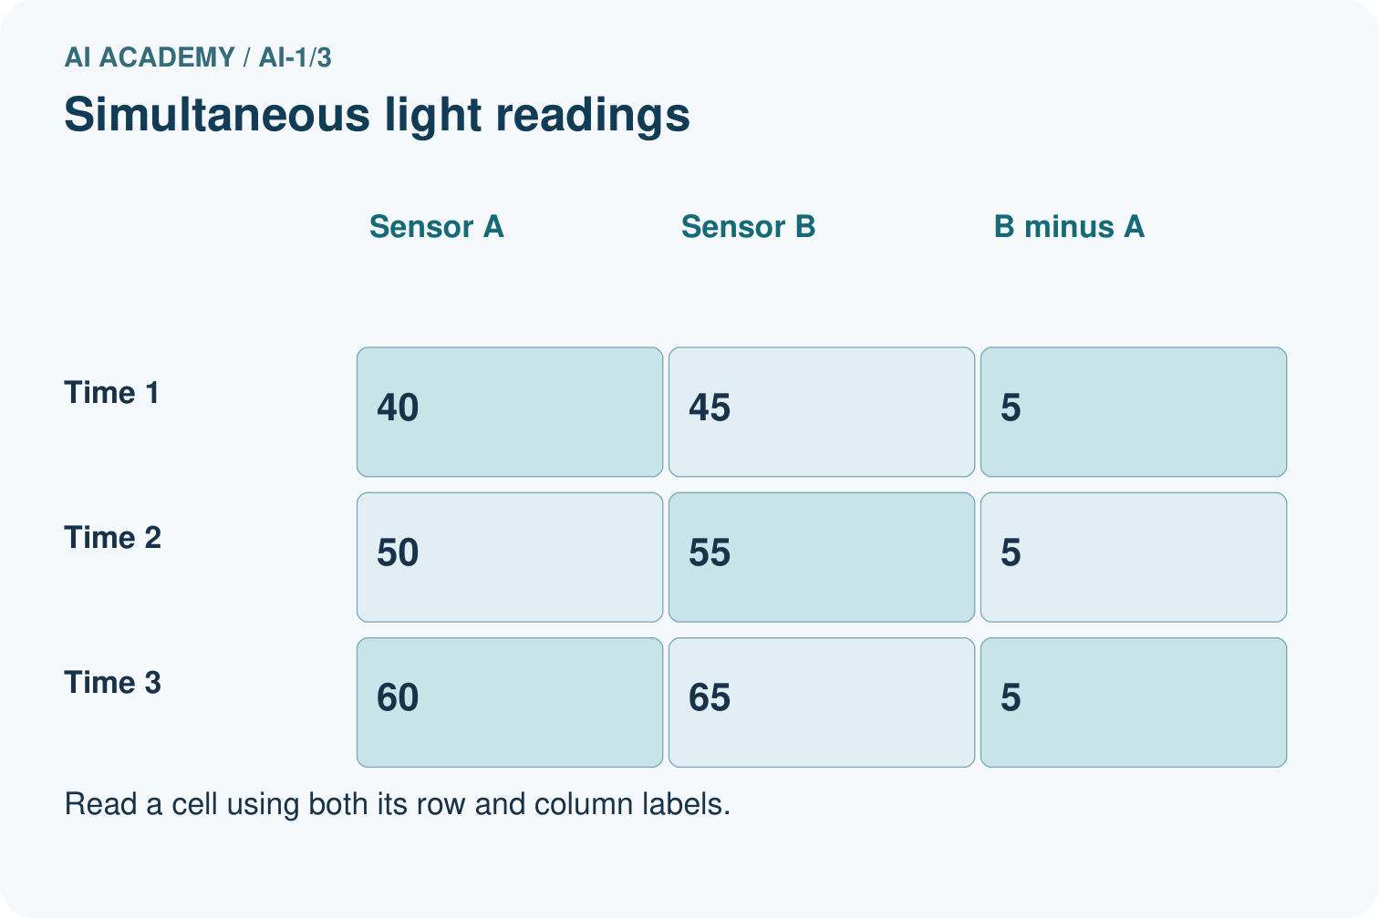
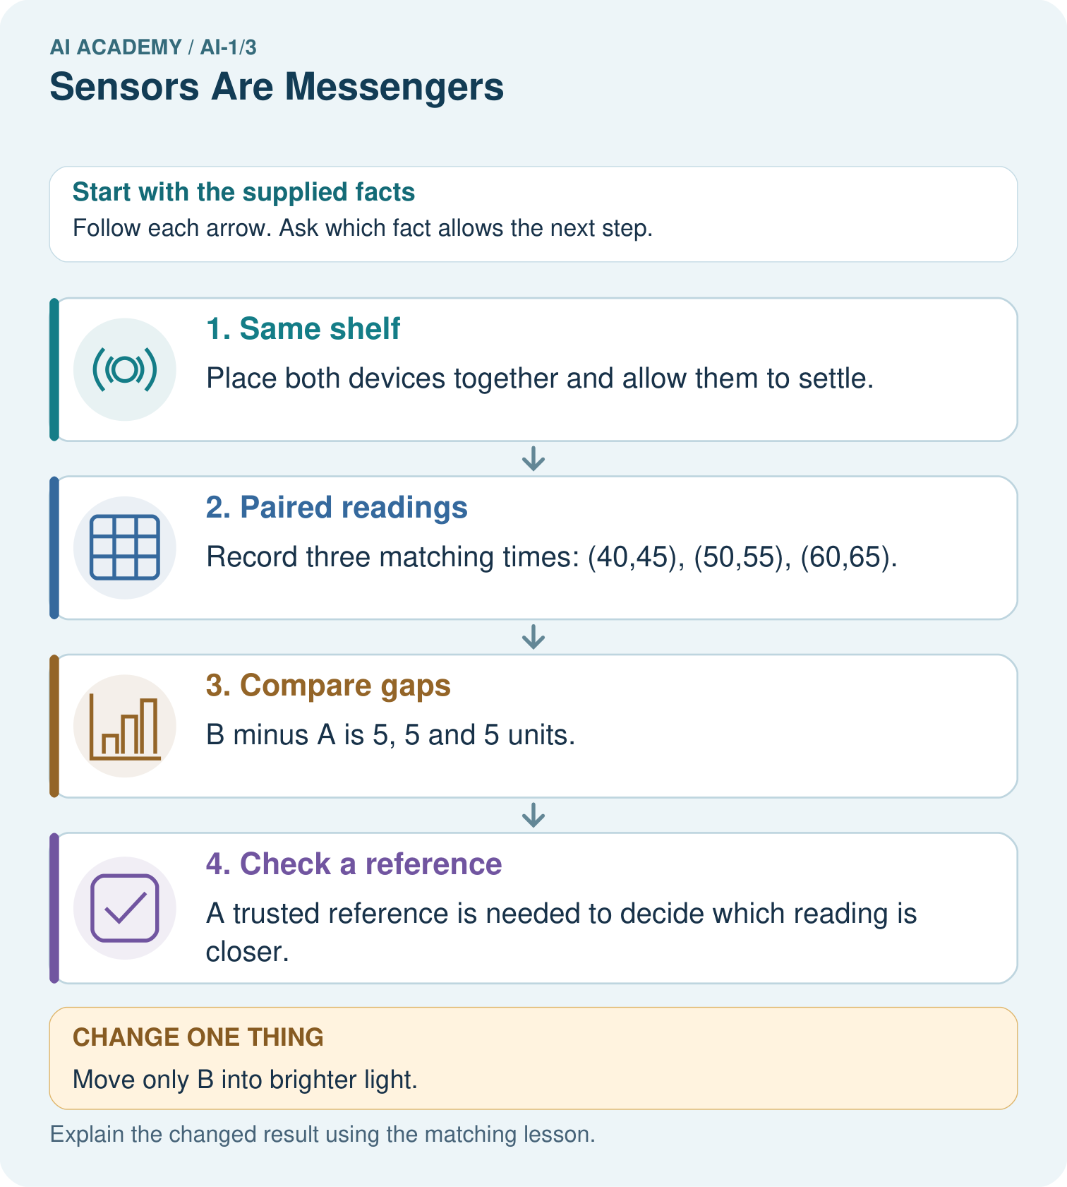
Why can we calculate the earlier gap but not predict an exact new B reading?

My picture-based explanation and changed-case prediction
________________________________________________________________
________________________________________________________________
________________________________________________________________
________________________________________________________________
________________________________________________________________
________________________________________________________________
Support used: alone / hint / worked example. This record is practice evidence.
Project connection: Save sorter measurements with device, location and time so unusual inputs can be checked before decisions.

19. Project portfolio milestone
Project: Helpful Classroom Sorter
Current milestone: Frame the need. Name the user, the problem, allowed inputs and a safe simple starting method.
Save sorter measurements with device, location and time so unusual inputs can be checked before decisions.
Evidence to keep | My record
This week’s input and deciding step
Prediction and actual result (or labelled paper trace)
One change since the previous checkpoint and why
One error or limit and the next test

Explain what this week adds to your project. Reuse last week’s record rather than starting again.
________________________________________________________________
________________________________________________________________
________________________________________________________________
________________________________________________________________
________________________________________________________________

20. Supported practice and learning evidence
Use this supported practice once, in the browser or on paper. Keep the reserved independent assessment for a separate first attempt before teacher feedback.
Two fictional light sensors disagree in a classroom. Compare them fairly rather than declaring one broken.

Practice 1: explain the deciding evidence
Which labelled step matches this detail? A trusted reference is needed to decide which reading is closer.
1. Compare gaps
2. Check a reference
3. Paired readings
4. Same shelf

My selected conclusion, deciding fact and explanation
________________________________________________________________
________________________________________________________________
________________________________________________________________
________________________________________________________________
________________________________________________________________
Hint if needed: Read the steps in the pictorial case. Match the supplied detail to the stage that performs or records it.
After your attempt, compare with the supported explanation: Check a reference A trusted reference is needed to decide which reading is closer. A repeated difference of 5 supports investigating an offset between devices. Matching time and location removes two obvious comparison problems. It does not show which device is correct: both could have errors. Preserve paired readings instead of adjusting them silently.

Practice 2: explain the deciding evidence
Changed-case practice: Move only B into brighter light. Which conclusion is supported by the supplied facts?
1. The next gap could change for reasons other than a difference in device accuracy.
2. This one example guarantees correct results for every future input.
3. We can decide the result without examining the changed input or the procedure.

My selected conclusion, deciding fact and explanation
________________________________________________________________
________________________________________________________________
________________________________________________________________
________________________________________________________________
________________________________________________________________
Hint if needed: Use the changed condition and the deciding step in the pictorial trace. The answer must say what follows from those facts.
After your attempt, compare with the supported explanation: The next gap could change for reasons other than a difference in device accuracy. The comparison now changes location as well as device; there is no supplied reading from the new location.

Repair a missing building block
Review Input, Process, Output (ai-1/2). Goal: Trace information through a system without confusing information with a physical action. Short practice: Use the richer record to find blue pencils in Box B. Explain why total alone was insufficient.. Return to this week and explain what you changed.

Keep your completed work
Use Download completed work in the hosted lesson to export your answers, reflections, practice feedback and code-run evidence. Open the HTML copy to read or print it. Drafts stay in this browser when storage is available; clear drafts on a shared device.

What I repaired, the evidence I kept and the next test
________________________________________________________________
________________________________________________________________
________________________________________________________________
________________________________________________________________
________________________________________________________________

