AI ACADEMY · WORKBOOK · ai-1/4

Rules or Learned Patterns?
Project: Helpful Classroom Sorter

01. Recall and choose your starting point
Try the recall before opening notes. Then use a different colour or a labelled second line to correct your explanation.

Sensors Are Messengers
Without opening the old lesson, explain one key idea from Sensors Are Messengers. Give an example and a mistake that the idea helps you avoid.

My remembered idea, example and correction
________________________________________________________________
________________________________________________________________
________________________________________________________________

AI or Not?
Without opening the old lesson, explain one key idea from AI or Not?. Give an example and a mistake that the idea helps you avoid.

My remembered idea, example and correction
________________________________________________________________
________________________________________________________________
________________________________________________________________

02. Practise with fading help
Use W2: Complete the supported comparison for Rules and learned patterns. Record the answer once; the lesson and workbook refer to the same attempt.
Given inputs | Procedure I chose | Middle steps | Result and check

The step I completed without help, and the hint I needed
________________________________________________________________
________________________________________________________________
________________________________________________________________

03. Individual reasoning check
Use the worked case for Rules and learned patterns. Proposed explanation: “A learned rule cannot be written simply”. Decide whether this explanation is supported. Point to the step or supplied fact that decides; explain your repair if needed.

My explanation before partner discussion
________________________________________________________________
________________________________________________________________
________________________________________________________________
________________________________________________________________

04. Independent transfer case

Independent case: Fit a new paper classifier
A fictional sorting task has lengths 2, 5, 7, 9 cm with labels short, short, long, long. Candidate rules predict long when length is at least 5 or at least 7. List predictions and errors for both, choose one, and predict a new length of 6 before any label is revealed. State one limit of your conclusion.

My independent explanation, trace and limits
________________________________________________________________
________________________________________________________________
________________________________________________________________
________________________________________________________________
________________________________________________________________
________________________________________________________________
________________________________________________________________
Attempt this case before feedback. Record any help. Earlier examples below are further practice; a case already practised with feedback cannot establish fresh transfer.

05. Your learning target
Sorter A follows 'red left, blue right'. Sorter B was trained using labelled red and blue cards. Both send a purple card left. Does their shared output show that they used the same process? What evidence is missing?

06. Solve the given case
Sorter A follows a written red-card-left rule. Sorter B is fitted using labelled leaves.
How were their decision processes obtained? Where should A send blue cards?
Show your trace, calculation or evidence

Write or draw your reasoning and evidence.
________________________________________________________________
________________________________________________________________
________________________________________________________________
________________________________________________________________
________________________________________________________________

07. Check a changed case
System A uses the written rule green means go. System B learns fruit labels from example photographs. Who supplies A's rule? What changes when B is trained on different examples?
My independent answer and reason

Write or draw your reasoning and evidence.
________________________________________________________________
________________________________________________________________
________________________________________________________________
________________________________________________________________
________________________________________________________________

Week 4 Test and reflect

08. Design a revealing test
Create a changed input, boundary case or missing-information case. Write the expected answer or safe response before testing.
Test record | My evidence
Changed input or condition
Expected answer or fallback
Observed result
Why the result occurred

09. Project checkpoint
Draw a fixed-rule version and a learned-pattern version of the Classroom Sorter; state what evidence would justify the learned version.
The project change and evidence I will keep

Write or draw your reasoning and evidence.
________________________________________________________________
________________________________________________________________
________________________________________________________________
________________________________________________________________
________________________________________________________________

10. Self check
I can explain the mechanism. I can show evidence. I can handle a changed case. I can name a limit. Mark each as not yet, with help or independently, and attach supporting work.
Teacher review ____________________ Next step ____________________

11. Transfer practice from the original programme
Sorter A follows 'red left, blue right'. Sorter B was trained using labelled red and blue cards. Both send a purple card left. Does their shared output show that they used the same process? What evidence is missing?

My independently reasoned answer
________________________________________________________________
________________________________________________________________
________________________________________________________________
________________________________________________________________
________________________________________________________________
________________________________________________________________
________________________________________________________________
Record support used: none, hint or teacher explanation.

12. W1 Execute before fitting
Use wide when width is at least 5 cm. Predict the label for widths 4, 5 and 6. Then state what changes if the rule uses greater than 5 instead.

My reasoning and evidence
________________________________________________________________
________________________________________________________________
________________________________________________________________
________________________________________________________________
________________________________________________________________

13. W2 Complete the supported comparison
Widths 1, 3, 5, 7 have labels narrow, narrow, wide, wide. For candidates 3 and 5, list all predictions using wide when width is at least the candidate. Count disagreements and select the lower-error candidate.

My reasoning and evidence
________________________________________________________________
________________________________________________________________
________________________________________________________________
________________________________________________________________
________________________________________________________________
________________________________________________________________

14. W3 Make a tie visible
For the worked widths 2, 4, 6, 8 with labels narrow, narrow, wide, wide, compare thresholds 5 and 6. Give a width where they predict differently. Explain why the four fitting examples cannot decide that case.

My reasoning and evidence
________________________________________________________________
________________________________________________________________
________________________________________________________________
________________________________________________________________
________________________________________________________________
________________________________________________________________

15. W4 Fit a new paper classifier
A fictional sorting task has lengths 2, 5, 7, 9 cm with labels short, short, long, long. Candidate rules predict long when length is at least 5 or at least 7. List predictions and errors for both, choose one, and predict a new length of 6 before any label is revealed. State one limit of your conclusion.

My reasoning and evidence
________________________________________________________________
________________________________________________________________
________________________________________________________________
________________________________________________________________
________________________________________________________________
________________________________________________________________
________________________________________________________________
________________________________________________________________

16. W5 Keep the check honest
A learner sees that their final-check card was predicted incorrectly, changes the threshold to match it and reports the same card as an unseen test. Explain the problem and propose a valid next check.

My reasoning and evidence
________________________________________________________________
________________________________________________________________
________________________________________________________________
________________________________________________________________
________________________________________________________________

17. Feedback, return check and learning record
Evidence | My record
Worked alone / hint / model
First step I repaired and why
New case checked later; date and result
What I can now explain without notes
One remaining question
Revisit this idea with your teacher after a delay. Familiarity is different from explaining and using it on a changed case.

18. Pictorial case practice: Rules or Learned Patterns?
A fictional paper sorter learns a size boundary for toy pebbles.
Training diameters are 1,3,5,7 cm with labels small,small,large,large.
Compare large-at-least-3 with large-at-least-5; choose fewer errors.
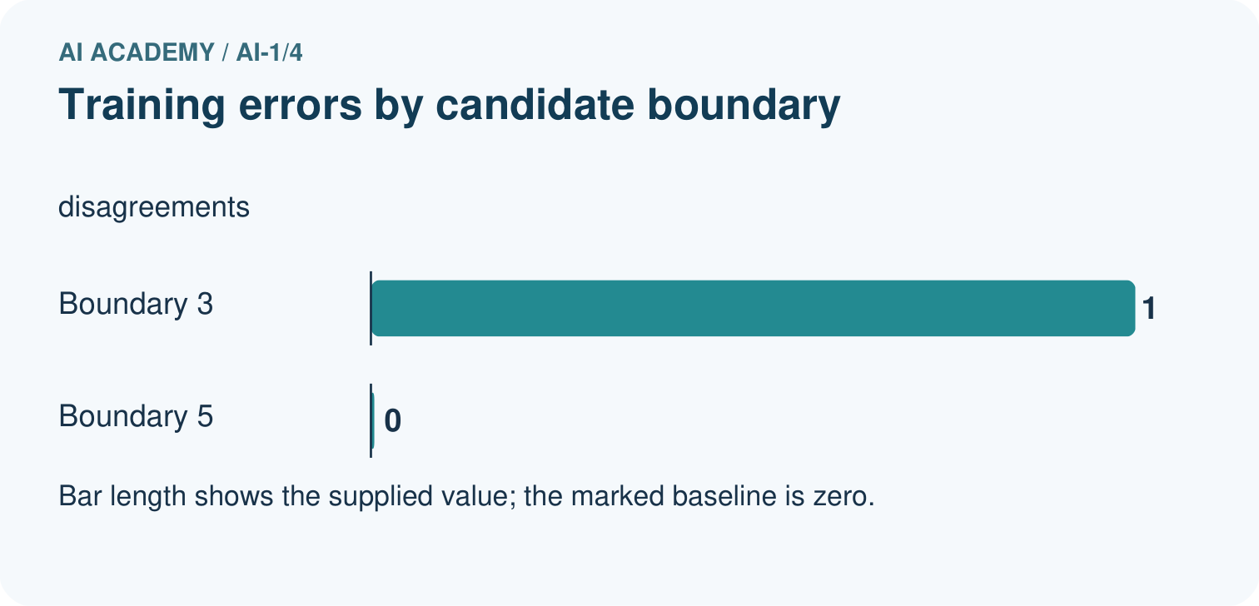
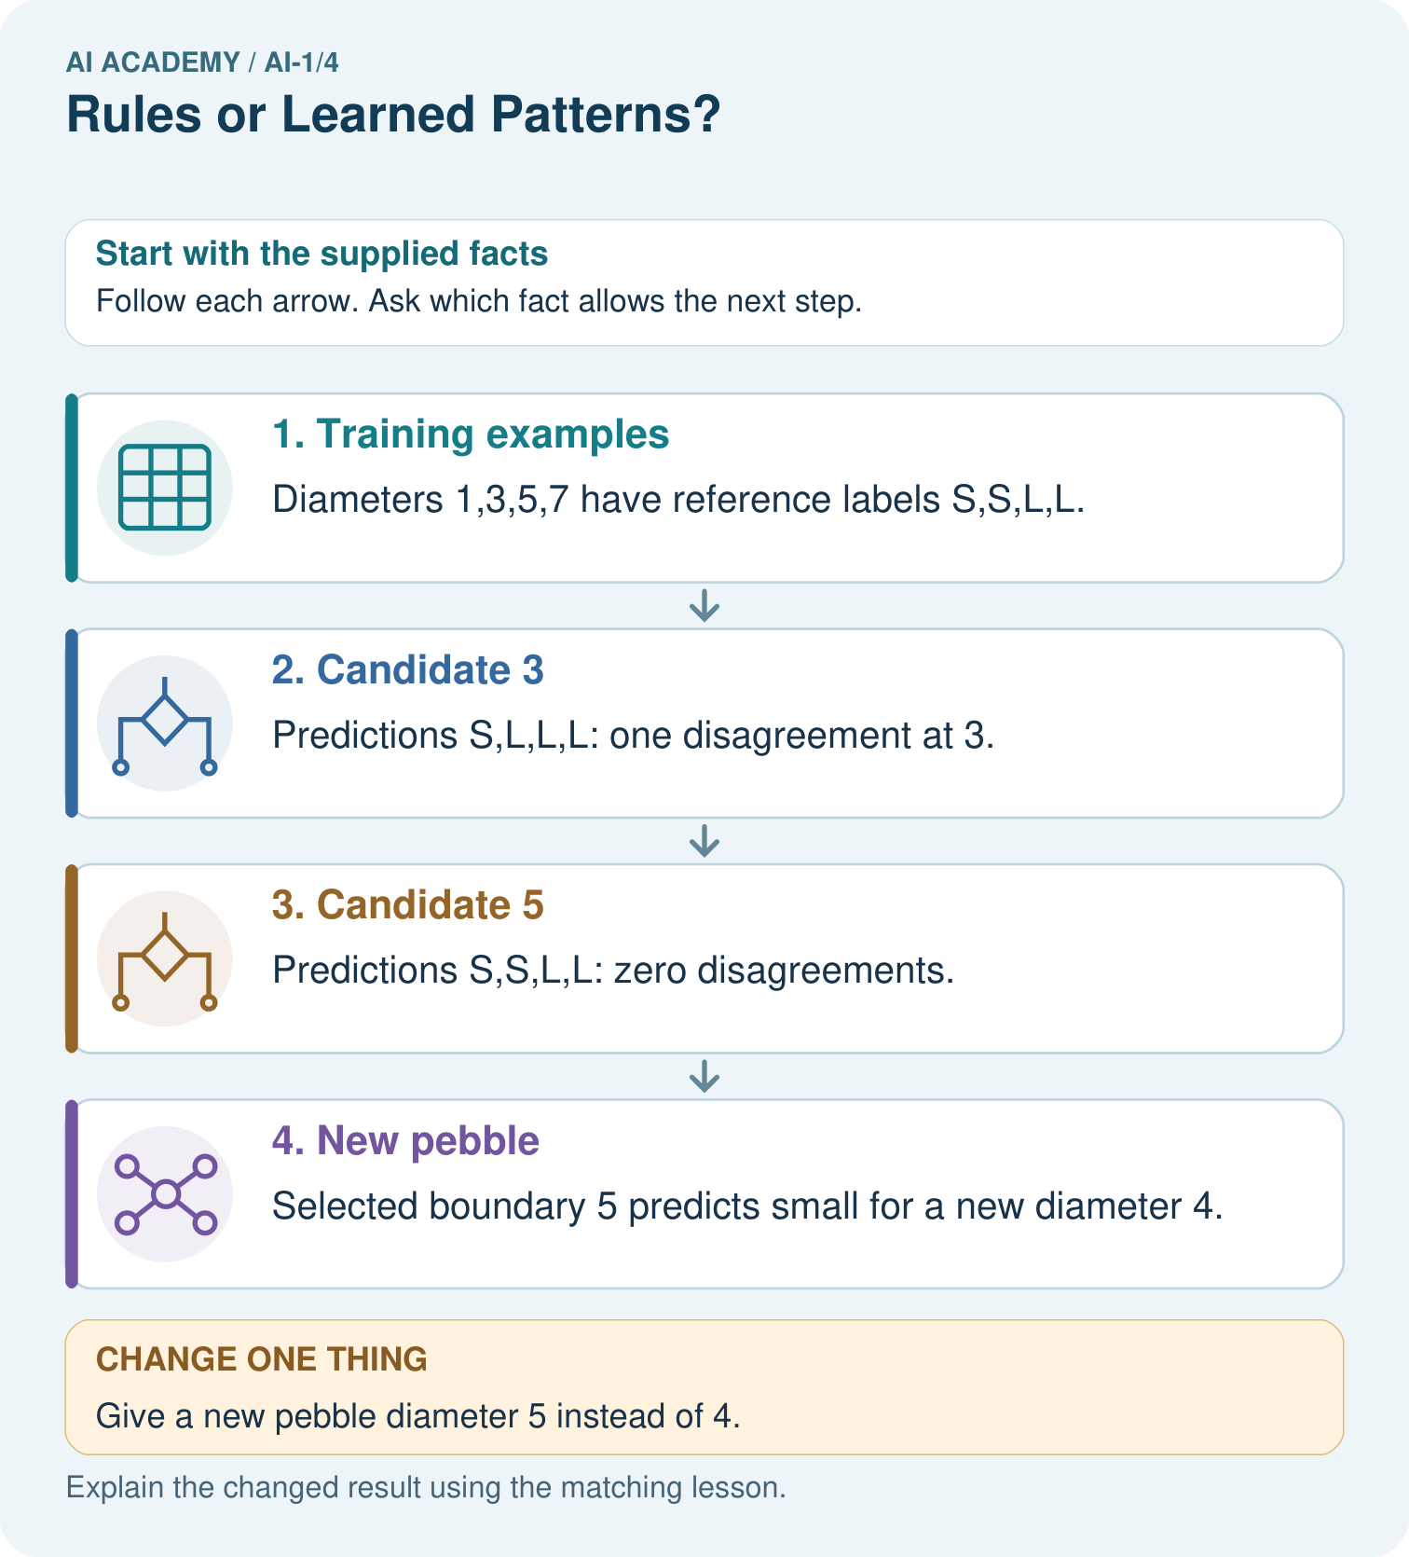
Show which stage used labels and which stage used only the new measurement.

My picture-based explanation and changed-case prediction
________________________________________________________________
________________________________________________________________
________________________________________________________________
________________________________________________________________
________________________________________________________________
________________________________________________________________
Support used: alone / hint / worked example. This record is practice evidence.
Project connection: Document whether the sorter’s rules were teacher-written or chosen from examples, retaining candidate errors.

19. Project portfolio milestone
Project: Helpful Classroom Sorter
Current milestone: Frame the need. Name the user, the problem, allowed inputs and a safe simple starting method.
Document whether the sorter’s rules were teacher-written or chosen from examples, retaining candidate errors.
Evidence to keep | My record
This week’s input and deciding step
Prediction and actual result (or labelled paper trace)
One change since the previous checkpoint and why
One error or limit and the next test

Explain what this week adds to your project. Reuse last week’s record rather than starting again.
________________________________________________________________
________________________________________________________________
________________________________________________________________
________________________________________________________________
________________________________________________________________

20. Supported practice and learning evidence
Use this supported practice once, in the browser or on paper. Keep the reserved independent assessment for a separate first attempt before teacher feedback.
A fictional paper sorter learns a size boundary for toy pebbles.

Practice 1: explain the deciding evidence
Which labelled step matches this detail? Selected boundary 5 predicts small for a new diameter 4.
1. Training examples
2. Candidate 3
3. Candidate 5
4. New pebble

My selected conclusion, deciding fact and explanation
________________________________________________________________
________________________________________________________________
________________________________________________________________
________________________________________________________________
________________________________________________________________
Hint if needed: Read the steps in the pictorial case. Match the supplied detail to the stage that performs or records it.
After your attempt, compare with the supported explanation: New pebble Selected boundary 5 predicts small for a new diameter 4. The learning procedure compares candidate rules against supplied examples and selects boundary 5. Applying that boundary to diameter 4 is a later prediction step. An explicit threshold can be selected from data; being easy to write does not make its origin unknowable.

Practice 2: explain the deciding evidence
Changed-case practice: Give a new pebble diameter 5 instead of 4. Which conclusion is supported by the supplied facts?
1. The selected rule predicts large.
2. We can decide the result without examining the changed input or the procedure.
3. This one example guarantees correct results for every future input.

My selected conclusion, deciding fact and explanation
________________________________________________________________
________________________________________________________________
________________________________________________________________
________________________________________________________________
________________________________________________________________
Hint if needed: Use the changed condition and the deciding step in the pictorial trace. The answer must say what follows from those facts.
After your attempt, compare with the supported explanation: The selected rule predicts large. At least includes equality, so 5 meets the boundary.

Repair a missing building block
Review Sensors Are Messengers (ai-1/3). Goal: Describe a measurement using its quantity, value, unit and conditions. Short practice: Why can we calculate the earlier gap but not predict an exact new B reading?. Return to this week and explain what you changed.
Review AI or Not? (ai-1/1). Goal: Distinguish an observed result from an explanation of how it was produced. Short practice: Point to the learned stage. Does the changed display prove the weather forecast changed?. Return to this week and explain what you changed.

Keep your completed work
Use Download completed work in the hosted lesson to export your answers, reflections, practice feedback and code-run evidence. Open the HTML copy to read or print it. Drafts stay in this browser when storage is available; clear drafts on a shared device.

What I repaired, the evidence I kept and the next test
________________________________________________________________
________________________________________________________________
________________________________________________________________
________________________________________________________________
________________________________________________________________

