AI ACADEMY · WORKBOOK · ai-1/8

Features: Useful Clues
Project: Helpful Classroom Sorter

01. Recall and choose your starting point
Try the recall before opening notes. Then use a different colour or a labelled second line to correct your explanation.

Categories and Labels
Without opening the old lesson, explain one key idea from Categories and Labels. Give an example and a mistake that the idea helps you avoid.

My remembered idea, example and correction
________________________________________________________________
________________________________________________________________
________________________________________________________________

Pictures Become Numbers
Without opening the old lesson, explain one key idea from Pictures Become Numbers. Give an example and a mistake that the idea helps you avoid.

My remembered idea, example and correction
________________________________________________________________
________________________________________________________________
________________________________________________________________

Input, Process, Output
Without opening the old lesson, explain one key idea from Input, Process, Output. Give an example and a mistake that the idea helps you avoid.

My remembered idea, example and correction
________________________________________________________________
________________________________________________________________
________________________________________________________________

02. Practise with fading help
Use W2: Prove that one measurement is insufficient for Features and useful distinctions. Record the answer once; the lesson and workbook refer to the same attempt.
Given inputs | Procedure I chose | Middle steps | Result and check

The step I completed without help, and the hint I needed
________________________________________________________________
________________________________________________________________
________________________________________________________________

03. Individual reasoning check
Use the worked case for Features and useful distinctions. Proposed explanation: “A stronger model can always recover an omitted measurement”. Decide whether this explanation is supported. Point to the step or supplied fact that decides; explain your repair if needed.

My explanation before partner discussion
________________________________________________________________
________________________________________________________________
________________________________________________________________
________________________________________________________________

04. Independent transfer case

Independent case: Design a record for a new task
A fictional display tray accepts a tile if its height is at most 9 cm and its thickness is at most 2 cm, including equality. Other dimensions are fixed. Before checking, you can record height, thickness and pattern name. A pass sticker is added afterward. Choose inputs with units. Construct two tiles with the same height but different labels. Then label a 9 cm high, 2 cm thick striped tile and explain why the sticker is unsuitable as an input before checking.

My independent explanation, trace and limits
________________________________________________________________
________________________________________________________________
________________________________________________________________
________________________________________________________________
________________________________________________________________
________________________________________________________________
________________________________________________________________
Attempt this case before feedback. Record any help. Earlier examples below are further practice; a case already practised with feedback cannot establish fresh transfer.

05. Your learning target
A dataset contains only small smooth leaves and large toothed leaves. A model separates them by size. Design two fresh examples that distinguish a size shortcut from an edge-based rule.

06. Solve the given case
Two green leaves have smooth and toothed edges. The task is to distinguish edge types.
Choose the relevant feature and explain why size is insufficient.
Show your trace, calculation or evidence

Write or draw your reasoning and evidence.
________________________________________________________________
________________________________________________________________
________________________________________________________________
________________________________________________________________
________________________________________________________________

07. Check a changed case
A sorter separates round and square tiles. Both shapes come in red and blue. Choose a useful feature and a distracting feature. Test your choice on a blue circle.
My independent answer and reason

Write or draw your reasoning and evidence.
________________________________________________________________
________________________________________________________________
________________________________________________________________
________________________________________________________________
________________________________________________________________

Week 8 Test and reflect

08. Design a revealing test
Create a changed input, boundary case or missing-information case. Write the expected answer or safe response before testing.
Test record | My evidence
Changed input or condition
Expected answer or fallback
Observed result
Why the result occurred

09. Project checkpoint
Select the smallest useful features for lost-and-found sorting and reject clues tied to a particular classroom or owner.
The project change and evidence I will keep

Write or draw your reasoning and evidence.
________________________________________________________________
________________________________________________________________
________________________________________________________________
________________________________________________________________
________________________________________________________________

10. Self check
I can explain the mechanism. I can show evidence. I can handle a changed case. I can name a limit. Mark each as not yet, with help or independently, and attach supporting work.
Teacher review ____________________ Next step ____________________

11. Transfer practice from the original programme
A dataset contains only small smooth leaves and large toothed leaves. A model separates them by size. Design two fresh examples that distinguish a size shortcut from an edge-based rule.

My independently reasoned answer
________________________________________________________________
________________________________________________________________
________________________________________________________________
________________________________________________________________
________________________________________________________________
________________________________________________________________
________________________________________________________________
Record support used: none, hint or teacher explanation.

12. W1 Separate inputs from the target
For the fixed-orientation card task, fits requires length at most 12 cm and width at most 8 cm, including equality. Choose the measurements needed as inputs from length, width, colour, card number and the final inspection sticker. State the target label and write the feature record for a 12 cm by 8 cm red card using a defined order.

My reasoning and evidence
________________________________________________________________
________________________________________________________________
________________________________________________________________
________________________________________________________________
________________________________________________________________
________________________________________________________________

13. W2 Prove that one measurement is insufficient
Invent two cards with the same width but different correct labels under the card guide. Give both lengths and widths and justify the labels. Explain why a system receiving only width cannot always label both correctly.

My reasoning and evidence
________________________________________________________________
________________________________________________________________
________________________________________________________________
________________________________________________________________
________________________________________________________________
________________________________________________________________
________________________________________________________________

14. W3 Challenge an apparent colour shortcut
A practice set contains three blue cards that fit and three red cards that are too large. A helper uses blue means fits and red means too large. Create a new card that this helper mislabels. Explain why the perfect practice score did not establish that colour was a reliable feature for this task.

My reasoning and evidence
________________________________________________________________
________________________________________________________________
________________________________________________________________
________________________________________________________________
________________________________________________________________
________________________________________________________________

15. W4 Design a record for a new task
A fictional display tray accepts a tile if its height is at most 9 cm and its thickness is at most 2 cm, including equality. Other dimensions are fixed. Before checking, you can record height, thickness and pattern name. A pass sticker is added afterward. Choose inputs with units. Construct two tiles with the same height but different labels. Then label a 9 cm high, 2 cm thick striped tile and explain why the sticker is unsuitable as an input before checking.

My reasoning and evidence
________________________________________________________________
________________________________________________________________
________________________________________________________________
________________________________________________________________
________________________________________________________________
________________________________________________________________
________________________________________________________________
________________________________________________________________

16. W5 Notice when the task changes
The delivery station now sorts cards into red and blue bins instead of checking dimensions. Which previously unneeded feature becomes useful? Explain why length and width alone may now be insufficient. Give two cards that support your explanation.

My reasoning and evidence
________________________________________________________________
________________________________________________________________
________________________________________________________________
________________________________________________________________
________________________________________________________________
________________________________________________________________

17. Feedback, return check and learning record
Evidence | My record
Worked alone / hint / model
First step I repaired and why
New case checked later; date and result
What I can now explain without notes
One remaining question
Revisit this idea with your teacher after a delay. Familiarity is different from explaining and using it on a changed case.

18. Pictorial case practice: Features: Useful Clues
A fictional shelf accepts a craft box only if width is at most 6 cm and height at most 4 cm.
Boxes P=(6,4,stripes), Q=(7,4,stripes), R=(6,5,dots), S=(6,4,dots).
A green acceptance sticker is attached only after the shelf check.
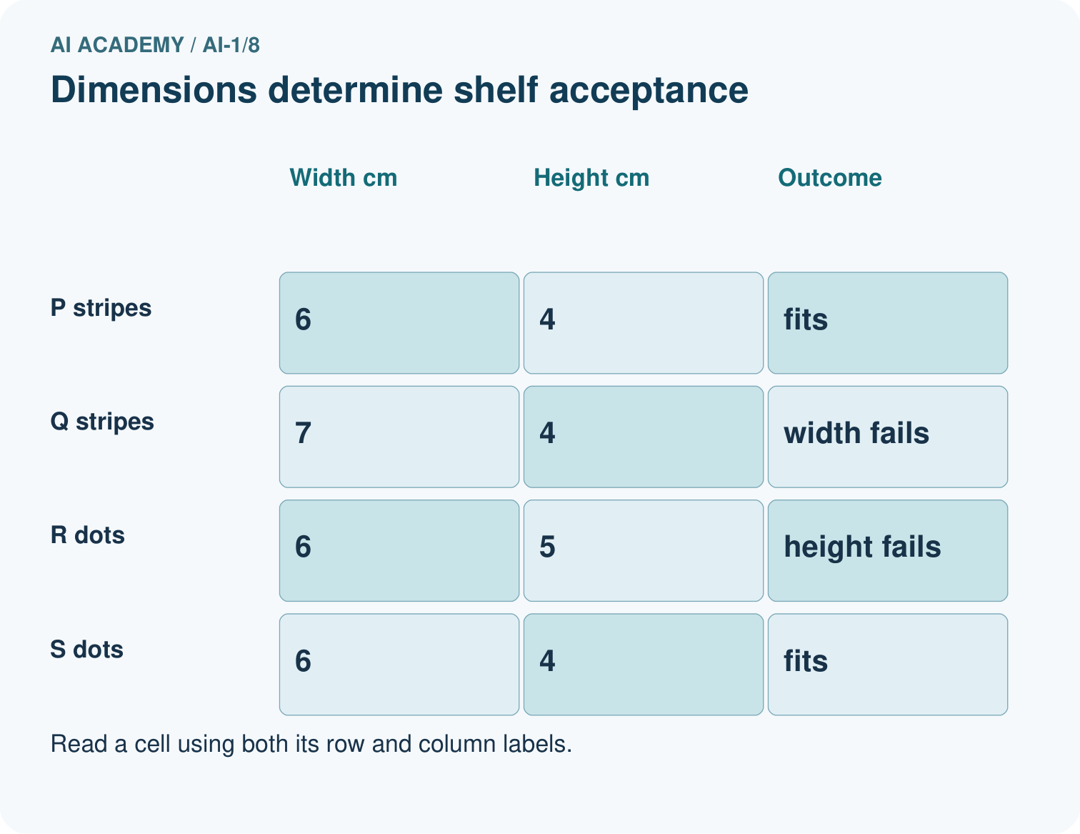
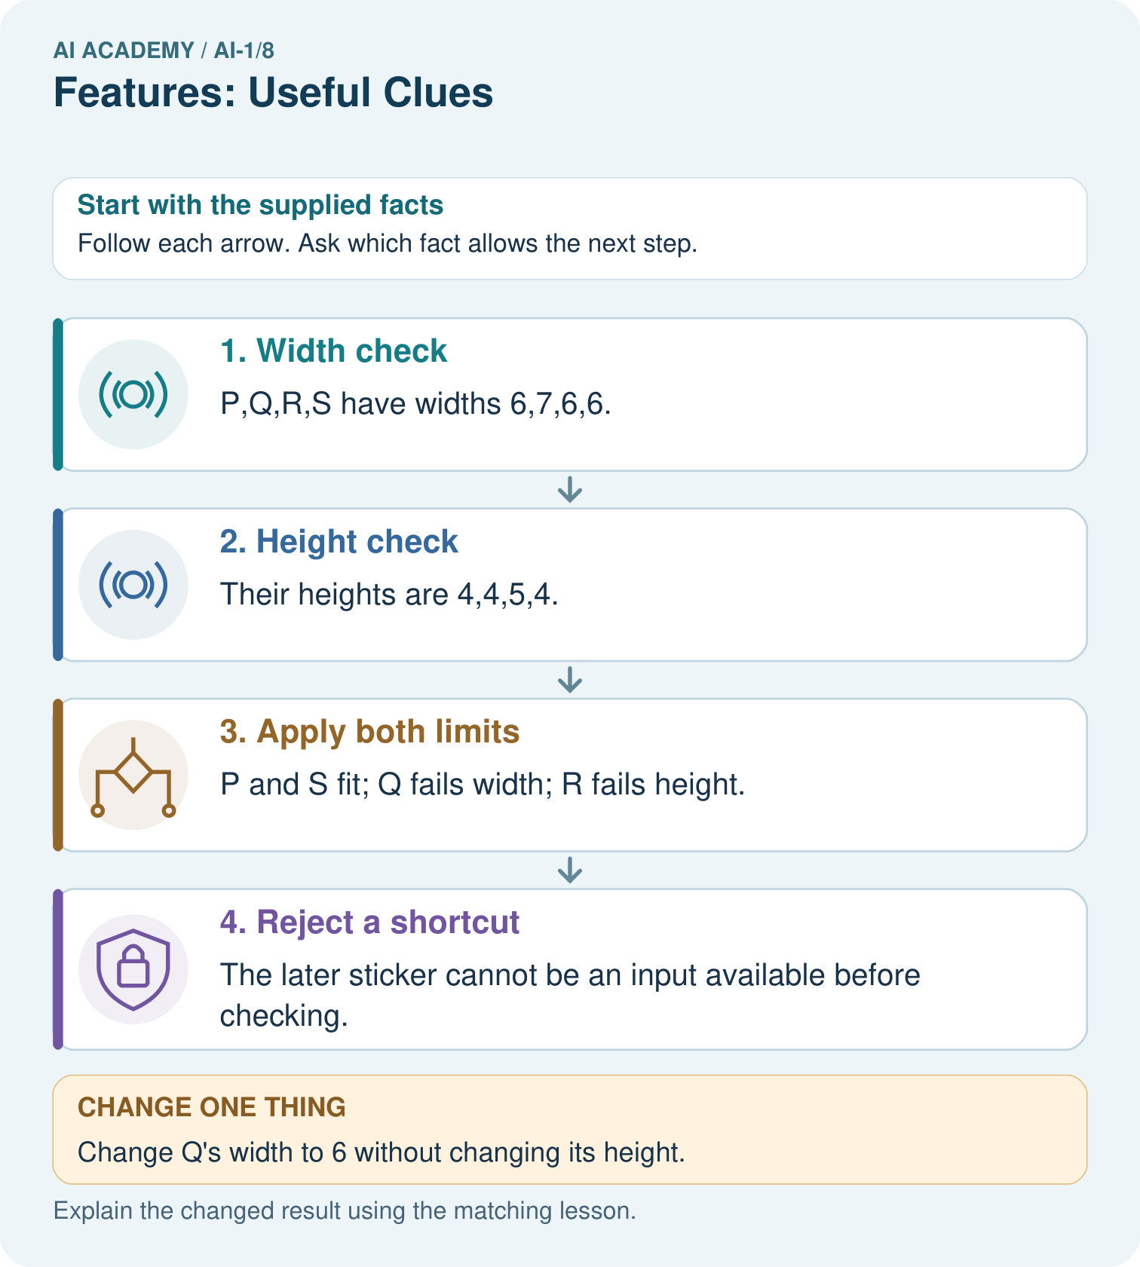
Point to the pair that tests pattern, then explain why the sticker is a bad early input.

My picture-based explanation and changed-case prediction
________________________________________________________________
________________________________________________________________
________________________________________________________________
________________________________________________________________
________________________________________________________________
________________________________________________________________
Support used: alone / hint / worked example. This record is practice evidence.
Project connection: Choose sorter features that exist at decision time and actually connect to the stated classroom requirement.

19. Project portfolio milestone
Project: Helpful Classroom Sorter
Current milestone: Make a transparent first version. Keep a trace of how one input becomes an output; explain the rule or learned component.
Choose sorter features that exist at decision time and actually connect to the stated classroom requirement.
Evidence to keep | My record
This week’s input and deciding step
Prediction and actual result (or labelled paper trace)
One change since the previous checkpoint and why
One error or limit and the next test

Explain what this week adds to your project. Reuse last week’s record rather than starting again.
________________________________________________________________
________________________________________________________________
________________________________________________________________
________________________________________________________________
________________________________________________________________

20. Supported practice and learning evidence
Use this supported practice once, in the browser or on paper. Keep the reserved independent assessment for a separate first attempt before teacher feedback.
A fictional shelf accepts a craft box only if width is at most 6 cm and height at most 4 cm.

Practice 1: explain the deciding evidence
Which labelled step matches this detail? The later sticker cannot be an input available before checking.
1. Apply both limits
2. Reject a shortcut
3. Height check
4. Width check

My selected conclusion, deciding fact and explanation
________________________________________________________________
________________________________________________________________
________________________________________________________________
________________________________________________________________
________________________________________________________________
Hint if needed: Read the steps in the pictorial case. Match the supplied detail to the stage that performs or records it.
After your attempt, compare with the supported explanation: Reject a shortcut The later sticker cannot be an input available before checking. Comparing P with Q isolates width; comparing P with R isolates height. Comparing P with S changes pattern while both remain accepted. Under this declared policy, pattern is not a deciding feature. A later acceptance sticker leaks the very answer the system should produce.

Practice 2: explain the deciding evidence
Changed-case practice: Change Q’s width to 6 without changing its height. Which conclusion is supported by the supplied facts?
1. We can decide the result without examining the changed input or the procedure.
2. This one example guarantees correct results for every future input.
3. Q fits the shelf.

My selected conclusion, deciding fact and explanation
________________________________________________________________
________________________________________________________________
________________________________________________________________
________________________________________________________________
________________________________________________________________
Hint if needed: Use the changed condition and the deciding step in the pictorial trace. The answer must say what follows from those facts.
After your attempt, compare with the supported explanation: Q fits the shelf. Both dimensions now meet their including equality limits; stripe pattern does not change the rule.

Repair a missing building block
Review Categories and Labels (ai-1/7). Goal: Apply a category definition using explicit evidence and boundary rules. Short practice: Explain why B originally was revise rather than review, then label its changed version.. Return to this week and explain what you changed.
Review Pictures Become Numbers (ai-1/5). Goal: Encode and reconstruct a small image using an explicit grid convention. Short practice: Find a position where the original badges differ, then read the changed A back as a picture.. Return to this week and explain what you changed.
Review Input, Process, Output (ai-1/2). Goal: Trace information through a system without confusing information with a physical action. Short practice: Use the richer record to find blue pencils in Box B. Explain why total alone was insufficient.. Return to this week and explain what you changed.

Keep your completed work
Use Download completed work in the hosted lesson to export your answers, reflections, practice feedback and code-run evidence. Open the HTML copy to read or print it. Drafts stay in this browser when storage is available; clear drafts on a shared device.

What I repaired, the evidence I kept and the next test
________________________________________________________________
________________________________________________________________
________________________________________________________________
________________________________________________________________
________________________________________________________________

