AI ACADEMY · WORKBOOK · ai-1/17

Prediction Is Not Fact
Project: Helpful Classroom Sorter

01. Recall and choose your starting point
Try the recall before opening notes. Then use a different colour or a labelled second line to correct your explanation.

Boundaries and 'Not Sure'
Without opening the old lesson, explain one key idea from Boundaries and 'Not Sure'. Give an example and a mistake that the idea helps you avoid.

My remembered idea, example and correction
________________________________________________________________
________________________________________________________________
________________________________________________________________

Build a Human Classifier
Without opening the old lesson, explain one key idea from Build a Human Classifier. Give an example and a mistake that the idea helps you avoid.

My remembered idea, example and correction
________________________________________________________________
________________________________________________________________
________________________________________________________________

Repeating Efficiently
Without opening the old lesson, explain one key idea from Repeating Efficiently. Give an example and a mistake that the idea helps you avoid.

My remembered idea, example and correction
________________________________________________________________
________________________________________________________________
________________________________________________________________

02. Practise with fading help
Use W2: Check a boundary without changing the rule for Predictions and observations. Record the answer once; the lesson and workbook refer to the same attempt.
Given inputs | Procedure I chose | Middle steps | Result and check

The step I completed without help, and the hint I needed
________________________________________________________________
________________________________________________________________
________________________________________________________________

03. Individual reasoning check
Use the worked case for Predictions and observations. Proposed explanation: “Running the rule correctly proves the prediction correct”. Decide whether this explanation is supported. Point to the step or supplied fact that decides; explain your repair if needed.

My explanation before partner discussion
________________________________________________________________
________________________________________________________________
________________________________________________________________
________________________________________________________________

04. Independent transfer case

Independent case: Transfer the check to drying predictions
In a fictional paper test, Dry1 predicts slow for a moisture score of at least 7, quick otherwise. Allowed scores are whole numbers 1 through 10. The observed outcome is slow if drying time is greater than 10 minutes, quick otherwise. Records are P: score 6, time 12; Q: score 7, time 10; R: score 9, time 14; S: score 5, time missing. Record all predictions, observed categories and comparison statuses. Summarise matches out of assessed cases, name the unassessed count, and limit the conclusion.

My independent explanation, trace and limits
________________________________________________________________
________________________________________________________________
________________________________________________________________
________________________________________________________________
________________________________________________________________
________________________________________________________________
________________________________________________________________
Attempt this case before feedback. Record any help. Earlier examples below are further practice; a case already practised with feedback cannot establish fresh transfer.

05. Your learning target
On Monday a team predicts 'rain on Tuesday'. On Tuesday they count a damp playground as success, although sprinklers ran. Write an observation rule that could have been agreed before Tuesday.

06. Solve the given case
A weather helper predicts tomorrow's rain.
Is this a fact about tomorrow? How can it be checked?
Show your trace, calculation or evidence

Write or draw your reasoning and evidence.
________________________________________________________________
________________________________________________________________
________________________________________________________________
________________________________________________________________
________________________________________________________________

07. Check a changed case
A model predicts rain tomorrow. Tomorrow is dry. Was the prediction an observation of tomorrow? Explain what new evidence settles the result.
My independent answer and reason

Write or draw your reasoning and evidence.
________________________________________________________________
________________________________________________________________
________________________________________________________________
________________________________________________________________
________________________________________________________________

Week 17 Test and reflect

08. Design a revealing test
Create a changed input, boundary case or missing-information case. Write the expected answer or safe response before testing.
Test record | My evidence
Changed input or condition
Expected answer or fallback
Observed result
Why the result occurred

09. Project checkpoint
Label the sorter's suggested bin as a prediction until a human confirms the final placement.
The project change and evidence I will keep

Write or draw your reasoning and evidence.
________________________________________________________________
________________________________________________________________
________________________________________________________________
________________________________________________________________
________________________________________________________________

10. Self check
I can explain the mechanism. I can show evidence. I can handle a changed case. I can name a limit. Mark each as not yet, with help or independently, and attach supporting work.
Teacher review ____________________ Next step ____________________

11. Transfer practice from the original programme
On Monday a team predicts 'rain on Tuesday'. On Tuesday they count a damp playground as success, although sprinklers ran. Write an observation rule that could have been agreed before Tuesday.

My independently reasoned answer
________________________________________________________________
________________________________________________________________
________________________________________________________________
________________________________________________________________
________________________________________________________________
________________________________________________________________
________________________________________________________________
Record support used: none, hint or teacher explanation.

12. W1 Separate inputs from observed outcomes
For Ramp1 trial B, height is 6 cm and the later travel distance is 3 units. State the input, prediction, observation, observed category and comparison status. Explain why the prediction rule and outcome rule use different measurements.

My reasoning and evidence
________________________________________________________________
________________________________________________________________
________________________________________________________________
________________________________________________________________
________________________________________________________________
________________________________________________________________

13. W2 Check a boundary without changing the rule
Trial F has height 6 cm and verified travel distance exactly 4 units. Apply Ramp1 and the outcome rule. A partner says exactly 4 is near because far means greater than 4. Use the stated rule to resolve the disagreement.

My reasoning and evidence
________________________________________________________________
________________________________________________________________
________________________________________________________________
________________________________________________________________
________________________________________________________________
________________________________________________________________

14. W3 Keep incomplete evidence visible
D predicts near but has no distance record. E predicts far but its two distance records say 3 and 4 units. State each comparison status, request useful evidence, and explain why neither guessing nor a new trial can establish the old trial’s outcome.

My reasoning and evidence
________________________________________________________________
________________________________________________________________
________________________________________________________________
________________________________________________________________
________________________________________________________________
________________________________________________________________

15. W4 Transfer the check to drying predictions
In a fictional paper test, Dry1 predicts slow for a moisture score of at least 7, quick otherwise. Allowed scores are whole numbers 1 through 10. The observed outcome is slow if drying time is greater than 10 minutes, quick otherwise. Records are P: score 6, time 12; Q: score 7, time 10; R: score 9, time 14; S: score 5, time missing. Record all predictions, observed categories and comparison statuses. Summarise matches out of assessed cases, name the unassessed count, and limit the conclusion.

My reasoning and evidence
________________________________________________________________
________________________________________________________________
________________________________________________________________
________________________________________________________________
________________________________________________________________
________________________________________________________________
________________________________________________________________
________________________________________________________________

16. W5 Correct a report without erasing evidence
After seeing B’s observed near category, a learner replaces Ramp1’s far prediction with near. They call the new entry a corrected observation and report a perfect result for A through C. Explain the two record-keeping errors and write a defensible replacement report.

My reasoning and evidence
________________________________________________________________
________________________________________________________________
________________________________________________________________
________________________________________________________________
________________________________________________________________
________________________________________________________________

17. Feedback, return check and learning record
Evidence | My record
Worked alone / hint / model
First step I repaired and why
New case checked later; date and result
What I can now explain without notes
One remaining question
Revisit this idea with your teacher after a delay. Familiarity is different from explaining and using it on a changed case.

18. Pictorial case practice: Prediction Is Not Fact
A fictional drying trial uses a fixed rule and later measures what actually happened.
Model D predicts slow when moisture score is at least 5; quick otherwise.
Observation policy: slow if drying takes above 8 minutes; quick otherwise. Trial T has score 4 and measured time 9 minutes.
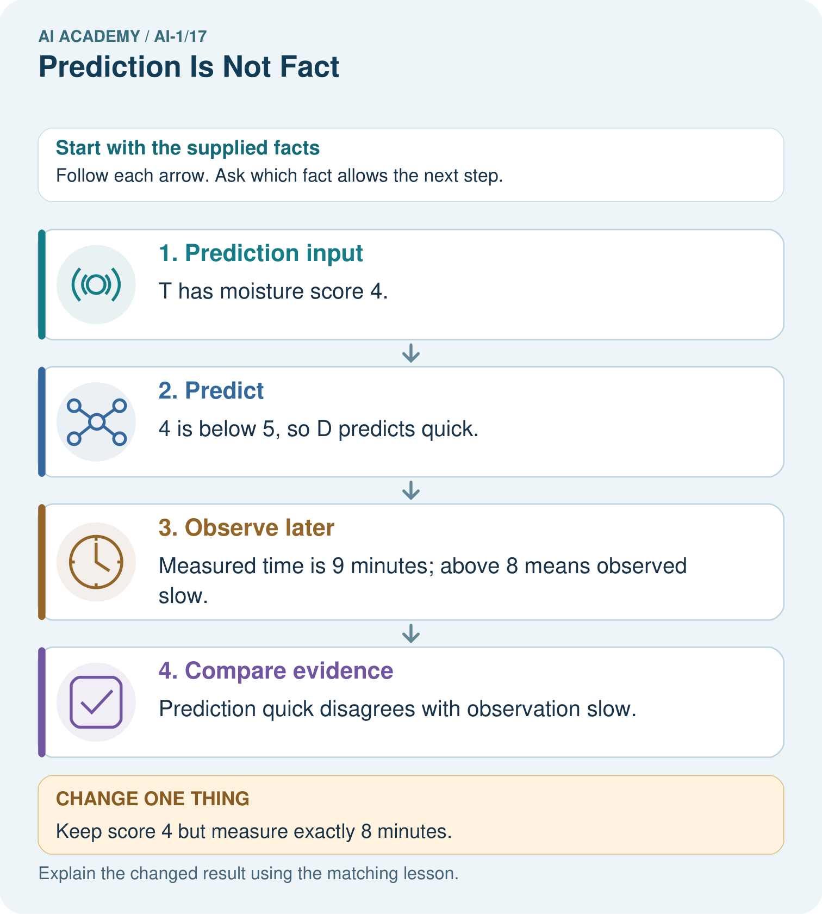
Which field changes the observation label, and which field changes the model prediction?

My picture-based explanation and changed-case prediction
________________________________________________________________
________________________________________________________________
________________________________________________________________
________________________________________________________________
________________________________________________________________
________________________________________________________________
Support used: alone / hint / worked example. This record is practice evidence.
Project connection: In sorter trials, record predicted categories before collecting reference evidence, then retain disagreements for investigation.

19. Project portfolio milestone
Project: Helpful Classroom Sorter
Current milestone: Test changed cases. Keep normal, boundary and failure cases; compare expected and observed results.
In sorter trials, record predicted categories before collecting reference evidence, then retain disagreements for investigation.
Evidence to keep | My record
This week’s input and deciding step
Prediction and actual result (or labelled paper trace)
One change since the previous checkpoint and why
One error or limit and the next test

Explain what this week adds to your project. Reuse last week’s record rather than starting again.
________________________________________________________________
________________________________________________________________
________________________________________________________________
________________________________________________________________
________________________________________________________________

20. Supported practice and learning evidence
Use this supported practice once, in the browser or on paper. Keep the reserved independent assessment for a separate first attempt before teacher feedback.
A fictional drying trial uses a fixed rule and later measures what actually happened.

Practice 1: explain the deciding evidence
Which labelled step matches this detail? Prediction quick disagrees with observation slow.
1. Predict
2. Compare evidence
3. Observe later
4. Prediction input

My selected conclusion, deciding fact and explanation
________________________________________________________________
________________________________________________________________
________________________________________________________________
________________________________________________________________
________________________________________________________________
Hint if needed: Read the steps in the pictorial case. Match the supplied detail to the stage that performs or records it.
After your attempt, compare with the supported explanation: Compare evidence Prediction quick disagrees with observation slow. The moisture score generates a prediction; it is not the observed drying time. The later measurement supplies separate evidence under the stated observation policy. Save both values and their units. Altering the recorded time to match D would destroy the evaluation rather than repair the model.

Practice 2: explain the deciding evidence
Changed-case practice: Keep score 4 but measure exactly 8 minutes. Which conclusion is supported by the supplied facts?
1. The observed label becomes quick and agrees with the prediction.
2. We can decide the result without examining the changed input or the procedure.
3. This one example guarantees correct results for every future input.

My selected conclusion, deciding fact and explanation
________________________________________________________________
________________________________________________________________
________________________________________________________________
________________________________________________________________
________________________________________________________________
Hint if needed: Use the changed condition and the deciding step in the pictorial trace. The answer must say what follows from those facts.
After your attempt, compare with the supported explanation: The observed label becomes quick and agrees with the prediction. Above 8 is strict: equality is quick under this policy.

Repair a missing building block
Review Boundaries and 'Not Sure' (ai-1/16). Goal: Identify a specific source of uncertainty and explain how it affects a prediction. Short practice: Which original block needs a better width before accepting or rejecting it? What should the reviewer do?. Return to this week and explain what you changed.
Review Build a Human Classifier (ai-1/14). Goal: Construct a classifier with a stated input format, selected rule and recorded output. Short practice: Trace 0 cm and explain why clarification is different from predicting short.. Return to this week and explain what you changed.
Review Repeating Efficiently (ai-1/11). Goal: Trace a loop by testing its condition before every repetition. Short practice: Trace a fresh start of 9. How many additions occur, and must the report equal 10?. Return to this week and explain what you changed.

Keep your completed work
Use Download completed work in the hosted lesson to export your answers, reflections, practice feedback and code-run evidence. Open the HTML copy to read or print it. Drafts stay in this browser when storage is available; clear drafts on a shared device.

What I repaired, the evidence I kept and the next test
________________________________________________________________
________________________________________________________________
________________________________________________________________
________________________________________________________________
________________________________________________________________

