AI ACADEMY · WORKBOOK · ai-1/19

Similarity
Project: Helpful Classroom Sorter

01. Recall and choose your starting point
Try the recall before opening notes. Then use a different colour or a labelled second line to correct your explanation.

Confidence Is Not Correctness
Without opening the old lesson, explain one key idea from Confidence Is Not Correctness. Give an example and a mistake that the idea helps you avoid.

My remembered idea, example and correction
________________________________________________________________
________________________________________________________________
________________________________________________________________

Boundaries and 'Not Sure'
Without opening the old lesson, explain one key idea from Boundaries and 'Not Sure'. Give an example and a mistake that the idea helps you avoid.

My remembered idea, example and correction
________________________________________________________________
________________________________________________________________
________________________________________________________________

Learning from Examples
Without opening the old lesson, explain one key idea from Learning from Examples. Give an example and a mistake that the idea helps you avoid.

My remembered idea, example and correction
________________________________________________________________
________________________________________________________________
________________________________________________________________

02. Practise with fading help
Use W2: Explain a changed winner for Similarity and selected features. Record the answer once; the lesson and workbook refer to the same attempt.
Given inputs | Procedure I chose | Middle steps | Result and check

The step I completed without help, and the hint I needed
________________________________________________________________
________________________________________________________________
________________________________________________________________

03. Individual reasoning check
Use the worked case for Similarity and selected features. Proposed explanation: “Similar has one objective meaning for every task”. Decide whether this explanation is supported. Point to the step or supplied fact that decides; explain your repair if needed.

My explanation before partner discussion
________________________________________________________________
________________________________________________________________
________________________________________________________________
________________________________________________________________

04. Independent transfer case

Independent case: Transfer the comparison to books
A target book has topic space, format comic and language English. Candidates are J: space, prose, English; K: animals, comic, English; L: space, comic, Spanish. Give 1 point per exact match and return all tied highest scorers. Then make topic worth 3 points while keeping the other weights at 1. Report both sets of totals and winners. Explain why a winner may still fail a requirement to read English.

My independent explanation, trace and limits
________________________________________________________________
________________________________________________________________
________________________________________________________________
________________________________________________________________
________________________________________________________________
________________________________________________________________
________________________________________________________________
Attempt this case before feedback. Record any help. Earlier examples below are further practice; a case already practised with feedback cannot establish fresh transfer.

05. Your learning target
A reader wants mystery and short books. A has both traits, B only mystery, C only short. Score one point per matching trait. The reader now says short is essential. Explain how the decision should change.

06. Solve the given case
Book A has animals and adventure; B has animals only; C has neither. A reader wants both traits.
Rank by number of matching traits.
Show your trace, calculation or evidence

Write or draw your reasoning and evidence.
________________________________________________________________
________________________________________________________________
________________________________________________________________
________________________________________________________________
________________________________________________________________

07. Check a changed case
Compare books using topic only. Book A is about space with a red cover; B is about space with a blue cover; C is about dogs with a red cover. Which matches A best?
My independent answer and reason

Write or draw your reasoning and evidence.
________________________________________________________________
________________________________________________________________
________________________________________________________________
________________________________________________________________
________________________________________________________________

Week 19 Test and reflect

08. Design a revealing test
Create a changed input, boundary case or missing-information case. Write the expected answer or safe response before testing.
Test record | My evidence
Changed input or condition
Expected answer or fallback
Observed result
Why the result occurred

09. Project checkpoint
Choose two useful item traits for similarity-based sorting and explain why each deserves its weight.
The project change and evidence I will keep

Write or draw your reasoning and evidence.
________________________________________________________________
________________________________________________________________
________________________________________________________________
________________________________________________________________
________________________________________________________________

10. Self check
I can explain the mechanism. I can show evidence. I can handle a changed case. I can name a limit. Mark each as not yet, with help or independently, and attach supporting work.
Teacher review ____________________ Next step ____________________

11. Transfer practice from the original programme
A reader wants mystery and short books. A has both traits, B only mystery, C only short. Score one point per matching trait. The reader now says short is essential. Explain how the decision should change.

My independently reasoned answer
________________________________________________________________
________________________________________________________________
________________________________________________________________
________________________________________________________________
________________________________________________________________
________________________________________________________________
________________________________________________________________
Record support used: none, hint or teacher explanation.

12. W1 Show the contributions before the total
For the red round smooth target and candidates A, B and C in the lesson, record the colour, shape and texture contributions under one point per match. Give each total and identify every highest scoring candidate.

My reasoning and evidence
________________________________________________________________
________________________________________________________________
________________________________________________________________
________________________________________________________________
________________________________________________________________
________________________________________________________________

13. W2 Explain a changed winner
Keep the same target and candidates but make texture worth 3 points, with colour and shape worth 1 each. Recalculate A, B and C. Explain what changed and what stayed the same.

My reasoning and evidence
________________________________________________________________
________________________________________________________________
________________________________________________________________
________________________________________________________________
________________________________________________________________
________________________________________________________________

14. W3 Keep unknown separate from different
Candidate E is red and round but its texture is missing. A learner assigns zero for texture and declares E fully scored. Apply our classroom policy. State the known contributions, the missing information and what must happen before a final ranking.

My reasoning and evidence
________________________________________________________________
________________________________________________________________
________________________________________________________________
________________________________________________________________
________________________________________________________________
________________________________________________________________

15. W4 Transfer the comparison to books
A target book has topic space, format comic and language English. Candidates are J: space, prose, English; K: animals, comic, English; L: space, comic, Spanish. Give 1 point per exact match and return all tied highest scorers. Then make topic worth 3 points while keeping the other weights at 1. Report both sets of totals and winners. Explain why a winner may still fail a requirement to read English.

My reasoning and evidence
________________________________________________________________
________________________________________________________________
________________________________________________________________
________________________________________________________________
________________________________________________________________
________________________________________________________________
________________________________________________________________
________________________________________________________________

16. W5 Notice an accidental extra weight
A designer adds a second colour column that copies the first and gives both columns one point. They say no feature has been given extra importance because every column has equal weight. Explain the problem and propose a clearer rule.

My reasoning and evidence
________________________________________________________________
________________________________________________________________
________________________________________________________________
________________________________________________________________
________________________________________________________________
________________________________________________________________

17. Feedback, return check and learning record
Evidence | My record
Worked alone / hint / model
First step I repaired and why
New case checked later; date and result
What I can now explain without notes
One remaining question
Revisit this idea with your teacher after a delay. Familiarity is different from explaining and using it on a changed case.

18. Pictorial case practice: Similarity
A fictional craft-card matcher compares each candidate with a target.
Target: red, round, smooth. A: red,square,smooth. B: blue,round,smooth. C: red,round,rough.
Initially each exact feature match scores 1; return all highest scorers.
For the second comparison only, colour and shape matches score 1 each and a texture match scores 3.
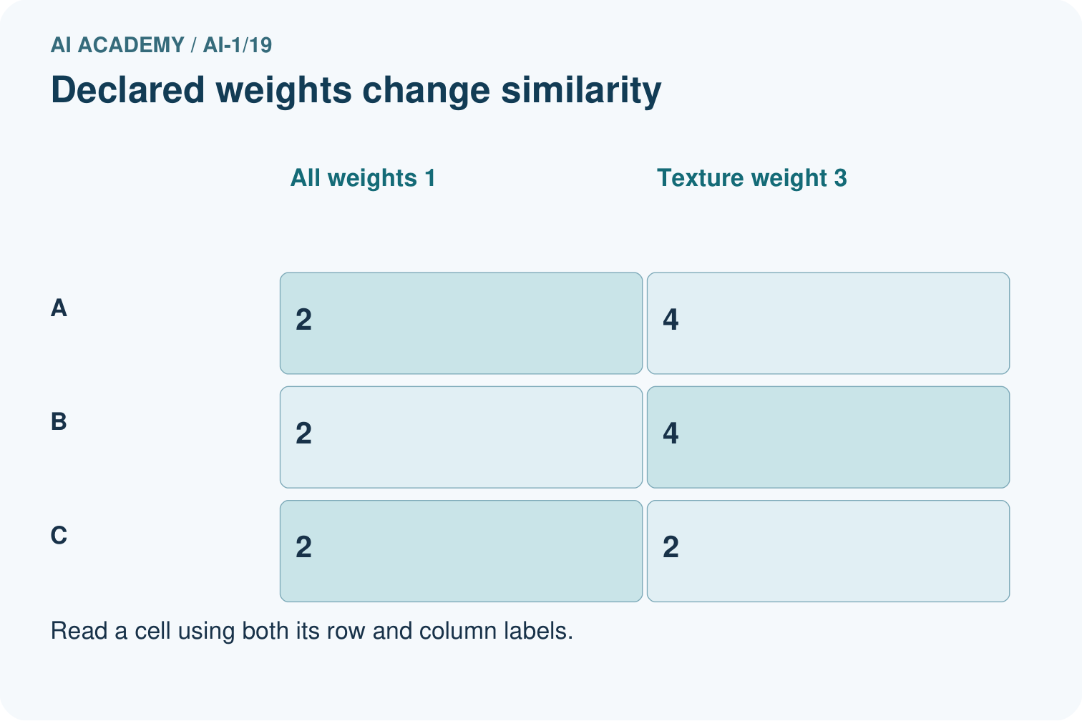
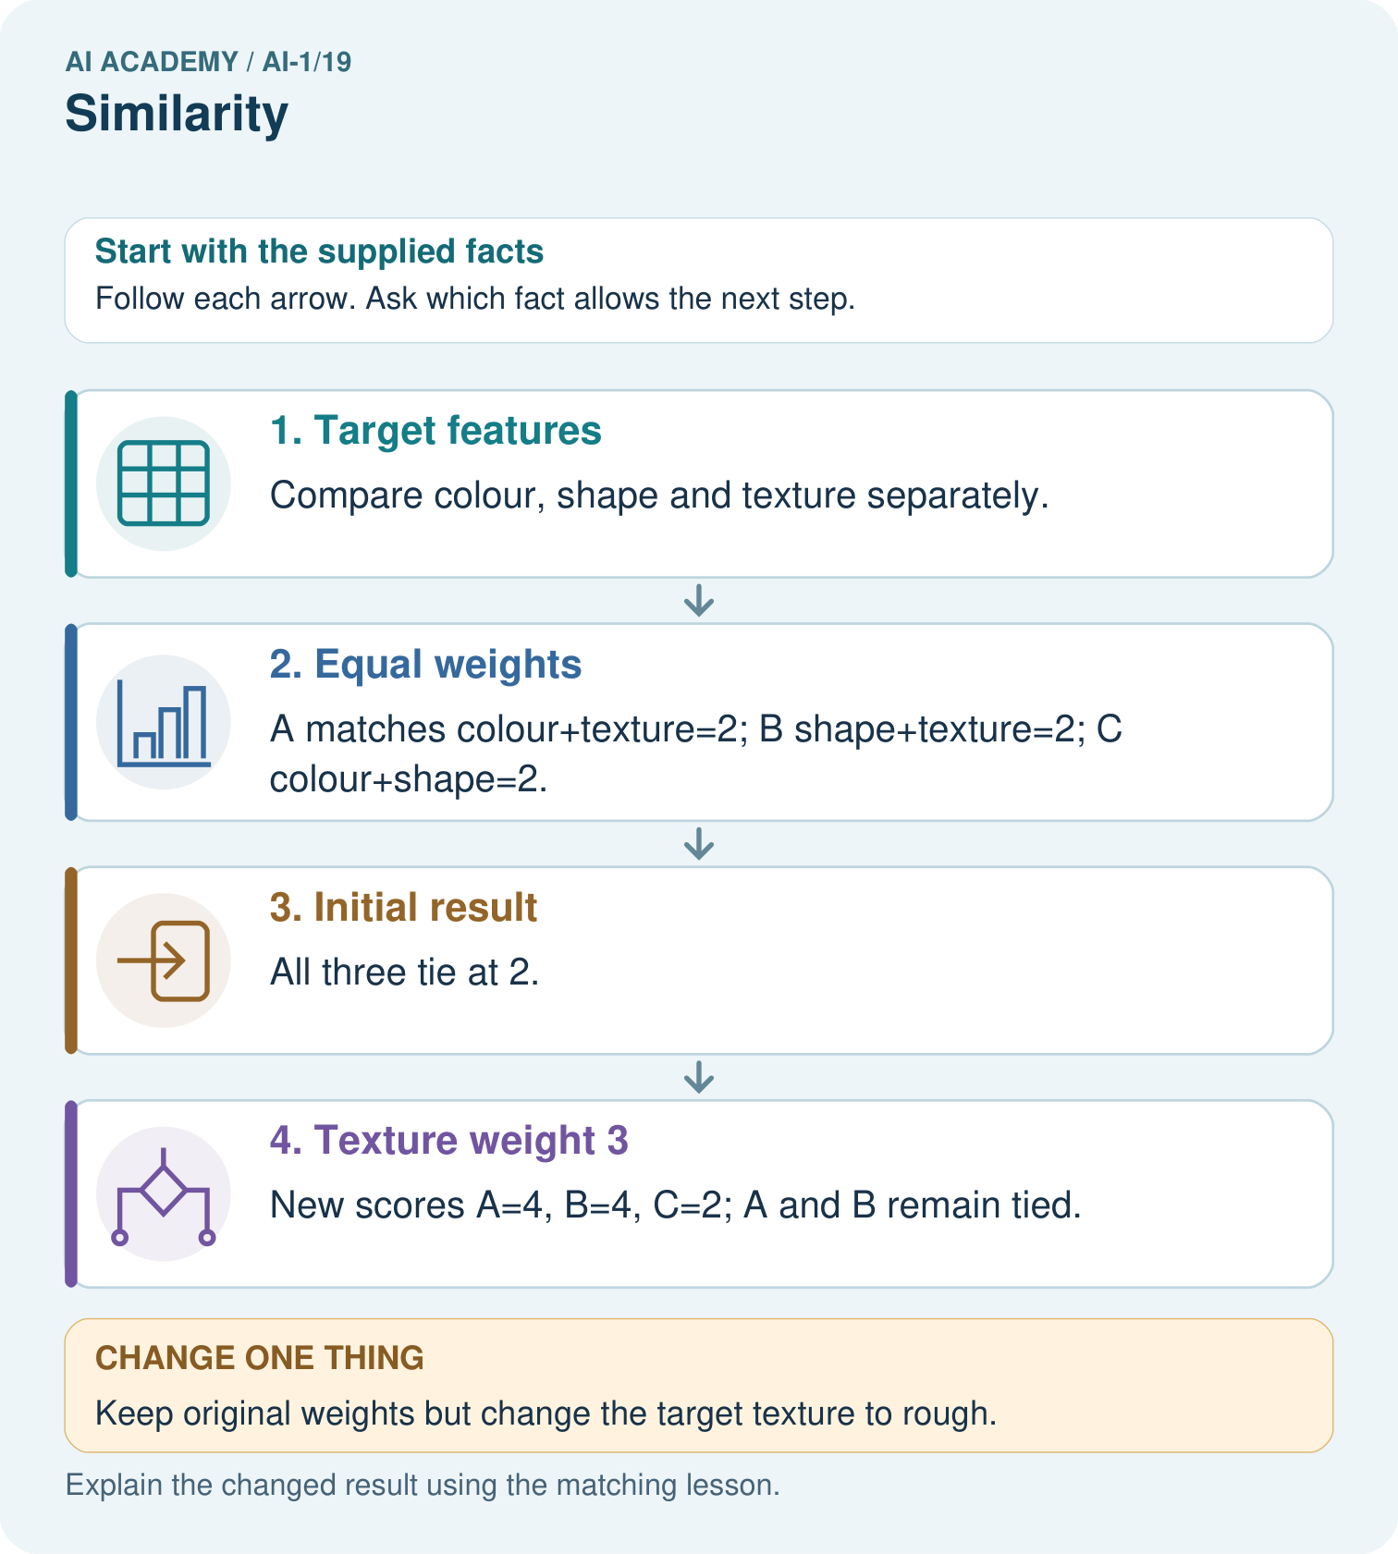
Point to the matches supporting C’s new score and explain why there is no tie.

My picture-based explanation and changed-case prediction
________________________________________________________________
________________________________________________________________
________________________________________________________________
________________________________________________________________
________________________________________________________________
________________________________________________________________
Support used: alone / hint / worked example. This record is practice evidence.
Project connection: Declare sorter similarity features, weights and tie behavior before using scores to explain recommendations.

19. Project portfolio milestone
Project: Helpful Classroom Sorter
Current milestone: Evaluate and revise. Compare with your starting method, explain errors and record a justified revision.
Declare sorter similarity features, weights and tie behavior before using scores to explain recommendations.
Evidence to keep | My record
This week’s input and deciding step
Prediction and actual result (or labelled paper trace)
One change since the previous checkpoint and why
One error or limit and the next test

Explain what this week adds to your project. Reuse last week’s record rather than starting again.
________________________________________________________________
________________________________________________________________
________________________________________________________________
________________________________________________________________
________________________________________________________________

20. Supported practice and learning evidence
Use this supported practice once, in the browser or on paper. Keep the reserved independent assessment for a separate first attempt before teacher feedback.
A fictional craft-card matcher compares each candidate with a target.

Practice 1: explain the deciding evidence
Which labelled step matches this detail? New scores A=4, B=4, C=2; A and B remain tied.
1. Target features
2. Initial result
3. Texture weight 3
4. Equal weights

My selected conclusion, deciding fact and explanation
________________________________________________________________
________________________________________________________________
________________________________________________________________
________________________________________________________________
________________________________________________________________
Hint if needed: Read the steps in the pictorial case. Match the supplied detail to the stage that performs or records it.
After your attempt, compare with the supported explanation: Texture weight 3 New scores A=4, B=4, C=2; A and B remain tied. Similarity is defined by the chosen representation and weights. The cards did not change when texture gained weight; the comparison rule did. Two high scores need not mean two identical cards. A complete rule also says what to do with tied scores, rather than choosing whichever appears first by accident.

Practice 2: explain the deciding evidence
Changed-case practice: Keep original weights but change the target texture to rough. Which conclusion is supported by the supplied facts?
1. We can decide the result without examining the changed input or the procedure.
2. This one example guarantees correct results for every future input.
3. C scores 3; A and B each score 1.

My selected conclusion, deciding fact and explanation
________________________________________________________________
________________________________________________________________
________________________________________________________________
________________________________________________________________
________________________________________________________________
Hint if needed: Use the changed condition and the deciding step in the pictorial trace. The answer must say what follows from those facts.
After your attempt, compare with the supported explanation: C scores 3; A and B each score 1. C now matches all three target features; the others lose their smooth-texture match.

Repair a missing building block
Review Confidence Is Not Correctness (ai-1/18). Goal: Distinguish a confidence claim from evidence that a prediction was correct. Short practice: Was the unknown label guaranteed correct because its confidence was 80%?. Return to this week and explain what you changed.
Review Boundaries and 'Not Sure' (ai-1/16). Goal: Identify a specific source of uncertainty and explain how it affects a prediction. Short practice: Which original block needs a better width before accepting or rejecting it? What should the reviewer do?. Return to this week and explain what you changed.
Review Learning from Examples (ai-1/13). Goal: Fit a threshold by tracing predictions and counting disagreements for every candidate. Short practice: Which new measured length would reveal disagreement between the candidates?. Return to this week and explain what you changed.

Keep your completed work
Use Download completed work in the hosted lesson to export your answers, reflections, practice feedback and code-run evidence. Open the HTML copy to read or print it. Drafts stay in this browser when storage is available; clear drafts on a shared device.

What I repaired, the evidence I kept and the next test
________________________________________________________________
________________________________________________________________
________________________________________________________________
________________________________________________________________
________________________________________________________________

