AI ACADEMY · WORKBOOK · ai-1/22

Missing and Unbalanced Examples
Project: Helpful Classroom Sorter

01. Recall and choose your starting point
Try the recall before opening notes. Then use a different colour or a labelled second line to correct your explanation.

Good Data, Bad Data
Without opening the old lesson, explain one key idea from Good Data, Bad Data. Give an example and a mistake that the idea helps you avoid.

My remembered idea, example and correction
________________________________________________________________
________________________________________________________________
________________________________________________________________

Similarity
Without opening the old lesson, explain one key idea from Similarity. Give an example and a mistake that the idea helps you avoid.

My remembered idea, example and correction
________________________________________________________________
________________________________________________________________
________________________________________________________________

Boundaries and 'Not Sure'
Without opening the old lesson, explain one key idea from Boundaries and 'Not Sure'. Give an example and a mistake that the idea helps you avoid.

My remembered idea, example and correction
________________________________________________________________
________________________________________________________________
________________________________________________________________

02. Practise with fading help
Use W2: Separate files from distinct cases for Sampling and coverage. Record the answer once; the lesson and workbook refer to the same attempt.
Given inputs | Procedure I chose | Middle steps | Result and check

The step I completed without help, and the hint I needed
________________________________________________________________
________________________________________________________________
________________________________________________________________

03. Individual reasoning check
Use the worked case for Sampling and coverage. Proposed explanation: “More records always remove bias”. Decide whether this explanation is supported. Point to the step or supplied fact that decides; explain your repair if needed.

My explanation before partner discussion
________________________________________________________________
________________________________________________________________
________________________________________________________________
________________________________________________________________

04. Independent transfer case

Independent case: Audit a new sound-recognition claim
A fixed target has 20 invented clips: 5 quiet bells, 5 noisy bells, 5 quiet claps and 5 noisy claps. A tester selects 4 distinct quiet bells from a quiet-bell-only list; 3 are correctly labelled and 1 is wrong. Write a supported result, name missing conditions and explain why the result is not established for all 20 clips. Propose an 8-clip plan that includes every condition, with no clip selected twice.

My independent explanation, trace and limits
________________________________________________________________
________________________________________________________________
________________________________________________________________
________________________________________________________________
________________________________________________________________
________________________________________________________________
________________________________________________________________
Attempt this case before feedback. Record any help. Earlier examples below are further practice; a case already practised with feedback cannot establish fresh transfer.

05. Your learning target
A training set has 18 daylight photos and two dark photos of one object. Copying the dark photos eight times balances the counts. Does it balance the variety? Design a better collection step.

06. Solve the given case
Training includes nine daylight leaf photos and one low-light photo.
What intended-use gap is present?
Show your trace, calculation or evidence

Write or draw your reasoning and evidence.
________________________________________________________________
________________________________________________________________
________________________________________________________________
________________________________________________________________
________________________________________________________________

07. Check a changed case
A photo sorter trains on ten bright photos and no dim photos. What group of examples is missing? Design a test that reveals the gap.
My independent answer and reason

Write or draw your reasoning and evidence.
________________________________________________________________
________________________________________________________________
________________________________________________________________
________________________________________________________________
________________________________________________________________

Week 22 Test and reflect

08. Design a revealing test
Create a changed input, boundary case or missing-information case. Write the expected answer or safe response before testing.
Test record | My evidence
Changed input or condition
Expected answer or fallback
Observed result
Why the result occurred

09. Project checkpoint
List normal, low-light, partly hidden, worn, and unusual items; mark which conditions are missing from the sorter data.
The project change and evidence I will keep

Write or draw your reasoning and evidence.
________________________________________________________________
________________________________________________________________
________________________________________________________________
________________________________________________________________
________________________________________________________________

10. Self check
I can explain the mechanism. I can show evidence. I can handle a changed case. I can name a limit. Mark each as not yet, with help or independently, and attach supporting work.
Teacher review ____________________ Next step ____________________

11. Transfer practice from the original programme
A training set has 18 daylight photos and two dark photos of one object. Copying the dark photos eight times balances the counts. Does it balance the variety? Design a better collection step.

My independently reasoned answer
________________________________________________________________
________________________________________________________________
________________________________________________________________
________________________________________________________________
________________________________________________________________
________________________________________________________________
________________________________________________________________
Record support used: none, hint or teacher explanation.

12. W1 Name target, frame and sample
Use the 24-card investigation. State the target collection, the original six-card sample and the three absent conditions. If the selection list contains only bright-circle IDs, explain why random selection from that list cannot reach every target condition.

My reasoning and evidence
________________________________________________________________
________________________________________________________________
________________________________________________________________
________________________________________________________________
________________________________________________________________
________________________________________________________________

13. W2 Separate files from distinct cases
Each of the six original sampled cards is photographed twice. State the number of image files and distinct cards. Has this covered a new shape or lighting condition? Explain why the counts need different labels.

My reasoning and evidence
________________________________________________________________
________________________________________________________________
________________________________________________________________
________________________________________________________________
________________________________________________________________
________________________________________________________________

14. W3 Read a coverage table in combinations
A different test includes 3 bright circles and 3 dim squares. A designer says it covers both shapes and both lighting conditions, so no combinations are missing. Identify the missing combinations and propose six additional distinct cards to investigate them.

My reasoning and evidence
________________________________________________________________
________________________________________________________________
________________________________________________________________
________________________________________________________________
________________________________________________________________
________________________________________________________________

15. W4 Audit a new sound-recognition claim
A fixed target has 20 invented clips: 5 quiet bells, 5 noisy bells, 5 quiet claps and 5 noisy claps. A tester selects 4 distinct quiet bells from a quiet-bell-only list; 3 are correctly labelled and 1 is wrong. Write a supported result, name missing conditions and explain why the result is not established for all 20 clips. Propose an 8-clip plan that includes every condition, with no clip selected twice.

My reasoning and evidence
________________________________________________________________
________________________________________________________________
________________________________________________________________
________________________________________________________________
________________________________________________________________
________________________________________________________________
________________________________________________________________
________________________________________________________________

16. W5 Report a selected case without an outcome
An 8-clip plan selects 2 from each sound condition. One selected noisy-clap file cannot be opened. The task measures recognition correctness only. State selected and assessed counts and the assessed count for each condition. Explain why a report of all 8 checked is wrong, and how to handle the missing file transparently.

My reasoning and evidence
________________________________________________________________
________________________________________________________________
________________________________________________________________
________________________________________________________________
________________________________________________________________
________________________________________________________________

17. Feedback, return check and learning record
Evidence | My record
Worked alone / hint / model
First step I repaired and why
New case checked later; date and result
What I can now explain without notes
One remaining question
Revisit this idea with your teacher after a delay. Familiarity is different from explaining and using it on a changed case.

18. Pictorial case practice: Missing and Unbalanced Examples
A fictional badge reader will be used in both bright and dim rooms.
Intended target has 8 bright plain,8 bright patterned,8 dim plain,8 dim patterned cards.
A development sample contains 6 bright plain cards and 2 bright patterned cards; no dim cards.
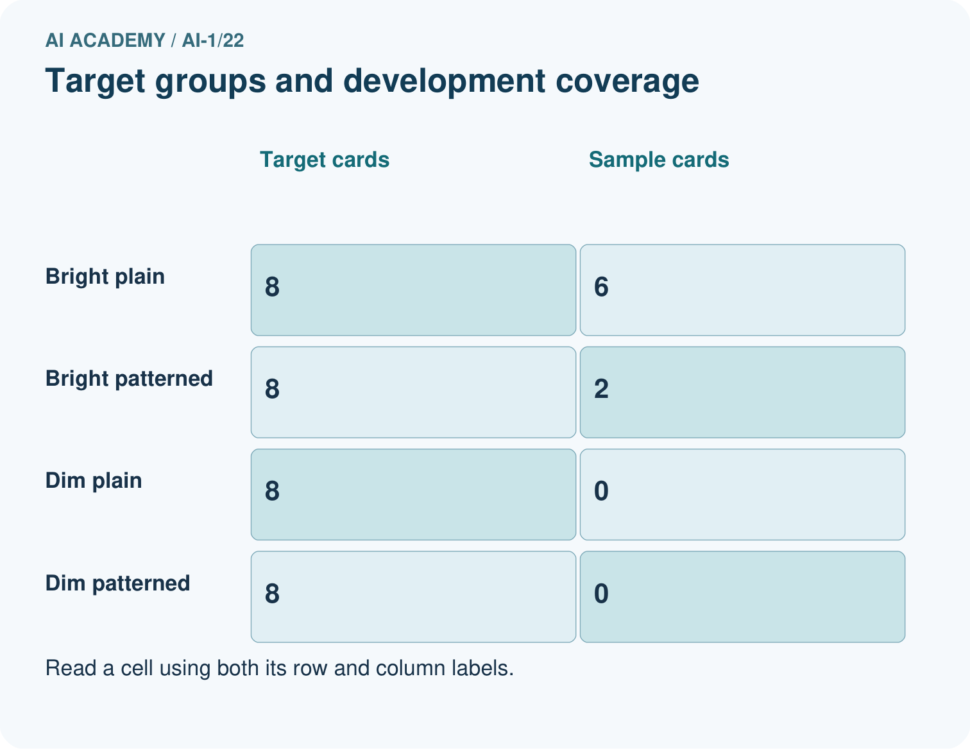
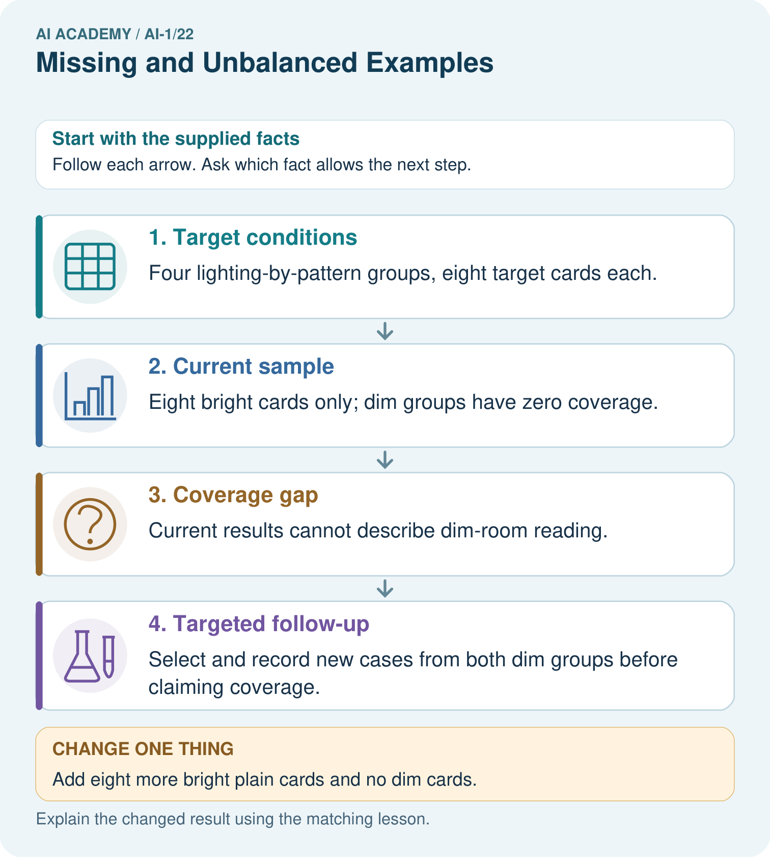
Would testing only dim plain cards close every current gap? Point to the target groups.

My picture-based explanation and changed-case prediction
________________________________________________________________
________________________________________________________________
________________________________________________________________
________________________________________________________________
________________________________________________________________
________________________________________________________________
Support used: alone / hint / worked example. This record is practice evidence.
Project connection: Create a sorter coverage table crossing important classroom conditions, then state which groups each test actually represents.

19. Project portfolio milestone
Project: Helpful Classroom Sorter
Current milestone: Evaluate and revise. Compare with your starting method, explain errors and record a justified revision.
Create a sorter coverage table crossing important classroom conditions, then state which groups each test actually represents.
Evidence to keep | My record
This week’s input and deciding step
Prediction and actual result (or labelled paper trace)
One change since the previous checkpoint and why
One error or limit and the next test

Explain what this week adds to your project. Reuse last week’s record rather than starting again.
________________________________________________________________
________________________________________________________________
________________________________________________________________
________________________________________________________________
________________________________________________________________

20. Supported practice and learning evidence
Use this supported practice once, in the browser or on paper. Keep the reserved independent assessment for a separate first attempt before teacher feedback.
A fictional badge reader will be used in both bright and dim rooms.

Practice 1: explain the deciding evidence
Which labelled step matches this detail? Select and record new cases from both dim groups before claiming coverage.
1. Target conditions
2. Current sample
3. Targeted follow-up
4. Coverage gap

My selected conclusion, deciding fact and explanation
________________________________________________________________
________________________________________________________________
________________________________________________________________
________________________________________________________________
________________________________________________________________
Hint if needed: Read the steps in the pictorial case. Match the supplied detail to the stage that performs or records it.
After your attempt, compare with the supported explanation: Targeted follow-up Select and record new cases from both dim groups before claiming coverage. Adding more bright cards can increase sample size without addressing the missing condition. A coverage check asks which relevant situations are absent, not merely how many rows exist. Deliberately selecting dim cases helps investigate those conditions, but the resulting test should not be advertised as a random survey unless its selection really was random.

Practice 2: explain the deciding evidence
Changed-case practice: Add eight more bright plain cards and no dim cards. Which conclusion is supported by the supplied facts?
1. This one example guarantees correct results for every future input.
2. We can decide the result without examining the changed input or the procedure.
3. The sample becomes larger but still has no dim coverage.

My selected conclusion, deciding fact and explanation
________________________________________________________________
________________________________________________________________
________________________________________________________________
________________________________________________________________
________________________________________________________________
Hint if needed: Use the changed condition and the deciding step in the pictorial trace. The answer must say what follows from those facts.
After your attempt, compare with the supported explanation: The sample becomes larger but still has no dim coverage. The missing lighting condition remains untested.

Repair a missing building block
Review Good Data, Bad Data (ai-1/21). Goal: Check records against a stated format, unit and meaning before using them. Short practice: Which repairs are evidence-backed in the original case, and which row must remain unknown?. Return to this week and explain what you changed.
Review Similarity (ai-1/19). Goal: Calculate similarity using explicitly selected features and a stated scoring rule. Short practice: Point to the matches supporting C’s new score and explain why there is no tie.. Return to this week and explain what you changed.
Review Boundaries and 'Not Sure' (ai-1/16). Goal: Identify a specific source of uncertainty and explain how it affects a prediction. Short practice: Which original block needs a better width before accepting or rejecting it? What should the reviewer do?. Return to this week and explain what you changed.

Keep your completed work
Use Download completed work in the hosted lesson to export your answers, reflections, practice feedback and code-run evidence. Open the HTML copy to read or print it. Drafts stay in this browser when storage is available; clear drafts on a shared device.

What I repaired, the evidence I kept and the next test
________________________________________________________________
________________________________________________________________
________________________________________________________________
________________________________________________________________
________________________________________________________________

