AI ACADEMY · WORKBOOK · ai-1/23

Fair for Whom?
Project: Helpful Classroom Sorter

01. Recall and choose your starting point
Try the recall before opening notes. Then use a different colour or a labelled second line to correct your explanation.

Missing and Unbalanced Examples
Without opening the old lesson, explain one key idea from Missing and Unbalanced Examples. Give an example and a mistake that the idea helps you avoid.

My remembered idea, example and correction
________________________________________________________________
________________________________________________________________
________________________________________________________________

Recommendations
Without opening the old lesson, explain one key idea from Recommendations. Give an example and a mistake that the idea helps you avoid.

My remembered idea, example and correction
________________________________________________________________
________________________________________________________________
________________________________________________________________

Prediction Is Not Fact
Without opening the old lesson, explain one key idea from Prediction Is Not Fact. Give an example and a mistake that the idea helps you avoid.

My remembered idea, example and correction
________________________________________________________________
________________________________________________________________
________________________________________________________________

02. Practise with fading help
Use W2: Compare totals and conditions for Fractions and performance comparisons. Record the answer once; the lesson and workbook refer to the same attempt.
Given inputs | Procedure I chose | Middle steps | Result and check

The step I completed without help, and the hint I needed
________________________________________________________________
________________________________________________________________
________________________________________________________________

03. Individual reasoning check
Use the worked case for Fractions and performance comparisons. Proposed explanation: “Only correct cases belong in the denominator”. Decide whether this explanation is supported. Point to the step or supplied fact that decides; explain your repair if needed.

My explanation before partner discussion
________________________________________________________________
________________________________________________________________
________________________________________________________________
________________________________________________________________

04. Independent transfer case

Independent case: Compare a new shared sound test
Versions X and Y label the same 20 previously unseen clips: 12 quiet and 8 noisy, with no missing outcomes. X is correct on 10 quiet and 2 noisy clips; Y on 9 quiet and 5 noisy clips. Calculate each combined fraction and percentage, identify the overall leader and compare the leaders within each group. Explain why an overall result cannot guarantee the next clip’s outcome.

My independent explanation, trace and limits
________________________________________________________________
________________________________________________________________
________________________________________________________________
________________________________________________________________
________________________________________________________________
________________________________________________________________
________________________________________________________________
Attempt this case before feedback. Record any help. Earlier examples below are further practice; a case already practised with feedback cannot establish fresh transfer.

05. Your learning target
System A succeeds on 6 of 8 quiet tests and 3 of 4 noisy tests. Is its noisy success rate lower? Show fractions and percentages. What can these small tests not establish?

06. Solve the given case
A voice system succeeds on 8/10 quiet and 4/10 noisy recordings.
Compare and propose the next investigation.
Show your trace, calculation or evidence

Write or draw your reasoning and evidence.
________________________________________________________________
________________________________________________________________
________________________________________________________________
________________________________________________________________
________________________________________________________________

07. Check a changed case
A helper succeeds on 4 of 4 clear voices and 1 of 4 quiet voices. Who is less well served? What evidence should a repair preserve?
My independent answer and reason

Write or draw your reasoning and evidence.
________________________________________________________________
________________________________________________________________
________________________________________________________________
________________________________________________________________
________________________________________________________________

Week 23 Test and reflect

08. Design a revealing test
Create a changed input, boundary case or missing-information case. Write the expected answer or safe response before testing.
Test record | My evidence
Changed input or condition
Expected answer or fallback
Observed result
Why the result occurred

09. Project checkpoint
Test the sorter across relevant item conditions and users; never infer sensitive identity to create a fairness check.
The project change and evidence I will keep

Write or draw your reasoning and evidence.
________________________________________________________________
________________________________________________________________
________________________________________________________________
________________________________________________________________
________________________________________________________________

10. Self check
I can explain the mechanism. I can show evidence. I can handle a changed case. I can name a limit. Mark each as not yet, with help or independently, and attach supporting work.
Teacher review ____________________ Next step ____________________

11. Transfer practice from the original programme
System A succeeds on 6 of 8 quiet tests and 3 of 4 noisy tests. Is its noisy success rate lower? Show fractions and percentages. What can these small tests not establish?

My independently reasoned answer
________________________________________________________________
________________________________________________________________
________________________________________________________________
________________________________________________________________
________________________________________________________________
________________________________________________________________
________________________________________________________________
Record support used: none, hint or teacher explanation.

12. W1 Explain both parts of a performance fraction
For version A in the lesson, write correct and assessed counts, simplify the accuracy fraction and express it as a percentage. Explain what its denominator includes and why 9/9 would be misleading.

My reasoning and evidence
________________________________________________________________
________________________________________________________________
________________________________________________________________
________________________________________________________________
________________________________________________________________
________________________________________________________________

13. W2 Compare totals and conditions
Compare A and B on the shared 12-card test and on its bright and dim groups. State the leader in each and explain why the overall result does not imply that one version wins in every condition.

My reasoning and evidence
________________________________________________________________
________________________________________________________________
________________________________________________________________
________________________________________________________________
________________________________________________________________
________________________________________________________________

14. W3 Do not hide unassessed outcomes
C has 9 correct and 1 incorrect assessed outcome, with 2 other selected cases unassessed. Write its assessed accuracy and missing count. A reviewer reports 9/12 as assessed accuracy; another reports 90% on all 12. Explain the problem with each label.

My reasoning and evidence
________________________________________________________________
________________________________________________________________
________________________________________________________________
________________________________________________________________
________________________________________________________________
________________________________________________________________

15. W4 Compare a new shared sound test
Versions X and Y label the same 20 previously unseen clips: 12 quiet and 8 noisy, with no missing outcomes. X is correct on 10 quiet and 2 noisy clips; Y on 9 quiet and 5 noisy clips. Calculate each combined fraction and percentage, identify the overall leader and compare the leaders within each group. Explain why an overall result cannot guarantee the next clip’s outcome.

My reasoning and evidence
________________________________________________________________
________________________________________________________________
________________________________________________________________
________________________________________________________________
________________________________________________________________
________________________________________________________________
________________________________________________________________
________________________________________________________________

16. W5 Combine counts rather than group percentages
A separate test has 2 correct out of 2 assessed in group P and 4 correct out of 8 assessed in group Q. Calculate combined accuracy as a fraction and percentage. A chart reports 75% by averaging the group percentages. Explain why that is not the accuracy over all assessed cases.

My reasoning and evidence
________________________________________________________________
________________________________________________________________
________________________________________________________________
________________________________________________________________
________________________________________________________________
________________________________________________________________

17. Feedback, return check and learning record
Evidence | My record
Worked alone / hint / model
First step I repaired and why
New case checked later; date and result
What I can now explain without notes
One remaining question
Revisit this idea with your teacher after a delay. Familiarity is different from explaining and using it on a changed case.

18. Pictorial case practice: Fair for Whom?
A fictional badge reader is evaluated on bright and dim cards with known reference labels.
Version M is correct on 9 of 10 bright cards and 3 of 6 dim cards.
Version N uses the same cards: 8 of 10 bright and 5 of 6 dim correct.
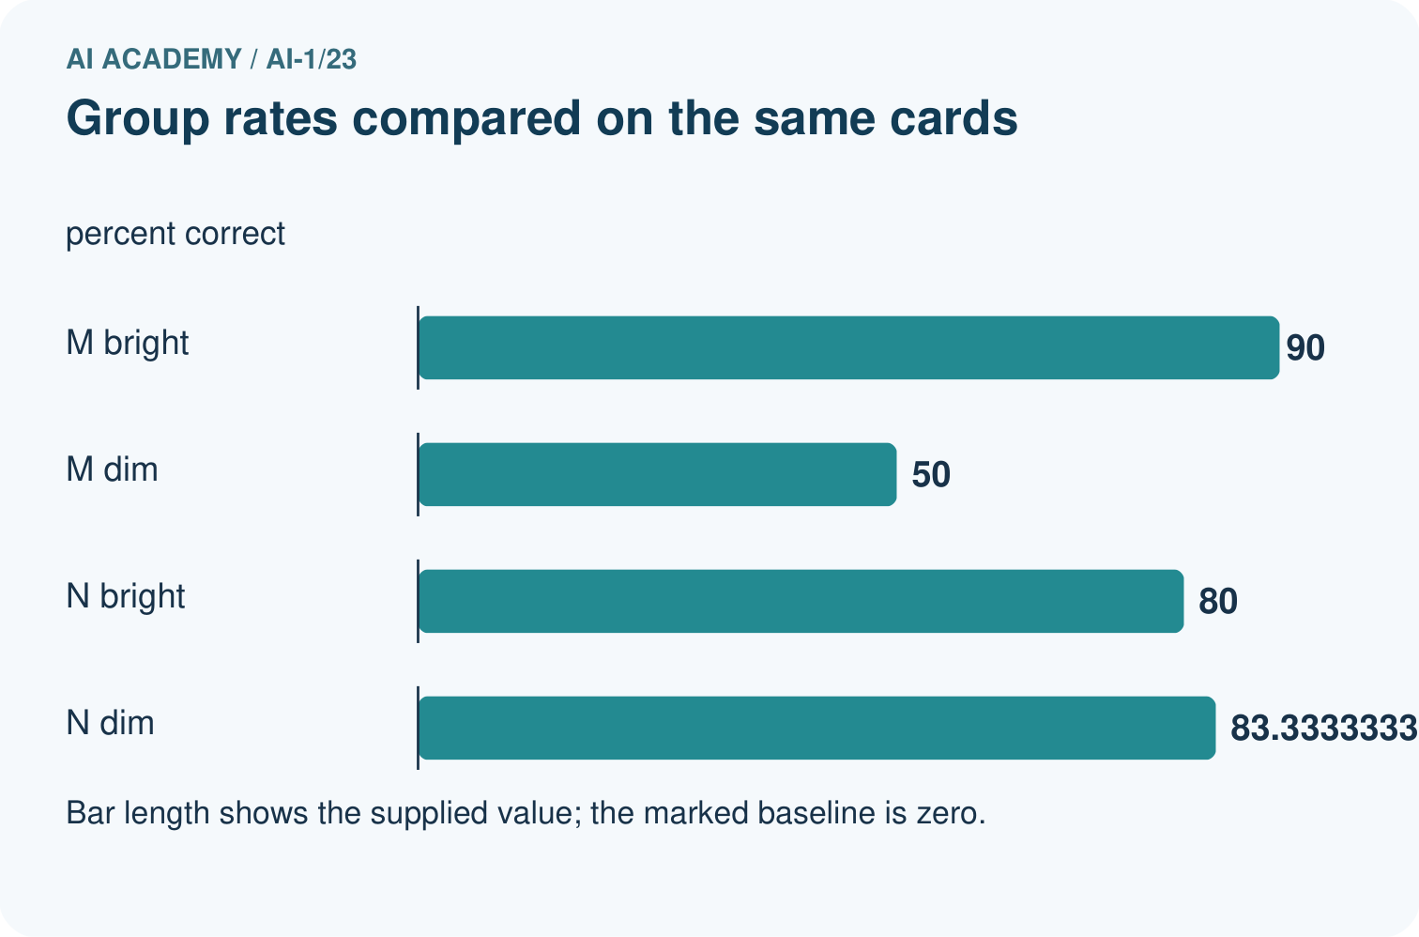
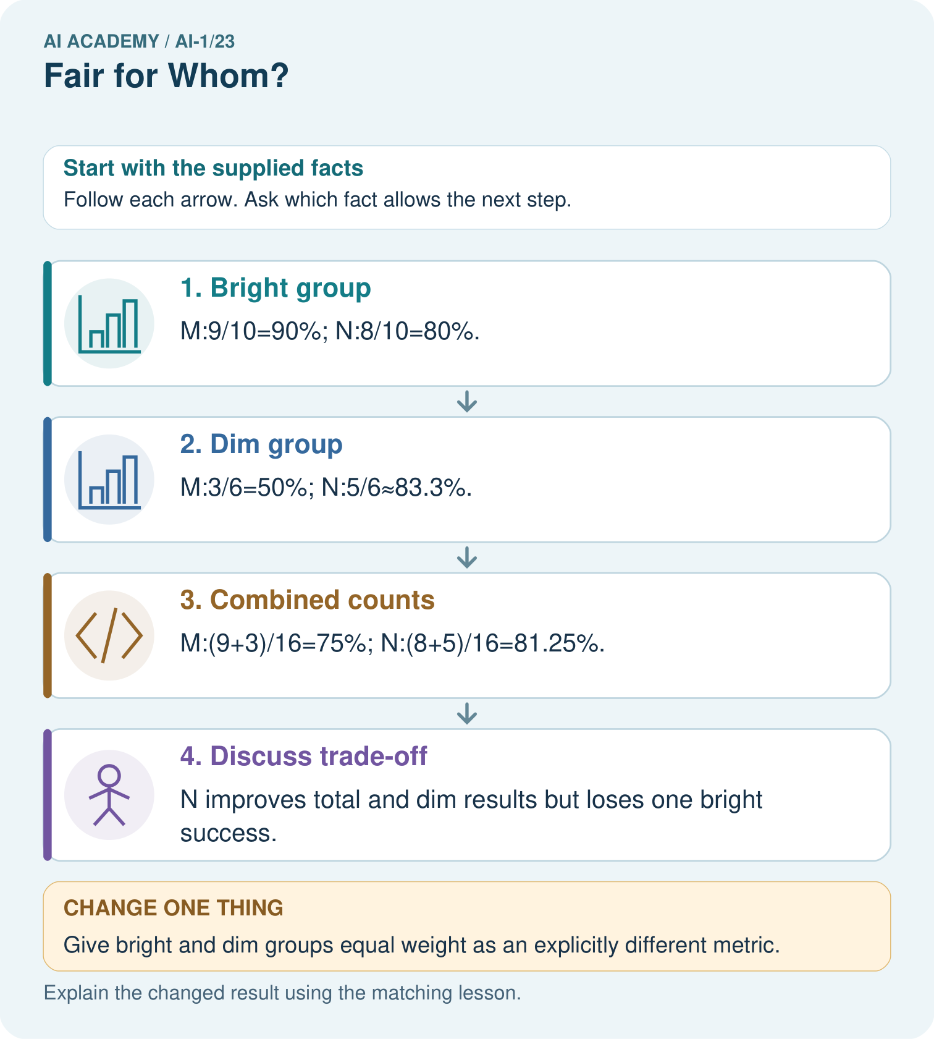
Which group loses performance under N, and can total improvement erase that fact?

My picture-based explanation and changed-case prediction
________________________________________________________________
________________________________________________________________
________________________________________________________________
________________________________________________________________
________________________________________________________________
________________________________________________________________
Support used: alone / hint / worked example. This record is practice evidence.
Project connection: Report sorter outcomes by relevant conditions and record whose failures matter when choosing a revision.

19. Project portfolio milestone
Project: Helpful Classroom Sorter
Current milestone: Evaluate and revise. Compare with your starting method, explain errors and record a justified revision.
Report sorter outcomes by relevant conditions and record whose failures matter when choosing a revision.
Evidence to keep | My record
This week’s input and deciding step
Prediction and actual result (or labelled paper trace)
One change since the previous checkpoint and why
One error or limit and the next test

Explain what this week adds to your project. Reuse last week’s record rather than starting again.
________________________________________________________________
________________________________________________________________
________________________________________________________________
________________________________________________________________
________________________________________________________________

20. Supported practice and learning evidence
Use this supported practice once, in the browser or on paper. Keep the reserved independent assessment for a separate first attempt before teacher feedback.
A fictional badge reader is evaluated on bright and dim cards with known reference labels.

Practice 1: explain the deciding evidence
Which labelled step matches this detail? N improves total and dim results but loses one bright success.
1. Dim group
2. Combined counts
3. Bright group
4. Discuss trade-off

My selected conclusion, deciding fact and explanation
________________________________________________________________
________________________________________________________________
________________________________________________________________
________________________________________________________________
________________________________________________________________
Hint if needed: Read the steps in the pictorial case. Match the supplied detail to the stage that performs or records it.
After your attempt, compare with the supported explanation: Discuss trade-off N improves total and dim results but loses one bright success. Adding correct counts and denominators weights each tested card once. Averaging 90% and 50% would incorrectly give unequal groups equal size in the all-card rate. The group breakdown reveals a trade-off hidden by the total. Decide what matters with the relevant users rather than announcing that one number proves fairness.

Practice 2: explain the deciding evidence
Changed-case practice: Give bright and dim groups equal weight as an explicitly different metric. Which conclusion is supported by the supplied facts?
1. We can decide the result without examining the changed input or the procedure.
2. This one example guarantees correct results for every future input.
3. M scores 70%; N scores about 81.7%.

My selected conclusion, deciding fact and explanation
________________________________________________________________
________________________________________________________________
________________________________________________________________
________________________________________________________________
________________________________________________________________
Hint if needed: Use the changed condition and the deciding step in the pictorial trace. The answer must say what follows from those facts.
After your attempt, compare with the supported explanation: M scores 70%; N scores about 81.7%. This averages group rates and is not the original 16-card agreement rate.

Repair a missing building block
Review Missing and Unbalanced Examples (ai-1/22). Goal: Name the target collection, selection list and cases actually assessed. Short practice: Would testing only dim plain cards close every current gap? Point to the target groups.. Return to this week and explain what you changed.
Review Recommendations (ai-1/20). Goal: Apply eligibility requirements before ranking candidates by preferences. Short practice: Why does the recommendation change without changing anyone’s preferences?. Return to this week and explain what you changed.
Review Prediction Is Not Fact (ai-1/17). Goal: Separate a recorded prediction from the observation used to check it. Short practice: Which field changes the observation label, and which field changes the model prediction?. Return to this week and explain what you changed.

Keep your completed work
Use Download completed work in the hosted lesson to export your answers, reflections, practice feedback and code-run evidence. Open the HTML copy to read or print it. Drafts stay in this browser when storage is available; clear drafts on a shared device.

What I repaired, the evidence I kept and the next test
________________________________________________________________
________________________________________________________________
________________________________________________________________
________________________________________________________________
________________________________________________________________

