AI ACADEMY · WORKBOOK · ai-1/26

Prompts Are Design Instructions
Project: Helpful Classroom Sorter

01. Recall and choose your starting point
Try the recall before opening notes. Then use a different colour or a labelled second line to correct your explanation.

Generate, Retrieve, or Calculate?
Without opening the old lesson, explain one key idea from Generate, Retrieve, or Calculate?. Give an example and a mistake that the idea helps you avoid.

My remembered idea, example and correction
________________________________________________________________
________________________________________________________________
________________________________________________________________

Fair for Whom?
Without opening the old lesson, explain one key idea from Fair for Whom?. Give an example and a mistake that the idea helps you avoid.

My remembered idea, example and correction
________________________________________________________________
________________________________________________________________
________________________________________________________________

Recommendations
Without opening the old lesson, explain one key idea from Recommendations. Give an example and a mistake that the idea helps you avoid.

My remembered idea, example and correction
________________________________________________________________
________________________________________________________________
________________________________________________________________

02. Practise with fading help
Use W2: Score a response by separate criteria for Specifying and testing prompts. Record the answer once; the lesson and workbook refer to the same attempt.
Given inputs | Procedure I chose | Middle steps | Result and check

The step I completed without help, and the hint I needed
________________________________________________________________
________________________________________________________________
________________________________________________________________

03. Individual reasoning check
Use the worked case for Specifying and testing prompts. Proposed explanation: “A tidy response is a correct response”. Decide whether this explanation is supported. Point to the step or supplied fact that decides; explain your repair if needed.

My explanation before partner discussion
________________________________________________________________
________________________________________________________________
________________________________________________________________
________________________________________________________________

04. Independent transfer case

Independent case: Specify and test a new exhibit card
Fictional record X says an exhibit is called Shadow Pairs and is in Hall 2; no opening time is given. Write a complete prompt for a Grade 6 card with exactly three labelled lines: Title, Location, Opening. Limit facts to supplied records, define missing and conflicting values and prohibit added claims. Give two test inputs and expected outputs: original X, then X with an opening time of 10 am added.

My independent explanation, trace and limits
________________________________________________________________
________________________________________________________________
________________________________________________________________
________________________________________________________________
________________________________________________________________
________________________________________________________________
________________________________________________________________
Attempt this case before feedback. Record any help. Earlier examples below are further practice; a case already practised with feedback cannot establish fresh transfer.

05. Your learning target
Write a request for a three-bullet explanation of evaporation for Grade 6 using only a supplied paragraph. Create three separately checkable acceptance criteria. What should happen if the paragraph does not explain evaporation?

06. Solve the given case
The prompt says make it good; the desired output is a four-line rain poem using simple words.
Write a checkable prompt.
Show your trace, calculation or evidence

Write or draw your reasoning and evidence.
________________________________________________________________
________________________________________________________________
________________________________________________________________
________________________________________________________________
________________________________________________________________

07. Check a changed case
Improve this prompt: tell me about space. Specify a reader, a focused task and an output format suitable for a young learner.
My independent answer and reason

Write or draw your reasoning and evidence.
________________________________________________________________
________________________________________________________________
________________________________________________________________
________________________________________________________________
________________________________________________________________

Week 26 Test and reflect

08. Design a revealing test
Create a changed input, boundary case or missing-information case. Write the expected answer or safe response before testing.
Test record | My evidence
Changed input or condition
Expected answer or fallback
Observed result
Why the result occurred

09. Project checkpoint
Write a transparent instruction for any generative explanation in the sorter and forbid invented item facts.
The project change and evidence I will keep

Write or draw your reasoning and evidence.
________________________________________________________________
________________________________________________________________
________________________________________________________________
________________________________________________________________
________________________________________________________________

10. Self check
I can explain the mechanism. I can show evidence. I can handle a changed case. I can name a limit. Mark each as not yet, with help or independently, and attach supporting work.
Teacher review ____________________ Next step ____________________

11. Transfer practice from the original programme
Write a request for a three-bullet explanation of evaporation for Grade 6 using only a supplied paragraph. Create three separately checkable acceptance criteria. What should happen if the paragraph does not explain evaporation?

My independently reasoned answer
________________________________________________________________
________________________________________________________________
________________________________________________________________
________________________________________________________________
________________________________________________________________
________________________________________________________________
________________________________________________________________
Record support used: none, hint or teacher explanation.

12. W1 Find what the vague request leaves open
The request says “Write something good about our club.” Name four decisions it leaves open. Then explain how source C, the Grade 6 audience and four labelled lines make the task easier to check.

My reasoning and evidence
________________________________________________________________
________________________________________________________________
________________________________________________________________
________________________________________________________________
________________________________________________________________
________________________________________________________________

13. W2 Score a response by separate criteria
For original C, a card gives four correctly labelled lines but says Time: 3 pm. All other values match C. State which format and evidence checks pass or fail. Is the card acceptable overall? Explain.

My reasoning and evidence
________________________________________________________________
________________________________________________________________
________________________________________________________________
________________________________________________________________
________________________________________________________________
________________________________________________________________

14. W3 Handle disagreement without choosing a favourite
C gives Room 7 and D gives Room 9 for the same club event, with no replacement or priority stated. Both agree on Monday and paper, and neither gives a time. Under P2, write the four output values and explain why the room cannot be selected from confidence or wording alone.

My reasoning and evidence
________________________________________________________________
________________________________________________________________
________________________________________________________________
________________________________________________________________
________________________________________________________________
________________________________________________________________

15. W4 Specify and test a new exhibit card
Fictional record X says an exhibit is called Shadow Pairs and is in Hall 2; no opening time is given. Write a complete prompt for a Grade 6 card with exactly three labelled lines: Title, Location, Opening. Limit facts to supplied records, define missing and conflicting values and prohibit added claims. Give two test inputs and expected outputs: original X, then X with an opening time of 10 am added.

My reasoning and evidence
________________________________________________________________
________________________________________________________________
________________________________________________________________
________________________________________________________________
________________________________________________________________
________________________________________________________________
________________________________________________________________
________________________________________________________________

16. W5 Preserve the comparison evidence
A pupil tries P1 once and P2 five times, then compares the P1 response only with the best P2 response and declares P2 always reliable. Identify two problems and design a fairer small comparison. State a conclusion the evidence could support.

My reasoning and evidence
________________________________________________________________
________________________________________________________________
________________________________________________________________
________________________________________________________________
________________________________________________________________
________________________________________________________________

17. Feedback, return check and learning record
Evidence | My record
Worked alone / hint / model
First step I repaired and why
New case checked later; date and result
What I can now explain without notes
One remaining question
Revisit this idea with your teacher after a delay. Familiarity is different from explaining and using it on a changed case.

18. Pictorial case practice: Prompts Are Design Instructions
A fictional club needs a short exhibit card, without guesses.
Source A: exhibit Paper Birds, location Shelf 2. No duration appears.
Required output: two labelled lines, Exhibit and Duration; missing values must say not supplied.
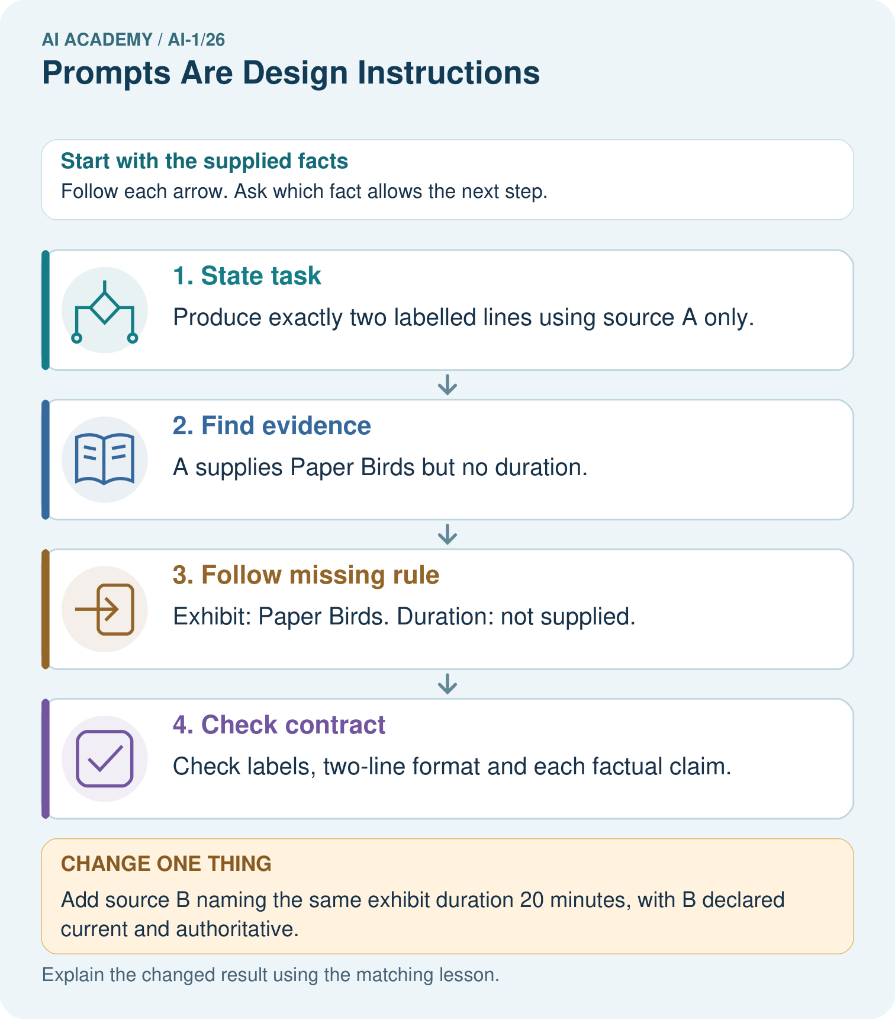
What must happen if B instead conflicts with another equally authoritative duration record?

My picture-based explanation and changed-case prediction
________________________________________________________________
________________________________________________________________
________________________________________________________________
________________________________________________________________
________________________________________________________________
________________________________________________________________
Support used: alone / hint / worked example. This record is practice evidence.
Project connection: Specify sorter input, output fields, evidence limits and missing/conflict behavior before improving its wording.

19. Project portfolio milestone
Project: Helpful Classroom Sorter
Current milestone: Prepare the demonstration. Gather reproducible instructions, evidence, access checks and remaining limitations.
Specify sorter input, output fields, evidence limits and missing/conflict behavior before improving its wording.
Evidence to keep | My record
This week’s input and deciding step
Prediction and actual result (or labelled paper trace)
One change since the previous checkpoint and why
One error or limit and the next test

Explain what this week adds to your project. Reuse last week’s record rather than starting again.
________________________________________________________________
________________________________________________________________
________________________________________________________________
________________________________________________________________
________________________________________________________________

20. Supported practice and learning evidence
Use this supported practice once, in the browser or on paper. Keep the reserved independent assessment for a separate first attempt before teacher feedback.
A fictional club needs a short exhibit card, without guesses.

Practice 1: explain the deciding evidence
Which labelled step matches this detail? Check labels, two-line format and each factual claim.
1. State task
2. Follow missing rule
3. Find evidence
4. Check contract

My selected conclusion, deciding fact and explanation
________________________________________________________________
________________________________________________________________
________________________________________________________________
________________________________________________________________
________________________________________________________________
Hint if needed: Read the steps in the pictorial case. Match the supplied detail to the stage that performs or records it.
After your attempt, compare with the supported explanation: Check contract Check labels, two-line format and each factual claim. A useful prompt describes both the wanted answer and what to do when evidence is insufficient. Asking for a duration does not create one. Examples can demonstrate the format, but they must not become sources of event facts. Check content support separately from whether the answer looks tidy.

Practice 2: explain the deciding evidence
Changed-case practice: Add source B naming the same exhibit duration 20 minutes, with B declared current and authoritative. Which conclusion is supported by the supplied facts?
1. We can decide the result without examining the changed input or the procedure.
2. This one example guarantees correct results for every future input.
3. Duration becomes 20 minutes.

My selected conclusion, deciding fact and explanation
________________________________________________________________
________________________________________________________________
________________________________________________________________
________________________________________________________________
________________________________________________________________
Hint if needed: Use the changed condition and the deciding step in the pictorial trace. The answer must say what follows from those facts.
After your attempt, compare with the supported explanation: Duration becomes 20 minutes. There is now an authorised source for the previously missing field.

Repair a missing building block
Review Generate, Retrieve, or Calculate? (ai-1/25). Goal: Distinguish retrieving a record, calculating from inputs and generating wording. Short practice: Label each arrow with its operation. Can the system add snacks because invitations often mention them?. Return to this week and explain what you changed.
Review Fair for Whom? (ai-1/23). Goal: Compute a correct-out-of-assessed fraction and explain its denominator. Short practice: Which group loses performance under N, and can total improvement erase that fact?. Return to this week and explain what you changed.
Review Recommendations (ai-1/20). Goal: Apply eligibility requirements before ranking candidates by preferences. Short practice: Why does the recommendation change without changing anyone’s preferences?. Return to this week and explain what you changed.

Keep your completed work
Use Download completed work in the hosted lesson to export your answers, reflections, practice feedback and code-run evidence. Open the HTML copy to read or print it. Drafts stay in this browser when storage is available; clear drafts on a shared device.

What I repaired, the evidence I kept and the next test
________________________________________________________________
________________________________________________________________
________________________________________________________________
________________________________________________________________
________________________________________________________________

