AI ACADEMY · WORKBOOK · ai-1/28

Humans Set Boundaries
Project: Helpful Classroom Sorter

01. Recall and choose your starting point
Try the recall before opening notes. Then use a different colour or a labelled second line to correct your explanation.

Verify Important Outputs
Without opening the old lesson, explain one key idea from Verify Important Outputs. Give an example and a mistake that the idea helps you avoid.

My remembered idea, example and correction
________________________________________________________________
________________________________________________________________
________________________________________________________________

Generate, Retrieve, or Calculate?
Without opening the old lesson, explain one key idea from Generate, Retrieve, or Calculate?. Give an example and a mistake that the idea helps you avoid.

My remembered idea, example and correction
________________________________________________________________
________________________________________________________________
________________________________________________________________

Missing and Unbalanced Examples
Without opening the old lesson, explain one key idea from Missing and Unbalanced Examples. Give an example and a mistake that the idea helps you avoid.

My remembered idea, example and correction
________________________________________________________________
________________________________________________________________
________________________________________________________________

02. Practise with fading help
Use W2: Read an approval without enlarging it for Human authority and permission. Record the answer once; the lesson and workbook refer to the same attempt.
Given inputs | Procedure I chose | Middle steps | Result and check

The step I completed without help, and the hint I needed
________________________________________________________________
________________________________________________________________
________________________________________________________________

03. Individual reasoning check
Use the worked case for Human authority and permission. Proposed explanation: “A working button grants permission”. Decide whether this explanation is supported. Point to the step or supplied fact that decides; explain your repair if needed.

My explanation before partner discussion
________________________________________________________________
________________________________________________________________
________________________________________________________________
________________________________________________________________

04. Independent transfer case

Independent case: Transfer the permission check to a new case
In a fictional library, the librarian controls the internal shelf list. The librarian tells assistant Jo: “Replace the internal list with checked version L2 on Friday, once. Do not change the public catalogue.” It is Friday, L2 remains checked, and no replacement has occurred. A tool offers both destinations. Assess these proposals separately: Jo replaces the internal list with L2; Jo updates the public catalogue with L2; visitor Sam replaces the internal list with L2; Jo replaces the internal list with a changed L3. Identify the approval detail that settles each case.

My independent explanation, trace and limits
________________________________________________________________
________________________________________________________________
________________________________________________________________
________________________________________________________________
________________________________________________________________
________________________________________________________________
________________________________________________________________
Attempt this case before feedback. Record any help. Earlier examples below are further practice; a case already practised with feedback cannot establish fresh transfer.

05. Your learning target
A classroom assistant may draft a reminder but cannot send messages. It displays a completed draft and waits. A student writes 'looks good' without a destination. Has a clear send authorisation been given? Specify what is needed.

06. Solve the given case
An assistant may suggest object locations; a teacher must approve moving valuable equipment.
What may happen without approval?
Show your trace, calculation or evidence

Write or draw your reasoning and evidence.
________________________________________________________________
________________________________________________________________
________________________________________________________________
________________________________________________________________
________________________________________________________________

07. Check a changed case
A sorter marks a child's notebook throw away. Who should decide whether it is discarded? Name a boundary the system should enforce.
My independent answer and reason

Write or draw your reasoning and evidence.
________________________________________________________________
________________________________________________________________
________________________________________________________________
________________________________________________________________
________________________________________________________________

Week 28 Test and reflect

08. Design a revealing test
Create a changed input, boundary case or missing-information case. Write the expected answer or safe response before testing.
Test record | My evidence
Changed input or condition
Expected answer or fallback
Observed result
Why the result occurred

09. Project checkpoint
Complete the sorter's human-control map: permissions, review triggers, override, correction, and stop conditions.
The project change and evidence I will keep

Write or draw your reasoning and evidence.
________________________________________________________________
________________________________________________________________
________________________________________________________________
________________________________________________________________
________________________________________________________________

10. Self check
I can explain the mechanism. I can show evidence. I can handle a changed case. I can name a limit. Mark each as not yet, with help or independently, and attach supporting work.
Teacher review ____________________ Next step ____________________

11. Transfer practice from the original programme
A classroom assistant may draft a reminder but cannot send messages. It displays a completed draft and waits. A student writes 'looks good' without a destination. Has a clear send authorisation been given? Specify what is needed.

My independently reasoned answer
________________________________________________________________
________________________________________________________________
________________________________________________________________
________________________________________________________________
________________________________________________________________
________________________________________________________________
________________________________________________________________
Record support used: none, hint or teacher explanation.

12. W1 Separate three kinds of evidence
A tool offers a Public website button. The exhibition facts in A have been verified. The teacher’s approval covers the classroom board only. State what the button, the fact check and the approval each establish. Decide whether the editor may publish A publicly.

My reasoning and evidence
________________________________________________________________
________________________________________________________________
________________________________________________________________
________________________________________________________________
________________________________________________________________
________________________________________________________________

13. W2 Read an approval without enlarging it
List the decision maker, allowed actor, version, destination, timing and number of postings in the original exhibition approval. Before any posting and with no changes to the facts or permission, explain whether the editor can carry out that exact action without asking again.

My reasoning and evidence
________________________________________________________________
________________________________________________________________
________________________________________________________________
________________________________________________________________
________________________________________________________________
________________________________________________________________

14. W3 Prepare a reviewable change
The room changes to Room 8 and the editor creates B. Explain why publishing old A and publishing unapproved B each fail a different check. Write a specific request for the teacher to review B, keeping the original destination and one-posting limit.

My reasoning and evidence
________________________________________________________________
________________________________________________________________
________________________________________________________________
________________________________________________________________
________________________________________________________________
________________________________________________________________

15. W4 Transfer the permission check to a new case
In a fictional library, the librarian controls the internal shelf list. The librarian tells assistant Jo: “Replace the internal list with checked version L2 on Friday, once. Do not change the public catalogue.” It is Friday, L2 remains checked, and no replacement has occurred. A tool offers both destinations. Assess these proposals separately: Jo replaces the internal list with L2; Jo updates the public catalogue with L2; visitor Sam replaces the internal list with L2; Jo replaces the internal list with a changed L3. Identify the approval detail that settles each case.

My reasoning and evidence
________________________________________________________________
________________________________________________________________
________________________________________________________________
________________________________________________________________
________________________________________________________________
________________________________________________________________
________________________________________________________________
________________________________________________________________

16. W5 Avoid an accidental second action
Jo attempts the permitted internal replacement, but the tool’s response does not show whether it succeeded. Explain why immediately repeating it is a poor choice under a once-only approval. What should Jo check? If Jo discovers a public change occurred instead, describe the first recovery steps.

My reasoning and evidence
________________________________________________________________
________________________________________________________________
________________________________________________________________
________________________________________________________________
________________________________________________________________
________________________________________________________________

17. Feedback, return check and learning record
Evidence | My record
Worked alone / hint / model
First step I repaired and why
New case checked later; date and result
What I can now explain without notes
One remaining question
Revisit this idea with your teacher after a delay. Familiarity is different from explaining and using it on a changed case.

18. Pictorial case practice: Humans Set Boundaries
A fictional teacher approves one checked classroom poster for internal display.
Approval: publish exactly poster P2 on the classroom noticeboard today, once.
Assistant proposes P2 there; P3 there after an edit; P2 on a public website.
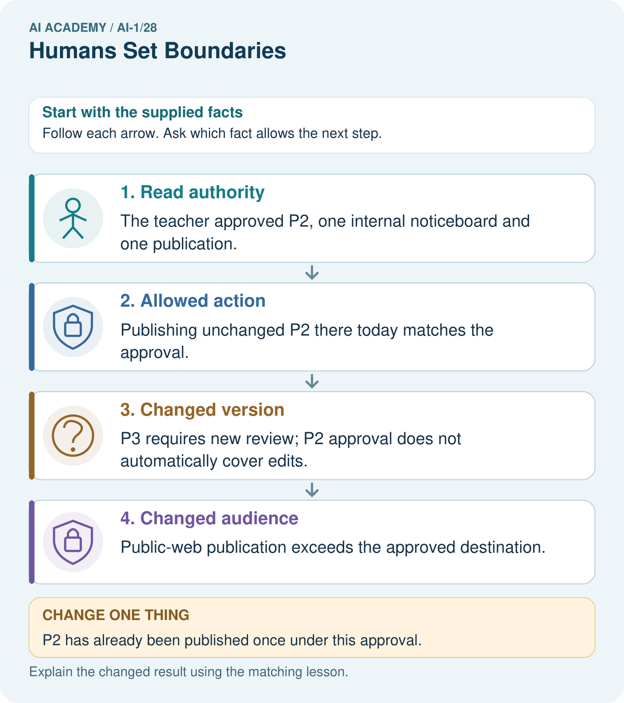
Which original proposal is authorised? Why do the other two need separate approval?

My picture-based explanation and changed-case prediction
________________________________________________________________
________________________________________________________________
________________________________________________________________
________________________________________________________________
________________________________________________________________
________________________________________________________________
Support used: alone / hint / worked example. This record is practice evidence.
Project connection: Record sorter actions allowed automatically and actions requiring the classroom owner’s explicit review.

19. Project portfolio milestone
Project: Helpful Classroom Sorter
Current milestone: Prepare the demonstration. Gather reproducible instructions, evidence, access checks and remaining limitations.
Record sorter actions allowed automatically and actions requiring the classroom owner’s explicit review.
Evidence to keep | My record
This week’s input and deciding step
Prediction and actual result (or labelled paper trace)
One change since the previous checkpoint and why
One error or limit and the next test

Explain what this week adds to your project. Reuse last week’s record rather than starting again.
________________________________________________________________
________________________________________________________________
________________________________________________________________
________________________________________________________________
________________________________________________________________

20. Supported practice and learning evidence
Use this supported practice once, in the browser or on paper. Keep the reserved independent assessment for a separate first attempt before teacher feedback.
A fictional teacher approves one checked classroom poster for internal display.

Practice 1: explain the deciding evidence
Which labelled step matches this detail? Public-web publication exceeds the approved destination.
1. Allowed action
2. Changed audience
3. Read authority
4. Changed version

My selected conclusion, deciding fact and explanation
________________________________________________________________
________________________________________________________________
________________________________________________________________
________________________________________________________________
________________________________________________________________
Hint if needed: Read the steps in the pictorial case. Match the supplied detail to the stage that performs or records it.
After your attempt, compare with the supported explanation: Changed audience Public-web publication exceeds the approved destination. A general intention to help the class does not grant every action that might help. Check the version, destination and time explicitly. An edit may improve accuracy while still changing the approved artifact. The assistant should hold the changed poster for review rather than treating its own confidence as permission.

Practice 2: explain the deciding evidence
Changed-case practice: P2 has already been published once under this approval. Which conclusion is supported by the supplied facts?
1. We can decide the result without examining the changed input or the procedure.
2. A second publication is not covered.
3. This one example guarantees correct results for every future input.

My selected conclusion, deciding fact and explanation
________________________________________________________________
________________________________________________________________
________________________________________________________________
________________________________________________________________
________________________________________________________________
Hint if needed: Use the changed condition and the deciding step in the pictorial trace. The answer must say what follows from those facts.
After your attempt, compare with the supported explanation: A second publication is not covered. The instruction allowed a single use, not repeated actions.

Repair a missing building block
Review Verify Important Outputs (ai-1/27). Goal: Separate an answer into claims and connect each claim to relevant evidence. Short practice: Correct the draft and identify which part needs another source rather than a calculation.. Return to this week and explain what you changed.
Review Generate, Retrieve, or Calculate? (ai-1/25). Goal: Distinguish retrieving a record, calculating from inputs and generating wording. Short practice: Label each arrow with its operation. Can the system add snacks because invitations often mention them?. Return to this week and explain what you changed.
Review Missing and Unbalanced Examples (ai-1/22). Goal: Name the target collection, selection list and cases actually assessed. Short practice: Would testing only dim plain cards close every current gap? Point to the target groups.. Return to this week and explain what you changed.

Keep your completed work
Use Download completed work in the hosted lesson to export your answers, reflections, practice feedback and code-run evidence. Open the HTML copy to read or print it. Drafts stay in this browser when storage is available; clear drafts on a shared device.

What I repaired, the evidence I kept and the next test
________________________________________________________________
________________________________________________________________
________________________________________________________________
________________________________________________________________
________________________________________________________________

