AI ACADEMY · WORKBOOK · ai-1/31

Design the Decision Process
Project: Helpful Classroom Sorter

01. Recall and choose your starting point
Try the recall before opening notes. Then use a different colour or a labelled second line to correct your explanation.

Choose Inputs and Outputs
Without opening the old lesson, explain one key idea from Choose Inputs and Outputs. Give an example and a mistake that the idea helps you avoid.

My remembered idea, example and correction
________________________________________________________________
________________________________________________________________
________________________________________________________________

Humans Set Boundaries
Without opening the old lesson, explain one key idea from Humans Set Boundaries. Give an example and a mistake that the idea helps you avoid.

My remembered idea, example and correction
________________________________________________________________
________________________________________________________________
________________________________________________________________

Generate, Retrieve, or Calculate?
Without opening the old lesson, explain one key idea from Generate, Retrieve, or Calculate?. Give an example and a mistake that the idea helps you avoid.

My remembered idea, example and correction
________________________________________________________________
________________________________________________________________
________________________________________________________________

02. Practise with fading help
Use W2: Track the current candidate for Designing a complete decision process. Record the answer once; the lesson and workbook refer to the same attempt.
Given inputs | Procedure I chose | Middle steps | Result and check

The step I completed without help, and the hint I needed
________________________________________________________________
________________________________________________________________
________________________________________________________________

03. Individual reasoning check
Use the worked case for Designing a complete decision process. Proposed explanation: “One failed row proves no match”. Decide whether this explanation is supported. Point to the step or supplied fact that decides; explain your repair if needed.

My explanation before partner discussion
________________________________________________________________
________________________________________________________________
________________________________________________________________
________________________________________________________________

04. Independent transfer case

Independent case: Design a complete room decision process
A new paper catalogue lists C1 first, capacity 4, quiet Yes; C2 second, capacity 8, quiet No. Valid requests give a whole group size from 1 to 10 and Quiet required Yes or No. A room fits if capacity is at least group size and the quiet condition is met; choose the first fit. Write a complete process with validation, search, state change and stopping rules. Trace 6 people No and explain the outcome for a blank quiet field. No booking takes place.

My independent explanation, trace and limits
________________________________________________________________
________________________________________________________________
________________________________________________________________
________________________________________________________________
________________________________________________________________
________________________________________________________________
________________________________________________________________
Attempt this case before feedback. Record any help. Earlier examples below are further practice; a case already practised with feedback cannot establish fresh transfer.

05. Your learning target
Rule: if paper then P, otherwise M. Inputs are paper, metal, glass and unknown. Repair the rule for paper and metal trays without inventing a glass tray. Trace all four inputs.

06. Solve the given case
A rule sends paper to P and everything else to M. Inputs include paper, metal and glass.
Trace glass and repair the rule.
Show your trace, calculation or evidence

Write or draw your reasoning and evidence.
________________________________________________________________
________________________________________________________________
________________________________________________________________
________________________________________________________________
________________________________________________________________

07. Check a changed case
Write a decision process: a clear pencil goes to the pencil tray, a clear book to the shelf, and an unknown object to review. Trace a lunch box.
My independent answer and reason

Write or draw your reasoning and evidence.
________________________________________________________________
________________________________________________________________
________________________________________________________________
________________________________________________________________
________________________________________________________________

Week 31 Test and reflect

08. Design a revealing test
Create a changed input, boundary case or missing-information case. Write the expected answer or safe response before testing.
Test record | My evidence
Changed input or condition
Expected answer or fallback
Observed result
Why the result occurred

09. Project checkpoint
Complete the sorter v1 decision flow and annotate every branch with the evidence it uses.
The project change and evidence I will keep

Write or draw your reasoning and evidence.
________________________________________________________________
________________________________________________________________
________________________________________________________________
________________________________________________________________
________________________________________________________________

10. Self check
I can explain the mechanism. I can show evidence. I can handle a changed case. I can name a limit. Mark each as not yet, with help or independently, and attach supporting work.
Teacher review ____________________ Next step ____________________

11. Transfer practice from the original programme
Rule: if paper then P, otherwise M. Inputs are paper, metal, glass and unknown. Repair the rule for paper and metal trays without inventing a glass tray. Trace all four inputs.

My independently reasoned answer
________________________________________________________________
________________________________________________________________
________________________________________________________________
________________________________________________________________
________________________________________________________________
________________________________________________________________
________________________________________________________________
Record support used: none, hint or teacher explanation.

12. W1 Describe all possible kinds of ending
Name the three kinds of final output in the activity process and the condition that leads to each. Explain why a candidate failing its time check is not automatically a final no-match result.

My reasoning and evidence
________________________________________________________________
________________________________________________________________
________________________________________________________________
________________________________________________________________
________________________________________________________________
________________________________________________________________

13. W2 Track the current candidate
Trace 9 minutes with Quiet required No. Record the current candidate, time result, quiet condition and next step until the process stops. Explain why the request values should not change as the candidate advances.

My reasoning and evidence
________________________________________________________________
________________________________________________________________
________________________________________________________________
________________________________________________________________
________________________________________________________________
________________________________________________________________

14. W3 Repair an incorrect branch
A design says “If the activity is quiet OR its time fits, suggest it.” For 5 minutes with Quiet required Yes it selects B1. Identify the failed requirement and replace the condition with a correct one. Give the correct result for this request.

My reasoning and evidence
________________________________________________________________
________________________________________________________________
________________________________________________________________
________________________________________________________________
________________________________________________________________
________________________________________________________________

15. W4 Design a complete room decision process
A new paper catalogue lists C1 first, capacity 4, quiet Yes; C2 second, capacity 8, quiet No. Valid requests give a whole group size from 1 to 10 and Quiet required Yes or No. A room fits if capacity is at least group size and the quiet condition is met; choose the first fit. Write a complete process with validation, search, state change and stopping rules. Trace 6 people No and explain the outcome for a blank quiet field. No booking takes place.

My reasoning and evidence
________________________________________________________________
________________________________________________________________
________________________________________________________________
________________________________________________________________
________________________________________________________________
________________________________________________________________
________________________________________________________________
________________________________________________________________

16. W5 Preserve the first compatible option
For the activity catalogue, 15 minutes with Quiet required No allows several activities. Explain why returning the last compatible row breaks the agreed rule even though it fits. Describe a stopping rule that preserves the first match, and one way to check that a loop cannot repeat forever.

My reasoning and evidence
________________________________________________________________
________________________________________________________________
________________________________________________________________
________________________________________________________________
________________________________________________________________
________________________________________________________________

17. Feedback, return check and learning record
Evidence | My record
Worked alone / hint / model
First step I repaired and why
New case checked later; date and result
What I can now explain without notes
One remaining question
Revisit this idea with your teacher after a delay. Familiarity is different from explaining and using it on a changed case.

18. Pictorial case practice: Design the Decision Process
A fictional worksheet routes craft kits by required glue and number of scissors.
K1: glue No, scissors 2. K2: glue Yes, scissors 2. K3: glue Yes, scissors 4.
Request: glue required Yes, scissors needed 2. Return first kit meeting both requirements.
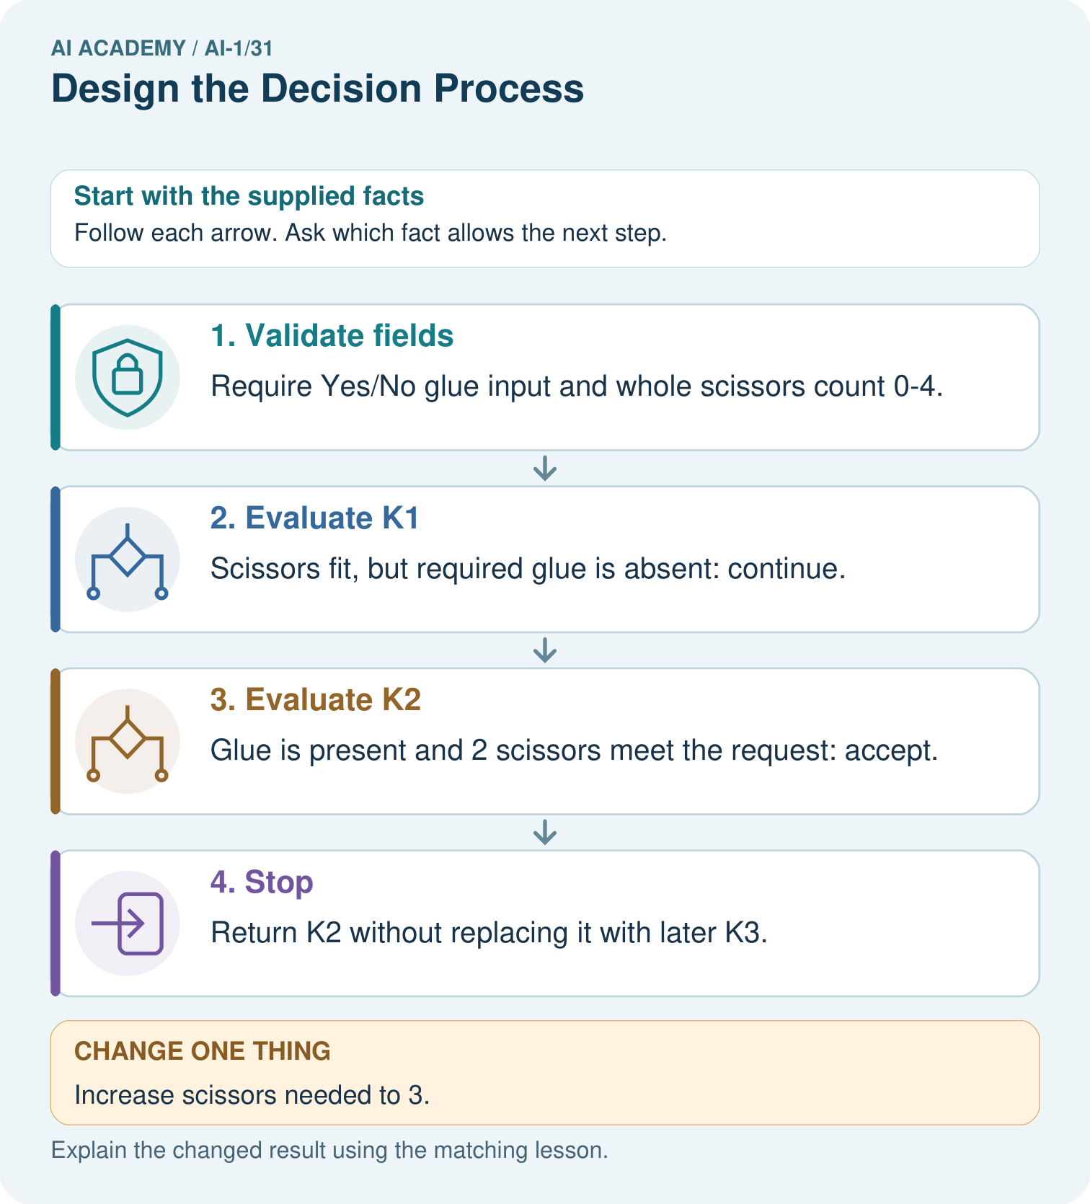
Where does the first original rejection occur, and why is K3 not originally selected?

My picture-based explanation and changed-case prediction
________________________________________________________________
________________________________________________________________
________________________________________________________________
________________________________________________________________
________________________________________________________________
________________________________________________________________
Support used: alone / hint / worked example. This record is practice evidence.
Project connection: Draw the sorter’s decision branches, loop-back arrows, final outputs and invalid-input path so every valid case can terminate.

19. Project portfolio milestone
Project: Helpful Classroom Sorter
Current milestone: Present and defend. Demonstrate the system, explain one failure and justify the next improvement with evidence.
Draw the sorter’s decision branches, loop-back arrows, final outputs and invalid-input path so every valid case can terminate.
Evidence to keep | My record
This week’s input and deciding step
Prediction and actual result (or labelled paper trace)
One change since the previous checkpoint and why
One error or limit and the next test

Explain what this week adds to your project. Reuse last week’s record rather than starting again.
________________________________________________________________
________________________________________________________________
________________________________________________________________
________________________________________________________________
________________________________________________________________

20. Supported practice and learning evidence
Use this supported practice once, in the browser or on paper. Keep the reserved independent assessment for a separate first attempt before teacher feedback.
A fictional worksheet routes craft kits by required glue and number of scissors.

Practice 1: explain the deciding evidence
Which labelled step matches this detail? Return K2 without replacing it with later K3.
1. Stop
2. Evaluate K1
3. Evaluate K2
4. Validate fields

My selected conclusion, deciding fact and explanation
________________________________________________________________
________________________________________________________________
________________________________________________________________
________________________________________________________________
________________________________________________________________
Hint if needed: Read the steps in the pictorial case. Match the supplied detail to the stage that performs or records it.
After your attempt, compare with the supported explanation: Stop Return K2 without replacing it with later K3. A complete decision process specifies what to do after each result. One passing requirement is insufficient. After a kit passes both, stopping preserves the first-match contract; automatically choosing the largest later kit would implement a different rule. A full scan with no accepted kit returns no match.

Practice 2: explain the deciding evidence
Changed-case practice: Increase scissors needed to 3. Which conclusion is supported by the supplied facts?
1. K3 is selected.
2. We can decide the result without examining the changed input or the procedure.
3. This one example guarantees correct results for every future input.

My selected conclusion, deciding fact and explanation
________________________________________________________________
________________________________________________________________
________________________________________________________________
________________________________________________________________
________________________________________________________________
Hint if needed: Use the changed condition and the deciding step in the pictorial trace. The answer must say what follows from those facts.
After your attempt, compare with the supported explanation: K3 is selected. K1 lacks glue; K2 has only 2 scissors; K3 has glue and 4.

Repair a missing building block
Review Choose Inputs and Outputs (ai-1/30). Goal: Turn the project outcome into precise input and output requirements. Short practice: Trace requests 10 and blank. Why should they not receive the same explanation?. Return to this week and explain what you changed.
Review Humans Set Boundaries (ai-1/28). Goal: Distinguish a system’s capability, the correctness of its output and permission to take an action. Short practice: Which original proposal is authorised? Why do the other two need separate approval?. Return to this week and explain what you changed.
Review Generate, Retrieve, or Calculate? (ai-1/25). Goal: Distinguish retrieving a record, calculating from inputs and generating wording. Short practice: Label each arrow with its operation. Can the system add snacks because invitations often mention them?. Return to this week and explain what you changed.

Keep your completed work
Use Download completed work in the hosted lesson to export your answers, reflections, practice feedback and code-run evidence. Open the HTML copy to read or print it. Drafts stay in this browser when storage is available; clear drafts on a shared device.

What I repaired, the evidence I kept and the next test
________________________________________________________________
________________________________________________________________
________________________________________________________________
________________________________________________________________
________________________________________________________________

