AI ACADEMY · WORKBOOK · ai-1/34

Test Edge Cases and Fairness
Project: Helpful Classroom Sorter

01. Recall and choose your starting point
Try the recall before opening notes. Then use a different colour or a labelled second line to correct your explanation.

Test Normal Cases
Without opening the old lesson, explain one key idea from Test Normal Cases. Give an example and a mistake that the idea helps you avoid.

My remembered idea, example and correction
________________________________________________________________
________________________________________________________________
________________________________________________________________

Design the Decision Process
Without opening the old lesson, explain one key idea from Design the Decision Process. Give an example and a mistake that the idea helps you avoid.

My remembered idea, example and correction
________________________________________________________________
________________________________________________________________
________________________________________________________________

Humans Set Boundaries
Without opening the old lesson, explain one key idea from Humans Set Boundaries. Give an example and a mistake that the idea helps you avoid.

My remembered idea, example and correction
________________________________________________________________
________________________________________________________________
________________________________________________________________

02. Practise with fading help
Use W2: Check the validation boundary for Testing boundaries and varied conditions. Record the answer once; the lesson and workbook refer to the same attempt.
Given inputs | Procedure I chose | Middle steps | Result and check

The step I completed without help, and the hint I needed
________________________________________________________________
________________________________________________________________
________________________________________________________________

03. Individual reasoning check
Use the worked case for Testing boundaries and varied conditions. Proposed explanation: “At the limit means outside the rule”. Decide whether this explanation is supported. Point to the step or supplied fact that decides; explain your repair if needed.

My explanation before partner discussion
________________________________________________________________
________________________________________________________________
________________________________________________________________
________________________________________________________________

04. Independent transfer case

Independent case: Find an independent capacity boundary
A new equipment selector lists E1 first, capacity 4; E2 second, capacity 8. Valid group size is a whole number from 1 to 10. Choose the first item whose capacity is at least the group size, or no match; invalid input needs clarification. A faulty version uses capacity strictly greater than group size. Independently give correct and faulty outputs for groups 3, 4 and 5, then for group 8. Explain the defect and give the correct response to group 0. No booking occurs.

My independent explanation, trace and limits
________________________________________________________________
________________________________________________________________
________________________________________________________________
________________________________________________________________
________________________________________________________________
________________________________________________________________
________________________________________________________________
Attempt this case before feedback. Record any help. Earlier examples below are further practice; a case already practised with feedback cannot establish fresh transfer.

05. Your learning target
Before testing, define outcomes for clean paper, metal foil, mixed packaging and an unreadable card. The team later changes mixed packaging's expected result to match its sorter. Explain the evaluation problem.

06. Solve the given case
A sorter handles clean paper but fails on crumpled paper and mixed packaging.
Design revealing tests.
Show your trace, calculation or evidence

Write or draw your reasoning and evidence.
________________________________________________________________
________________________________________________________________
________________________________________________________________
________________________________________________________________
________________________________________________________________

07. Check a changed case
A sorter works on clear photos. Test a blurred pencil, a dim book and an unfamiliar lunch box. What makes these useful tests?
My independent answer and reason

Write or draw your reasoning and evidence.
________________________________________________________________
________________________________________________________________
________________________________________________________________
________________________________________________________________
________________________________________________________________

Week 34 Test and reflect

08. Design a revealing test
Create a changed input, boundary case or missing-information case. Write the expected answer or safe response before testing.
Test record | My evidence
Changed input or condition
Expected answer or fallback
Observed result
Why the result occurred

09. Project checkpoint
Expand the sorter test suite with edge, missing-data, and fairness cases plus expected safe behavior.
The project change and evidence I will keep

Write or draw your reasoning and evidence.
________________________________________________________________
________________________________________________________________
________________________________________________________________
________________________________________________________________
________________________________________________________________

10. Self check
I can explain the mechanism. I can show evidence. I can handle a changed case. I can name a limit. Mark each as not yet, with help or independently, and attach supporting work.
Teacher review ____________________ Next step ____________________

11. Transfer practice from the original programme
Before testing, define outcomes for clean paper, metal foil, mixed packaging and an unreadable card. The team later changes mixed packaging's expected result to match its sorter. Explain the evaluation problem.

My independently reasoned answer
________________________________________________________________
________________________________________________________________
________________________________________________________________
________________________________________________________________
________________________________________________________________
________________________________________________________________
________________________________________________________________
Record support used: none, hint or teacher explanation.

12. W1 Plan the equality tests
For catalogue B version 1, write expected outputs and reasons for 9 Yes, 10 Yes and 11 Yes. Explain why keeping quiet and catalogue fixed helps examine the time boundary. Predict what the faulty strictly-less-than S comparison does for 10 Yes.

My reasoning and evidence
________________________________________________________________
________________________________________________________________
________________________________________________________________
________________________________________________________________
________________________________________________________________
________________________________________________________________

13. W2 Check the validation boundary
Classify these requests before searching: 0 Yes, 30 Yes, 31 Yes, blank minutes with Yes, 10.5 Yes, and 10 Maybe. Give each expected output or clarification and explain whether any candidate should be checked. Why must zero not be treated like a blank?

My reasoning and evidence
________________________________________________________________
________________________________________________________________
________________________________________________________________
________________________________________________________________
________________________________________________________________
________________________________________________________________

14. W3 Run a labelled catalogue variation
Copy B version 1 and change only B1’s duration to 20, labelling it B version 2. Write the expected result for 12 Yes, then run your saved P1 and the manual baseline on this copy. Record the actual traces separately. Explain why an answer checked against B version 1 would not be a fair judgement of this run.

My reasoning and evidence
________________________________________________________________
________________________________________________________________
________________________________________________________________
________________________________________________________________
________________________________________________________________
________________________________________________________________

15. W4 Find an independent capacity boundary
A new equipment selector lists E1 first, capacity 4; E2 second, capacity 8. Valid group size is a whole number from 1 to 10. Choose the first item whose capacity is at least the group size, or no match; invalid input needs clarification. A faulty version uses capacity strictly greater than group size. Independently give correct and faulty outputs for groups 3, 4 and 5, then for group 8. Explain the defect and give the correct response to group 0. No booking occurs.

My reasoning and evidence
________________________________________________________________
________________________________________________________________
________________________________________________________________
________________________________________________________________
________________________________________________________________
________________________________________________________________
________________________________________________________________
________________________________________________________________

16. W5 Audit what changed in the test
A team runs 15 No on B version 3, gets B4, but records “B version 1” and calls B4 correct. Explain the documentation error and the expected result under each catalogue. State what must stay the same in a fair prototype-versus-baseline comparison and why a test not yet run cannot be counted as a pass.

My reasoning and evidence
________________________________________________________________
________________________________________________________________
________________________________________________________________
________________________________________________________________
________________________________________________________________
________________________________________________________________

17. Feedback, return check and learning record
Evidence | My record
Worked alone / hint / model
First step I repaired and why
New case checked later; date and result
What I can now explain without notes
One remaining question
Revisit this idea with your teacher after a delay. Familiarity is different from explaining and using it on a changed case.

18. Pictorial case practice: Test Edge Cases and Fairness
A fictional craft-book chooser accepts requests for whole available minutes from 0 to 20.
Booklet A takes 6 minutes; B takes 12. Return first duration at most available time.
Check 5,6,7; also 0,20,21 and blank. Same catalogue applies to every user.
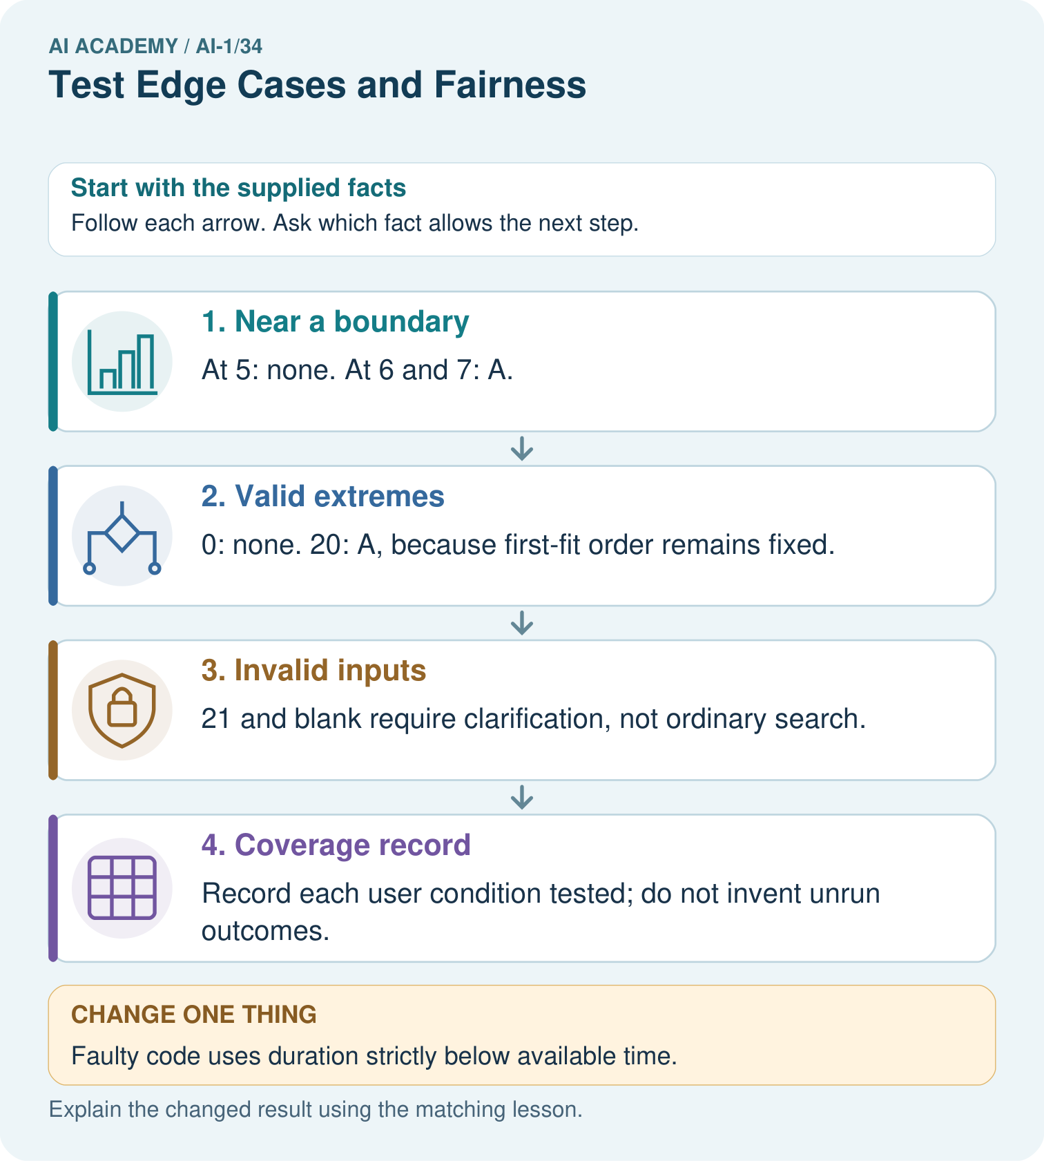
Which single boundary run most directly detects the strict-comparison bug, and why?

My picture-based explanation and changed-case prediction
________________________________________________________________
________________________________________________________________
________________________________________________________________
________________________________________________________________
________________________________________________________________
________________________________________________________________
Support used: alone / hint / worked example. This record is practice evidence.
Project connection: Add sorter boundary cases, missing fields and relevant user conditions to the test plan before making fairness claims.

19. Project portfolio milestone
Project: Helpful Classroom Sorter
Current milestone: Present and defend. Demonstrate the system, explain one failure and justify the next improvement with evidence.
Add sorter boundary cases, missing fields and relevant user conditions to the test plan before making fairness claims.
Evidence to keep | My record
This week’s input and deciding step
Prediction and actual result (or labelled paper trace)
One change since the previous checkpoint and why
One error or limit and the next test

Explain what this week adds to your project. Reuse last week’s record rather than starting again.
________________________________________________________________
________________________________________________________________
________________________________________________________________
________________________________________________________________
________________________________________________________________

20. Supported practice and learning evidence
Use this supported practice once, in the browser or on paper. Keep the reserved independent assessment for a separate first attempt before teacher feedback.
A fictional craft-book chooser accepts requests for whole available minutes from 0 to 20.

Practice 1: explain the deciding evidence
Which labelled step matches this detail? Record each user condition tested; do not invent unrun outcomes.
1. Near a boundary
2. Invalid inputs
3. Coverage record
4. Valid extremes

My selected conclusion, deciding fact and explanation
________________________________________________________________
________________________________________________________________
________________________________________________________________
________________________________________________________________
________________________________________________________________
Hint if needed: Read the steps in the pictorial case. Match the supplied detail to the stage that performs or records it.
After your attempt, compare with the supported explanation: Coverage record Record each user condition tested; do not invent unrun outcomes. Adjacent values below, at and above 6 expose an accidental strict inequality. Zero is valid even though no activity fits. The top valid input does not require selecting the longest activity: catalogue order still controls selection. Coverage also asks whose conditions were tested, which cannot be inferred from these numbers alone.

Practice 2: explain the deciding evidence
Changed-case practice: Faulty code uses duration strictly below available time. Which conclusion is supported by the supplied facts?
1. This one example guarantees correct results for every future input.
2. We can decide the result without examining the changed input or the procedure.
3. Request 6 now wrongly returns none.

My selected conclusion, deciding fact and explanation
________________________________________________________________
________________________________________________________________
________________________________________________________________
________________________________________________________________
________________________________________________________________
Hint if needed: Use the changed condition and the deciding step in the pictorial trace. The answer must say what follows from those facts.
After your attempt, compare with the supported explanation: Request 6 now wrongly returns none. A’s duration equals the available time and should be eligible under at most.

Repair a missing building block
Review Test Normal Cases (ai-1/33). Goal: Plan routine cases with expected results derived from the requirements. Short practice: Why is none correct for 8 but incorrect for 6? Use both capacity cards.. Return to this week and explain what you changed.
Review Design the Decision Process (ai-1/31). Goal: Design a decision process that covers valid, invalid and no-match requests. Short practice: Where does the first original rejection occur, and why is K3 not originally selected?. Return to this week and explain what you changed.
Review Humans Set Boundaries (ai-1/28). Goal: Distinguish a system’s capability, the correctness of its output and permission to take an action. Short practice: Which original proposal is authorised? Why do the other two need separate approval?. Return to this week and explain what you changed.

Keep your completed work
Use Download completed work in the hosted lesson to export your answers, reflections, practice feedback and code-run evidence. Open the HTML copy to read or print it. Drafts stay in this browser when storage is available; clear drafts on a shared device.

What I repaired, the evidence I kept and the next test
________________________________________________________________
________________________________________________________________
________________________________________________________________
________________________________________________________________
________________________________________________________________

