AI ACADEMY · WORKBOOK · ai-2/1

Precision in Algorithms
Project: Transparent Book Recommender

01. Recall and choose your starting point
Try the recall before opening notes. Then use a different colour or a labelled second line to correct your explanation.

Expo and Defense
Without opening the old lesson, explain one key idea from Expo and Defense. Give an example and a mistake that the idea helps you avoid.

My remembered idea, example and correction
________________________________________________________________
________________________________________________________________
________________________________________________________________

02. Practise with fading help
Use W2: Predict then observe for From a paper algorithm to Python. Record the answer once; the lesson and workbook refer to the same attempt.
Given inputs | Procedure I chose | Middle steps | Result and check

The step I completed without help, and the hint I needed
________________________________________________________________
________________________________________________________________
________________________________________________________________

03. Individual reasoning check
Use the worked case for From a paper algorithm to Python. Proposed explanation: “An equals sign displays the answer”. Decide whether this explanation is supported. Point to the step or supplied fact that decides; explain your repair if needed.

My explanation before partner discussion
________________________________________________________________
________________________________________________________________
________________________________________________________________
________________________________________________________________

04. Independent transfer case

Independent case: Transfer the procedure independently
A fictional shelf has 3 trays of 7 tiles each. Write a four-line Python script using trays, per_tray and tiles. Predict its output. Then change only trays to 0 and predict again. Explain why adding the two quantities is wrong.

My independent explanation, trace and limits
________________________________________________________________
________________________________________________________________
________________________________________________________________
________________________________________________________________
________________________________________________________________
________________________________________________________________
________________________________________________________________
Attempt this case before feedback. Record any help. Earlier examples below are further practice; a case already practised with feedback cannot establish fresh transfer.

05. Your learning target
Write an algorithm for borrowing a classroom book when the book may already be on loan. Include inputs, a no-copy-available outcome and a check that prevents two borrowers receiving the same copy.

06. Solve the given case
A sandwich algorithm says add spread, close it, cut it, without stating materials or directions.
Expose assumptions and write a precise paper simulation.
Show your trace, calculation or evidence

Write or draw your reasoning and evidence.
________________________________________________________________
________________________________________________________________
________________________________________________________________
________________________________________________________________
________________________________________________________________

07. Check a changed case
A robot starts at square 0. Replace move a bit and stop nearby with instructions that put it exactly on square 3 using steps of one square.
My independent answer and reason

Write or draw your reasoning and evidence.
________________________________________________________________
________________________________________________________________
________________________________________________________________
________________________________________________________________
________________________________________________________________

Week 1 Test and reflect

08. Design a revealing test
Create a changed input, boundary case or missing-information case. Write the expected answer or safe response before testing.
Test record | My evidence
Changed input or condition
Expected answer or fallback
Observed result
Why the result occurred

09. Project checkpoint
Write exact scoring steps so two people rank the same book the same way.
The project change and evidence I will keep

Write or draw your reasoning and evidence.
________________________________________________________________
________________________________________________________________
________________________________________________________________
________________________________________________________________
________________________________________________________________

10. Self check
I can explain the mechanism. I can show evidence. I can handle a changed case. I can name a limit. Mark each as not yet, with help or independently, and attach supporting work.
Teacher review ____________________ Next step ____________________

11. Transfer practice from the original programme
Write an algorithm for borrowing a classroom book when the book may already be on loan. Include inputs, a no-copy-available outcome and a check that prevents two borrowers receiving the same copy.

My independently reasoned answer
________________________________________________________________
________________________________________________________________
________________________________________________________________
________________________________________________________________
________________________________________________________________
________________________________________________________________
________________________________________________________________
Record support used: none, hint or teacher explanation.

12. W1 Connect the paper steps to Python
Write the complete four-line script for 4 packs of 6. Beside each line explain what it does. Which line displays information?

My reasoning and evidence
________________________________________________________________
________________________________________________________________
________________________________________________________________
________________________________________________________________
________________________________________________________________
________________________________________________________________

13. W2 Predict then observe
Make records for 4 packs of 6, then 5 packs of 6. Predict before running. Record actual output, any error and what changed. If working on paper, label both results as traces.

My reasoning and evidence
________________________________________________________________
________________________________________________________________
________________________________________________________________
________________________________________________________________
________________________________________________________________
________________________________________________________________

14. W3 Explain an order error
Move print(total) to the first line of a fresh script. Predict what happens and why. Put the lines back into an order that meets the requirement.

My reasoning and evidence
________________________________________________________________
________________________________________________________________
________________________________________________________________
________________________________________________________________
________________________________________________________________
________________________________________________________________

15. W4 Transfer the procedure independently
A fictional shelf has 3 trays of 7 tiles each. Write a four-line Python script using trays, per_tray and tiles. Predict its output. Then change only trays to 0 and predict again. Explain why adding the two quantities is wrong.

My reasoning and evidence
________________________________________________________________
________________________________________________________________
________________________________________________________________
________________________________________________________________
________________________________________________________________
________________________________________________________________
________________________________________________________________

16. W5 Keep an honest conclusion
Explain the difference between a successful run and a correct calculation. State one limit of this program and what you would keep so another person can check your work.

My reasoning and evidence
________________________________________________________________
________________________________________________________________
________________________________________________________________
________________________________________________________________
________________________________________________________________
________________________________________________________________

17. Feedback, return check and learning record
Evidence | My record
Worked alone / hint / model
First step I repaired and why
New case checked later; date and result
What I can now explain without notes
One remaining question
Revisit this idea with your teacher after a delay. Familiarity is different from explaining and using it on a changed case.

18. Pictorial case practice: Precision in Algorithms
A fictional book-box counter has three boxes with five books each and two loose books.
Python instructions: boxes=3; total=boxes*5; total=total+2; print(total).
Run the instructions in this order with ordinary integer arithmetic.
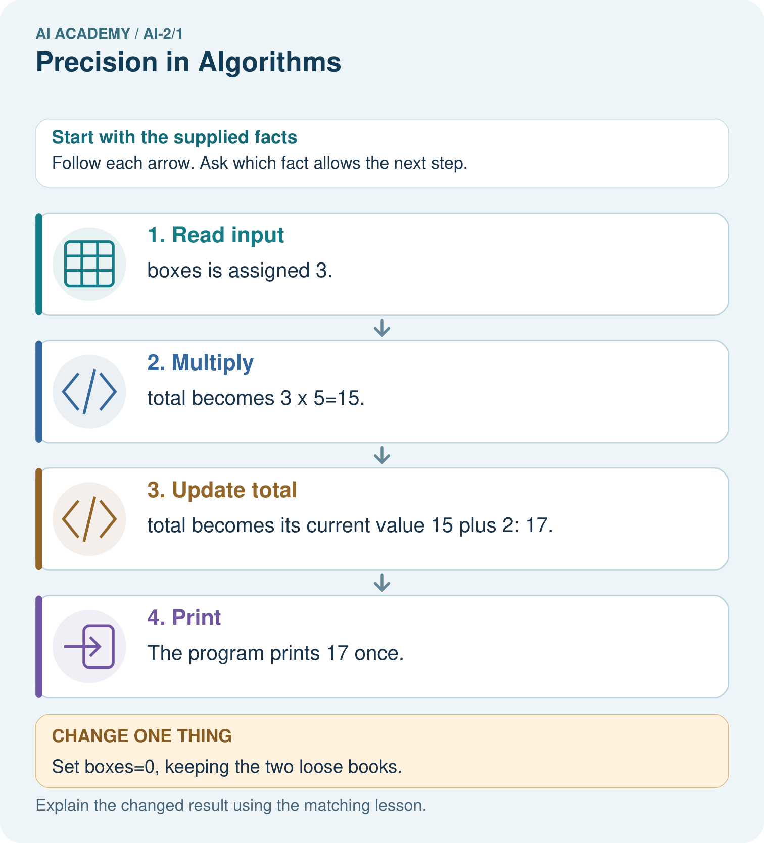
If print(total) moves before total=total+2, what gets printed for the original input?

My picture-based explanation and changed-case prediction
________________________________________________________________
________________________________________________________________
________________________________________________________________
________________________________________________________________
________________________________________________________________
________________________________________________________________
Support used: alone / hint / worked example. This record is practice evidence.
Project connection: Use small predicted traces when translating the Transparent Book Recommender’s paper logic into code.

19. Project portfolio milestone
Project: Transparent Book Recommender
Current milestone: Frame the need. Name the user, the problem, allowed inputs and a safe simple starting method.
Use small predicted traces when translating the Transparent Book Recommender’s paper logic into code.
Evidence to keep | My record
This week’s input and deciding step
Prediction and actual result (or labelled paper trace)
One change since the previous checkpoint and why
One error or limit and the next test

Explain what this week adds to your project. Reuse last week’s record rather than starting again.
________________________________________________________________
________________________________________________________________
________________________________________________________________
________________________________________________________________
________________________________________________________________

20. Supported practice and learning evidence
Use this supported practice once, in the browser or on paper. Keep the reserved independent assessment for a separate first attempt before teacher feedback.
A fictional book-box counter has three boxes with five books each and two loose books.

Practice 1: explain the deciding evidence
Which labelled step matches this detail? The program prints 17 once.
1. Read input
2. Print
3. Multiply
4. Update total

My selected conclusion, deciding fact and explanation
________________________________________________________________
________________________________________________________________
________________________________________________________________
________________________________________________________________
________________________________________________________________
Hint if needed: Read the steps in the pictorial case. Match the supplied detail to the stage that performs or records it.
After your attempt, compare with the supported explanation: Print The program prints 17 once. Assignment replaces a variable’s stored value. In total=total+2, Python first reads the current total on the right, calculates 17, then assigns that result to total on the left. The equal sign is an instruction here, not a claim that 15 and 17 are mathematically equal. Predict output before running.

Practice 2: explain the deciding evidence
Changed-case practice: Set boxes=0, keeping the two loose books. Which conclusion is supported by the supplied facts?
1. This one example guarantees correct results for every future input.
2. The printed result is 2.
3. We can decide the result without examining the changed input or the procedure.

My selected conclusion, deciding fact and explanation
________________________________________________________________
________________________________________________________________
________________________________________________________________
________________________________________________________________
________________________________________________________________
Hint if needed: Use the changed condition and the deciding step in the pictorial trace. The answer must say what follows from those facts.
After your attempt, compare with the supported explanation: The printed result is 2. 0×5+2=2; there is no rule saying zero boxes means zero loose books.

Repair a missing building block
Review Expo and Defense (ai-1/36). Goal: Evaluate a saved candidate and a manual baseline fairly. Short practice: Write one defensible success statement and one claim the evidence cannot support.. Return to this week and explain what you changed.

Predict, run and debug
The browser lab lets you edit the supported Python examples already included in this lesson. Predict first, run, inspect the actual output or error, change one input, then run again. Keep code, predictions, actual results and a reasoned revision together. On paper, label your result as a trace rather than an execution.

Keep your completed work
Use Download completed work in the hosted lesson to export your answers, reflections, practice feedback and code-run evidence. Open the HTML copy to read or print it. Drafts stay in this browser when storage is available; clear drafts on a shared device.

What I repaired, the evidence I kept and the next test
________________________________________________________________
________________________________________________________________
________________________________________________________________
________________________________________________________________
________________________________________________________________

