AI ACADEMY · WORKBOOK · ai-2/2

Decompose a Goal
Project: Transparent Book Recommender

01. Recall and choose your starting point
Try the recall before opening notes. Then use a different colour or a labelled second line to correct your explanation.

Precision in Algorithms
Without opening the old lesson, explain one key idea from Precision in Algorithms. Give an example and a mistake that the idea helps you avoid.

My remembered idea, example and correction
________________________________________________________________
________________________________________________________________
________________________________________________________________

02. Practise with fading help
Use W2: Follow the execution order for Functions and arguments. Record the answer once; the lesson and workbook refer to the same attempt.
Given inputs | Procedure I chose | Middle steps | Result and check

The step I completed without help, and the hint I needed
________________________________________________________________
________________________________________________________________
________________________________________________________________

03. Individual reasoning check
Use the worked case for Functions and arguments. Proposed explanation: “Writing def runs the body immediately”. Decide whether this explanation is supported. Point to the step or supplied fact that decides; explain your repair if needed.

My explanation before partner discussion
________________________________________________________________
________________________________________________________________
________________________________________________________________
________________________________________________________________

04. Independent transfer case

Independent case: Create a new function independently
Each sealed box contains 6 counters. Define show_stock(boxes, loose) to print the total counters using its two parameters. Assume nonnegative integer arguments. Call it with (3, 2), (0, 2) and (3, 0). Predict each output and explain why show_stock(2, 3) is a different case.

My independent explanation, trace and limits
________________________________________________________________
________________________________________________________________
________________________________________________________________
________________________________________________________________
________________________________________________________________
________________________________________________________________
________________________________________________________________
Attempt this case before feedback. Record any help. Earlier examples below are further practice; a case already practised with feedback cannot establish fresh transfer.

05. Your learning target
Decompose a recommender for books under 120 pages in a requested genre. A teammate scores every book before checking the page limit. Explain a clearer order and the record passed between stages.

06. Solve the given case
A class wants to recommend one of five library books.
Decompose the goal into checkable steps.
Show your trace, calculation or evidence

Write or draw your reasoning and evidence.
________________________________________________________________
________________________________________________________________
________________________________________________________________
________________________________________________________________
________________________________________________________________

07. Check a changed case
A recommender must receive a topic, find matching books and show one title. Split the goal into three tasks and state what passes between them.
My independent answer and reason

Write or draw your reasoning and evidence.
________________________________________________________________
________________________________________________________________
________________________________________________________________
________________________________________________________________
________________________________________________________________

Week 2 Test and reflect

08. Design a revealing test
Create a changed input, boundary case or missing-information case. Write the expected answer or safe response before testing.
Test record | My evidence
Changed input or condition
Expected answer or fallback
Observed result
Why the result occurred

09. Project checkpoint
Separate reader profile, book data, score calculation, ranking, and explanation.
The project change and evidence I will keep

Write or draw your reasoning and evidence.
________________________________________________________________
________________________________________________________________
________________________________________________________________
________________________________________________________________
________________________________________________________________

10. Self check
I can explain the mechanism. I can show evidence. I can handle a changed case. I can name a limit. Mark each as not yet, with help or independently, and attach supporting work.
Teacher review ____________________ Next step ____________________

11. Transfer practice from the original programme
Decompose a recommender for books under 120 pages in a requested genre. A teammate scores every book before checking the page limit. Explain a clearer order and the record passed between stages.

My independently reasoned answer
________________________________________________________________
________________________________________________________________
________________________________________________________________
________________________________________________________________
________________________________________________________________
________________________________________________________________
________________________________________________________________
Record support used: none, hint or teacher explanation.

12. W1 Label the parts
In def show_remaining(capacity, used), identify the function name and parameters. In show_remaining(15, 6), identify the arguments and their matching parameters.

My reasoning and evidence
________________________________________________________________
________________________________________________________________
________________________________________________________________
________________________________________________________________
________________________________________________________________
________________________________________________________________

13. W2 Follow the execution order
Using the correct definition, predict show_remaining(8, 3), show_remaining(8, 8) and show_remaining(8, 0) in that order. Explain what happens if the file contains only the definition.

My reasoning and evidence
________________________________________________________________
________________________________________________________________
________________________________________________________________
________________________________________________________________
________________________________________________________________
________________________________________________________________

14. W3 Repair ignored arguments
The faulty body calculates 12 - 4 regardless of the call. State the output and expected output for show_remaining(11, 2). Repair the expression and name an earlier call to rerun.

My reasoning and evidence
________________________________________________________________
________________________________________________________________
________________________________________________________________
________________________________________________________________
________________________________________________________________
________________________________________________________________

15. W4 Create a new function independently
Each sealed box contains 6 counters. Define show_stock(boxes, loose) to print the total counters using its two parameters. Assume nonnegative integer arguments. Call it with (3, 2), (0, 2) and (3, 0). Predict each output and explain why show_stock(2, 3) is a different case.

My reasoning and evidence
________________________________________________________________
________________________________________________________________
________________________________________________________________
________________________________________________________________
________________________________________________________________
________________________________________________________________
________________________________________________________________
________________________________________________________________

16. W5 State the input assumption
The correct subtraction function prints -1 for show_remaining(4, 5). Does successful execution make this a valid cupboard record? Explain what the function assumes and what needs checking.

My reasoning and evidence
________________________________________________________________
________________________________________________________________
________________________________________________________________
________________________________________________________________
________________________________________________________________
________________________________________________________________

17. Feedback, return check and learning record
Evidence | My record
Worked alone / hint / model
First step I repaired and why
New case checked later; date and result
What I can now explain without notes
One remaining question
Revisit this idea with your teacher after a delay. Familiarity is different from explaining and using it on a changed case.

18. Pictorial case practice: Decompose a Goal
A fictional library computes total spine labels needed for several equal shelves.
Define labels(shelves,per_shelf): return shelves*per_shelf.
Call needed=labels(4,6), then print(needed). No other side effects are defined.
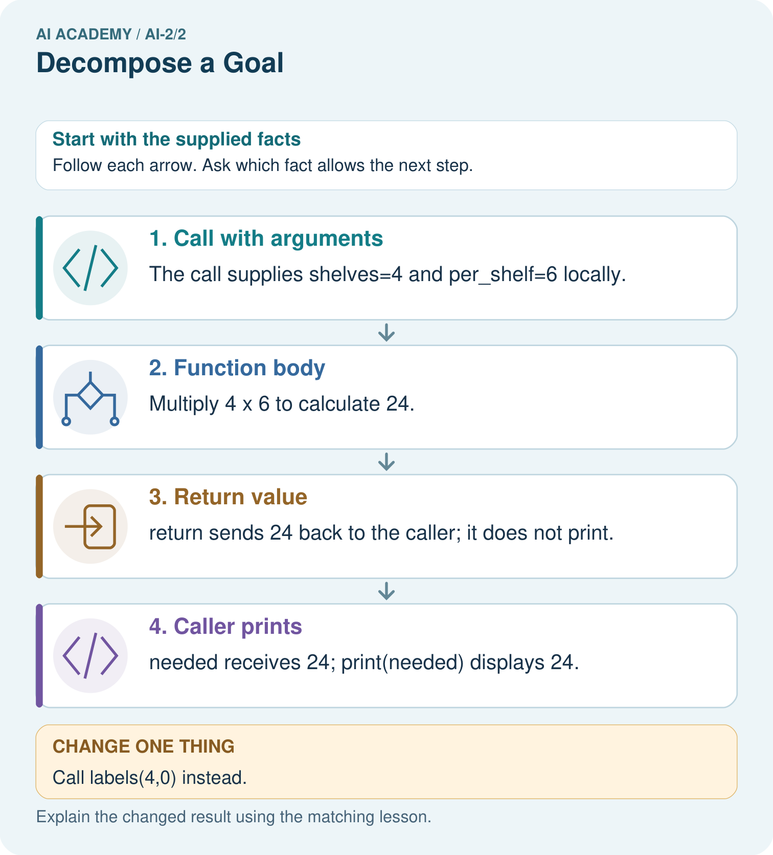
What happens visibly if the caller stores needed but omits print(needed)?

My picture-based explanation and changed-case prediction
________________________________________________________________
________________________________________________________________
________________________________________________________________
________________________________________________________________
________________________________________________________________
________________________________________________________________
Support used: alone / hint / worked example. This record is practice evidence.
Project connection: Give the recommender separate validation, eligibility and scoring functions whose inputs and results can be tested independently.

19. Project portfolio milestone
Project: Transparent Book Recommender
Current milestone: Frame the need. Name the user, the problem, allowed inputs and a safe simple starting method.
Give the recommender separate validation, eligibility and scoring functions whose inputs and results can be tested independently.
Evidence to keep | My record
This week’s input and deciding step
Prediction and actual result (or labelled paper trace)
One change since the previous checkpoint and why
One error or limit and the next test

Explain what this week adds to your project. Reuse last week’s record rather than starting again.
________________________________________________________________
________________________________________________________________
________________________________________________________________
________________________________________________________________
________________________________________________________________

20. Supported practice and learning evidence
Use this supported practice once, in the browser or on paper. Keep the reserved independent assessment for a separate first attempt before teacher feedback.
A fictional library computes total spine labels needed for several equal shelves.

Practice 1: explain the deciding evidence
Which labelled step matches this detail? needed receives 24; print(needed) displays 24.
1. Function body
2. Caller prints
3. Call with arguments
4. Return value

My selected conclusion, deciding fact and explanation
________________________________________________________________
________________________________________________________________
________________________________________________________________
________________________________________________________________
________________________________________________________________
Hint if needed: Read the steps in the pictorial case. Match the supplied detail to the stage that performs or records it.
After your attempt, compare with the supported explanation: Caller prints needed receives 24; print(needed) displays 24. A function separates one named job from the surrounding program. Arguments supply data for this call; return supplies its result. A print statement in the caller is a different action. Clear parameter names help detect swapping or misusing inputs without assuming every function prints automatically.

Practice 2: explain the deciding evidence
Changed-case practice: Call labels(4,0) instead. Which conclusion is supported by the supplied facts?
1. This one example guarantees correct results for every future input.
2. We can decide the result without examining the changed input or the procedure.
3. The returned result is 0, and the caller prints 0.

My selected conclusion, deciding fact and explanation
________________________________________________________________
________________________________________________________________
________________________________________________________________
________________________________________________________________
________________________________________________________________
Hint if needed: Use the changed condition and the deciding step in the pictorial trace. The answer must say what follows from those facts.
After your attempt, compare with the supported explanation: The returned result is 0, and the caller prints 0. Four shelves times zero labels per shelf is zero.

Repair a missing building block
Review Precision in Algorithms (ai-2/1). Goal: Translate a short paper calculation into a Python script. Short practice: If print(total) moves before total=total+2, what gets printed for the original input?. Return to this week and explain what you changed.

Predict, run and debug
The browser lab lets you edit the supported Python examples already included in this lesson. Predict first, run, inspect the actual output or error, change one input, then run again. Keep code, predictions, actual results and a reasoned revision together. On paper, label your result as a trace rather than an execution.

Keep your completed work
Use Download completed work in the hosted lesson to export your answers, reflections, practice feedback and code-run evidence. Open the HTML copy to read or print it. Drafts stay in this browser when storage is available; clear drafts on a shared device.

What I repaired, the evidence I kept and the next test
________________________________________________________________
________________________________________________________________
________________________________________________________________
________________________________________________________________
________________________________________________________________

