AI ACADEMY · WORKBOOK · ai-2/3

Branching Logic
Project: Transparent Book Recommender

01. Recall and choose your starting point
Try the recall before opening notes. Then use a different colour or a labelled second line to correct your explanation.

Decompose a Goal
Without opening the old lesson, explain one key idea from Decompose a Goal. Give an example and a mistake that the idea helps you avoid.

My remembered idea, example and correction
________________________________________________________________
________________________________________________________________
________________________________________________________________

02. Practise with fading help
Use W2: Trace the tested path for Branching and boundary tests. Record the answer once; the lesson and workbook refer to the same attempt.
Given inputs | Procedure I chose | Middle steps | Result and check

The step I completed without help, and the hint I needed
________________________________________________________________
________________________________________________________________
________________________________________________________________

03. Individual reasoning check
Use the worked case for Branching and boundary tests. Proposed explanation: “Every condition in the chain always runs”. Decide whether this explanation is supported. Point to the step or supplied fact that decides; explain your repair if needed.

My explanation before partner discussion
________________________________________________________________
________________________________________________________________
________________________________________________________________
________________________________________________________________

04. Independent transfer case

Independent case: Build a new sorter independently
Use an integer tiles count. Label a negative value Invalid, zero Empty, 1 through 6 Small and values above 6 Large. Write an ordered if elif else script and predict -1, 0, 1, 6 and 7. Include one print after the chain.

My independent explanation, trace and limits
________________________________________________________________
________________________________________________________________
________________________________________________________________
________________________________________________________________
________________________________________________________________
________________________________________________________________
________________________________________________________________
Attempt this case before feedback. Record any help. Earlier examples below are further practice; a case already practised with feedback cannot establish fresh transfer.

05. Your learning target
Classify lengths with if pages<80 then Short; else if pages<=160 then Medium; else Long. Trace 79,80,160,161. What happens if the <=160 branch is placed first?

06. Solve the given case
If pages<100 choose Short; otherwise if pages<=200 choose Medium; otherwise Long.
Classify 99,100,200,201 pages.
Show your trace, calculation or evidence

Write or draw your reasoning and evidence.
________________________________________________________________
________________________________________________________________
________________________________________________________________
________________________________________________________________
________________________________________________________________

07. Check a changed case
If pages are at most 80, choose short; otherwise choose long. Classify books with 79, 80 and 81 pages and explain the boundary.
My independent answer and reason

Write or draw your reasoning and evidence.
________________________________________________________________
________________________________________________________________
________________________________________________________________
________________________________________________________________
________________________________________________________________

Week 3 Test and reflect

08. Design a revealing test
Create a changed input, boundary case or missing-information case. Write the expected answer or safe response before testing.
Test record | My evidence
Changed input or condition
Expected answer or fallback
Observed result
Why the result occurred

09. Project checkpoint
Branch when a reader has a hard constraint such as language, format, or maximum length.
The project change and evidence I will keep

Write or draw your reasoning and evidence.
________________________________________________________________
________________________________________________________________
________________________________________________________________
________________________________________________________________
________________________________________________________________

10. Self check
I can explain the mechanism. I can show evidence. I can handle a changed case. I can name a limit. Mark each as not yet, with help or independently, and attach supporting work.
Teacher review ____________________ Next step ____________________

11. Transfer practice from the original programme
Classify lengths with if pages<80 then Short; else if pages<=160 then Medium; else Long. Trace 79,80,160,161. What happens if the <=160 branch is placed first?

My independently reasoned answer
________________________________________________________________
________________________________________________________________
________________________________________________________________
________________________________________________________________
________________________________________________________________
________________________________________________________________
________________________________________________________________
Record support used: none, hint or teacher explanation.

12. W1 Explain the chain
Describe the purpose of if, elif and else in the worked duration sorter. Explain why print(label) is outside the indented branches.

My reasoning and evidence
________________________________________________________________
________________________________________________________________
________________________________________________________________
________________________________________________________________
________________________________________________________________
________________________________________________________________

13. W2 Trace the tested path
For -1, 12 and 13, record checked conditions, skipped conditions and the final label. Run each as a fresh script after predicting.

My reasoning and evidence
________________________________________________________________
________________________________________________________________
________________________________________________________________
________________________________________________________________
________________________________________________________________
________________________________________________________________

14. W3 Repair the overwritten result
Trace the two-independent-if example for -1. Identify which assignment overwrites the earlier label and make the smallest repair.

My reasoning and evidence
________________________________________________________________
________________________________________________________________
________________________________________________________________
________________________________________________________________
________________________________________________________________
________________________________________________________________

15. W4 Build a new sorter independently
Use an integer tiles count. Label a negative value Invalid, zero Empty, 1 through 6 Small and values above 6 Large. Write an ordered if elif else script and predict -1, 0, 1, 6 and 7. Include one print after the chain.

My reasoning and evidence
________________________________________________________________
________________________________________________________________
________________________________________________________________
________________________________________________________________
________________________________________________________________
________________________________________________________________
________________________________________________________________
________________________________________________________________

16. W5 Choose revealing regression tests
A repair changes the small-count condition from < 6 to <= 6. Name the case that exposes the original error and two different kinds of earlier cases to rerun.

My reasoning and evidence
________________________________________________________________
________________________________________________________________
________________________________________________________________
________________________________________________________________
________________________________________________________________
________________________________________________________________

17. Feedback, return check and learning record
Evidence | My record
Worked alone / hint / model
First step I repaired and why
New case checked later; date and result
What I can now explain without notes
One remaining question
Revisit this idea with your teacher after a delay. Familiarity is different from explaining and using it on a changed case.

18. Pictorial case practice: Branching Logic
A fictional reading-time labeler uses one Python if/elif/else chain.
Whole minutes below 0: Invalid; 0: Empty; 1–10: Short; above 10: Long.
Order checks as minutes<0, minutes==0, minutes<=10, otherwise. Print the assigned label once.
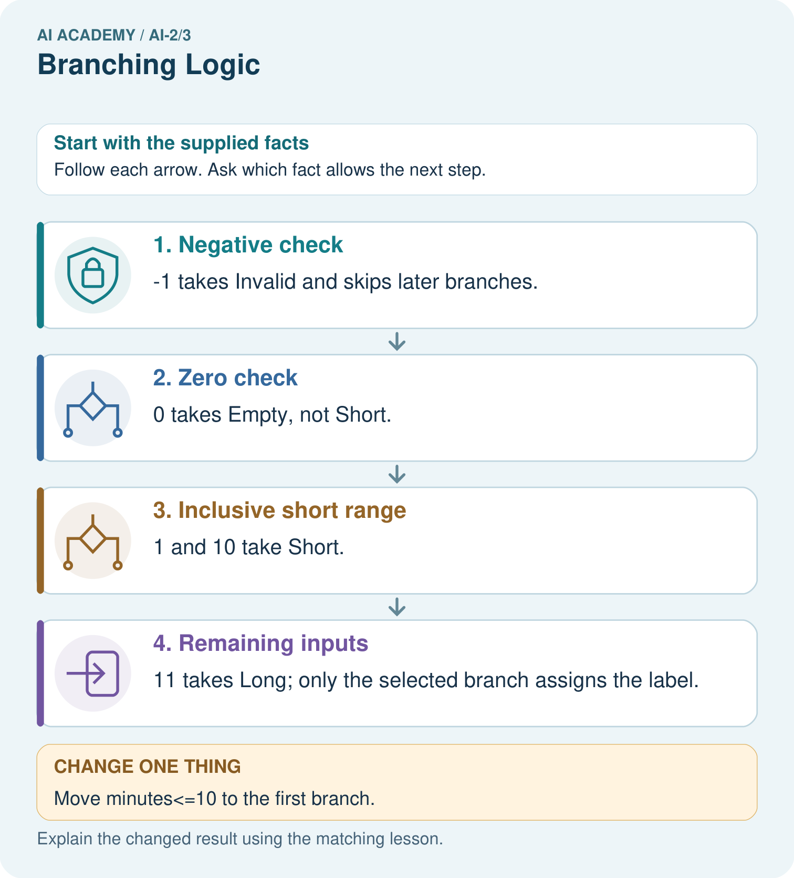
Give expected labels for −1,0,10,11 and identify the equality boundary for Short.

My picture-based explanation and changed-case prediction
________________________________________________________________
________________________________________________________________
________________________________________________________________
________________________________________________________________
________________________________________________________________
________________________________________________________________
Support used: alone / hint / worked example. This record is practice evidence.
Project connection: Validate recommender requests before ranking items, retaining explicit labels for missing or invalid cases.

19. Project portfolio milestone
Project: Transparent Book Recommender
Current milestone: Frame the need. Name the user, the problem, allowed inputs and a safe simple starting method.
Validate recommender requests before ranking items, retaining explicit labels for missing or invalid cases.
Evidence to keep | My record
This week’s input and deciding step
Prediction and actual result (or labelled paper trace)
One change since the previous checkpoint and why
One error or limit and the next test

Explain what this week adds to your project. Reuse last week’s record rather than starting again.
________________________________________________________________
________________________________________________________________
________________________________________________________________
________________________________________________________________
________________________________________________________________

20. Supported practice and learning evidence
Use this supported practice once, in the browser or on paper. Keep the reserved independent assessment for a separate first attempt before teacher feedback.
A fictional reading-time labeler uses one Python if/elif/else chain.

Practice 1: explain the deciding evidence
Which labelled step matches this detail? 11 takes Long; only the selected branch assigns the label.
1. Negative check
2. Zero check
3. Inclusive short range
4. Remaining inputs

My selected conclusion, deciding fact and explanation
________________________________________________________________
________________________________________________________________
________________________________________________________________
________________________________________________________________
________________________________________________________________
Hint if needed: Read the steps in the pictorial case. Match the supplied detail to the stage that performs or records it.
After your attempt, compare with the supported explanation: Remaining inputs 11 takes Long; only the selected branch assigns the label. The third comparison alone would include negative values and zero, but earlier branches already handle them. An elif chain selects its first true branch. Multiple independent if statements would have different behavior and could overwrite an earlier label. Boundary traces show why order belongs to the specification.

Practice 2: explain the deciding evidence
Changed-case practice: Move minutes<=10 to the first branch. Which conclusion is supported by the supplied facts?
1. We can decide the result without examining the changed input or the procedure.
2. −1 and 0 wrongly receive Short.
3. This one example guarantees correct results for every future input.

My selected conclusion, deciding fact and explanation
________________________________________________________________
________________________________________________________________
________________________________________________________________
________________________________________________________________
________________________________________________________________
Hint if needed: Use the changed condition and the deciding step in the pictorial trace. The answer must say what follows from those facts.
After your attempt, compare with the supported explanation: −1 and 0 wrongly receive Short. Both satisfy the earlier comparison before their intended checks are reached.

Repair a missing building block
Review Decompose a Goal (ai-2/2). Goal: Distinguish a function definition from a function call. Short practice: What happens visibly if the caller stores needed but omits print(needed)?. Return to this week and explain what you changed.

Predict, run and debug
The browser lab lets you edit the supported Python examples already included in this lesson. Predict first, run, inspect the actual output or error, change one input, then run again. Keep code, predictions, actual results and a reasoned revision together. On paper, label your result as a trace rather than an execution.

Keep your completed work
Use Download completed work in the hosted lesson to export your answers, reflections, practice feedback and code-run evidence. Open the HTML copy to read or print it. Drafts stay in this browser when storage is available; clear drafts on a shared device.

What I repaired, the evidence I kept and the next test
________________________________________________________________
________________________________________________________________
________________________________________________________________
________________________________________________________________
________________________________________________________________

