AI ACADEMY · WORKBOOK · ai-2/4

Trace Tables
Project: Transparent Book Recommender

01. Recall and choose your starting point
Try the recall before opening notes. Then use a different colour or a labelled second line to correct your explanation.

Branching Logic
Without opening the old lesson, explain one key idea from Branching Logic. Give an example and a mistake that the idea helps you avoid.

My remembered idea, example and correction
________________________________________________________________
________________________________________________________________
________________________________________________________________

Precision in Algorithms
Without opening the old lesson, explain one key idea from Precision in Algorithms. Give an example and a mistake that the idea helps you avoid.

My remembered idea, example and correction
________________________________________________________________
________________________________________________________________
________________________________________________________________

02. Practise with fading help
Use W2: Trace before running for Loops and trace tables. Record the answer once; the lesson and workbook refer to the same attempt.
Given inputs | Procedure I chose | Middle steps | Result and check

The step I completed without help, and the hint I needed
________________________________________________________________
________________________________________________________________
________________________________________________________________

03. Individual reasoning check
Use the worked case for Loops and trace tables. Proposed explanation: “The stop value is included”. Decide whether this explanation is supported. Point to the step or supplied fact that decides; explain your repair if needed.

My explanation before partner discussion
________________________________________________________________
________________________________________________________________
________________________________________________________________
________________________________________________________________

04. Independent transfer case

Independent case: Build a repeated addition independently
A box starts with 5 counters. Each round adds 2 counters. Use rounds = 3, an initialized total and for turn in range(rounds). Print the final total once after the loop. Trace the totals and predict fresh runs with rounds 0, 1 and 3. Assume rounds is a nonnegative integer.

My independent explanation, trace and limits
________________________________________________________________
________________________________________________________________
________________________________________________________________
________________________________________________________________
________________________________________________________________
________________________________________________________________
________________________________________________________________
Attempt this case before feedback. Record any help. Earlier examples below are further practice; a case already practised with feedback cannot establish fresh transfer.

05. Your learning target
Start score=1; add 4; if score>3 subtract 2; double score. Record score after every operation. A student evaluates the condition using the initial value. Locate the divergence.

06. Solve the given case
Set score=2; add 3; if score>4 subtract 1; double score.
Trace every value.
Show your trace, calculation or evidence

Write or draw your reasoning and evidence.
________________________________________________________________
________________________________________________________________
________________________________________________________________
________________________________________________________________
________________________________________________________________

07. Check a changed case
Set score to 2. Add 3, then double the result. Record the score after each operation. What changes if you double before adding?
My independent answer and reason

Write or draw your reasoning and evidence.
________________________________________________________________
________________________________________________________________
________________________________________________________________
________________________________________________________________
________________________________________________________________

Week 4 Test and reflect

08. Design a revealing test
Create a changed input, boundary case or missing-information case. Write the expected answer or safe response before testing.
Test record | My evidence
Changed input or condition
Expected answer or fallback
Observed result
Why the result occurred

09. Project checkpoint
Trace each book’s genre, length, difficulty, and total score before sorting.
The project change and evidence I will keep

Write or draw your reasoning and evidence.
________________________________________________________________
________________________________________________________________
________________________________________________________________
________________________________________________________________
________________________________________________________________

10. Self check
I can explain the mechanism. I can show evidence. I can handle a changed case. I can name a limit. Mark each as not yet, with help or independently, and attach supporting work.
Teacher review ____________________ Next step ____________________

11. Transfer practice from the original programme
Start score=1; add 4; if score>3 subtract 2; double score. Record score after every operation. A student evaluates the condition using the initial value. Locate the divergence.

My independently reasoned answer
________________________________________________________________
________________________________________________________________
________________________________________________________________
________________________________________________________________
________________________________________________________________
________________________________________________________________
________________________________________________________________
Record support used: none, hint or teacher explanation.

12. W1 Explain the range
List the values supplied by range(2, 5) and explain why 5 is absent. How many times does its body run?

My reasoning and evidence
________________________________________________________________
________________________________________________________________
________________________________________________________________
________________________________________________________________
________________________________________________________________
________________________________________________________________

13. W2 Trace before running
Copy the worked script. Change the range to range(2, 5). Record turn, total before and total after each iteration. Predict the single output, then run and compare.

My reasoning and evidence
________________________________________________________________
________________________________________________________________
________________________________________________________________
________________________________________________________________
________________________________________________________________
________________________________________________________________

14. W3 Repair the reset
For the faulty script with range(1, 4), record total after each addition. Explain the wrong final output and remove only the faulty reset.

My reasoning and evidence
________________________________________________________________
________________________________________________________________
________________________________________________________________
________________________________________________________________
________________________________________________________________
________________________________________________________________

15. W4 Build a repeated addition independently
A box starts with 5 counters. Each round adds 2 counters. Use rounds = 3, an initialized total and for turn in range(rounds). Print the final total once after the loop. Trace the totals and predict fresh runs with rounds 0, 1 and 3. Assume rounds is a nonnegative integer.

My reasoning and evidence
________________________________________________________________
________________________________________________________________
________________________________________________________________
________________________________________________________________
________________________________________________________________
________________________________________________________________
________________________________________________________________
________________________________________________________________

16. W5 Check a contract limitation
In your counter script, range(-2) performs no iterations. Does returning the initial 5 make negative rounds valid? Explain what the script checks and what it assumes.

My reasoning and evidence
________________________________________________________________
________________________________________________________________
________________________________________________________________
________________________________________________________________
________________________________________________________________
________________________________________________________________

17. Feedback, return check and learning record
Evidence | My record
Worked alone / hint / model
First step I repaired and why
New case checked later; date and result
What I can now explain without notes
One remaining question
Revisit this idea with your teacher after a delay. Familiarity is different from explaining and using it on a changed case.

18. Pictorial case practice: Trace Tables
A fictional reading-token jar starts with one token and gains three per round.
Python: total=1; for turn in range(4): total=total+3; after the loop print(total).
The update is inside the loop; print is outside.
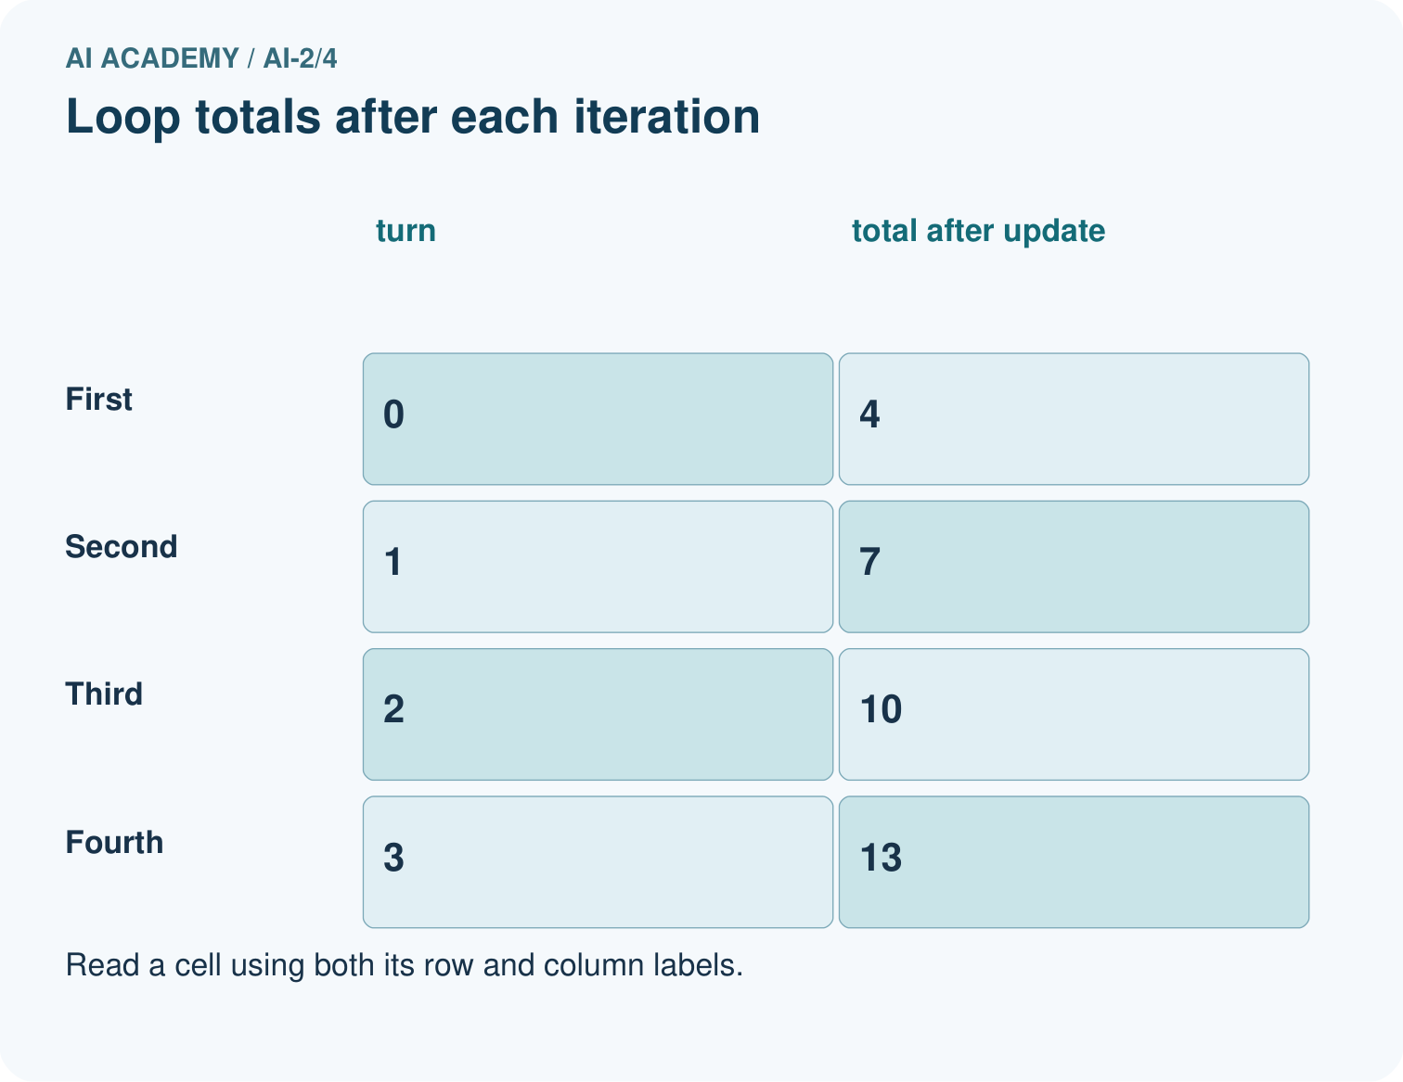
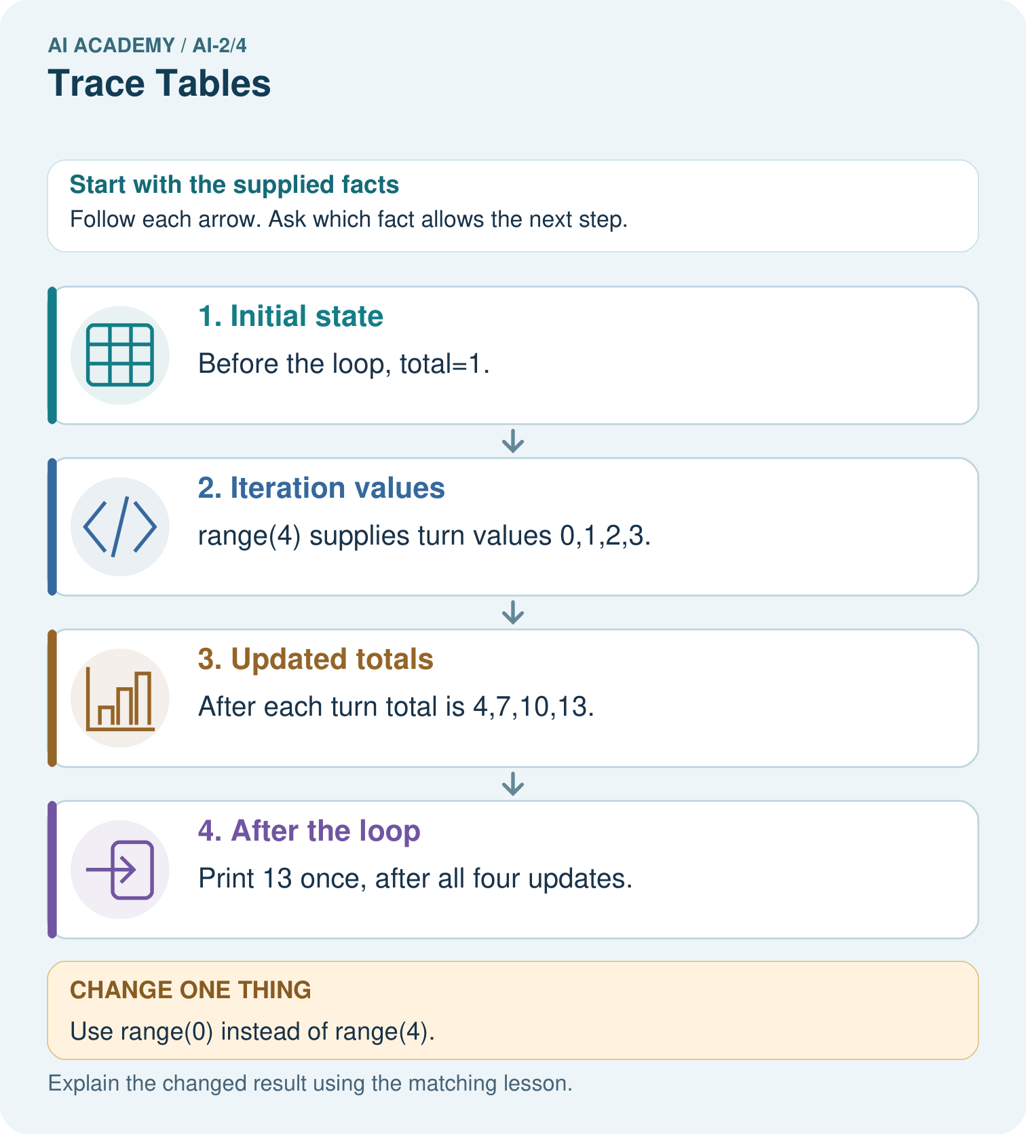
Move print inside the original loop. What sequence is displayed?

My picture-based explanation and changed-case prediction
________________________________________________________________
________________________________________________________________
________________________________________________________________
________________________________________________________________
________________________________________________________________
________________________________________________________________
Support used: alone / hint / worked example. This record is practice evidence.
Project connection: Trace recommender loops with current item, eligibility, score and current best so each update can be explained.

19. Project portfolio milestone
Project: Transparent Book Recommender
Current milestone: Frame the need. Name the user, the problem, allowed inputs and a safe simple starting method.
Trace recommender loops with current item, eligibility, score and current best so each update can be explained.
Evidence to keep | My record
This week’s input and deciding step
Prediction and actual result (or labelled paper trace)
One change since the previous checkpoint and why
One error or limit and the next test

Explain what this week adds to your project. Reuse last week’s record rather than starting again.
________________________________________________________________
________________________________________________________________
________________________________________________________________
________________________________________________________________
________________________________________________________________

20. Supported practice and learning evidence
Use this supported practice once, in the browser or on paper. Keep the reserved independent assessment for a separate first attempt before teacher feedback.
A fictional reading-token jar starts with one token and gains three per round.

Practice 1: explain the deciding evidence
Which labelled step matches this detail? Print 13 once, after all four updates.
1. Iteration values
2. Updated totals
3. After the loop
4. Initial state

My selected conclusion, deciding fact and explanation
________________________________________________________________
________________________________________________________________
________________________________________________________________
________________________________________________________________
________________________________________________________________
Hint if needed: Read the steps in the pictorial case. Match the supplied detail to the stage that performs or records it.
After your attempt, compare with the supported explanation: After the loop Print 13 once, after all four updates. The turn value labels an iteration; it is not the number added. The fixed update adds three each time. Four iterations take the total from 1 to 13. Keeping print outside the loop produces one final display rather than four intermediate displays. Initialise total before the loop so a zero-iteration run still has a defined value.

Practice 2: explain the deciding evidence
Changed-case practice: Use range(0) instead of range(4). Which conclusion is supported by the supplied facts?
1. The loop body never runs and the printed total is 1.
2. This one example guarantees correct results for every future input.
3. We can decide the result without examining the changed input or the procedure.

My selected conclusion, deciding fact and explanation
________________________________________________________________
________________________________________________________________
________________________________________________________________
________________________________________________________________
________________________________________________________________
Hint if needed: Use the changed condition and the deciding step in the pictorial trace. The answer must say what follows from those facts.
After your attempt, compare with the supported explanation: The loop body never runs and the printed total is 1. The iterable contains no turn values; the initial assignment still happened.

Repair a missing building block
Review Branching Logic (ai-2/3). Goal: Trace the selected branch in an if elif else chain. Short practice: Give expected labels for −1,0,10,11 and identify the equality boundary for Short.. Return to this week and explain what you changed.
Review Precision in Algorithms (ai-2/1). Goal: Translate a short paper calculation into a Python script. Short practice: If print(total) moves before total=total+2, what gets printed for the original input?. Return to this week and explain what you changed.

Predict, run and debug
The browser lab lets you edit the supported Python examples already included in this lesson. Predict first, run, inspect the actual output or error, change one input, then run again. Keep code, predictions, actual results and a reasoned revision together. On paper, label your result as a trace rather than an execution.

Keep your completed work
Use Download completed work in the hosted lesson to export your answers, reflections, practice feedback and code-run evidence. Open the HTML copy to read or print it. Drafts stay in this browser when storage is available; clear drafts on a shared device.

What I repaired, the evidence I kept and the next test
________________________________________________________________
________________________________________________________________
________________________________________________________________
________________________________________________________________
________________________________________________________________

