AI ACADEMY · WORKBOOK · ai-2/7

Rows Columns and Data Types
Project: Transparent Book Recommender

01. Recall and choose your starting point
Try the recall before opening notes. Then use a different colour or a labelled second line to correct your explanation.

Debugging Strategies
Without opening the old lesson, explain one key idea from Debugging Strategies. Give an example and a mistake that the idea helps you avoid.

My remembered idea, example and correction
________________________________________________________________
________________________________________________________________
________________________________________________________________

Trace Tables
Without opening the old lesson, explain one key idea from Trace Tables. Give an example and a mistake that the idea helps you avoid.

My remembered idea, example and correction
________________________________________________________________
________________________________________________________________
________________________________________________________________

Precision in Algorithms
Without opening the old lesson, explain one key idea from Precision in Algorithms. Give an example and a mistake that the idea helps you avoid.

My remembered idea, example and correction
________________________________________________________________
________________________________________________________________
________________________________________________________________

02. Practise with fading help
Use W2: Classify records for Rows columns and schemas. Record the answer once; the lesson and workbook refer to the same attempt.
Given inputs | Procedure I chose | Middle steps | Result and check

The step I completed without help, and the hint I needed
________________________________________________________________
________________________________________________________________
________________________________________________________________

03. Individual reasoning check
Use the worked case for Rows columns and schemas. Proposed explanation: “A successful run proves the conclusion”. Decide whether this explanation is supported. Point to the step or supplied fact that decides; explain your repair if needed.

My explanation before partner discussion
________________________________________________________________
________________________________________________________________
________________________________________________________________
________________________________________________________________

04. Independent transfer case

Independent case: Design a schema independently
For a fictional shelf audit, define label and book_count fields. Require a nonempty text label and an integer count from 0 to 40. Give two valid and two invalid records with reasons.

My independent explanation, trace and limits
________________________________________________________________
________________________________________________________________
________________________________________________________________
________________________________________________________________
________________________________________________________________
________________________________________________________________
________________________________________________________________
Attempt this case before feedback. Record any help. Earlier examples below are further practice; a case already practised with feedback cannot establish fresh transfer.

05. Your learning target
A row contains title='Sky', pages='120', available='false'. Explain why treating nonempty text as true can misread availability. Propose explicit conversions and a rejected-input case.

06. Solve the given case
Fields are Title, Pages and Borrowed; a row contains River, ninety and yes.
Assign intended types and a repair.
Show your trace, calculation or evidence

Write or draw your reasoning and evidence.
________________________________________________________________
________________________________________________________________
________________________________________________________________
________________________________________________________________
________________________________________________________________

07. Check a changed case
A table row is book_id B7, pages 84, available true. Name the type of each field and explain why pages stored as eighty-four complicates calculation.
My independent answer and reason

Write or draw your reasoning and evidence.
________________________________________________________________
________________________________________________________________
________________________________________________________________
________________________________________________________________
________________________________________________________________

Week 7 Test and reflect

08. Design a revealing test
Create a changed input, boundary case or missing-information case. Write the expected answer or safe response before testing.
Test record | My evidence
Changed input or condition
Expected answer or fallback
Observed result
Why the result occurred

09. Project checkpoint
Store one book per row and keep reader preferences in a separate record.
The project change and evidence I will keep

Write or draw your reasoning and evidence.
________________________________________________________________
________________________________________________________________
________________________________________________________________
________________________________________________________________
________________________________________________________________

10. Self check
I can explain the mechanism. I can show evidence. I can handle a changed case. I can name a limit. Mark each as not yet, with help or independently, and attach supporting work.
Teacher review ____________________ Next step ____________________

11. Transfer practice from the original programme
A row contains title='Sky', pages='120', available='false'. Explain why treating nonempty text as true can misread availability. Propose explicit conversions and a rejected-input case.

My independently reasoned answer
________________________________________________________________
________________________________________________________________
________________________________________________________________
________________________________________________________________
________________________________________________________________
________________________________________________________________
________________________________________________________________
Record support used: none, hint or teacher explanation.

12. W1 State a schema
List the required fields, types and duration boundaries for the worked table.

My reasoning and evidence
________________________________________________________________
________________________________________________________________
________________________________________________________________
________________________________________________________________
________________________________________________________________
________________________________________________________________

13. W2 Classify records
Classify minutes values 0, 60, -1 and 61 under this schema.

My reasoning and evidence
________________________________________________________________
________________________________________________________________
________________________________________________________________
________________________________________________________________
________________________________________________________________
________________________________________________________________

14. W3 Repair a unit problem
A source says 180 seconds but the row says minutes: 180. Give a documented correction.

My reasoning and evidence
________________________________________________________________
________________________________________________________________
________________________________________________________________
________________________________________________________________
________________________________________________________________
________________________________________________________________

15. W4 Design a schema independently
For a fictional shelf audit, define label and book_count fields. Require a nonempty text label and an integer count from 0 to 40. Give two valid and two invalid records with reasons.

My reasoning and evidence
________________________________________________________________
________________________________________________________________
________________________________________________________________
________________________________________________________________
________________________________________________________________
________________________________________________________________
________________________________________________________________
________________________________________________________________

16. W5 Separate validity and truth
A row says Reading, 12 and passes. Does that establish the session really lasted 12 minutes?

My reasoning and evidence
________________________________________________________________
________________________________________________________________
________________________________________________________________
________________________________________________________________
________________________________________________________________
________________________________________________________________

17. Feedback, return check and learning record
Evidence | My record
Worked alone / hint / model
First step I repaired and why
New case checked later; date and result
What I can now explain without notes
One remaining question
Revisit this idea with your teacher after a delay. Familiarity is different from explaining and using it on a changed case.

18. Pictorial case practice: Rows Columns and Data Types
A fictional approved book catalogue has three fields per row.
Schema: id is nonempty text; pages is an integer 1–300; illustrated is Boolean True or False.
Rows A={id:"B7",pages:90,illustrated:True}; B={id:"B8",pages:"90",illustrated:False}; C={id:"",pages:80,illustrated:True}.
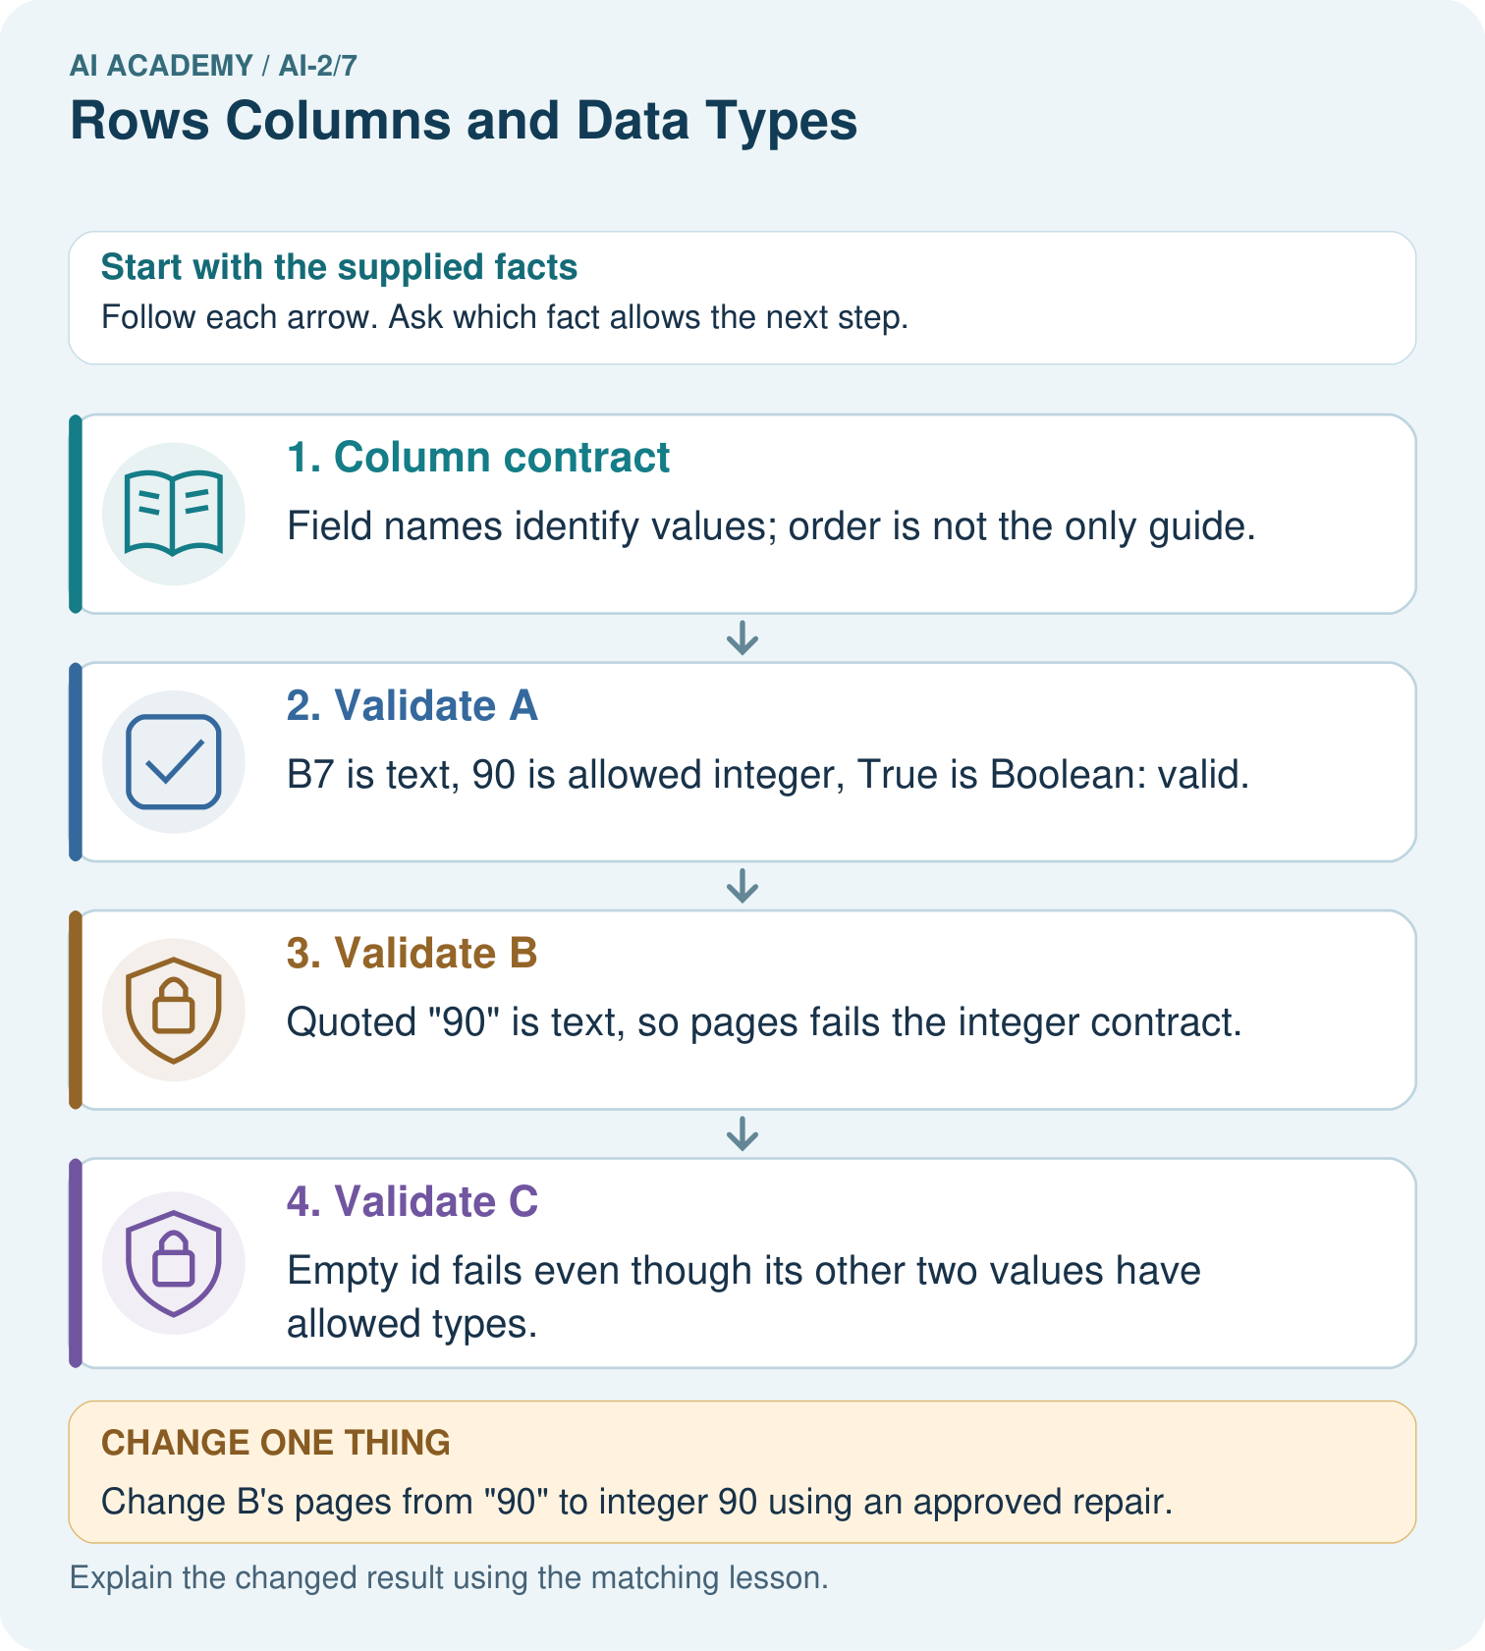
Which two rows originally fail, and do they fail for the same reason?

My picture-based explanation and changed-case prediction
________________________________________________________________
________________________________________________________________
________________________________________________________________
________________________________________________________________
________________________________________________________________
________________________________________________________________
Support used: alone / hint / worked example. This record is practice evidence.
Project connection: Publish the recommender’s row schema and validation results before ranking books, preserving repair provenance.

19. Project portfolio milestone
Project: Transparent Book Recommender
Current milestone: Make a transparent first version. Keep a trace of how one input becomes an output; explain the rule or learned component.
Publish the recommender’s row schema and validation results before ranking books, preserving repair provenance.
Evidence to keep | My record
This week’s input and deciding step
Prediction and actual result (or labelled paper trace)
One change since the previous checkpoint and why
One error or limit and the next test

Explain what this week adds to your project. Reuse last week’s record rather than starting again.
________________________________________________________________
________________________________________________________________
________________________________________________________________
________________________________________________________________
________________________________________________________________

20. Supported practice and learning evidence
Use this supported practice once, in the browser or on paper. Keep the reserved independent assessment for a separate first attempt before teacher feedback.
A fictional approved book catalogue has three fields per row.

Practice 1: explain the deciding evidence
Which labelled step matches this detail? Empty id fails even though its other two values have allowed types.
1. Column contract
2. Validate C
3. Validate B
4. Validate A

My selected conclusion, deciding fact and explanation
________________________________________________________________
________________________________________________________________
________________________________________________________________
________________________________________________________________
________________________________________________________________
Hint if needed: Read the steps in the pictorial case. Match the supplied detail to the stage that performs or records it.
After your attempt, compare with the supported explanation: Validate C Empty id fails even though its other two values have allowed types. A schema makes row meanings and expected types explicit. The string "90" looks like a number when printed but does not meet this strict integer schema. A repair can be authorised later, but must not be assumed silently. Missing or empty identifiers also prevent tracing an item back to its source.

Practice 2: explain the deciding evidence
Changed-case practice: Change B’s pages from "90" to integer 90 using an approved repair. Which conclusion is supported by the supplied facts?
1. B now satisfies the declared schema.
2. We can decide the result without examining the changed input or the procedure.
3. This one example guarantees correct results for every future input.

My selected conclusion, deciding fact and explanation
________________________________________________________________
________________________________________________________________
________________________________________________________________
________________________________________________________________
________________________________________________________________
Hint if needed: Use the changed condition and the deciding step in the pictorial trace. The answer must say what follows from those facts.
After your attempt, compare with the supported explanation: B now satisfies the declared schema. Its id is nonempty and illustrated is Boolean; the page-type defect is removed.

Repair a missing building block
Review Debugging Strategies (ai-2/6). Goal: Design revealing tests for a function. Short practice: Which test most directly isolates the handling of loose books, and what should it produce?. Return to this week and explain what you changed.
Review Trace Tables (ai-2/4). Goal: Trace variable values before and after each loop iteration. Short practice: Move print inside the original loop. What sequence is displayed?. Return to this week and explain what you changed.
Review Precision in Algorithms (ai-2/1). Goal: Translate a short paper calculation into a Python script. Short practice: If print(total) moves before total=total+2, what gets printed for the original input?. Return to this week and explain what you changed.

Predict, run and debug
The browser lab lets you edit the supported Python examples already included in this lesson. Predict first, run, inspect the actual output or error, change one input, then run again. Keep code, predictions, actual results and a reasoned revision together. On paper, label your result as a trace rather than an execution.

Keep your completed work
Use Download completed work in the hosted lesson to export your answers, reflections, practice feedback and code-run evidence. Open the HTML copy to read or print it. Drafts stay in this browser when storage is available; clear drafts on a shared device.

What I repaired, the evidence I kept and the next test
________________________________________________________________
________________________________________________________________
________________________________________________________________
________________________________________________________________
________________________________________________________________

