AI ACADEMY · WORKBOOK · ai-2/16

Overfitting Intuition
Project: Transparent Book Recommender

01. Recall and choose your starting point
Try the recall before opening notes. Then use a different colour or a labelled second line to correct your explanation.

Choose Informative Questions
Without opening the old lesson, explain one key idea from Choose Informative Questions. Give an example and a mistake that the idea helps you avoid.

My remembered idea, example and correction
________________________________________________________________
________________________________________________________________
________________________________________________________________

Types of Classification Error
Without opening the old lesson, explain one key idea from Types of Classification Error. Give an example and a mistake that the idea helps you avoid.

My remembered idea, example and correction
________________________________________________________________
________________________________________________________________
________________________________________________________________

Human Classifier Simulation
Without opening the old lesson, explain one key idea from Human Classifier Simulation. Give an example and a mistake that the idea helps you avoid.

My remembered idea, example and correction
________________________________________________________________
________________________________________________________________
________________________________________________________________

02. Practise with fading help
Use W2: Interpret a gap for Overfitting and model capacity. Record the answer once; the lesson and workbook refer to the same attempt.
Given inputs | Procedure I chose | Middle steps | Result and check

The step I completed without help, and the hint I needed
________________________________________________________________
________________________________________________________________
________________________________________________________________

03. Individual reasoning check
Use the worked case for Overfitting and model capacity. Proposed explanation: “A final answer is enough”. Decide whether this explanation is supported. Point to the step or supplied fact that decides; explain your repair if needed.

My explanation before partner discussion
________________________________________________________________
________________________________________________________________
________________________________________________________________
________________________________________________________________

04. Independent transfer case

Independent case: Apply independently
Models A training 4 validation 5, B training 1 validation 2, C training 0 validation 2. Lowest validation MAE then simpler; B is simpler than C. Choose and justify.

My independent explanation, trace and limits
________________________________________________________________
________________________________________________________________
________________________________________________________________
________________________________________________________________
________________________________________________________________
________________________________________________________________
________________________________________________________________
Attempt this case before feedback. Record any help. Earlier examples below are further practice; a case already practised with feedback cannot establish fresh transfer.

05. Your learning target
Rule A memorises eight training IDs and gets 8/8 training, 2/8 validation. Rule B uses genre and gets 6/8 training, 6/8 validation. Which is preferable on this evidence, and what test remains?

06. Solve the given case
Rule A memorises six training book names. It scores 6/6 familiar and 2/6 new. Rule B uses relevant traits but is untested.
What does the evidence support?
Show your trace, calculation or evidence

Write or draw your reasoning and evidence.
________________________________________________________________
________________________________________________________________
________________________________________________________________
________________________________________________________________
________________________________________________________________

07. Check a changed case
Rule A memorises six training book IDs. Rule B uses a relevant topic feature. Why might A fail on a new ID? What test is needed?
My independent answer and reason

Write or draw your reasoning and evidence.
________________________________________________________________
________________________________________________________________
________________________________________________________________
________________________________________________________________
________________________________________________________________

Week 16 Test and reflect

08. Design a revealing test
Create a changed input, boundary case or missing-information case. Write the expected answer or safe response before testing.
Test record | My evidence
Changed input or condition
Expected answer or fallback
Observed result
Why the result occurred

09. Project checkpoint
Avoid title-by-title patches; improve features or thresholds that transfer.
The project change and evidence I will keep

Write or draw your reasoning and evidence.
________________________________________________________________
________________________________________________________________
________________________________________________________________
________________________________________________________________
________________________________________________________________

10. Self check
I can explain the mechanism. I can show evidence. I can handle a changed case. I can name a limit. Mark each as not yet, with help or independently, and attach supporting work.
Teacher review ____________________ Next step ____________________

11. Transfer practice from the original programme
Rule A memorises eight training IDs and gets 8/8 training, 2/8 validation. Rule B uses genre and gets 6/8 training, 6/8 validation. Which is preferable on this evidence, and what test remains?

My independently reasoned answer
________________________________________________________________
________________________________________________________________
________________________________________________________________
________________________________________________________________
________________________________________________________________
________________________________________________________________
________________________________________________________________
Record support used: none, hint or teacher explanation.

12. W1 Select from evidence
Choose among the three worked candidates and explain the training trap.

My reasoning and evidence
________________________________________________________________
________________________________________________________________
________________________________________________________________
________________________________________________________________
________________________________________________________________
________________________________________________________________

13. W2 Interpret a gap
Does a training-validation gap alone prove overfitting?

My reasoning and evidence
________________________________________________________________
________________________________________________________________
________________________________________________________________
________________________________________________________________
________________________________________________________________
________________________________________________________________

14. W3 Propose a controlled change
Describe one fair next development comparison.

My reasoning and evidence
________________________________________________________________
________________________________________________________________
________________________________________________________________
________________________________________________________________
________________________________________________________________
________________________________________________________________

15. W4 Apply independently
Models A training 4 validation 5, B training 1 validation 2, C training 0 validation 2. Lowest validation MAE then simpler; B is simpler than C. Choose and justify.

My reasoning and evidence
________________________________________________________________
________________________________________________________________
________________________________________________________________
________________________________________________________________
________________________________________________________________
________________________________________________________________
________________________________________________________________
________________________________________________________________

16. W5 Limit a diagnosis
What extra evidence would you inspect before concluding a model memorized noise?

My reasoning and evidence
________________________________________________________________
________________________________________________________________
________________________________________________________________
________________________________________________________________
________________________________________________________________
________________________________________________________________

17. Feedback, return check and learning record
Evidence | My record
Worked alone / hint / model
First step I repaired and why
New case checked later; date and result
What I can now explain without notes
One remaining question
Revisit this idea with your teacher after a delay. Familiarity is different from explaining and using it on a changed case.

18. Pictorial case practice: Overfitting Intuition
A fictional project compares three book-length prediction models on the same development sets.
Mean absolute errors in pages: Simple training 5, validation 6; Medium training 2, validation 3; Complex training 0, validation 7.
Select lowest validation error; untouched final tests are not used for selection.
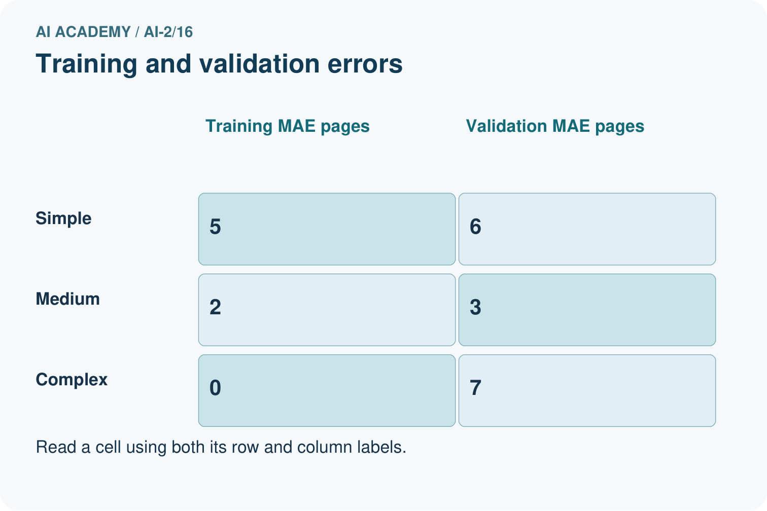
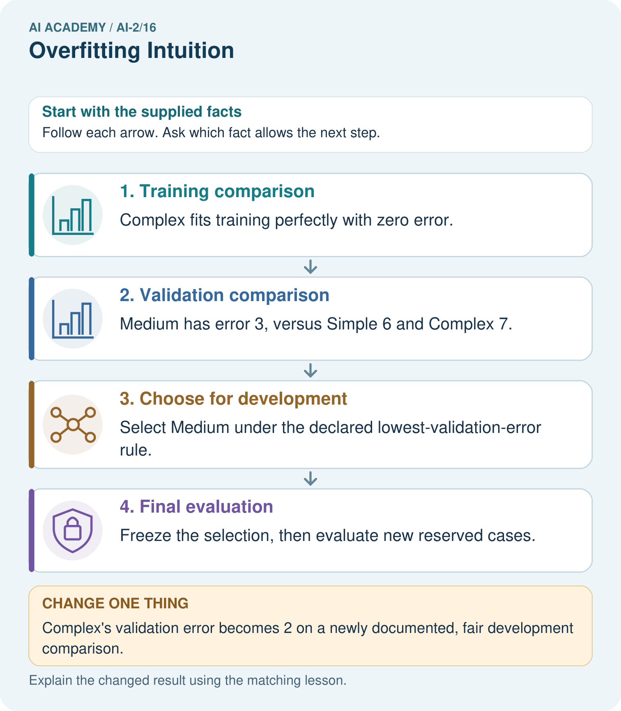
Does zero training error justify choosing Complex in the original record?

My picture-based explanation and changed-case prediction
________________________________________________________________
________________________________________________________________
________________________________________________________________
________________________________________________________________
________________________________________________________________
________________________________________________________________
Support used: alone / hint / worked example. This record is practice evidence.
Project connection: Compare recommender revisions on fixed development cases, reserving new cases for the final presentation.

19. Project portfolio milestone
Project: Transparent Book Recommender
Current milestone: Test changed cases. Keep normal, boundary and failure cases; compare expected and observed results.
Compare recommender revisions on fixed development cases, reserving new cases for the final presentation.
Evidence to keep | My record
This week’s input and deciding step
Prediction and actual result (or labelled paper trace)
One change since the previous checkpoint and why
One error or limit and the next test

Explain what this week adds to your project. Reuse last week’s record rather than starting again.
________________________________________________________________
________________________________________________________________
________________________________________________________________
________________________________________________________________
________________________________________________________________

20. Supported practice and learning evidence
Use this supported practice once, in the browser or on paper. Keep the reserved independent assessment for a separate first attempt before teacher feedback.
A fictional project compares three book-length prediction models on the same development sets.

Practice 1: explain the deciding evidence
Which labelled step matches this detail? Freeze the selection, then evaluate new reserved cases.
1. Final evaluation
2. Training comparison
3. Choose for development
4. Validation comparison

My selected conclusion, deciding fact and explanation
________________________________________________________________
________________________________________________________________
________________________________________________________________
________________________________________________________________
________________________________________________________________
Hint if needed: Read the steps in the pictorial case. Match the supplied detail to the stage that performs or records it.
After your attempt, compare with the supported explanation: Final evaluation Freeze the selection, then evaluate new reserved cases. A flexible model can fit quirks of its training set without predicting new examples well. Here Complex’s training success occur togethers with the worst validation error. The numbers are invented comparisons, not a claim that complexity always hurts. Choosing Medium uses development evidence; its validation score must not be advertised as an untouched final-test result.

Practice 2: explain the deciding evidence
Changed-case practice: Complex’s validation error becomes 2 on a newly documented, fair development comparison. Which conclusion is supported by the supplied facts?
1. We can decide the result without examining the changed input or the procedure.
2. This one example guarantees correct results for every future input.
3. The stated rule now selects Complex.

My selected conclusion, deciding fact and explanation
________________________________________________________________
________________________________________________________________
________________________________________________________________
________________________________________________________________
________________________________________________________________
Hint if needed: Use the changed condition and the deciding step in the pictorial trace. The answer must say what follows from those facts.
After your attempt, compare with the supported explanation: The stated rule now selects Complex. The rule compares validation errors; it does not ban complex models.

Repair a missing building block
Review Choose Informative Questions (ai-2/15). Goal: Fit a root question and leaf predictions from training examples. Short practice: Choose the best original question and explain why its more balanced split matters here.. Return to this week and explain what you changed.
Review Types of Classification Error (ai-2/13). Goal: Build a labelled confusion matrix from matched reference and prediction pairs. Short practice: Which error causes a sound book to be sent for unnecessary repair review?. Return to this week and explain what you changed.
Review Human Classifier Simulation (ai-2/10). Goal: Construct a classifier with a stated input format, selected rule and recorded output. Short practice: Why are J and M initially treated differently even though both are illustrated mysteries?. Return to this week and explain what you changed.

Keep your completed work
Use Download completed work in the hosted lesson to export your answers, reflections, practice feedback and code-run evidence. Open the HTML copy to read or print it. Drafts stay in this browser when storage is available; clear drafts on a shared device.

What I repaired, the evidence I kept and the next test
________________________________________________________________
________________________________________________________________
________________________________________________________________
________________________________________________________________
________________________________________________________________

