AI ACADEMY · WORKBOOK · ai-2/21

Similarity by Selected Traits
Project: Transparent Book Recommender

01. Recall and choose your starting point
Try the recall before opening notes. Then use a different colour or a labelled second line to correct your explanation.

Repair Bias in Data
Without opening the old lesson, explain one key idea from Repair Bias in Data. Give an example and a mistake that the idea helps you avoid.

My remembered idea, example and correction
________________________________________________________________
________________________________________________________________
________________________________________________________________

Missing Data
Without opening the old lesson, explain one key idea from Missing Data. Give an example and a mistake that the idea helps you avoid.

My remembered idea, example and correction
________________________________________________________________
________________________________________________________________
________________________________________________________________

Choose Informative Questions
Without opening the old lesson, explain one key idea from Choose Informative Questions. Give an example and a mistake that the idea helps you avoid.

My remembered idea, example and correction
________________________________________________________________
________________________________________________________________
________________________________________________________________

02. Practise with fading help
Use W2: Compute distances for Distance between feature vectors. Record the answer once; the lesson and workbook refer to the same attempt.
Given inputs | Procedure I chose | Middle steps | Result and check

The step I completed without help, and the hint I needed
________________________________________________________________
________________________________________________________________
________________________________________________________________

03. Individual reasoning check
Use the worked case for Distance between feature vectors. Proposed explanation: “A successful run proves the conclusion”. Decide whether this explanation is supported. Point to the step or supplied fact that decides; explain your repair if needed.

My explanation before partner discussion
________________________________________________________________
________________________________________________________________
________________________________________________________________
________________________________________________________________

04. Independent transfer case

Independent case: Rank independently
Target is [3, 2]. Options A [1, 2], B [3, 4], C [4, 2]. Calculate distances, select the closest, and identify a tie among the others.

My independent explanation, trace and limits
________________________________________________________________
________________________________________________________________
________________________________________________________________
________________________________________________________________
________________________________________________________________
________________________________________________________________
________________________________________________________________
Attempt this case before feedback. Record any help. Earlier examples below are further practice; a case already practised with feedback cannot establish fresh transfer.

05. Your learning target
Represent books as [animal,short,illustrated] with 1=yes. Query=[1,1,0]; A=[1,0,0], B=[1,1,1], C=[0,0,0]. Count mismatches. What changes if illustrations matter twice as much?

06. Solve the given case
Traits are [animals,adventure]. A=[1,1], B=[1,0], C=[0,0]; query=[1,0].
Use number of differing traits as distance.
Show your trace, calculation or evidence

Write or draw your reasoning and evidence.
________________________________________________________________
________________________________________________________________
________________________________________________________________
________________________________________________________________
________________________________________________________________

07. Check a changed case
Score similarity using one point for same topic and one for same difficulty. Target is space, easy. A is space, hard; B is animals, easy. What happens?
My independent answer and reason

Write or draw your reasoning and evidence.
________________________________________________________________
________________________________________________________________
________________________________________________________________
________________________________________________________________
________________________________________________________________

Week 21 Test and reflect

08. Design a revealing test
Create a changed input, boundary case or missing-information case. Write the expected answer or safe response before testing.
Test record | My evidence
Changed input or condition
Expected answer or fallback
Observed result
Why the result occurred

09. Project checkpoint
Make selected traits and their scales visible in every recommendation explanation.
The project change and evidence I will keep

Write or draw your reasoning and evidence.
________________________________________________________________
________________________________________________________________
________________________________________________________________
________________________________________________________________
________________________________________________________________

10. Self check
I can explain the mechanism. I can show evidence. I can handle a changed case. I can name a limit. Mark each as not yet, with help or independently, and attach supporting work.
Teacher review ____________________ Next step ____________________

11. Transfer practice from the original programme
Represent books as [animal,short,illustrated] with 1=yes. Query=[1,1,0]; A=[1,0,0], B=[1,1,1], C=[0,0,0]. Count mismatches. What changes if illustrations matter twice as much?

My independently reasoned answer
________________________________________________________________
________________________________________________________________
________________________________________________________________
________________________________________________________________
________________________________________________________________
________________________________________________________________
________________________________________________________________
Record support used: none, hint or teacher explanation.

12. W1 Read a vector
For [4, 1] under the worked feature order, identify energy and group-work ratings.

My reasoning and evidence
________________________________________________________________
________________________________________________________________
________________________________________________________________
________________________________________________________________
________________________________________________________________
________________________________________________________________

13. W2 Compute distances
From target [1, 2], find distances to A [2, 2] and B [0, 4].

My reasoning and evidence
________________________________________________________________
________________________________________________________________
________________________________________________________________
________________________________________________________________
________________________________________________________________
________________________________________________________________

14. W3 Repair feature order
One record uses [group work, energy] while others use [energy, group work]. Why is the distance unreliable?

My reasoning and evidence
________________________________________________________________
________________________________________________________________
________________________________________________________________
________________________________________________________________
________________________________________________________________
________________________________________________________________

15. W4 Rank independently
Target is [3, 2]. Options A [1, 2], B [3, 4], C [4, 2]. Calculate distances, select the closest, and identify a tie among the others.

My reasoning and evidence
________________________________________________________________
________________________________________________________________
________________________________________________________________
________________________________________________________________
________________________________________________________________
________________________________________________________________
________________________________________________________________
________________________________________________________________

16. W5 Limit similarity
Two activities have distance zero. Must they suit every learner equally well?

My reasoning and evidence
________________________________________________________________
________________________________________________________________
________________________________________________________________
________________________________________________________________
________________________________________________________________
________________________________________________________________

17. Feedback, return check and learning record
Evidence | My record
Worked alone / hint / model
First step I repaired and why
New case checked later; date and result
What I can now explain without notes
One remaining question
Revisit this idea with your teacher after a delay. Familiarity is different from explaining and using it on a changed case.

18. Pictorial case practice: Similarity by Selected Traits
A fictional toy book matcher represents two preferences with numeric features.
Target vector [2,5]. Candidate A=[2,2], B=[4,5], C=[3,4].
Use Manhattan distance: add absolute coordinate differences; return all smallest-distance candidates.
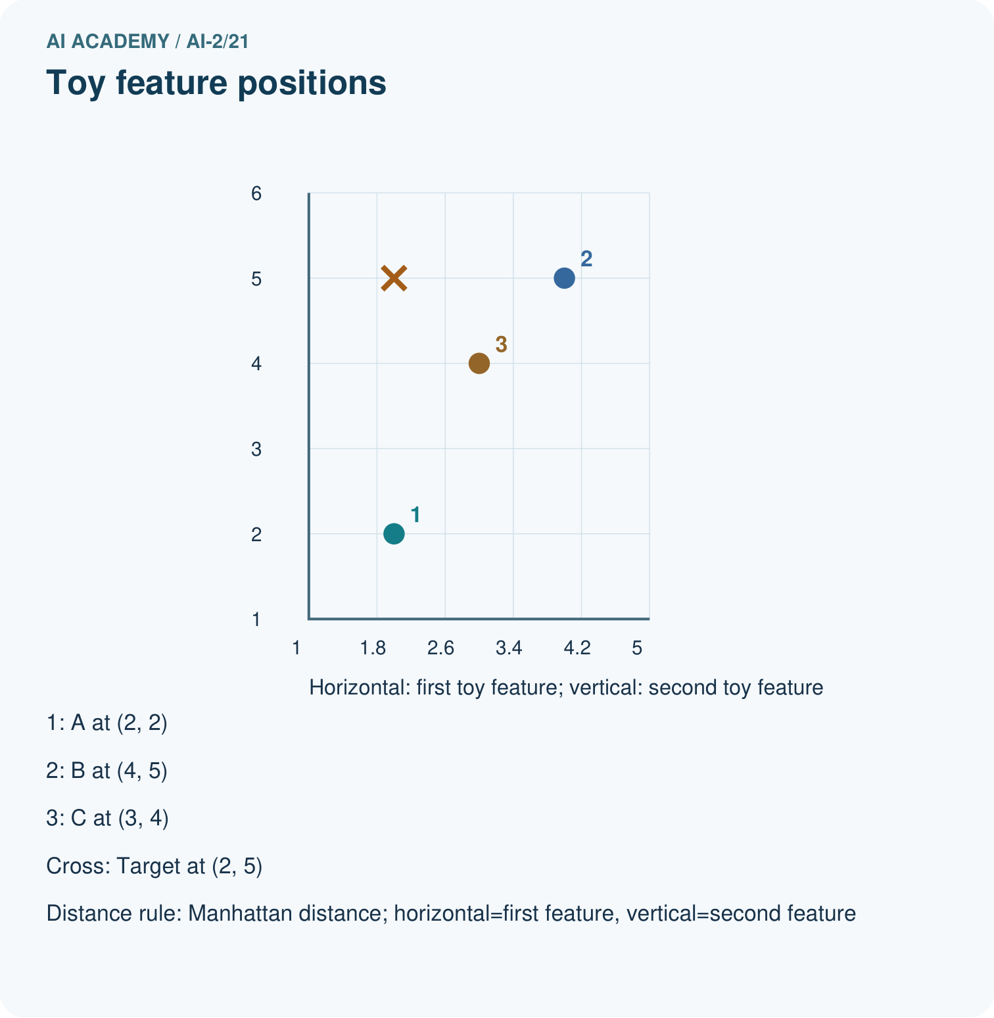
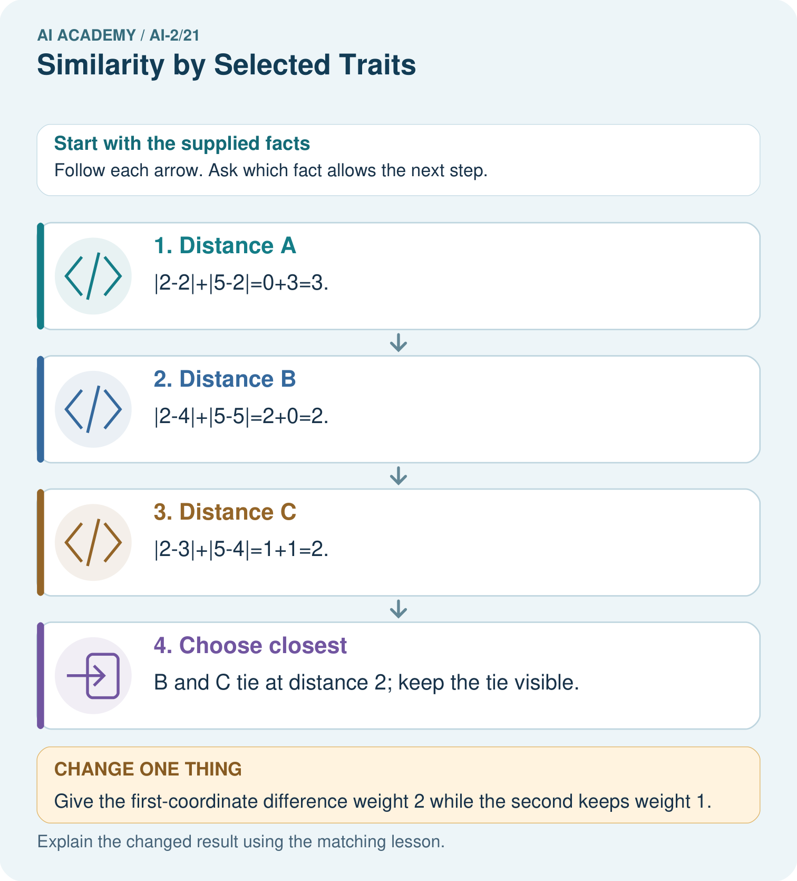
Explain why B ceases to be a closest option without any candidate data changing.

My picture-based explanation and changed-case prediction
________________________________________________________________
________________________________________________________________
________________________________________________________________
________________________________________________________________
________________________________________________________________
________________________________________________________________
Support used: alone / hint / worked example. This record is practice evidence.
Project connection: Specify recommender feature meanings, units, scaling and tie policy before explaining nearest matches.

19. Project portfolio milestone
Project: Transparent Book Recommender
Current milestone: Evaluate and revise. Compare with your starting method, explain errors and record a justified revision.
Specify recommender feature meanings, units, scaling and tie policy before explaining nearest matches.
Evidence to keep | My record
This week’s input and deciding step
Prediction and actual result (or labelled paper trace)
One change since the previous checkpoint and why
One error or limit and the next test

Explain what this week adds to your project. Reuse last week’s record rather than starting again.
________________________________________________________________
________________________________________________________________
________________________________________________________________
________________________________________________________________
________________________________________________________________

20. Supported practice and learning evidence
Use this supported practice once, in the browser or on paper. Keep the reserved independent assessment for a separate first attempt before teacher feedback.
A fictional toy book matcher represents two preferences with numeric features.

Practice 1: explain the deciding evidence
Which labelled step matches this detail? B and C tie at distance 2; keep the tie visible.
1. Distance C
2. Choose closest
3. Distance A
4. Distance B

My selected conclusion, deciding fact and explanation
________________________________________________________________
________________________________________________________________
________________________________________________________________
________________________________________________________________
________________________________________________________________
Hint if needed: Read the steps in the pictorial case. Match the supplied detail to the stage that performs or records it.
After your attempt, compare with the supported explanation: Choose closest B and C tie at distance 2; keep the tie visible. Each coordinate contributes according to the declared distance rule. Smaller distance means closer in this representation, not automatically a better reading experience. If one coordinate uses a much larger numerical scale, it can dominate the sum even when it is not more important. Feature units and scaling belong in the method record.

Practice 2: explain the deciding evidence
Changed-case practice: Give the first-coordinate difference weight 2 while the second keeps weight 1. Which conclusion is supported by the supplied facts?
1. Distances become A=3, B=4, C=3; A and C tie.
2. This one example guarantees correct results for every future input.
3. We can decide the result without examining the changed input or the procedure.

My selected conclusion, deciding fact and explanation
________________________________________________________________
________________________________________________________________
________________________________________________________________
________________________________________________________________
________________________________________________________________
Hint if needed: Use the changed condition and the deciding step in the pictorial trace. The answer must say what follows from those facts.
After your attempt, compare with the supported explanation: Distances become A=3, B=4, C=3; A and C tie. The representation’s comparison rule changes; the supplied vectors stay the same.

Repair a missing building block
Review Repair Bias in Data (ai-2/20). Goal: Identify selection and coverage bias. Short practice: Why must 35% be labelled an illustration rather than the measured grade-wide Yes rate?. Return to this week and explain what you changed.
Review Missing Data (ai-2/18). Goal: Detect absent and unusable values. Short practice: Why is the Boolean True rejected even though arithmetic can treat it like 1 in Python?. Return to this week and explain what you changed.
Review Choose Informative Questions (ai-2/15). Goal: Fit a root question and leaf predictions from training examples. Short practice: Choose the best original question and explain why its more balanced split matters here.. Return to this week and explain what you changed.

Predict, run and debug
The browser lab lets you edit the supported Python examples already included in this lesson. Predict first, run, inspect the actual output or error, change one input, then run again. Keep code, predictions, actual results and a reasoned revision together. On paper, label your result as a trace rather than an execution.

Keep your completed work
Use Download completed work in the hosted lesson to export your answers, reflections, practice feedback and code-run evidence. Open the HTML copy to read or print it. Drafts stay in this browser when storage is available; clear drafts on a shared device.

What I repaired, the evidence I kept and the next test
________________________________________________________________
________________________________________________________________
________________________________________________________________
________________________________________________________________
________________________________________________________________

