AI ACADEMY · WORKBOOK · ai-2/23

Recommendation Scores
Project: Transparent Book Recommender

01. Recall and choose your starting point
Try the recall before opening notes. Then use a different colour or a labelled second line to correct your explanation.

Nearest Neighbor Reasoning
Without opening the old lesson, explain one key idea from Nearest Neighbor Reasoning. Give an example and a mistake that the idea helps you avoid.

My remembered idea, example and correction
________________________________________________________________
________________________________________________________________
________________________________________________________________

Repair Bias in Data
Without opening the old lesson, explain one key idea from Repair Bias in Data. Give an example and a mistake that the idea helps you avoid.

My remembered idea, example and correction
________________________________________________________________
________________________________________________________________
________________________________________________________________

Noise and Outliers
Without opening the old lesson, explain one key idea from Noise and Outliers. Give an example and a mistake that the idea helps you avoid.

My remembered idea, example and correction
________________________________________________________________
________________________________________________________________
________________________________________________________________

02. Practise with fading help
Use W2: Check a boundary for Weighted scores and constraints. Record the answer once; the lesson and workbook refer to the same attempt.
Given inputs | Procedure I chose | Middle steps | Result and check

The step I completed without help, and the hint I needed
________________________________________________________________
________________________________________________________________
________________________________________________________________

03. Individual reasoning check
Use the worked case for Weighted scores and constraints. Proposed explanation: “A successful run proves the conclusion”. Decide whether this explanation is supported. Point to the step or supplied fact that decides; explain your repair if needed.

My explanation before partner discussion
________________________________________________________________
________________________________________________________________
________________________________________________________________
________________________________________________________________

04. Independent transfer case

Independent case: Choose independently
Limit is 15 minutes. A has fun 3, learning 4, minutes 15; B has 5, 1, 16; C has 2, 5, 12. Calculate scores with 2 * fun + learning and choose.

My independent explanation, trace and limits
________________________________________________________________
________________________________________________________________
________________________________________________________________
________________________________________________________________
________________________________________________________________
________________________________________________________________
________________________________________________________________
Attempt this case before feedback. Record any help. Earlier examples below are further practice; a case already practised with feedback cannot establish fresh transfer.

05. Your learning target
Score=3×genreMatch+2×short+illustrated. Compute A=[1,0,1], B=[0,1,1], C=[1,1,0]. A reader now requires illustrations. Which book wins after applying that constraint?

06. Solve the given case
Score=2 times genre match + length match. A matches both, B genre only, C length only.
Score and rank.
Show your trace, calculation or evidence

Write or draw your reasoning and evidence.
________________________________________________________________
________________________________________________________________
________________________________________________________________
________________________________________________________________
________________________________________________________________

07. Check a changed case
A recommender gives 3 points for topic match and 1 for difficulty match. Book A matches topic only; B matches difficulty only. Compute scores and justify the ranking.
My independent answer and reason

Write or draw your reasoning and evidence.
________________________________________________________________
________________________________________________________________
________________________________________________________________
________________________________________________________________
________________________________________________________________

Week 23 Test and reflect

08. Design a revealing test
Create a changed input, boundary case or missing-information case. Write the expected answer or safe response before testing.
Test record | My evidence
Changed input or condition
Expected answer or fallback
Observed result
Why the result occurred

09. Project checkpoint
Publish the features, weights, raw scores, and reason for the top result.
The project change and evidence I will keep

Write or draw your reasoning and evidence.
________________________________________________________________
________________________________________________________________
________________________________________________________________
________________________________________________________________
________________________________________________________________

10. Self check
I can explain the mechanism. I can show evidence. I can handle a changed case. I can name a limit. Mark each as not yet, with help or independently, and attach supporting work.
Teacher review ____________________ Next step ____________________

11. Transfer practice from the original programme
Score=3×genreMatch+2×short+illustrated. Compute A=[1,0,1], B=[0,1,1], C=[1,1,0]. A reader now requires illustrations. Which book wins after applying that constraint?

My independently reasoned answer
________________________________________________________________
________________________________________________________________
________________________________________________________________
________________________________________________________________
________________________________________________________________
________________________________________________________________
________________________________________________________________
Record support used: none, hint or teacher explanation.

12. W1 Calculate a score
An eligible activity has fun 2 and learning 4. Use 2 * fun + learning.

My reasoning and evidence
________________________________________________________________
________________________________________________________________
________________________________________________________________
________________________________________________________________
________________________________________________________________
________________________________________________________________

13. W2 Check a boundary
Which durations 19, 20, 21 qualify under at most 20?

My reasoning and evidence
________________________________________________________________
________________________________________________________________
________________________________________________________________
________________________________________________________________
________________________________________________________________
________________________________________________________________

14. W3 Repair selection
An ineligible item scores 15 and an eligible item scores 9. Which should be offered under the stated policy?

My reasoning and evidence
________________________________________________________________
________________________________________________________________
________________________________________________________________
________________________________________________________________
________________________________________________________________
________________________________________________________________

15. W4 Choose independently
Limit is 15 minutes. A has fun 3, learning 4, minutes 15; B has 5, 1, 16; C has 2, 5, 12. Calculate scores with 2 * fun + learning and choose.

My reasoning and evidence
________________________________________________________________
________________________________________________________________
________________________________________________________________
________________________________________________________________
________________________________________________________________
________________________________________________________________
________________________________________________________________
________________________________________________________________

16. W5 Test sensitivity
For eligible A (fun 4, learning 1) and B (fun 2, learning 4), compare weights (2,1) with (1,2).

My reasoning and evidence
________________________________________________________________
________________________________________________________________
________________________________________________________________
________________________________________________________________
________________________________________________________________
________________________________________________________________

17. Feedback, return check and learning record
Evidence | My record
Worked alone / hint / model
First step I repaired and why
New case checked later; date and result
What I can now explain without notes
One remaining question
Revisit this idea with your teacher after a delay. Familiarity is different from explaining and using it on a changed case.

18. Pictorial case practice: Recommendation Scores
A fictional book-activity chooser has a 14-minute limit.
Score=2×interest+practice. A=(interest3,practice2,time14); B=(4,3,15); C=(2,5,12).
Require whole nonnegative feature values; time must be at most the limit. Highest score wins; tie by ID.
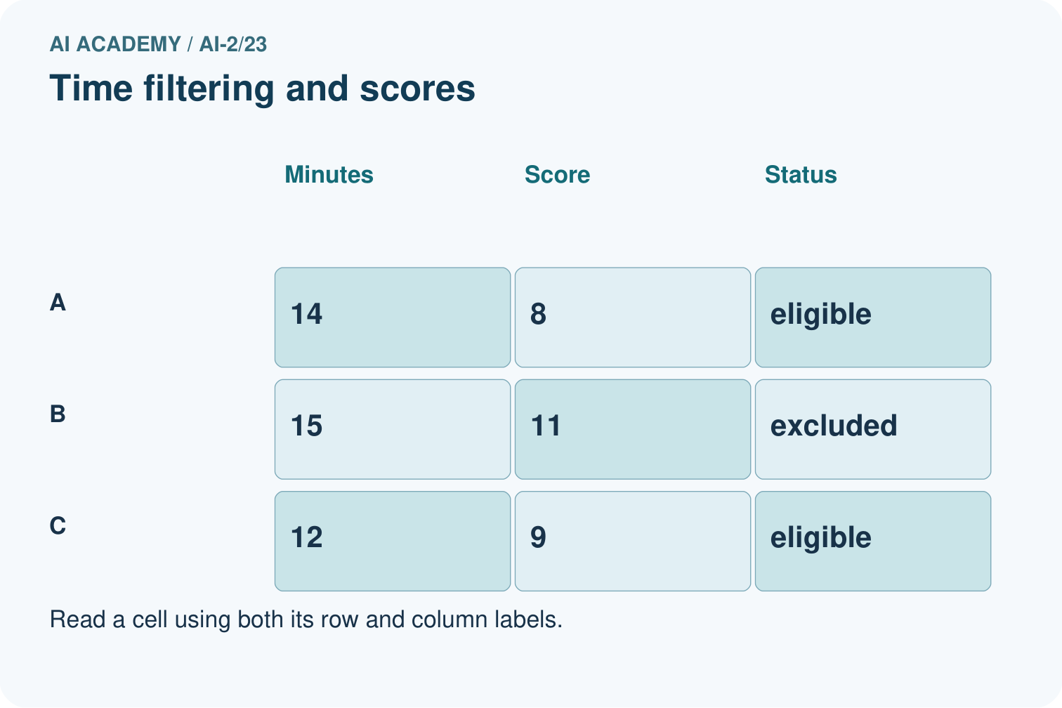
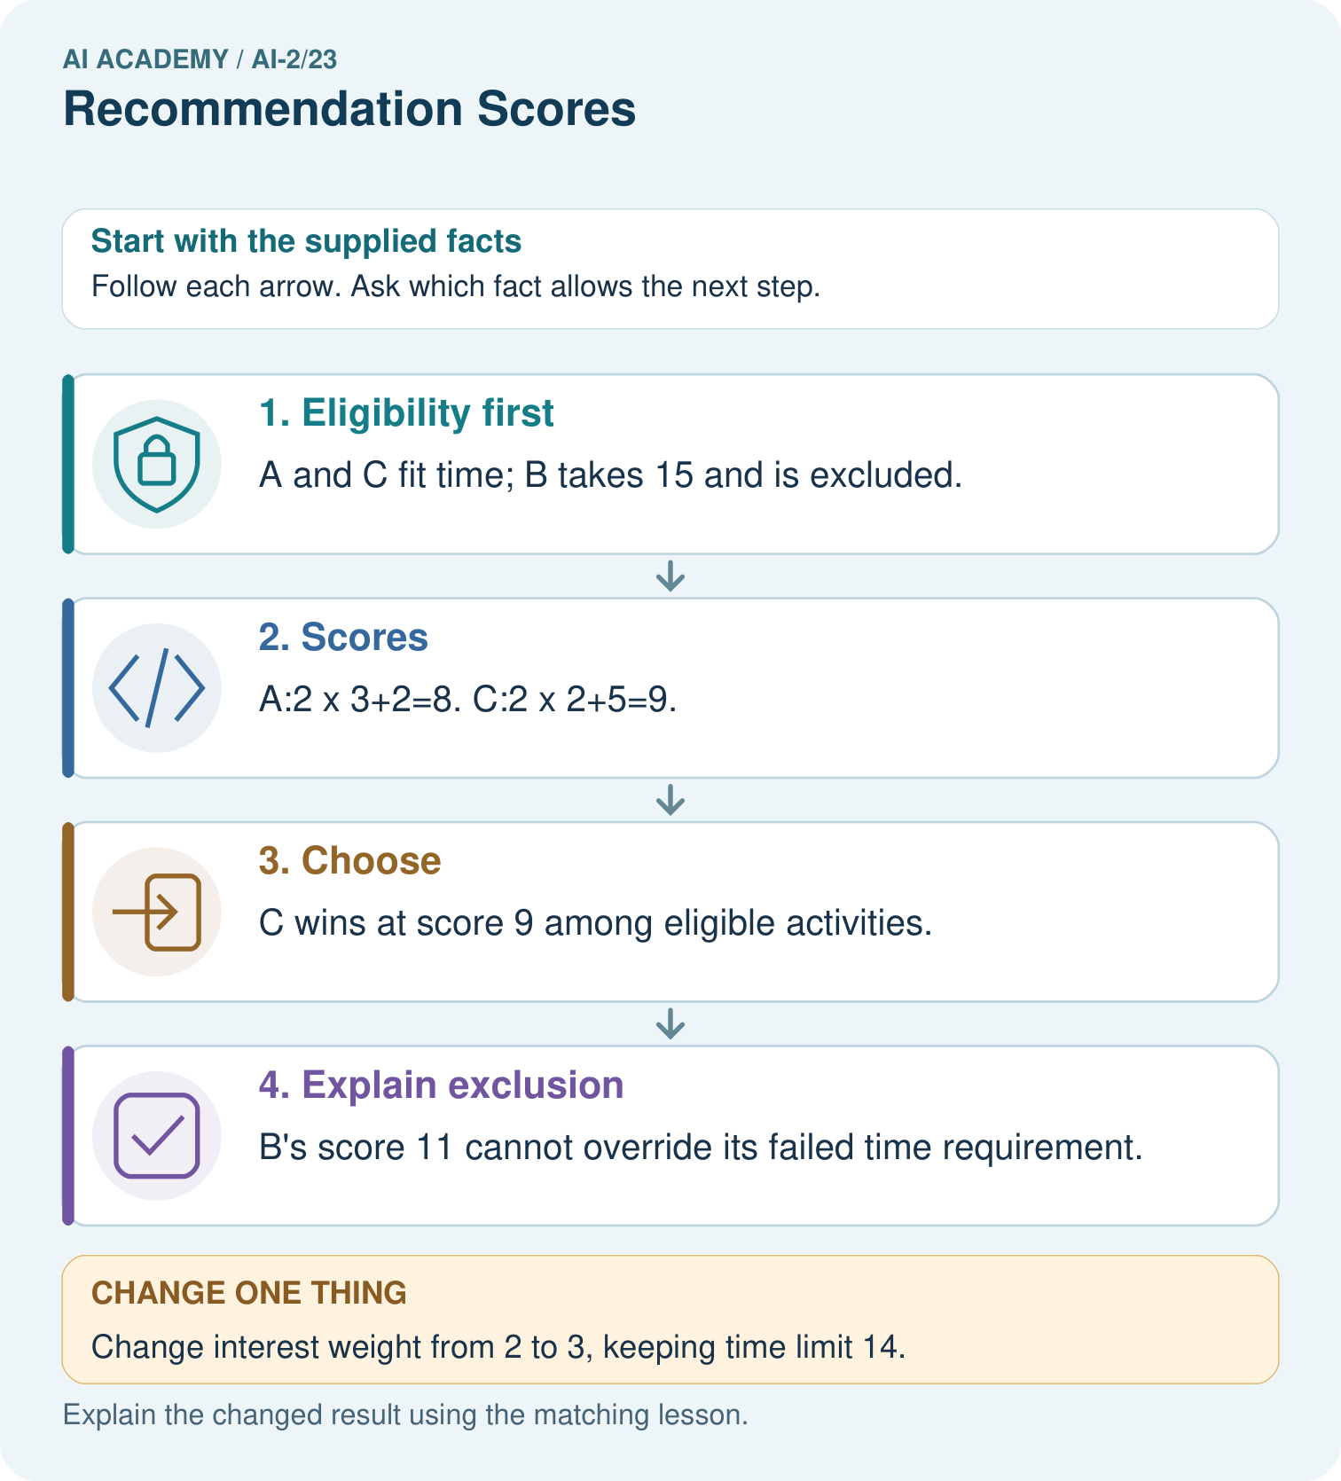
Why does B not become the winner when its score is largest?

My picture-based explanation and changed-case prediction
________________________________________________________________
________________________________________________________________
________________________________________________________________
________________________________________________________________
________________________________________________________________
________________________________________________________________
Support used: alone / hint / worked example. This record is practice evidence.
Project connection: Publish the recommender’s constraints, score formula and tie rule; include component-level reasons in each suggestion.

19. Project portfolio milestone
Project: Transparent Book Recommender
Current milestone: Evaluate and revise. Compare with your starting method, explain errors and record a justified revision.
Publish the recommender’s constraints, score formula and tie rule; include component-level reasons in each suggestion.
Evidence to keep | My record
This week’s input and deciding step
Prediction and actual result (or labelled paper trace)
One change since the previous checkpoint and why
One error or limit and the next test

Explain what this week adds to your project. Reuse last week’s record rather than starting again.
________________________________________________________________
________________________________________________________________
________________________________________________________________
________________________________________________________________
________________________________________________________________

20. Supported practice and learning evidence
Use this supported practice once, in the browser or on paper. Keep the reserved independent assessment for a separate first attempt before teacher feedback.
A fictional book-activity chooser has a 14-minute limit.

Practice 1: explain the deciding evidence
Which labelled step matches this detail? B’s score 11 cannot override its failed time requirement.
1. Choose
2. Explain exclusion
3. Eligibility first
4. Scores

My selected conclusion, deciding fact and explanation
________________________________________________________________
________________________________________________________________
________________________________________________________________
________________________________________________________________
________________________________________________________________
Hint if needed: Read the steps in the pictorial case. Match the supplied detail to the stage that performs or records it.
After your attempt, compare with the supported explanation: Explain exclusion B’s score 11 cannot override its failed time requirement. A score combines preferences according to explicitly chosen weights; it does not erase hard constraints. Computing a high score for an excluded item can be useful in an audit, but it must not allow that item back into the candidate set. Store both eligibility reasons and score components for explanations.

Practice 2: explain the deciding evidence
Changed-case practice: Change interest weight from 2 to 3, keeping time limit 14. Which conclusion is supported by the supplied facts?
1. This one example guarantees correct results for every future input.
2. We can decide the result without examining the changed input or the procedure.
3. A scores 11; C also scores 11; tie-by-ID chooses A.

My selected conclusion, deciding fact and explanation
________________________________________________________________
________________________________________________________________
________________________________________________________________
________________________________________________________________
________________________________________________________________
Hint if needed: Use the changed condition and the deciding step in the pictorial trace. The answer must say what follows from those facts.
After your attempt, compare with the supported explanation: A scores 11; C also scores 11; tie-by-ID chooses A. B remains too long; changing preferences changes only ranking of A and C.

Repair a missing building block
Review Nearest Neighbor Reasoning (ai-2/22). Goal: Compute absolute distances and rank training neighbours. Short practice: Why do k=1 and k=3 disagree for the original query?. Return to this week and explain what you changed.
Review Repair Bias in Data (ai-2/20). Goal: Identify selection and coverage bias. Short practice: Why must 35% be labelled an illustration rather than the measured grade-wide Yes rate?. Return to this week and explain what you changed.
Review Noise and Outliers (ai-2/17). Goal: Calculate mean and median. Short practice: If 18 was genuine, which summary better describes the middle observed task, and what extra fact should be shown?. Return to this week and explain what you changed.

Predict, run and debug
The browser lab lets you edit the supported Python examples already included in this lesson. Predict first, run, inspect the actual output or error, change one input, then run again. Keep code, predictions, actual results and a reasoned revision together. On paper, label your result as a trace rather than an execution.

Keep your completed work
Use Download completed work in the hosted lesson to export your answers, reflections, practice feedback and code-run evidence. Open the HTML copy to read or print it. Drafts stay in this browser when storage is available; clear drafts on a shared device.

What I repaired, the evidence I kept and the next test
________________________________________________________________
________________________________________________________________
________________________________________________________________
________________________________________________________________
________________________________________________________________

