AI ACADEMY · WORKBOOK · ai-2/25

Text as Pieces
Project: Transparent Book Recommender

01. Recall and choose your starting point
Try the recall before opening notes. Then use a different colour or a labelled second line to correct your explanation.

Feedback Loops
Without opening the old lesson, explain one key idea from Feedback Loops. Give an example and a mistake that the idea helps you avoid.

My remembered idea, example and correction
________________________________________________________________
________________________________________________________________
________________________________________________________________

Nearest Neighbor Reasoning
Without opening the old lesson, explain one key idea from Nearest Neighbor Reasoning. Give an example and a mistake that the idea helps you avoid.

My remembered idea, example and correction
________________________________________________________________
________________________________________________________________
________________________________________________________________

Sampling and Representation
Without opening the old lesson, explain one key idea from Sampling and Representation. Give an example and a mistake that the idea helps you avoid.

My remembered idea, example and correction
________________________________________________________________
________________________________________________________________
________________________________________________________________

02. Practise with fading help
Use W2: Encode and decode for Tokenisation and vocabulary. Record the answer once; the lesson and workbook refer to the same attempt.
Given inputs | Procedure I chose | Middle steps | Result and check

The step I completed without help, and the hint I needed
________________________________________________________________
________________________________________________________________
________________________________________________________________

03. Individual reasoning check
Use the worked case for Tokenisation and vocabulary. Proposed explanation: “A token always equals a word”. Decide whether this explanation is supported. Point to the step or supplied fact that decides; explain your repair if needed.

My explanation before partner discussion
________________________________________________________________
________________________________________________________________
________________________________________________________________
________________________________________________________________

04. Independent transfer case

Independent case: Trace a new input independently
Under the original vocabulary encode sat cats, decode it and count text tokens. Then trace sat cat! and state the exact failure position using zero-based character positions.

My independent explanation, trace and limits
________________________________________________________________
________________________________________________________________
________________________________________________________________
________________________________________________________________
________________________________________________________________
________________________________________________________________
________________________________________________________________
Attempt this case before feedback. Record any help. Earlier examples below are further practice; a case already practised with feedback cannot establish fresh transfer.

05. Your learning target
Toy tokenizer A splits 'unhelpful' into un/help/ful; B keeps it whole. Count tokens for each and explain why a three-word sentence need not use three tokens.

06. Solve the given case
Toy tokenizer A splits rainbows as [rain][bow][s]; B uses [rainbows].
Count tokens and state the limit of the example.
Show your trace, calculation or evidence

Write or draw your reasoning and evidence.
________________________________________________________________
________________________________________________________________
________________________________________________________________
________________________________________________________________
________________________________________________________________

07. Check a changed case
A classroom tokenizer splits sunflower into sun and flower. How many pieces result? Must every real tokenizer split it the same way?
My independent answer and reason

Write or draw your reasoning and evidence.
________________________________________________________________
________________________________________________________________
________________________________________________________________
________________________________________________________________
________________________________________________________________

Week 25 Test and reflect

08. Design a revealing test
Create a changed input, boundary case or missing-information case. Write the expected answer or safe response before testing.
Test record | My evidence
Changed input or condition
Expected answer or fallback
Observed result
Why the result occurred

09. Project checkpoint
Tokenize book descriptions before any text-based matching, while preserving the original source text.
The project change and evidence I will keep

Write or draw your reasoning and evidence.
________________________________________________________________
________________________________________________________________
________________________________________________________________
________________________________________________________________
________________________________________________________________

10. Self check
I can explain the mechanism. I can show evidence. I can handle a changed case. I can name a limit. Mark each as not yet, with help or independently, and attach supporting work.
Teacher review ____________________ Next step ____________________

11. Transfer practice from the original programme
Toy tokenizer A splits 'unhelpful' into un/help/ful; B keeps it whole. Count tokens for each and explain why a three-word sentence need not use three tokens.

My independently reasoned answer
________________________________________________________________
________________________________________________________________
________________________________________________________________
________________________________________________________________
________________________________________________________________
________________________________________________________________
________________________________________________________________
Record support used: none, hint or teacher explanation.

12. W1 Read the contract
Explain why sat wins over s at the start of sat and why uppercase C is unsupported.

My reasoning and evidence
________________________________________________________________
________________________________________________________________
________________________________________________________________
________________________________________________________________
________________________________________________________________
________________________________________________________________

13. W2 Encode and decode
Encode cats sat using the given vocabulary, decode it, and count with and without an appended end marker.

My reasoning and evidence
________________________________________________________________
________________________________________________________________
________________________________________________________________
________________________________________________________________
________________________________________________________________
________________________________________________________________

14. W3 Compare sequence lengths
Encode cats sat with character tokens only. Explain the difference from four text tokens in the original vocabulary.

My reasoning and evidence
________________________________________________________________
________________________________________________________________
________________________________________________________________
________________________________________________________________
________________________________________________________________
________________________________________________________________

15. W4 Trace a new input independently
Under the original vocabulary encode sat cats, decode it and count text tokens. Then trace sat cat! and state the exact failure position using zero-based character positions.

My reasoning and evidence
________________________________________________________________
________________________________________________________________
________________________________________________________________
________________________________________________________________
________________________________________________________________
________________________________________________________________
________________________________________________________________
________________________________________________________________

16. W5 Audit silent repair
An encoder lowercases Cat and removes punctuation before encoding, but labels its output an exact encoding of the original. Explain what must be recorded or changed.

My reasoning and evidence
________________________________________________________________
________________________________________________________________
________________________________________________________________
________________________________________________________________
________________________________________________________________
________________________________________________________________

17. Feedback, return check and learning record
Evidence | My record
Worked alone / hint / model
First step I repaired and why
New case checked later; date and result
What I can now explain without notes
One remaining question
Revisit this idea with your teacher after a delay. Familiarity is different from explaining and using it on a changed case.

18. Pictorial case practice: Text as Pieces
A fictional tokenizer converts a short catalogue phrase into tokens.
Vocabulary entries: book, books and the space character. At each position choose the longest matching entry; preserve the actual space.
Text is “books book”. Exclamation marks have no token; zero-based character positions are used.
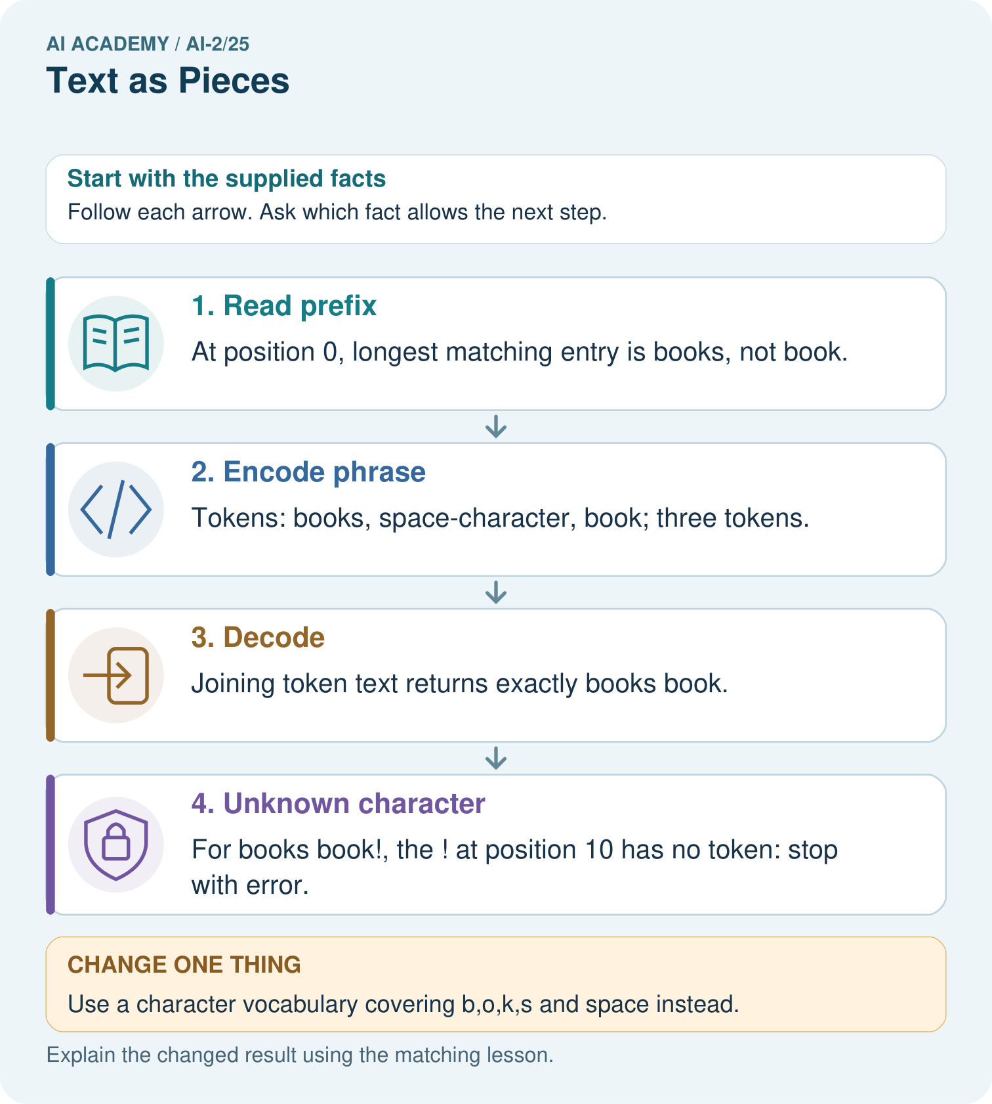
Why is the unknown ! at position 10 rather than position 9?

My picture-based explanation and changed-case prediction
________________________________________________________________
________________________________________________________________
________________________________________________________________
________________________________________________________________
________________________________________________________________
________________________________________________________________
Support used: alone / hint / worked example. This record is practice evidence.
Project connection: Document the recommender’s text representation and unknown-token behavior rather than assuming every model counts words identically.

19. Project portfolio milestone
Project: Transparent Book Recommender
Current milestone: Prepare the demonstration. Gather reproducible instructions, evidence, access checks and remaining limitations.
Document the recommender’s text representation and unknown-token behavior rather than assuming every model counts words identically.
Evidence to keep | My record
This week’s input and deciding step
Prediction and actual result (or labelled paper trace)
One change since the previous checkpoint and why
One error or limit and the next test

Explain what this week adds to your project. Reuse last week’s record rather than starting again.
________________________________________________________________
________________________________________________________________
________________________________________________________________
________________________________________________________________
________________________________________________________________

20. Supported practice and learning evidence
Use this supported practice once, in the browser or on paper. Keep the reserved independent assessment for a separate first attempt before teacher feedback.
A fictional tokenizer converts a short catalogue phrase into tokens.

Practice 1: explain the deciding evidence
Which labelled step matches this detail? For books book!, the ! at position 10 has no token: stop with error.
1. Unknown character
2. Decode
3. Encode phrase
4. Read prefix

My selected conclusion, deciding fact and explanation
________________________________________________________________
________________________________________________________________
________________________________________________________________
________________________________________________________________
________________________________________________________________
Hint if needed: Read the steps in the pictorial case. Match the supplied detail to the stage that performs or records it.
After your attempt, compare with the supported explanation: Unknown character For books book!, the ! at position 10 has no token: stop with error. A token is defined by the vocabulary and encoding rule; it need not be one word or one character. Longest matching matters where vocabulary entries overlap. Counting text tokens here does not count letters. Preserve spaces during decoding so the reconstructed text matches the original exactly.

Practice 2: explain the deciding evidence
Changed-case practice: Use a character vocabulary covering b,o,k,s and space instead. Which conclusion is supported by the supplied facts?
1. This one example guarantees correct results for every future input.
2. We can decide the result without examining the changed input or the procedure.
3. The same phrase uses ten character tokens.

My selected conclusion, deciding fact and explanation
________________________________________________________________
________________________________________________________________
________________________________________________________________
________________________________________________________________
________________________________________________________________
Hint if needed: Use the changed condition and the deciding step in the pictorial trace. The answer must say what follows from those facts.
After your attempt, compare with the supported explanation: The same phrase uses ten character tokens. There are five letters, one space and four letters; its decoded text remains unchanged.

Repair a missing building block
Review Feedback Loops (ai-2/24). Goal: Implement a deterministic recommender. Short practice: What extra field would reveal why comparing raw clicks is misleading?. Return to this week and explain what you changed.
Review Nearest Neighbor Reasoning (ai-2/22). Goal: Compute absolute distances and rank training neighbours. Short practice: Why do k=1 and k=3 disagree for the original query?. Return to this week and explain what you changed.
Review Sampling and Representation (ai-2/19). Goal: Define a question and target population. Short practice: Can 80% response be reported as 80% of the whole grade responding?. Return to this week and explain what you changed.

Keep your completed work
Use Download completed work in the hosted lesson to export your answers, reflections, practice feedback and code-run evidence. Open the HTML copy to read or print it. Drafts stay in this browser when storage is available; clear drafts on a shared device.

What I repaired, the evidence I kept and the next test
________________________________________________________________
________________________________________________________________
________________________________________________________________
________________________________________________________________
________________________________________________________________

