AI ACADEMY · WORKBOOK · ai-2/28

Prompt Experiments
Project: Transparent Book Recommender

01. Recall and choose your starting point
Try the recall before opening notes. Then use a different colour or a labelled second line to correct your explanation.

Predictive vs Generative
Without opening the old lesson, explain one key idea from Predictive vs Generative. Give an example and a mistake that the idea helps you avoid.

My remembered idea, example and correction
________________________________________________________________
________________________________________________________________
________________________________________________________________

Text as Pieces
Without opening the old lesson, explain one key idea from Text as Pieces. Give an example and a mistake that the idea helps you avoid.

My remembered idea, example and correction
________________________________________________________________
________________________________________________________________
________________________________________________________________

Nearest Neighbor Reasoning
Without opening the old lesson, explain one key idea from Nearest Neighbor Reasoning. Give an example and a mistake that the idea helps you avoid.

My remembered idea, example and correction
________________________________________________________________
________________________________________________________________
________________________________________________________________

02. Practise with fading help
Use W2: Trace the worked case for Controlled prompt experiments. Record the answer once; the lesson and workbook refer to the same attempt.
Given inputs | Procedure I chose | Middle steps | Result and check

The step I completed without help, and the hint I needed
________________________________________________________________
________________________________________________________________
________________________________________________________________

03. Individual reasoning check
Use the worked case for Controlled prompt experiments. Proposed explanation: “The worked result establishes every future case”. Decide whether this explanation is supported. Point to the step or supplied fact that decides; explain your repair if needed.

My explanation before partner discussion
________________________________________________________________
________________________________________________________________
________________________________________________________________
________________________________________________________________

04. Independent transfer case

Independent case: Apply a new case independently
On eight paired cases A passes 1–5; B passes 1–4, 6, 7. Special cases are 5 and 8. Compare overall and special-case results; select by total passes.

My independent explanation, trace and limits
________________________________________________________________
________________________________________________________________
________________________________________________________________
________________________________________________________________
________________________________________________________________
________________________________________________________________
________________________________________________________________
Attempt this case before feedback. Record any help. Earlier examples below are further practice; a case already practised with feedback cannot establish fresh transfer.

05. Your learning target
Prompt A is tested on easy requests and B on requests with missing data. B scores lower. Design a fair comparison and specify what to do when outputs vary across runs.

06. Solve the given case
Prompt B adds under 100 pages and explain the match to Prompt A. Both use a catalogue.
Design a fair comparison.
Show your trace, calculation or evidence

Write or draw your reasoning and evidence.
________________________________________________________________
________________________________________________________________
________________________________________________________________
________________________________________________________________
________________________________________________________________

07. Check a changed case
Prompt A and B are tested on different questions. B scores higher. Can wording alone explain the difference? Design a controlled comparison.
My independent answer and reason

Write or draw your reasoning and evidence.
________________________________________________________________
________________________________________________________________
________________________________________________________________
________________________________________________________________
________________________________________________________________

Week 28 Test and reflect

08. Design a revealing test
Create a changed input, boundary case or missing-information case. Write the expected answer or safe response before testing.
Test record | My evidence
Changed input or condition
Expected answer or fallback
Observed result
Why the result occurred

09. Project checkpoint
Test generated book explanations with a fixed rubric and prohibit invented details.
The project change and evidence I will keep

Write or draw your reasoning and evidence.
________________________________________________________________
________________________________________________________________
________________________________________________________________
________________________________________________________________
________________________________________________________________

10. Self check
I can explain the mechanism. I can show evidence. I can handle a changed case. I can name a limit. Mark each as not yet, with help or independently, and attach supporting work.
Teacher review ____________________ Next step ____________________

11. Transfer practice from the original programme
Prompt A is tested on easy requests and B on requests with missing data. B scores lower. Design a fair comparison and specify what to do when outputs vary across runs.

My independently reasoned answer
________________________________________________________________
________________________________________________________________
________________________________________________________________
________________________________________________________________
________________________________________________________________
________________________________________________________________
________________________________________________________________
Record support used: none, hint or teacher explanation.

12. W1 Explain the mechanism
Explain the weekly mechanism in your own words. Use the worked scenario to name its input, decision rule and output.

My reasoning and evidence
________________________________________________________________
________________________________________________________________
________________________________________________________________
________________________________________________________________
________________________________________________________________
________________________________________________________________

13. W2 Trace the worked case
On six development cases P passes cases 1, 2, 3, 4; Q passes 1, 2, 3, 5, 6. Missing-approval cases are 4 and 6. Compare totals and condition results. Show the intermediate steps and give the conclusion with its scope.

My reasoning and evidence
________________________________________________________________
________________________________________________________________
________________________________________________________________
________________________________________________________________
________________________________________________________________
________________________________________________________________
________________________________________________________________

14. W3 Audit the limit
A report omits this qualification: Prompt selection on development cases cannot be reported as independent final performance. Explain how omitting it could change a reader's interpretation, and write an accurate replacement.

My reasoning and evidence
________________________________________________________________
________________________________________________________________
________________________________________________________________
________________________________________________________________
________________________________________________________________
________________________________________________________________

15. W4 Apply a new case independently
On eight paired cases A passes 1–5; B passes 1–4, 6, 7. Special cases are 5 and 8. Compare overall and special-case results; select by total passes.

My reasoning and evidence
________________________________________________________________
________________________________________________________________
________________________________________________________________
________________________________________________________________
________________________________________________________________
________________________________________________________________
________________________________________________________________
________________________________________________________________

16. W5 Design a revealing follow-up
For the worked scenario, propose one additional case that could reveal a failure, describe its expected outcome before running it, and explain what would need to remain fixed for a fair comparison. Do not reuse W4 as a new final test after receiving feedback.

My reasoning and evidence
________________________________________________________________
________________________________________________________________
________________________________________________________________
________________________________________________________________
________________________________________________________________
________________________________________________________________
________________________________________________________________

17. Feedback, return check and learning record
Evidence | My record
Worked alone / hint / model
First step I repaired and why
New case checked later; date and result
What I can now explain without notes
One remaining question
Revisit this idea with your teacher after a delay. Familiarity is different from explaining and using it on a changed case.

18. Pictorial case practice: Prompt Experiments
A fictional book-help project tests two prompt versions on seven shared development cases.
P passes cases 1,2,3,4. Q passes 1,2,3,5,6. Cases 4 and 7 involve missing sources.
Same inputs, system configuration and rubric; only the prompt changes. These are invented records.
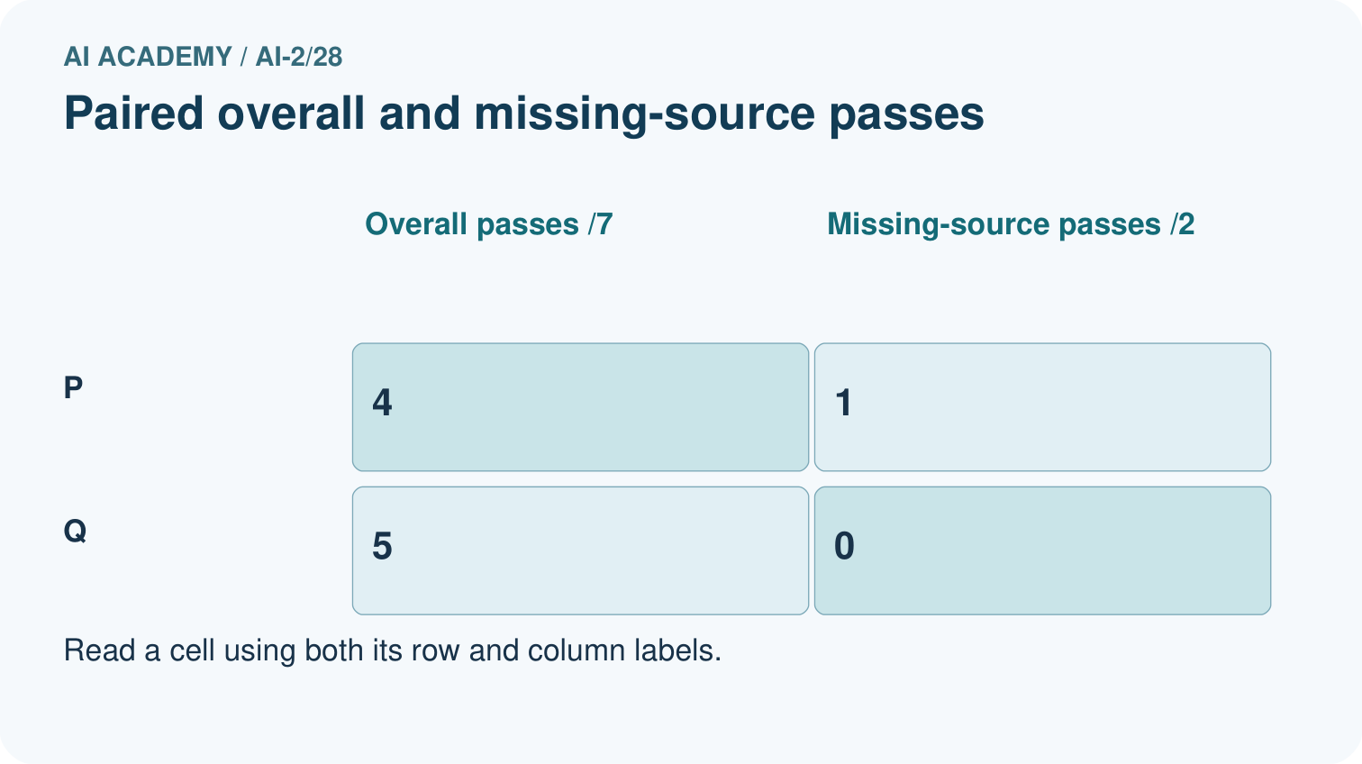
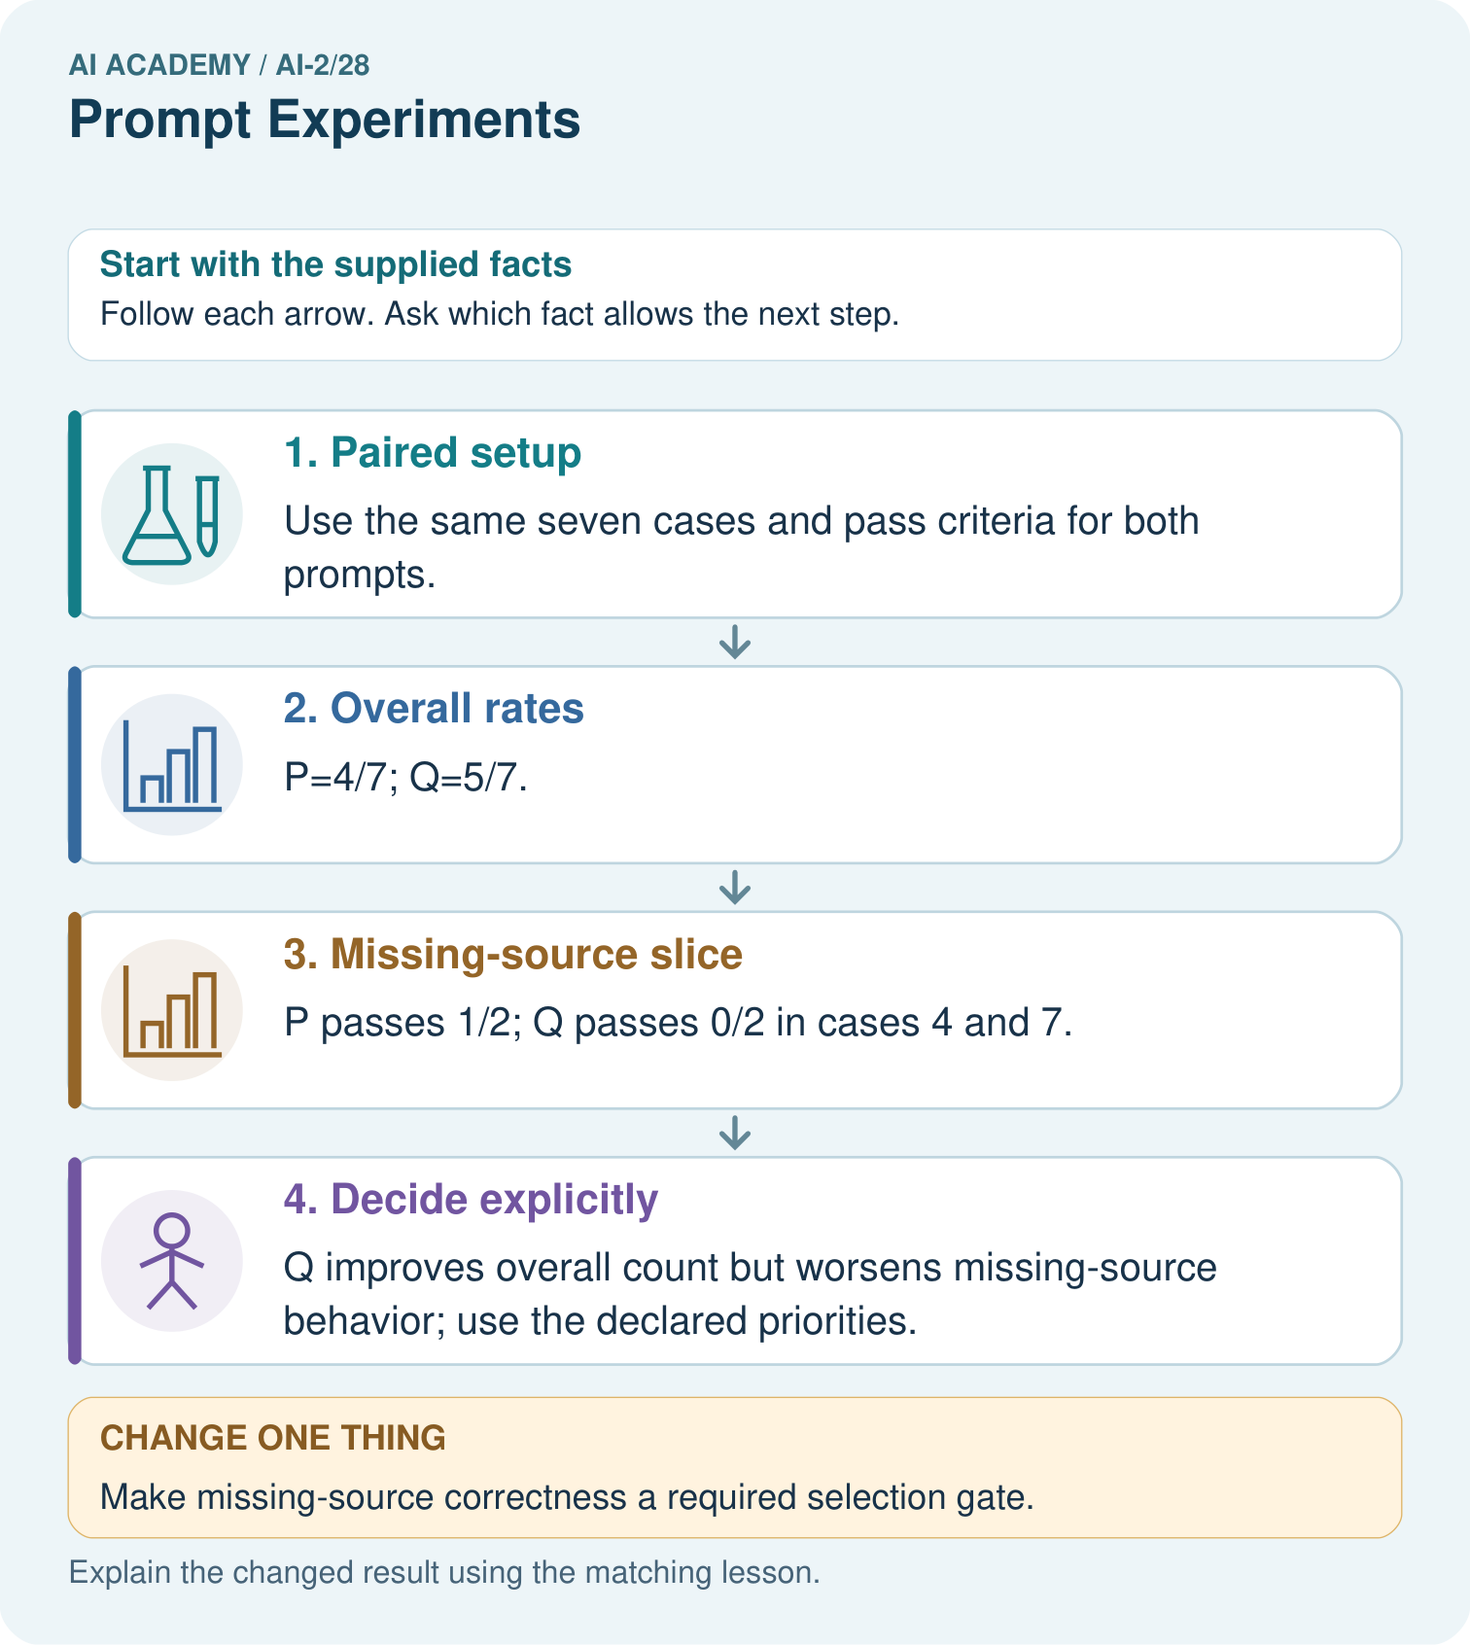
Name the case P passes and Q fails, and explain why it matters.

My picture-based explanation and changed-case prediction
________________________________________________________________
________________________________________________________________
________________________________________________________________
________________________________________________________________
________________________________________________________________
________________________________________________________________
Support used: alone / hint / worked example. This record is practice evidence.
Project connection: Run controlled recommender explanation experiments with paired cases and report important failure conditions separately.

19. Project portfolio milestone
Project: Transparent Book Recommender
Current milestone: Prepare the demonstration. Gather reproducible instructions, evidence, access checks and remaining limitations.
Run controlled recommender explanation experiments with paired cases and report important failure conditions separately.
Evidence to keep | My record
This week’s input and deciding step
Prediction and actual result (or labelled paper trace)
One change since the previous checkpoint and why
One error or limit and the next test

Explain what this week adds to your project. Reuse last week’s record rather than starting again.
________________________________________________________________
________________________________________________________________
________________________________________________________________
________________________________________________________________
________________________________________________________________

20. Supported practice and learning evidence
Use this supported practice once, in the browser or on paper. Keep the reserved independent assessment for a separate first attempt before teacher feedback.
A fictional book-help project tests two prompt versions on seven shared development cases.

Practice 1: explain the deciding evidence
Which labelled step matches this detail? Q improves overall count but worsens missing-source behavior; use the declared priorities.
1. Decide explicitly
2. Paired setup
3. Missing-source slice
4. Overall rates

My selected conclusion, deciding fact and explanation
________________________________________________________________
________________________________________________________________
________________________________________________________________
________________________________________________________________
________________________________________________________________
Hint if needed: Read the steps in the pictorial case. Match the supplied detail to the stage that performs or records it.
After your attempt, compare with the supported explanation: Decide explicitly Q improves overall count but worsens missing-source behavior; use the declared priorities. A larger total can conceal a more serious failure category. Paired records show which cases changed, not just how many passed. If refusing unsupported claims is mandatory, Q’s overall advantage may not justify selection. Keep the failing examples for development and obtain fresh cases after choosing a final version.

Practice 2: explain the deciding evidence
Changed-case practice: Make missing-source correctness a required selection gate. Which conclusion is supported by the supplied facts?
1. We can decide the result without examining the changed input or the procedure.
2. Neither prompt clears a 2/2 gate on these records.
3. This one example guarantees correct results for every future input.

My selected conclusion, deciding fact and explanation
________________________________________________________________
________________________________________________________________
________________________________________________________________
________________________________________________________________
________________________________________________________________
Hint if needed: Use the changed condition and the deciding step in the pictorial trace. The answer must say what follows from those facts.
After your attempt, compare with the supported explanation: Neither prompt clears a 2/2 gate on these records. P fails 7 and Q fails both 4 and 7; both need revision.

Repair a missing building block
Review Predictive vs Generative (ai-2/27). Goal: Distinguish discriminative prediction from generation by inspecting the requested output. Short practice: Does matching the physical box in the changed table prove the generator measures boxes?. Return to this week and explain what you changed.
Review Text as Pieces (ai-2/25). Goal: Encode and decode text under an explicit toy vocabulary. Short practice: Why is the unknown ! at position 10 rather than position 9?. Return to this week and explain what you changed.
Review Nearest Neighbor Reasoning (ai-2/22). Goal: Compute absolute distances and rank training neighbours. Short practice: Why do k=1 and k=3 disagree for the original query?. Return to this week and explain what you changed.

Keep your completed work
Use Download completed work in the hosted lesson to export your answers, reflections, practice feedback and code-run evidence. Open the HTML copy to read or print it. Drafts stay in this browser when storage is available; clear drafts on a shared device.

What I repaired, the evidence I kept and the next test
________________________________________________________________
________________________________________________________________
________________________________________________________________
________________________________________________________________
________________________________________________________________

