AI ACADEMY · WORKBOOK · ai-2/29

Evidence and Sources
Project: Transparent Book Recommender

01. Recall and choose your starting point
Try the recall before opening notes. Then use a different colour or a labelled second line to correct your explanation.

Prompt Experiments
Without opening the old lesson, explain one key idea from Prompt Experiments. Give an example and a mistake that the idea helps you avoid.

My remembered idea, example and correction
________________________________________________________________
________________________________________________________________
________________________________________________________________

Image and Voice Pipelines
Without opening the old lesson, explain one key idea from Image and Voice Pipelines. Give an example and a mistake that the idea helps you avoid.

My remembered idea, example and correction
________________________________________________________________
________________________________________________________________
________________________________________________________________

Recommendation Scores
Without opening the old lesson, explain one key idea from Recommendation Scores. Give an example and a mistake that the idea helps you avoid.

My remembered idea, example and correction
________________________________________________________________
________________________________________________________________
________________________________________________________________

02. Practise with fading help
Use W2: Trace the worked case for Claim support and citation evaluation. Record the answer once; the lesson and workbook refer to the same attempt.
Given inputs | Procedure I chose | Middle steps | Result and check

The step I completed without help, and the hint I needed
________________________________________________________________
________________________________________________________________
________________________________________________________________

03. Individual reasoning check
Use the worked case for Claim support and citation evaluation. Proposed explanation: “The worked result establishes every future case”. Decide whether this explanation is supported. Point to the step or supplied fact that decides; explain your repair if needed.

My explanation before partner discussion
________________________________________________________________
________________________________________________________________
________________________________________________________________
________________________________________________________________

04. Independent transfer case

Independent case: Apply a new case independently
Five claims; four cited; three supported by cited passages; one cited ID is nonexistent. Compute support and citation presence and explain link limits.

My independent explanation, trace and limits
________________________________________________________________
________________________________________________________________
________________________________________________________________
________________________________________________________________
________________________________________________________________
________________________________________________________________
________________________________________________________________
Attempt this case before feedback. Record any help. Earlier examples below are further practice; a case already practised with feedback cannot establish fresh transfer.

05. Your learning target
Two catalogue records list 96 and 112 pages for a title. A helper averages them and reports 104. Explain the mistake and a better verification process.

06. Solve the given case
An answer says 80 pages, but the catalogue for that edition says 120.
What evidence guides correction?
Show your trace, calculation or evidence

Write or draw your reasoning and evidence.
________________________________________________________________
________________________________________________________________
________________________________________________________________
________________________________________________________________
________________________________________________________________

07. Check a changed case
An answer cites a page about opening hours to support a claim about book prices. Is a citation enough? What must be checked?
My independent answer and reason

Write or draw your reasoning and evidence.
________________________________________________________________
________________________________________________________________
________________________________________________________________
________________________________________________________________
________________________________________________________________

Week 29 Test and reflect

08. Design a revealing test
Create a changed input, boundary case or missing-information case. Write the expected answer or safe response before testing.
Test record | My evidence
Changed input or condition
Expected answer or fallback
Observed result
Why the result occurred

09. Project checkpoint
Separate profile-based ranking evidence from factual book information and cite the latter.
The project change and evidence I will keep

Write or draw your reasoning and evidence.
________________________________________________________________
________________________________________________________________
________________________________________________________________
________________________________________________________________
________________________________________________________________

10. Self check
I can explain the mechanism. I can show evidence. I can handle a changed case. I can name a limit. Mark each as not yet, with help or independently, and attach supporting work.
Teacher review ____________________ Next step ____________________

11. Transfer practice from the original programme
Two catalogue records list 96 and 112 pages for a title. A helper averages them and reports 104. Explain the mistake and a better verification process.

My independently reasoned answer
________________________________________________________________
________________________________________________________________
________________________________________________________________
________________________________________________________________
________________________________________________________________
________________________________________________________________
________________________________________________________________
Record support used: none, hint or teacher explanation.

12. W1 Explain the mechanism
Explain the weekly mechanism in your own words. Use the worked scenario to name its input, decision rule and output.

My reasoning and evidence
________________________________________________________________
________________________________________________________________
________________________________________________________________
________________________________________________________________
________________________________________________________________
________________________________________________________________

13. W2 Trace the worked case
An answer has four factual claims. Three have citations, but only two are supported by their cited passages. All links exist. Show the intermediate steps and give the conclusion with its scope.

My reasoning and evidence
________________________________________________________________
________________________________________________________________
________________________________________________________________
________________________________________________________________
________________________________________________________________
________________________________________________________________
________________________________________________________________

14. W3 Audit the limit
A report omits this qualification: Citation counts do not establish truth beyond the supplied sources or the correctness of uncited claims. Explain how omitting it could change a reader's interpretation, and write an accurate replacement.

My reasoning and evidence
________________________________________________________________
________________________________________________________________
________________________________________________________________
________________________________________________________________
________________________________________________________________
________________________________________________________________

15. W4 Apply a new case independently
Five claims; four cited; three supported by cited passages; one cited ID is nonexistent. Compute support and citation presence and explain link limits.

My reasoning and evidence
________________________________________________________________
________________________________________________________________
________________________________________________________________
________________________________________________________________
________________________________________________________________
________________________________________________________________
________________________________________________________________
________________________________________________________________

16. W5 Design a revealing follow-up
For the worked scenario, propose one additional case that could reveal a failure, describe its expected outcome before running it, and explain what would need to remain fixed for a fair comparison. Do not reuse W4 as a new final test after receiving feedback.

My reasoning and evidence
________________________________________________________________
________________________________________________________________
________________________________________________________________
________________________________________________________________
________________________________________________________________
________________________________________________________________
________________________________________________________________

17. Feedback, return check and learning record
Evidence | My record
Worked alone / hint / model
First step I repaired and why
New case checked later; date and result
What I can now explain without notes
One remaining question
Revisit this idea with your teacher after a delay. Familiarity is different from explaining and using it on a changed case.

18. Pictorial case practice: Evidence and Sources
A fictional catalogue answer contains three factual statements and cites existing records.
Record R: book Ocean Maps has 80 pages and is available on shelf 2.
Claims: 80 pages [R]; shelf 2 [R]; suitable for every child [R]. All three citations resolve to R.
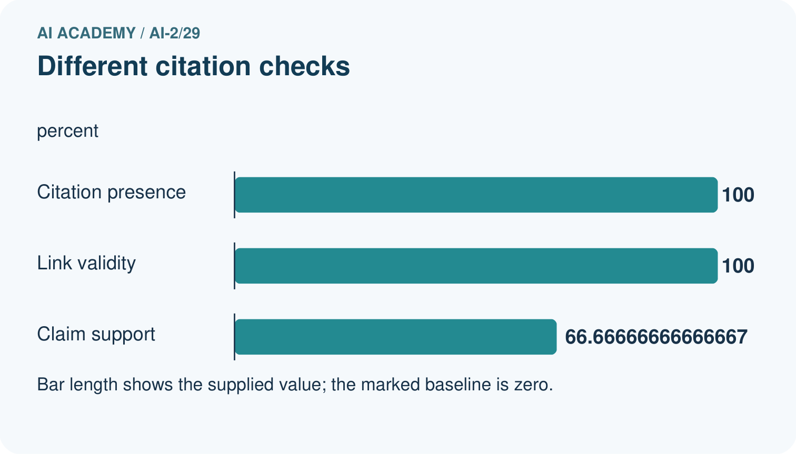
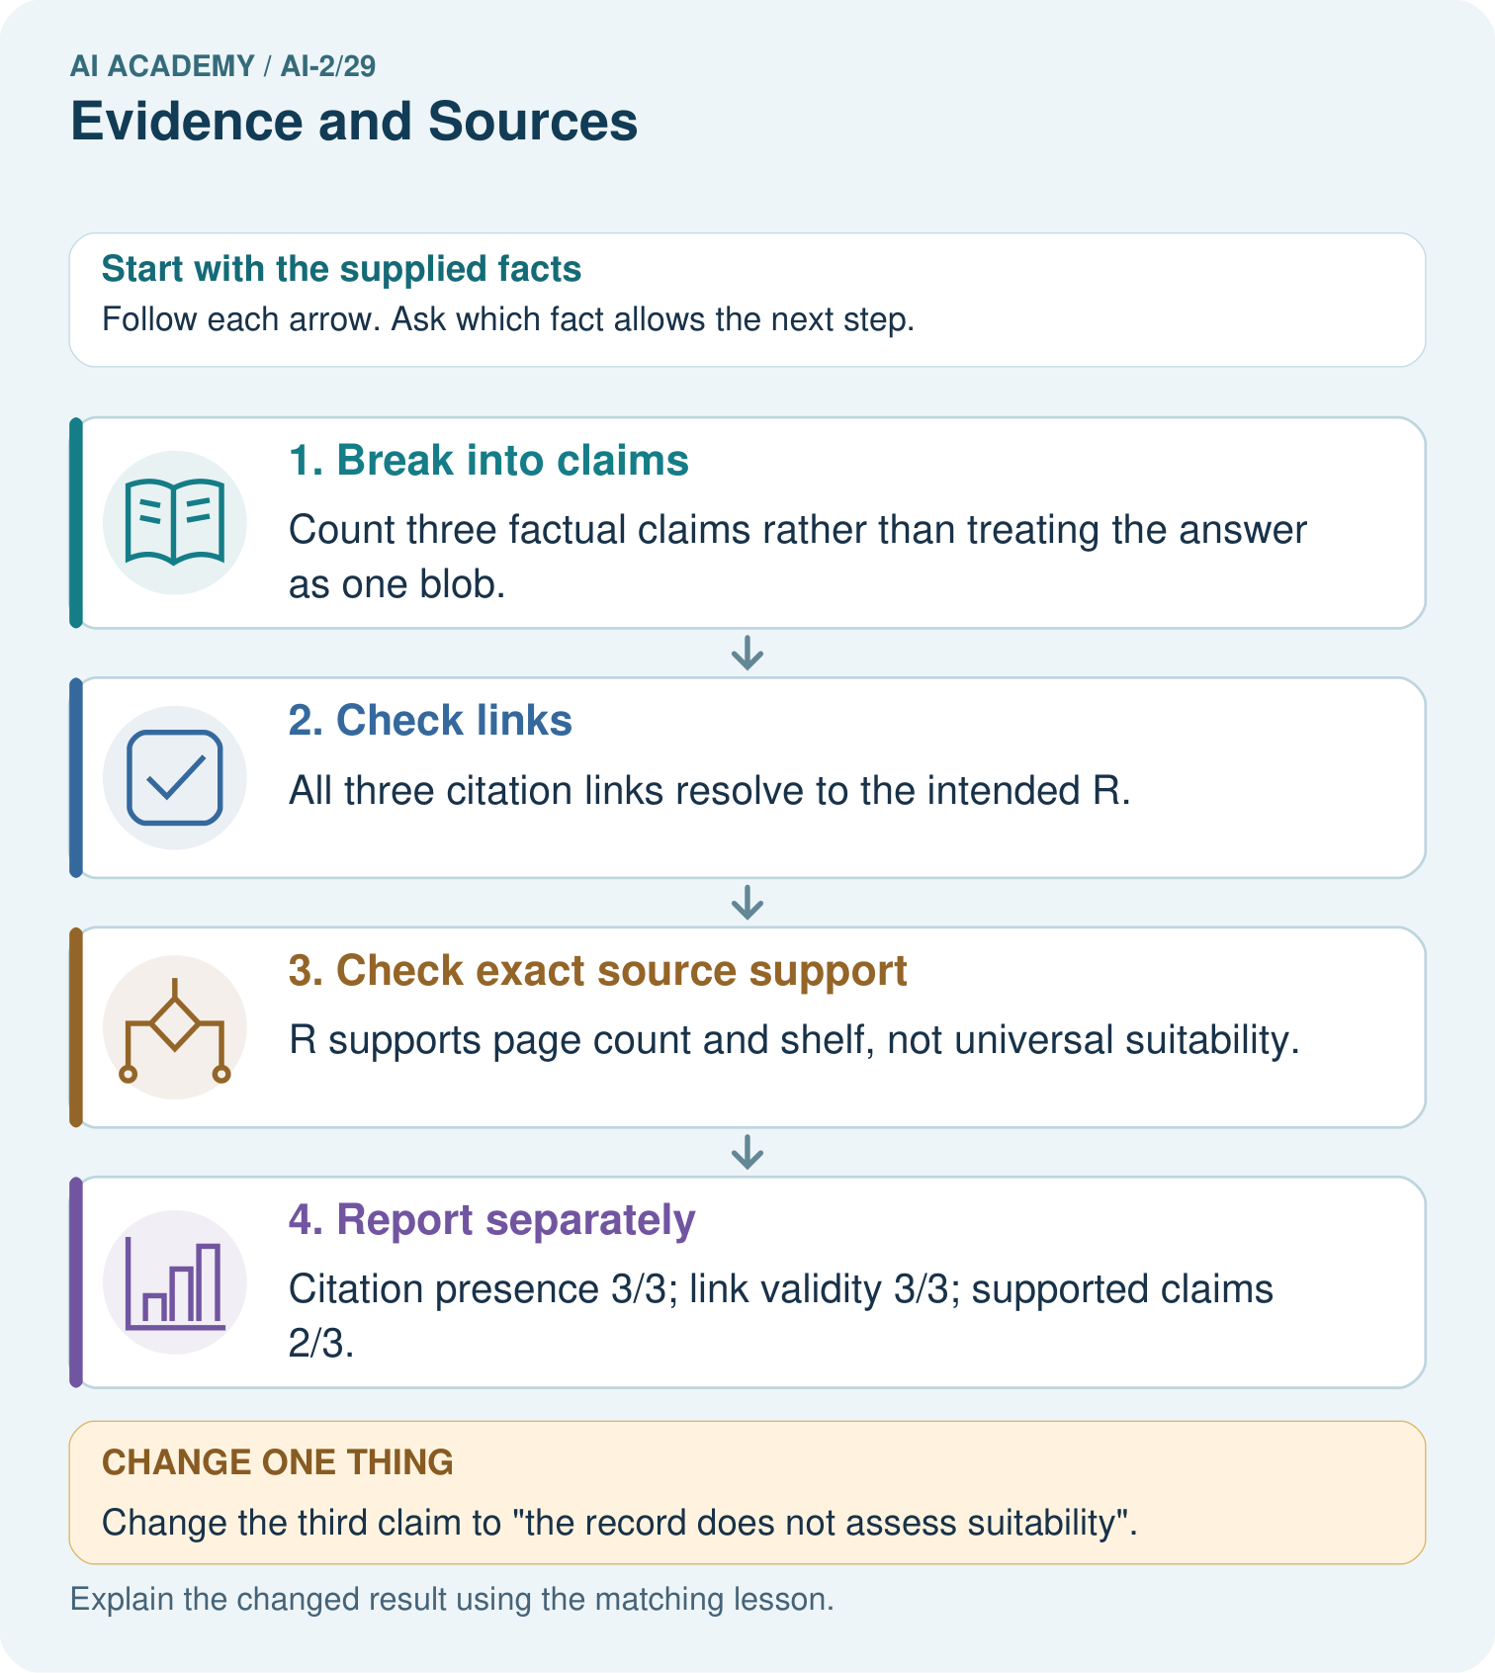
Why is the original answer not fully supported despite having citations on every claim?

My picture-based explanation and changed-case prediction
________________________________________________________________
________________________________________________________________
________________________________________________________________
________________________________________________________________
________________________________________________________________
________________________________________________________________
Support used: alone / hint / worked example. This record is practice evidence.
Project connection: Attach source IDs to recommender explanation facts and separately audit whether each source supports its precise statement.

19. Project portfolio milestone
Project: Transparent Book Recommender
Current milestone: Prepare the demonstration. Gather reproducible instructions, evidence, access checks and remaining limitations.
Attach source IDs to recommender explanation facts and separately audit whether each source supports its precise statement.
Evidence to keep | My record
This week’s input and deciding step
Prediction and actual result (or labelled paper trace)
One change since the previous checkpoint and why
One error or limit and the next test

Explain what this week adds to your project. Reuse last week’s record rather than starting again.
________________________________________________________________
________________________________________________________________
________________________________________________________________
________________________________________________________________
________________________________________________________________

20. Supported practice and learning evidence
Use this supported practice once, in the browser or on paper. Keep the reserved independent assessment for a separate first attempt before teacher feedback.
A fictional catalogue answer contains three factual statements and cites existing records.

Practice 1: explain the deciding evidence
Which labelled step matches this detail? Citation presence 3/3; link validity 3/3; supported claims 2/3.
1. Check exact source support
2. Check links
3. Report separately
4. Break into claims

My selected conclusion, deciding fact and explanation
________________________________________________________________
________________________________________________________________
________________________________________________________________
________________________________________________________________
________________________________________________________________
Hint if needed: Read the steps in the pictorial case. Match the supplied detail to the stage that performs or records it.
After your attempt, compare with the supported explanation: Report separately Citation presence 3/3; link validity 3/3; supported claims 2/3. An existing citation is not automatically evidence for every nearby sentence. Read the cited passage and compare its exact scope with the claim. The universal suitability statement extends beyond what R says. Remove or qualify unsupported content; adding more copies of the same link does not create the missing evidence.

Practice 2: explain the deciding evidence
Changed-case practice: Change the third claim to “the record does not assess suitability”. Which conclusion is supported by the supplied facts?
1. That statement accurately describes the supplied record’s limits.
2. This one example guarantees correct results for every future input.
3. We can decide the result without examining the changed input or the procedure.

My selected conclusion, deciding fact and explanation
________________________________________________________________
________________________________________________________________
________________________________________________________________
________________________________________________________________
________________________________________________________________
Hint if needed: Use the changed condition and the deciding step in the pictorial trace. The answer must say what follows from those facts.
After your attempt, compare with the supported explanation: That statement accurately describes the supplied record’s limits. R gives pages and shelf only; it contains no suitability assessment.

Repair a missing building block
Review Prompt Experiments (ai-2/28). Goal: Explain the mechanism and terminology of controlled prompt experiments. Short practice: Name the case P passes and Q fails, and explain why it matters.. Return to this week and explain what you changed.
Review Image and Voice Pipelines (ai-2/26). Goal: Explain the mechanism and terminology of speech pipelines and multimodal evidence. Short practice: Which stage first fails, and why should the faulty transcript not be silently overwritten?. Return to this week and explain what you changed.
Review Recommendation Scores (ai-2/23). Goal: Compute a weighted score. Short practice: Why does B not become the winner when its score is largest?. Return to this week and explain what you changed.

Keep your completed work
Use Download completed work in the hosted lesson to export your answers, reflections, practice feedback and code-run evidence. Open the HTML copy to read or print it. Drafts stay in this browser when storage is available; clear drafts on a shared device.

What I repaired, the evidence I kept and the next test
________________________________________________________________
________________________________________________________________
________________________________________________________________
________________________________________________________________
________________________________________________________________

