AI ACADEMY · WORKBOOK · ai-2/35

Improve and Challenge
Project: Transparent Book Recommender

01. Recall and choose your starting point
Try the recall before opening notes. Then use a different colour or a labelled second line to correct your explanation.

Test Diverse Users
Without opening the old lesson, explain one key idea from Test Diverse Users. Give an example and a mistake that the idea helps you avoid.

My remembered idea, example and correction
________________________________________________________________
________________________________________________________________
________________________________________________________________

Project Problem and Success Test
Without opening the old lesson, explain one key idea from Project Problem and Success Test. Give an example and a mistake that the idea helps you avoid.

My remembered idea, example and correction
________________________________________________________________
________________________________________________________________
________________________________________________________________

Evidence and Sources
Without opening the old lesson, explain one key idea from Evidence and Sources. Give an example and a mistake that the idea helps you avoid.

My remembered idea, example and correction
________________________________________________________________
________________________________________________________________
________________________________________________________________

02. Practise with fading help
Use W2: Test neighbors for Improving without hiding failures. Record the answer once; the lesson and workbook refer to the same attempt.
Given inputs | Procedure I chose | Middle steps | Result and check

The step I completed without help, and the hint I needed
________________________________________________________________
________________________________________________________________
________________________________________________________________

03. Individual reasoning check
Use the worked case for Improving without hiding failures. Proposed explanation: “A successful run proves the conclusion”. Decide whether this explanation is supported. Point to the step or supplied fact that decides; explain your repair if needed.

My explanation before partner discussion
________________________________________________________________
________________________________________________________________
________________________________________________________________
________________________________________________________________

04. Independent transfer case

Independent case: Repair independently
Write the eligibility predicate for at most 12 minutes and a regression set including 11,12,13 and 0. Add one chooser tie case and one invalid-data case to rerun.

My independent explanation, trace and limits
________________________________________________________________
________________________________________________________________
________________________________________________________________
________________________________________________________________
________________________________________________________________
________________________________________________________________
________________________________________________________________
Attempt this case before feedback. Record any help. Earlier examples below are further practice; a case already practised with feedback cannot establish fresh transfer.

05. Your learning target
After a scoring change, four old failures pass but two previous passes fail. On the original ten cases there were six passes. Compute the new total and explain what else should be reported.

06. Solve the given case
A repair raises success from 7/10 to 9/10 on the same validation set.
What belongs in the improvement claim?
Show your trace, calculation or evidence

Write or draw your reasoning and evidence.
________________________________________________________________
________________________________________________________________
________________________________________________________________
________________________________________________________________
________________________________________________________________

07. Check a changed case
After changing a scoring weight, the system fixes one request but breaks two previously correct ones. What should the improvement record say?
My independent answer and reason

Write or draw your reasoning and evidence.
________________________________________________________________
________________________________________________________________
________________________________________________________________
________________________________________________________________
________________________________________________________________

Week 35 Test and reflect

08. Design a revealing test
Create a changed input, boundary case or missing-information case. Write the expected answer or safe response before testing.
Test record | My evidence
Changed input or condition
Expected answer or fallback
Observed result
Why the result occurred

09. Project checkpoint
Publish the cause, one change, fixed test set, before/after evidence, and remaining limitation.
The project change and evidence I will keep

Write or draw your reasoning and evidence.
________________________________________________________________
________________________________________________________________
________________________________________________________________
________________________________________________________________
________________________________________________________________

10. Self check
I can explain the mechanism. I can show evidence. I can handle a changed case. I can name a limit. Mark each as not yet, with help or independently, and attach supporting work.
Teacher review ____________________ Next step ____________________

11. Transfer practice from the original programme
After a scoring change, four old failures pass but two previous passes fail. On the original ten cases there were six passes. Compute the new total and explain what else should be reported.

My independently reasoned answer
________________________________________________________________
________________________________________________________________
________________________________________________________________
________________________________________________________________
________________________________________________________________
________________________________________________________________
________________________________________________________________
Record support used: none, hint or teacher explanation.

12. W1 Locate the cause
Why does minutes < limit reject a valid exactly-at-limit activity?

My reasoning and evidence
________________________________________________________________
________________________________________________________________
________________________________________________________________
________________________________________________________________
________________________________________________________________
________________________________________________________________

13. W2 Test neighbors
For limit 15, give expected eligibility at 14, 15 and 16.

My reasoning and evidence
________________________________________________________________
________________________________________________________________
________________________________________________________________
________________________________________________________________
________________________________________________________________
________________________________________________________________

14. W3 Reject a bad fix
A proposed fix accepts minutes <= limit + 1. Give a counterexample at limit 15.

My reasoning and evidence
________________________________________________________________
________________________________________________________________
________________________________________________________________
________________________________________________________________
________________________________________________________________
________________________________________________________________

15. W4 Repair independently
Write the eligibility predicate for at most 12 minutes and a regression set including 11,12,13 and 0. Add one chooser tie case and one invalid-data case to rerun.

My reasoning and evidence
________________________________________________________________
________________________________________________________________
________________________________________________________________
________________________________________________________________
________________________________________________________________
________________________________________________________________
________________________________________________________________
________________________________________________________________

16. W5 Write the change log
Record the bug, change, evidence and one remaining limit without claiming all bugs are gone.

My reasoning and evidence
________________________________________________________________
________________________________________________________________
________________________________________________________________
________________________________________________________________
________________________________________________________________
________________________________________________________________

17. Testing functions and interfaces — W1 Choose test scale
Classify testing score(3,2) versus running raw rows through the whole chooser.

My reasoning and evidence
________________________________________________________________
________________________________________________________________
________________________________________________________________
________________________________________________________________
________________________________________________________________
________________________________________________________________

18. Testing functions and interfaces — W2 Calculate an oracle
What expected score should a test use for fun 4 and learning 3?

My reasoning and evidence
________________________________________________________________
________________________________________________________________
________________________________________________________________
________________________________________________________________
________________________________________________________________
________________________________________________________________

19. Testing functions and interfaces — W3 Repair a weak test
A test compares recommend(items,10) to itself. Replace it with a useful assertion.

My reasoning and evidence
________________________________________________________________
________________________________________________________________
________________________________________________________________
________________________________________________________________
________________________________________________________________
________________________________________________________________

20. Testing functions and interfaces — W4 Test independently
Design an integration fixture: A valid (minutes 10, fun 2, learning 4), B valid (10,3,2), C invalid (5,9,1), limit 10. State winner, counts and a reversed-order expectation.

My reasoning and evidence
________________________________________________________________
________________________________________________________________
________________________________________________________________
________________________________________________________________
________________________________________________________________
________________________________________________________________
________________________________________________________________
________________________________________________________________

21. Testing functions and interfaces — W5 Cover absence
What expected result should an empty-input integration case specify?

My reasoning and evidence
________________________________________________________________
________________________________________________________________
________________________________________________________________
________________________________________________________________
________________________________________________________________
________________________________________________________________

22. Feedback, return check and learning record
Evidence | My record
Worked alone / hint / model
First step I repaired and why
New case checked later; date and result
What I can now explain without notes
One remaining question
Revisit this idea with your teacher after a delay. Familiarity is different from explaining and using it on a changed case.

23. Pictorial case practice: Improve and Challenge
A fictional recommender excludes books at an intended including equality page limit.
Contract: pages<=100; highest interest; ties choose smaller ID. Old code uses pages<100.
Rows A pages100 interest5; B pages90 interest3; C pages101 interest5.
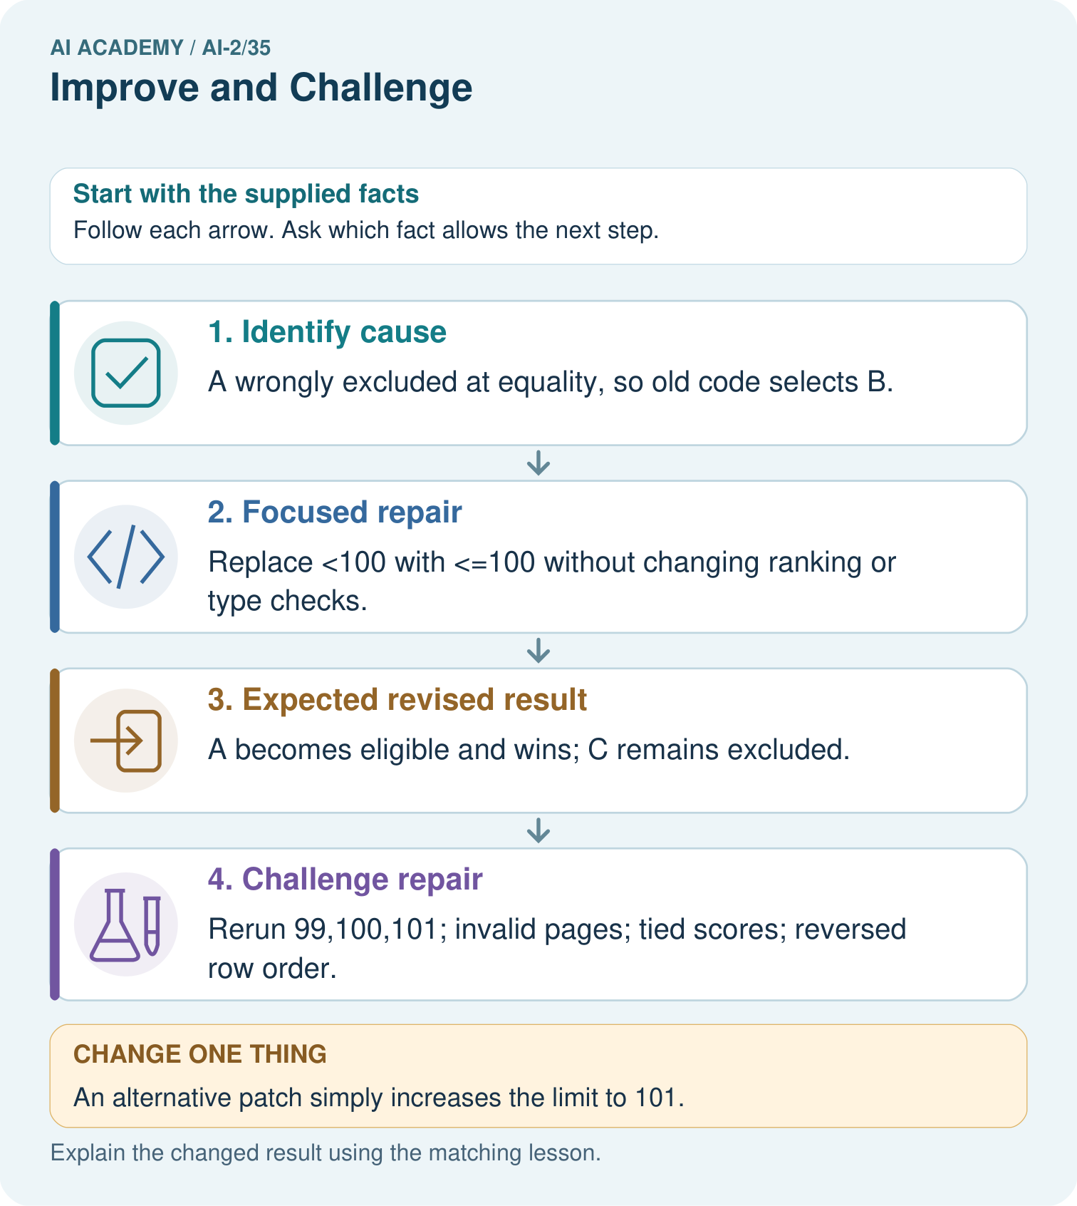
Why are tests at both 100 and 101 needed?

My picture-based explanation and changed-case prediction
________________________________________________________________
________________________________________________________________
________________________________________________________________
________________________________________________________________
________________________________________________________________
________________________________________________________________
Support used: alone / hint / worked example. This record is practice evidence.
Project connection: For each recommender revision, retain cause, code change, targeted test, regression results and unresolved issues.

24. Project portfolio milestone
Project: Transparent Book Recommender
Current milestone: Present and defend. Demonstrate the system, explain one failure and justify the next improvement with evidence.
For each recommender revision, retain cause, code change, targeted test, regression results and unresolved issues.
Evidence to keep | My record
This week’s input and deciding step
Prediction and actual result (or labelled paper trace)
One change since the previous checkpoint and why
One error or limit and the next test

Explain what this week adds to your project. Reuse last week’s record rather than starting again.
________________________________________________________________
________________________________________________________________
________________________________________________________________
________________________________________________________________
________________________________________________________________

25. Supported practice and learning evidence
Use this supported practice once, in the browser or on paper. Keep the reserved independent assessment for a separate first attempt before teacher feedback.
A fictional recommender excludes books at an intended including equality page limit.

Practice 1: explain the deciding evidence
Which labelled step matches this detail? Rerun 99,100,101; invalid pages; tied scores; reversed row order.
1. Identify cause
2. Expected revised result
3. Challenge repair
4. Focused repair

My selected conclusion, deciding fact and explanation
________________________________________________________________
________________________________________________________________
________________________________________________________________
________________________________________________________________
________________________________________________________________
Hint if needed: Read the steps in the pictorial case. Match the supplied detail to the stage that performs or records it.
After your attempt, compare with the supported explanation: Challenge repair Rerun 99,100,101; invalid pages; tied scores; reversed row order. A focused change makes the claim about what caused the error testable: the equality comparison rule caused this specific failure. Regression tests check surrounding behavior that should remain unchanged. A tie case and reversed input order are necessary because a correct boundary does not ensure deterministic selection. Log the old failure and revised replay separately.

Practice 2: explain the deciding evidence
Changed-case practice: An alternative patch simply increases the limit to 101. Which conclusion is supported by the supplied facts?
1. We can decide the result without examining the changed input or the procedure.
2. This one example guarantees correct results for every future input.
3. C is wrongly admitted as well as A.

My selected conclusion, deciding fact and explanation
________________________________________________________________
________________________________________________________________
________________________________________________________________
________________________________________________________________
________________________________________________________________
Hint if needed: Use the changed condition and the deciding step in the pictorial trace. The answer must say what follows from those facts.
After your attempt, compare with the supported explanation: C is wrongly admitted as well as A. Changing the maximum alters the contract instead of repairing its comparison.

Repair a missing building block
Review Test Diverse Users (ai-2/34). Goal: Evaluate across varied cases. Short practice: Can these records establish performance for different user groups?. Return to this week and explain what you changed.
Review Project Problem and Success Test (ai-2/32). Goal: Define a small application purpose. Short practice: Write an equality test and explain which requirement it checks.. Return to this week and explain what you changed.
Review Evidence and Sources (ai-2/29). Goal: Explain the mechanism and terminology of claim support and citation evaluation. Short practice: Why is the original answer not fully supported despite having citations on every claim?. Return to this week and explain what you changed.

Predict, run and debug
The browser lab lets you edit the supported Python examples already included in this lesson. Predict first, run, inspect the actual output or error, change one input, then run again. Keep code, predictions, actual results and a reasoned revision together. On paper, label your result as a trace rather than an execution.

Keep your completed work
Use Download completed work in the hosted lesson to export your answers, reflections, practice feedback and code-run evidence. Open the HTML copy to read or print it. Drafts stay in this browser when storage is available; clear drafts on a shared device.

What I repaired, the evidence I kept and the next test
________________________________________________________________
________________________________________________________________
________________________________________________________________
________________________________________________________________
________________________________________________________________

