AI ACADEMY · WORKBOOK · ai-3/1

Predictive and Generative AI
Project: Verified Study Buddy

01. Recall and choose your starting point
Try the recall before opening notes. Then use a different colour or a labelled second line to correct your explanation.

Capstone Expo
Without opening the old lesson, explain one key idea from Capstone Expo. Give an example and a mistake that the idea helps you avoid.

My remembered idea, example and correction
________________________________________________________________
________________________________________________________________
________________________________________________________________

02. Practise with fading help
Use W2: Compute the distribution for Generative and predictive objectives. Record the answer once; the lesson and workbook refer to the same attempt.
Given inputs | Procedure I chose | Middle steps | Result and check

The step I completed without help, and the hint I needed
________________________________________________________________
________________________________________________________________
________________________________________________________________

03. Individual reasoning check
Use the worked case for Generative and predictive objectives. Proposed explanation: “Generative models do not predict”. Decide whether this explanation is supported. Point to the step or supplied fact that decides; explain your repair if needed.

My explanation before partner discussion
________________________________________________________________
________________________________________________________________
________________________________________________________________
________________________________________________________________

04. Independent transfer case

Independent case: Changed independent case
A system retrieves an approved Moon note, uses a trained classifier to predict reading difficulty, then writes a poem. Identify each mechanism and the evidence needed to check its output.

My independent explanation, trace and limits
________________________________________________________________
________________________________________________________________
________________________________________________________________
________________________________________________________________
________________________________________________________________
________________________________________________________________
________________________________________________________________
Attempt this case before feedback. Record any help. Earlier examples below are further practice; a case already practised with feedback cannot establish fresh transfer.

05. Your learning target
A study tool finds a paragraph, labels its difficulty and invents practice questions. Identify the three operations and one check for each.

06. Solve the given case
A tool labels a question biology, writes a new question and computes 7 times 8.
Identify each operation.
Show your trace, calculation or evidence

Write or draw your reasoning and evidence.
________________________________________________________________
________________________________________________________________
________________________________________________________________
________________________________________________________________
________________________________________________________________

07. Check a changed case
A system labels a message as spam. Another writes a new reply. Which task predicts a category and which generates content? Can the new reply contain a false fact?
My independent answer and reason

Write or draw your reasoning and evidence.
________________________________________________________________
________________________________________________________________
________________________________________________________________
________________________________________________________________
________________________________________________________________

Week 1 Test and reflect

08. Design a revealing test
Create a changed input, boundary case or missing-information case. Write the expected answer or safe response before testing.
Test record | My evidence
Changed input or condition
Expected answer or fallback
Observed result
Why the result occurred

09. Project checkpoint
Separate Study Buddy tasks into classify, calculate, retrieve, and generate stages.
The project change and evidence I will keep

Write or draw your reasoning and evidence.
________________________________________________________________
________________________________________________________________
________________________________________________________________
________________________________________________________________
________________________________________________________________

10. Self check
I can explain the mechanism. I can show evidence. I can handle a changed case. I can name a limit. Mark each as not yet, with help or independently, and attach supporting work.
Teacher review ____________________ Next step ____________________

11. Transfer practice from the original programme
A study tool finds a paragraph, labels its difficulty and invents practice questions. Identify the three operations and one check for each.

My independently reasoned answer
________________________________________________________________
________________________________________________________________
________________________________________________________________
________________________________________________________________
________________________________________________________________
________________________________________________________________
________________________________________________________________
Record support used: none, hint or teacher explanation.

12. W1 Identify the objective
Classify these components by target: label a message request/report; continue a prefix with a sequence; retrieve a stored sensor record. Explain why the application may combine them.

My reasoning and evidence
________________________________________________________________
________________________________________________________________
________________________________________________________________
________________________________________________________________
________________________________________________________________
________________________________________________________________

13. W2 Compute the distribution
For The marker is, calculate the three empirical probabilities, their sum and their meaning.

My reasoning and evidence
________________________________________________________________
________________________________________________________________
________________________________________________________________
________________________________________________________________
________________________________________________________________
________________________________________________________________

14. W3 Follow the prefix
After red is selected, the expanded-prefix table gives end 0.8 and today 0.2. Explain why these values cannot be substituted for the red/blue/green probabilities.

My reasoning and evidence
________________________________________________________________
________________________________________________________________
________________________________________________________________
________________________________________________________________
________________________________________________________________
________________________________________________________________

15. W4 Analyse a new corpus independently
For prefix The signal is, counts are high 2, low 5, unknown 3. Compute all probabilities and the most frequent continuation. A current measurement reports high. State what the most frequent continuation does and does not establish.

My reasoning and evidence
________________________________________________________________
________________________________________________________________
________________________________________________________________
________________________________________________________________
________________________________________________________________
________________________________________________________________
________________________________________________________________
________________________________________________________________

16. W5 Design a useful evaluation
A system reports current room status using retrieved measurements and generated sentences. Name checks for evidence, response quality and permission.

My reasoning and evidence
________________________________________________________________
________________________________________________________________
________________________________________________________________
________________________________________________________________
________________________________________________________________
________________________________________________________________

17. Feedback, return check and learning record
Evidence | My record
Worked alone / hint / model
First step I repaired and why
New case checked later; date and result
What I can now explain without notes
One remaining question
Revisit this idea with your teacher after a delay. Familiarity is different from explaining and using it on a changed case.

18. Pictorial case practice: Predictive and Generative AI
A fictional learning tool first classifies a question, then drafts an answer from a supplied note.
A fitted classifier labels a question science; its training used labelled questions.
Approved note N: evaporation changes liquid water into water vapour. A generator drafts: “Water evaporates into vapour and always disappears forever.”
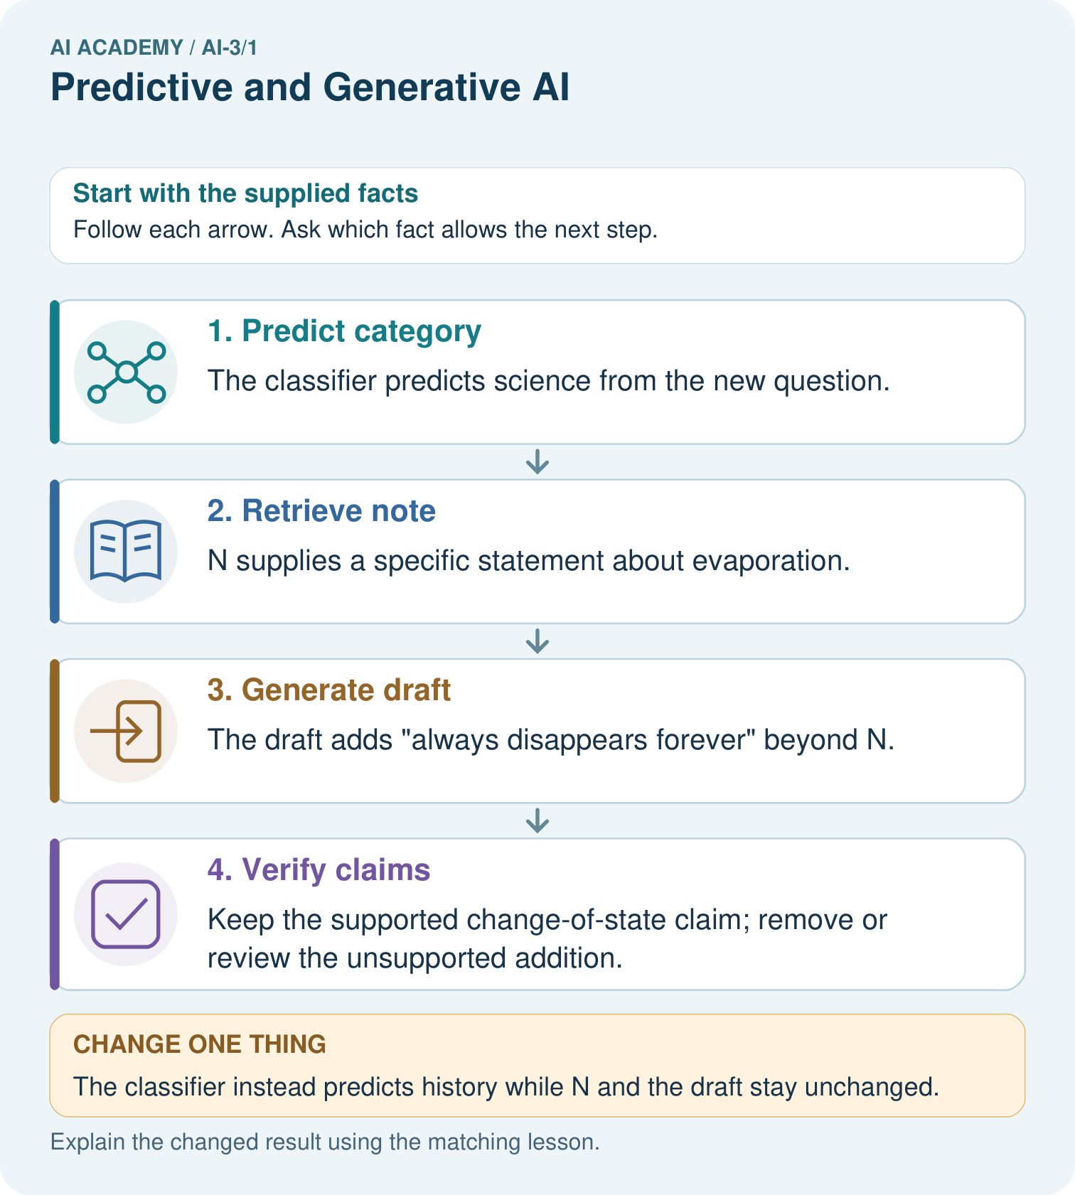
Identify the first unsupported claim and explain what source would be needed before asserting it.

My picture-based explanation and changed-case prediction
________________________________________________________________
________________________________________________________________
________________________________________________________________
________________________________________________________________
________________________________________________________________
________________________________________________________________
Support used: alone / hint / worked example. This record is practice evidence.
Project connection: For the Verified Study Buddy, separate routing predictions, source retrieval and generated explanations in its evidence record.

19. Project portfolio milestone
Project: Verified Study Buddy
Current milestone: Frame the need. Name the user, the problem, allowed inputs and a safe simple starting method.
For the Verified Study Buddy, separate routing predictions, source retrieval and generated explanations in its evidence record.
Evidence to keep | My record
This week’s input and deciding step
Prediction and actual result (or labelled paper trace)
One change since the previous checkpoint and why
One error or limit and the next test

Explain what this week adds to your project. Reuse last week’s record rather than starting again.
________________________________________________________________
________________________________________________________________
________________________________________________________________
________________________________________________________________
________________________________________________________________

20. Supported practice and learning evidence
Use this supported practice once, in the browser or on paper. Keep the reserved independent assessment for a separate first attempt before teacher feedback.
A fictional learning tool first classifies a question, then drafts an answer from a supplied note.

Practice 1: explain the deciding evidence
Which labelled step matches this detail? Keep the supported change-of-state claim; remove or review the unsupported addition.
1. Predict category
2. Verify claims
3. Retrieve note
4. Generate draft

My selected conclusion, deciding fact and explanation
________________________________________________________________
________________________________________________________________
________________________________________________________________
________________________________________________________________
________________________________________________________________
Hint if needed: Read the steps in the pictorial case. Match the supplied detail to the stage that performs or records it.
After your attempt, compare with the supported explanation: Verify claims Keep the supported change-of-state claim; remove or review the unsupported addition. Classification predicts a category under a trained mapping. Generation produces a sequence of words under a language objective. Supplying a note can support factual grounding, but the draft still requires claim-level checking. The category being correct does not prove every sentence in the answer is correct.

Practice 2: explain the deciding evidence
Changed-case practice: The classifier instead predicts history while N and the draft stay unchanged. Which conclusion is supported by the supplied facts?
1. We can decide the result without examining the changed input or the procedure.
2. This one example guarantees correct results for every future input.
3. The category prediction changes, but the same unsupported draft claim still needs checking.

My selected conclusion, deciding fact and explanation
________________________________________________________________
________________________________________________________________
________________________________________________________________
________________________________________________________________
________________________________________________________________
Hint if needed: Use the changed condition and the deciding step in the pictorial trace. The answer must say what follows from those facts.
After your attempt, compare with the supported explanation: The category prediction changes, but the same unsupported draft claim still needs checking. Stages can fail independently; one result does not validate another.

Repair a missing building block
Review Capstone Expo (ai-2/36). Goal: Defend an application using reproducible evidence. Short practice: Give the original winning ID, its score, and counts of eligible, excluded and invalid rows.. Return to this week and explain what you changed.

Keep your completed work
Use Download completed work in the hosted lesson to export your answers, reflections, practice feedback and code-run evidence. Open the HTML copy to read or print it. Drafts stay in this browser when storage is available; clear drafts on a shared device.

What I repaired, the evidence I kept and the next test
________________________________________________________________
________________________________________________________________
________________________________________________________________
________________________________________________________________
________________________________________________________________

