AI ACADEMY · WORKBOOK · ai-3/2

A Distribution of Possibilities
Project: Verified Study Buddy

01. Recall and choose your starting point
Try the recall before opening notes. Then use a different colour or a labelled second line to correct your explanation.

Predictive and Generative AI
Without opening the old lesson, explain one key idea from Predictive and Generative AI. Give an example and a mistake that the idea helps you avoid.

My remembered idea, example and correction
________________________________________________________________
________________________________________________________________
________________________________________________________________

02. Practise with fading help
Use W2: Calculate the paths for Next token distributions. Record the answer once; the lesson and workbook refer to the same attempt.
Given inputs | Procedure I chose | Middle steps | Result and check

The step I completed without help, and the hint I needed
________________________________________________________________
________________________________________________________________
________________________________________________________________

03. Individual reasoning check
Use the worked case for Next token distributions. Proposed explanation: “Conditional products assume independence”. Decide whether this explanation is supported. Point to the step or supplied fact that decides; explain your repair if needed.

My explanation before partner discussion
________________________________________________________________
________________________________________________________________
________________________________________________________________
________________________________________________________________

04. Independent transfer case

Independent case: Analyse a new table independently
First tokens go=0.4, wait=0.35, ask=0.25. End probabilities given them are 0.5,0.8,1 respectively; each branch has a complementary more token. Compute all three end-path probabilities and their sum. Which first token is greedy, which end path is largest, and does either verify a real status?

My independent explanation, trace and limits
________________________________________________________________
________________________________________________________________
________________________________________________________________
________________________________________________________________
________________________________________________________________
________________________________________________________________
________________________________________________________________
Attempt this case before feedback. Record any help. Earlier examples below are further practice; a case already practised with feedback cannot establish fresh transfer.

05. Your learning target
A toy next-token distribution is sun=.5, rain=.3, snow=.2. Over ten samples, must sun occur exactly five times? Does the highest-probability token establish a true statement about weather?

06. Solve the given case
A toy next-token distribution is rain .5, sun .3, snow .2.
Check total and interpret the largest value.
Show your trace, calculation or evidence

Write or draw your reasoning and evidence.
________________________________________________________________
________________________________________________________________
________________________________________________________________
________________________________________________________________
________________________________________________________________

07. Check a changed case
A toy next-token distribution assigns cat 0.5, dog 0.3 and bird 0.2. Check the total and name the most likely token. Must it be selected every time when sampling?
My independent answer and reason

Write or draw your reasoning and evidence.
________________________________________________________________
________________________________________________________________
________________________________________________________________
________________________________________________________________
________________________________________________________________

Week 2 Test and reflect

08. Design a revealing test
Create a changed input, boundary case or missing-information case. Write the expected answer or safe response before testing.
Test record | My evidence
Changed input or condition
Expected answer or fallback
Observed result
Why the result occurred

09. Project checkpoint
Explain that Study Buddy responses come from possibilities, so important claims need checks.
The project change and evidence I will keep

Write or draw your reasoning and evidence.
________________________________________________________________
________________________________________________________________
________________________________________________________________
________________________________________________________________
________________________________________________________________

10. Self check
I can explain the mechanism. I can show evidence. I can handle a changed case. I can name a limit. Mark each as not yet, with help or independently, and attach supporting work.
Teacher review ____________________ Next step ____________________

11. Transfer practice from the original programme
A toy next-token distribution is sun=.5, rain=.3, snow=.2. Over ten samples, must sun occur exactly five times? Does the highest-probability token establish a true statement about weather?

My independently reasoned answer
________________________________________________________________
________________________________________________________________
________________________________________________________________
________________________________________________________________
________________________________________________________________
________________________________________________________________
________________________________________________________________
Record support used: none, hint or teacher explanation.

12. W1 Validate the table
Check 0.5,0.3,0.2 as probabilities. Interpret their sum and the complement of ready.

My reasoning and evidence
________________________________________________________________
________________________________________________________________
________________________________________________________________
________________________________________________________________
________________________________________________________________
________________________________________________________________

13. W2 Calculate the paths
Compute ready,end; busy,end; unknown,end and their combined probability.

My reasoning and evidence
________________________________________________________________
________________________________________________________________
________________________________________________________________
________________________________________________________________
________________________________________________________________
________________________________________________________________

14. W3 Test a greedy claim
Use A=0.6,B=0.4 and end conditional probabilities 0.51 and 1. Compare greedy A,end with B,end.

My reasoning and evidence
________________________________________________________________
________________________________________________________________
________________________________________________________________
________________________________________________________________
________________________________________________________________
________________________________________________________________

15. W4 Analyse a new table independently
First tokens go=0.4, wait=0.35, ask=0.25. End probabilities given them are 0.5,0.8,1 respectively; each branch has a complementary more token. Compute all three end-path probabilities and their sum. Which first token is greedy, which end path is largest, and does either verify a real status?

My reasoning and evidence
________________________________________________________________
________________________________________________________________
________________________________________________________________
________________________________________________________________
________________________________________________________________
________________________________________________________________
________________________________________________________________
________________________________________________________________

16. W5 Normalise with a stated rule
Weights are ready 6,busy 3,unknown 1. Convert them into probabilities. What if a weight is -1?

My reasoning and evidence
________________________________________________________________
________________________________________________________________
________________________________________________________________
________________________________________________________________
________________________________________________________________
________________________________________________________________

17. Embeddings and position — W1 Look up vectors
For red blue name the IDs, embedding rows and shape before adding positions.

My reasoning and evidence
________________________________________________________________
________________________________________________________________
________________________________________________________________
________________________________________________________________
________________________________________________________________
________________________________________________________________

18. Embeddings and position — W2 Add positions
Compute representations for red blue and blue red under the stated position table.

My reasoning and evidence
________________________________________________________________
________________________________________________________________
________________________________________________________________
________________________________________________________________
________________________________________________________________
________________________________________________________________

19. Embeddings and position — W3 Audit the sum
Sum the rows for both sequences. Does the sum establish that the original text had the same order?

My reasoning and evidence
________________________________________________________________
________________________________________________________________
________________________________________________________________
________________________________________________________________
________________________________________________________________
________________________________________________________________

20. Embeddings and position — W4 Trace new vectors independently
Embeddings A=[1,2], B=[3,0], position 0=[0,1], position 1=[1,0]. Compute represented rows and sums for A B and B A. Explain what the equal sums mean.

My reasoning and evidence
________________________________________________________________
________________________________________________________________
________________________________________________________________
________________________________________________________________
________________________________________________________________
________________________________________________________________
________________________________________________________________
________________________________________________________________

21. Embeddings and position — W5 Handle a shape failure
An embedding has width two but its position vector has width three. The input also contains a third position absent from the table. Specify honest handling.

My reasoning and evidence
________________________________________________________________
________________________________________________________________
________________________________________________________________
________________________________________________________________
________________________________________________________________
________________________________________________________________

22. Feedback, return check and learning record
Evidence | My record
Worked alone / hint / model
First step I repaired and why
New case checked later; date and result
What I can now explain without notes
One remaining question
Revisit this idea with your teacher after a delay. Familiarity is different from explaining and using it on a changed case.

23. Pictorial case practice: A Distribution of Possibilities
A fictional two-stage token tree illustrates next-token prediction.
First token probabilities: sun 0.55, rain 0.45. Given sun: end 0.4, more 0.6. Given rain: end 0.9, more 0.1.
These are complete toy branches; end paths stop, more paths do not.
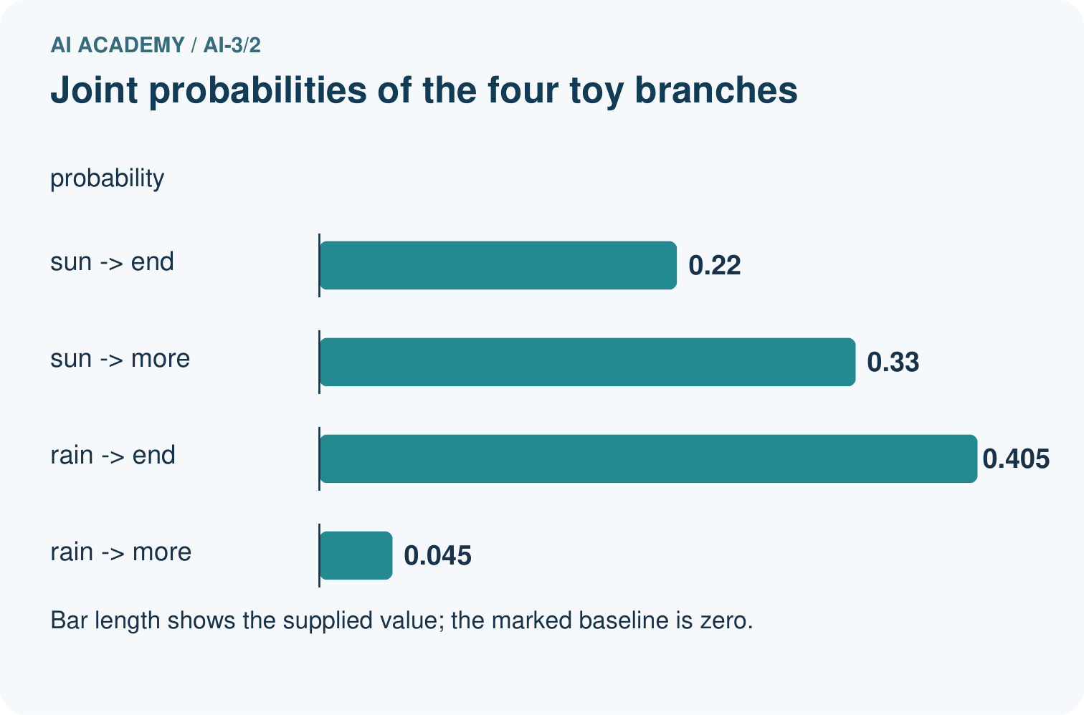
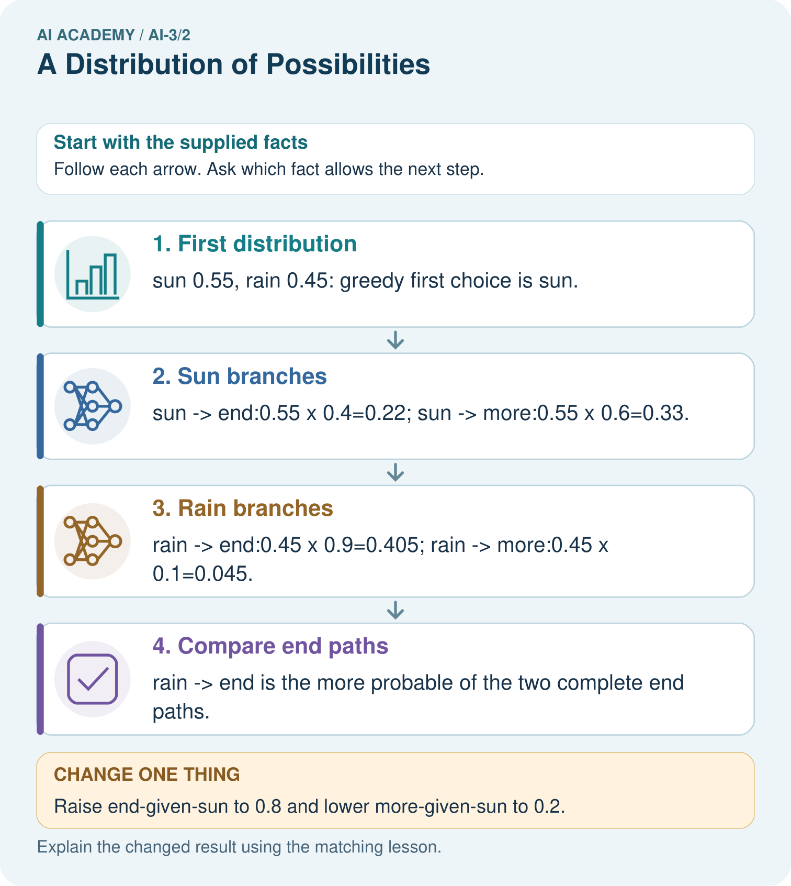
Why is 0.625 not a broken probability sum?

My picture-based explanation and changed-case prediction
________________________________________________________________
________________________________________________________________
________________________________________________________________
________________________________________________________________
________________________________________________________________
________________________________________________________________
Support used: alone / hint / worked example. This record is practice evidence.
Project connection: Explain Study Buddy generation as conditional choices, while checking the finished factual claims against sources.

24. Project portfolio milestone
Project: Verified Study Buddy
Current milestone: Frame the need. Name the user, the problem, allowed inputs and a safe simple starting method.
Explain Study Buddy generation as conditional choices, while checking the finished factual claims against sources.
Evidence to keep | My record
This week’s input and deciding step
Prediction and actual result (or labelled paper trace)
One change since the previous checkpoint and why
One error or limit and the next test

Explain what this week adds to your project. Reuse last week’s record rather than starting again.
________________________________________________________________
________________________________________________________________
________________________________________________________________
________________________________________________________________
________________________________________________________________

25. Supported practice and learning evidence
Use this supported practice once, in the browser or on paper. Keep the reserved independent assessment for a separate first attempt before teacher feedback.
A fictional two-stage token tree illustrates next-token prediction.

Practice 1: explain the deciding evidence
Which labelled step matches this detail? rain→end is the more probable of the two complete end paths.
1. Rain branches
2. Compare end paths
3. Sun branches
4. First distribution

My selected conclusion, deciding fact and explanation
________________________________________________________________
________________________________________________________________
________________________________________________________________
________________________________________________________________
________________________________________________________________
Hint if needed: Read the steps in the pictorial case. Match the supplied detail to the stage that performs or records it.
After your attempt, compare with the supported explanation: Compare end paths rain→end is the more probable of the two complete end paths. Conditional probabilities describe what follows a particular prefix. Multiplying along a path gives its joint probability. The four branch products sum to 1, but the two end paths sum to 0.625 because more branches have not ended. Greedy decoding selects sun then more; it does not guarantee the most likely complete sequence.

Practice 2: explain the deciding evidence
Changed-case practice: Raise end-given-sun to 0.8 and lower more-given-sun to 0.2. Which conclusion is supported by the supplied facts?
1. We can decide the result without examining the changed input or the procedure.
2. This one example guarantees correct results for every future input.
3. sun→end becomes 0.44, beating unchanged rain→end 0.405.

My selected conclusion, deciding fact and explanation
________________________________________________________________
________________________________________________________________
________________________________________________________________
________________________________________________________________
________________________________________________________________
Hint if needed: Use the changed condition and the deciding step in the pictorial trace. The answer must say what follows from those facts.
After your attempt, compare with the supported explanation: sun→end becomes 0.44, beating unchanged rain→end 0.405. Changing one conditional distribution changes its path products while the first-token probabilities remain fixed.

Repair a missing building block
Review Predictive and Generative AI (ai-3/1). Goal: Distinguish discriminative prediction from generation by inspecting the requested output. Short practice: Identify the first unsupported claim and explain what source would be needed before asserting it.. Return to this week and explain what you changed.

Keep your completed work
Use Download completed work in the hosted lesson to export your answers, reflections, practice feedback and code-run evidence. Open the HTML copy to read or print it. Drafts stay in this browser when storage is available; clear drafts on a shared device.

What I repaired, the evidence I kept and the next test
________________________________________________________________
________________________________________________________________
________________________________________________________________
________________________________________________________________
________________________________________________________________

