AI ACADEMY · WORKBOOK · ai-3/3

Tokens and Context
Project: Verified Study Buddy

01. Recall and choose your starting point
Try the recall before opening notes. Then use a different colour or a labelled second line to correct your explanation.

A Distribution of Possibilities
Without opening the old lesson, explain one key idea from A Distribution of Possibilities. Give an example and a mistake that the idea helps you avoid.

My remembered idea, example and correction
________________________________________________________________
________________________________________________________________
________________________________________________________________

02. Practise with fading help
Use W2: Choose complete support for Context limits and evidence selection. Record the answer once; the lesson and workbook refer to the same attempt.
Given inputs | Procedure I chose | Middle steps | Result and check

The step I completed without help, and the hint I needed
________________________________________________________________
________________________________________________________________
________________________________________________________________

03. Individual reasoning check
Use the worked case for Context limits and evidence selection. Proposed explanation: “Token count equals word count”. Decide whether this explanation is supported. Point to the step or supplied fact that decides; explain your repair if needed.

My explanation before partner discussion
________________________________________________________________
________________________________________________________________
________________________________________________________________
________________________________________________________________

04. Independent transfer case

Independent case: Budget new evidence independently
Total 120, instructions 25, question 15, output reserve 30. Source D is current approval, cost 28; E is current capacity, cost 22; F is old approval, cost 18. Compute capacity, compare D+E and E+F, and state an honest fallback if D is missing.

My independent explanation, trace and limits
________________________________________________________________
________________________________________________________________
________________________________________________________________
________________________________________________________________
________________________________________________________________
________________________________________________________________
________________________________________________________________
Attempt this case before feedback. Record any help. Earlier examples below are further practice; a case already practised with feedback cannot establish fresh transfer.

05. Your learning target
A toy system allows 12 tokens total for input and reserved output. Instructions use 3, a source uses 7 and the planned answer needs 4. Compute the excess and propose a revision that preserves evidence.

06. Solve the given case
A toy window holds eight tokens; prompt uses six and quotation uses three.
Does it fit? What should be preserved?
Show your trace, calculation or evidence

Write or draw your reasoning and evidence.
________________________________________________________________
________________________________________________________________
________________________________________________________________
________________________________________________________________
________________________________________________________________

07. Check a changed case
A system can use only the last two messages. Message 1 says use centimetres; messages 2 and 3 discuss plants. What instruction may be lost, and how can the next request repair this?
My independent answer and reason

Write or draw your reasoning and evidence.
________________________________________________________________
________________________________________________________________
________________________________________________________________
________________________________________________________________
________________________________________________________________

Week 3 Test and reflect

08. Design a revealing test
Create a changed input, boundary case or missing-information case. Write the expected answer or safe response before testing.
Test record | My evidence
Changed input or condition
Expected answer or fallback
Observed result
Why the result occurred

09. Project checkpoint
Keep the learner’s question, approved source excerpt, and output rules inside the active context.
The project change and evidence I will keep

Write or draw your reasoning and evidence.
________________________________________________________________
________________________________________________________________
________________________________________________________________
________________________________________________________________
________________________________________________________________

10. Self check
I can explain the mechanism. I can show evidence. I can handle a changed case. I can name a limit. Mark each as not yet, with help or independently, and attach supporting work.
Teacher review ____________________ Next step ____________________

11. Transfer practice from the original programme
A toy system allows 12 tokens total for input and reserved output. Instructions use 3, a source uses 7 and the planned answer needs 4. Compute the excess and propose a revision that preserves evidence.

My independently reasoned answer
________________________________________________________________
________________________________________________________________
________________________________________________________________
________________________________________________________________
________________________________________________________________
________________________________________________________________
________________________________________________________________
Record support used: none, hint or teacher explanation.

12. W1 Compute available evidence
Under total 100, instructions 20, question 10 and output reserve 20, calculate evidence capacity.

My reasoning and evidence
________________________________________________________________
________________________________________________________________
________________________________________________________________
________________________________________________________________
________________________________________________________________
________________________________________________________________

13. W2 Choose complete support
Compare A+B,A+C,C+B for fit and support of current approval and capacity.

My reasoning and evidence
________________________________________________________________
________________________________________________________________
________________________________________________________________
________________________________________________________________
________________________________________________________________
________________________________________________________________

14. W3 Preserve a qualifier
A passage says room B normally holds 12, except during maintenance when the approved limit is 8. Why is retaining only the first clause inadequate?

My reasoning and evidence
________________________________________________________________
________________________________________________________________
________________________________________________________________
________________________________________________________________
________________________________________________________________
________________________________________________________________

15. W4 Budget new evidence independently
Total 120, instructions 25, question 15, output reserve 30. Source D is current approval, cost 28; E is current capacity, cost 22; F is old approval, cost 18. Compute capacity, compare D+E and E+F, and state an honest fallback if D is missing.

My reasoning and evidence
________________________________________________________________
________________________________________________________________
________________________________________________________________
________________________________________________________________
________________________________________________________________
________________________________________________________________
________________________________________________________________
________________________________________________________________

16. W5 Audit inclusion
A team says every claim is verified because all chosen documents fit in context. What further check is needed?

My reasoning and evidence
________________________________________________________________
________________________________________________________________
________________________________________________________________
________________________________________________________________
________________________________________________________________
________________________________________________________________

17. Attention as weighted information selection — W1 Identify the roles
Explain query, key, value and weight without calling the largest weight a truth score.

My reasoning and evidence
________________________________________________________________
________________________________________________________________
________________________________________________________________
________________________________________________________________
________________________________________________________________
________________________________________________________________

18. Attention as weighted information selection — W2 Compute the mixture
Calculate the output from the three supplied values and weights.

My reasoning and evidence
________________________________________________________________
________________________________________________________________
________________________________________________________________
________________________________________________________________
________________________________________________________________
________________________________________________________________

19. Attention as weighted information selection — W3 Mask and renormalise
Exclude V3 and calculate permitted weights and output. Explain the empty-mask case.

My reasoning and evidence
________________________________________________________________
________________________________________________________________
________________________________________________________________
________________________________________________________________
________________________________________________________________
________________________________________________________________

20. Attention as weighted information selection — W4 Combine a new case independently
Values A=[4,1],B=[0,5],C=[2,3]; weights 0.25,0.5,0.25. Compute the full output. Mask B, renormalise the remaining weights and compute the new output.

My reasoning and evidence
________________________________________________________________
________________________________________________________________
________________________________________________________________
________________________________________________________________
________________________________________________________________
________________________________________________________________
________________________________________________________________
________________________________________________________________

21. Attention as weighted information selection — W5 Audit an explanation
A student claims the highest attention weight explains the entire model and authenticates a retrieved instruction. What additional reasoning is needed?

My reasoning and evidence
________________________________________________________________
________________________________________________________________
________________________________________________________________
________________________________________________________________
________________________________________________________________
________________________________________________________________

22. Feedback, return check and learning record
Evidence | My record
Worked alone / hint / model
First step I repaired and why
New case checked later; date and result
What I can now explain without notes
One remaining question
Revisit this idea with your teacher after a delay. Familiarity is different from explaining and using it on a changed case.

23. Pictorial case practice: Tokens and Context
A fictional assistant has a small context budget for answering an event-capacity question.
Total budget 100 toy tokens; instructions 20, question 10, output reserve 25. Evidence capacity is the remainder.
Current capacity record A costs 18; its safety exception B costs 20; unrelated slogan C costs 12. A says 20 seats; B caps this event at 12.
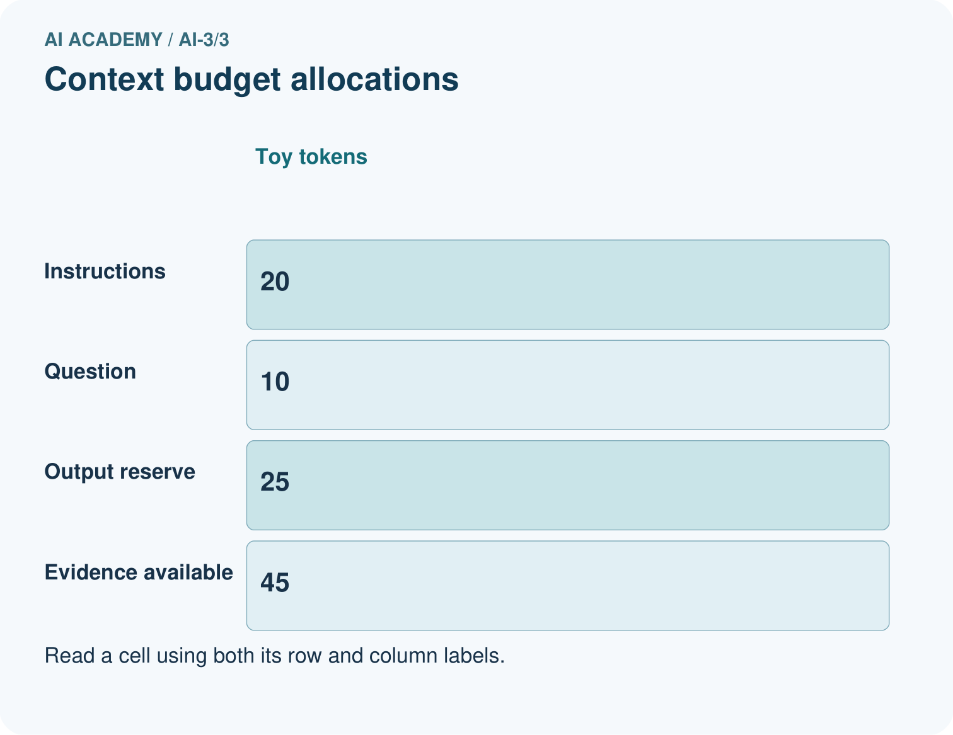
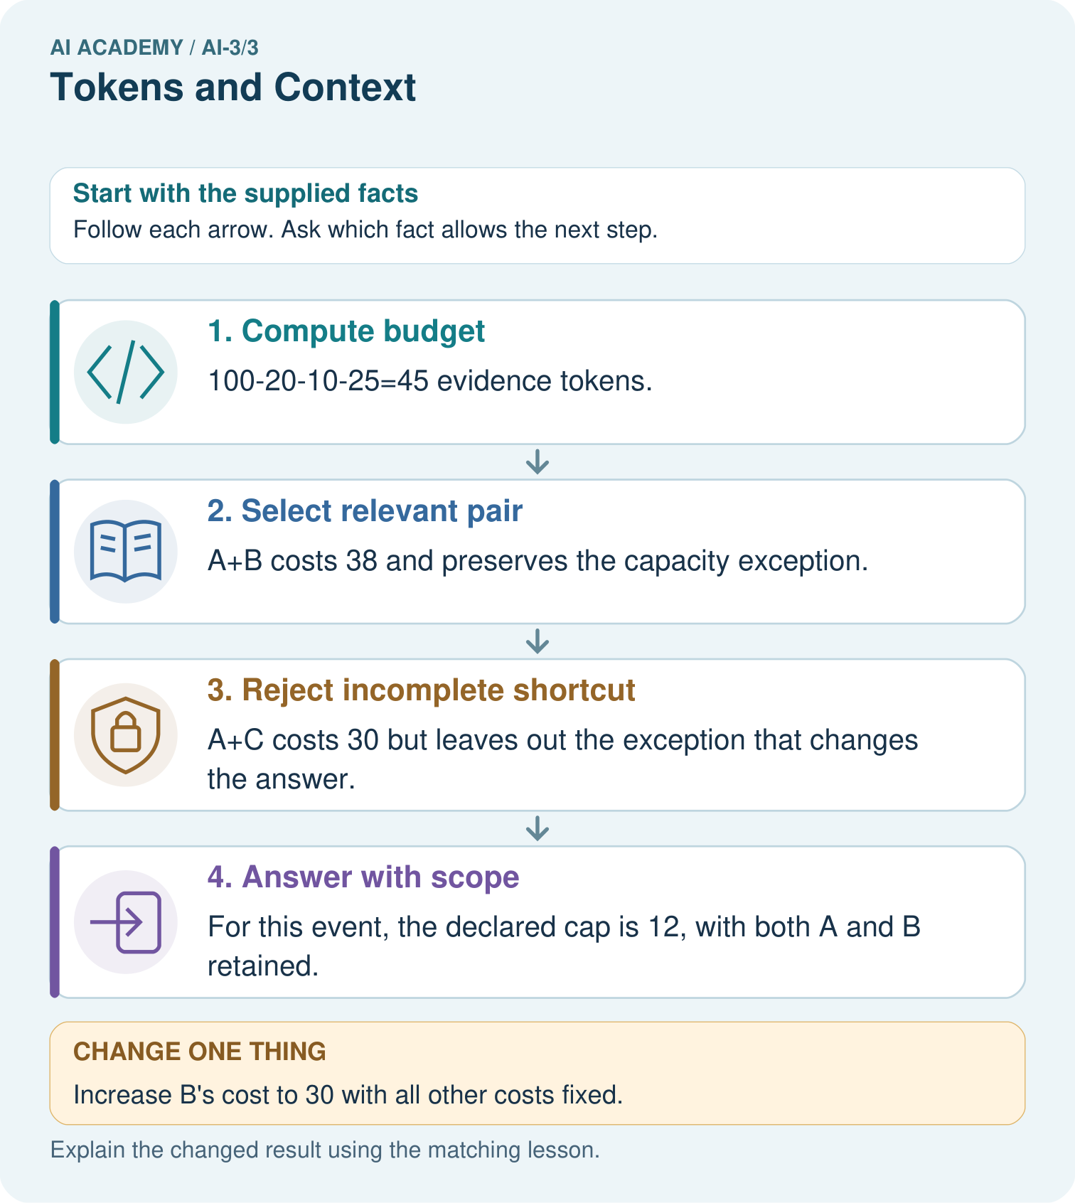
Can A alone justify answering 20 seats after the exception is known?

My picture-based explanation and changed-case prediction
________________________________________________________________
________________________________________________________________
________________________________________________________________
________________________________________________________________
________________________________________________________________
________________________________________________________________
Support used: alone / hint / worked example. This record is practice evidence.
Project connection: Design Study Buddy retrieval to preserve current facts, exceptions and source identity within its context budget.

24. Project portfolio milestone
Project: Verified Study Buddy
Current milestone: Frame the need. Name the user, the problem, allowed inputs and a safe simple starting method.
Design Study Buddy retrieval to preserve current facts, exceptions and source identity within its context budget.
Evidence to keep | My record
This week’s input and deciding step
Prediction and actual result (or labelled paper trace)
One change since the previous checkpoint and why
One error or limit and the next test

Explain what this week adds to your project. Reuse last week’s record rather than starting again.
________________________________________________________________
________________________________________________________________
________________________________________________________________
________________________________________________________________
________________________________________________________________

25. Supported practice and learning evidence
Use this supported practice once, in the browser or on paper. Keep the reserved independent assessment for a separate first attempt before teacher feedback.
A fictional assistant has a small context budget for answering an event-capacity question.

Practice 1: explain the deciding evidence
Which labelled step matches this detail? For this event, the declared cap is 12, with both A and B retained.
1. Answer with scope
2. Select relevant pair
3. Reject incomplete shortcut
4. Compute budget

My selected conclusion, deciding fact and explanation
________________________________________________________________
________________________________________________________________
________________________________________________________________
________________________________________________________________
________________________________________________________________
Hint if needed: Read the steps in the pictorial case. Match the supplied detail to the stage that performs or records it.
After your attempt, compare with the supported explanation: Answer with scope For this event, the declared cap is 12, with both A and B retained. A context window limits how much information is available in one model call. Selecting the shortest passage is not always sufficient: an exception can change the meaning of a general statement. Keep the relevant source relationship visible. Toy token costs are supplied here; real token counts depend on the model’s tokenizer.

Practice 2: explain the deciding evidence
Changed-case practice: Increase B’s cost to 30 with all other costs fixed. Which conclusion is supported by the supplied facts?
1. A+B costs 48 and no longer fits the 45-token evidence capacity.
2. This one example guarantees correct results for every future input.
3. We can decide the result without examining the changed input or the procedure.

My selected conclusion, deciding fact and explanation
________________________________________________________________
________________________________________________________________
________________________________________________________________
________________________________________________________________
________________________________________________________________
Hint if needed: Use the changed condition and the deciding step in the pictorial trace. The answer must say what follows from those facts.
After your attempt, compare with the supported explanation: A+B costs 48 and no longer fits the 45-token evidence capacity. Do not silently omit the exception; use an approved source-preserving summary, another retrieval step or an honest incomplete-evidence response.

Repair a missing building block
Review A Distribution of Possibilities (ai-3/2). Goal: Check whether a next-token table is a valid probability distribution. Short practice: Why is 0.625 not a broken probability sum?. Return to this week and explain what you changed.

Keep your completed work
Use Download completed work in the hosted lesson to export your answers, reflections, practice feedback and code-run evidence. Open the HTML copy to read or print it. Drafts stay in this browser when storage is available; clear drafts on a shared device.

What I repaired, the evidence I kept and the next test
________________________________________________________________
________________________________________________________________
________________________________________________________________
________________________________________________________________
________________________________________________________________

