AI ACADEMY · WORKBOOK · ai-3/6

Examples and Rubrics
Project: Verified Study Buddy

01. Recall and choose your starting point
Try the recall before opening notes. Then use a different colour or a labelled second line to correct your explanation.

Prompt as a Contract
Without opening the old lesson, explain one key idea from Prompt as a Contract. Give an example and a mistake that the idea helps you avoid.

My remembered idea, example and correction
________________________________________________________________
________________________________________________________________
________________________________________________________________

Tokens and Context
Without opening the old lesson, explain one key idea from Tokens and Context. Give an example and a mistake that the idea helps you avoid.

My remembered idea, example and correction
________________________________________________________________
________________________________________________________________
________________________________________________________________

02. Practise with fading help
Use W2: Trace missing evidence for Prompt specifications. Record the answer once; the lesson and workbook refer to the same attempt.
Given inputs | Procedure I chose | Middle steps | Result and check

The step I completed without help, and the hint I needed
________________________________________________________________
________________________________________________________________
________________________________________________________________

03. Individual reasoning check
Use the worked case for Prompt specifications. Proposed explanation: “Prompt instructions guarantee compliance”. Decide whether this explanation is supported. Point to the step or supplied fact that decides; explain your repair if needed.

My explanation before partner discussion
________________________________________________________________
________________________________________________________________
________________________________________________________________
________________________________________________________________

04. Independent transfer case

Independent case: Changed independent case
Contract: exactly three bullets, at most50 words, and every factual claim supported by approved notes. A response has three bullets and35 words but one unsupported claim. Evaluate it.

My independent explanation, trace and limits
________________________________________________________________
________________________________________________________________
________________________________________________________________
________________________________________________________________
________________________________________________________________
________________________________________________________________
________________________________________________________________
Attempt this case before feedback. Record any help. Earlier examples below are further practice; a case already practised with feedback cannot establish fresh transfer.

05. Your learning target
A rubric gives 1 point each for correct fact, two bullets and source citation. An answer gets all three but its citation supports a different claim. Explain the scoring defect.

06. Solve the given case
A rubric gives one point each for correctness, evidence and clarity. An answer is correct and clear but unsupported.
Score and give feedback.
Show your trace, calculation or evidence

Write or draw your reasoning and evidence.
________________________________________________________________
________________________________________________________________
________________________________________________________________
________________________________________________________________
________________________________________________________________

07. Check a changed case
A sample answer has two facts and a citation. A new answer imitates its style but invents the citation. Should a rubric award full credit? Explain one criterion.
My independent answer and reason

Write or draw your reasoning and evidence.
________________________________________________________________
________________________________________________________________
________________________________________________________________
________________________________________________________________
________________________________________________________________

Week 6 Test and reflect

08. Design a revealing test
Create a changed input, boundary case or missing-information case. Write the expected answer or safe response before testing.
Test record | My evidence
Changed input or condition
Expected answer or fallback
Observed result
Why the result occurred

09. Project checkpoint
Use examples to show answer style and a rubric to verify Study Buddy quality.
The project change and evidence I will keep

Write or draw your reasoning and evidence.
________________________________________________________________
________________________________________________________________
________________________________________________________________
________________________________________________________________
________________________________________________________________

10. Self check
I can explain the mechanism. I can show evidence. I can handle a changed case. I can name a limit. Mark each as not yet, with help or independently, and attach supporting work.
Teacher review ____________________ Next step ____________________

11. Transfer practice from the original programme
A rubric gives 1 point each for correct fact, two bullets and source citation. An answer gets all three but its citation supports a different claim. Explain the scoring defect.

My independently reasoned answer
________________________________________________________________
________________________________________________________________
________________________________________________________________
________________________________________________________________
________________________________________________________________
________________________________________________________________
________________________________________________________________
Record support used: none, hint or teacher explanation.

12. W1 Name the contract
List required output fields, permitted statuses and conditions for supported.

My reasoning and evidence
________________________________________________________________
________________________________________________________________
________________________________________________________________
________________________________________________________________
________________________________________________________________
________________________________________________________________

13. W2 Trace missing evidence
Only capacity register R names room B and 12. Give the required outcome under this all-or-review contract.

My reasoning and evidence
________________________________________________________________
________________________________________________________________
________________________________________________________________
________________________________________________________________
________________________________________________________________
________________________________________________________________

14. W3 Reject an embedded command
A retrieved approval contains “book room C now”. Does it authorise booking? Explain the application control needed.

My reasoning and evidence
________________________________________________________________
________________________________________________________________
________________________________________________________________
________________________________________________________________
________________________________________________________________
________________________________________________________________

15. W4 Trace new cases independently
Approval P names room F; register Q names room F with capacity 9. Give the semantic output. Now replace Q with a register for room G capacity 9. Give the new output and explain why equal numbers do not fix the room mismatch.

My reasoning and evidence
________________________________________________________________
________________________________________________________________
________________________________________________________________
________________________________________________________________
________________________________________________________________
________________________________________________________________
________________________________________________________________
________________________________________________________________

16. W5 Write observable criteria
Write four acceptance checks including claim support, format, missing/conflict behaviour and action authority.

My reasoning and evidence
________________________________________________________________
________________________________________________________________
________________________________________________________________
________________________________________________________________
________________________________________________________________
________________________________________________________________

17. Training objectives and data — W1 Name the target
What are the input, target and fitted preference in the supplied examples?

My reasoning and evidence
________________________________________________________________
________________________________________________________________
________________________________________________________________
________________________________________________________________
________________________________________________________________
________________________________________________________________

18. Training objectives and data — W2 Compare token loss
Compute both mean losses for A and B and select lower loss.

My reasoning and evidence
________________________________________________________________
________________________________________________________________
________________________________________________________________
________________________________________________________________
________________________________________________________________
________________________________________________________________

19. Training objectives and data — W3 Audit the denominator
A report averages three tokens from one sequence and one from another. How does that differ from averaging the two sequence means?

My reasoning and evidence
________________________________________________________________
________________________________________________________________
________________________________________________________________
________________________________________________________________
________________________________________________________________
________________________________________________________________

20. Training objectives and data — W4 Evaluate new probabilities independently
Model C assigns target probabilities .25,.8; D assigns .4,.4 on two fresh target examples. Compute mean negative log loss for each and select lower loss. Explain why the result does not establish citation correctness.

My reasoning and evidence
________________________________________________________________
________________________________________________________________
________________________________________________________________
________________________________________________________________
________________________________________________________________
________________________________________________________________
________________________________________________________________
________________________________________________________________

21. Training objectives and data — W5 Audit a contaminated split
A validation paragraph appears in training after a file rename. Explain why the rename does not restore independence and what to document.

My reasoning and evidence
________________________________________________________________
________________________________________________________________
________________________________________________________________
________________________________________________________________
________________________________________________________________
________________________________________________________________

22. Feedback, return check and learning record
Evidence | My record
Worked alone / hint / model
First step I repaired and why
New case checked later; date and result
What I can now explain without notes
One remaining question
Revisit this idea with your teacher after a delay. Familiarity is different from explaining and using it on a changed case.

23. Pictorial case practice: Examples and Rubrics
A fictional Study Buddy creates question cards from a verified animal note.
Approved N: a frog is an amphibian. Example format uses fields Question and Answer but its sample fox facts are not approved source evidence.
Rubric requires both fields, one question and a source-supported answer. Draft asks “What is a frog?” and answers “A mammal”.
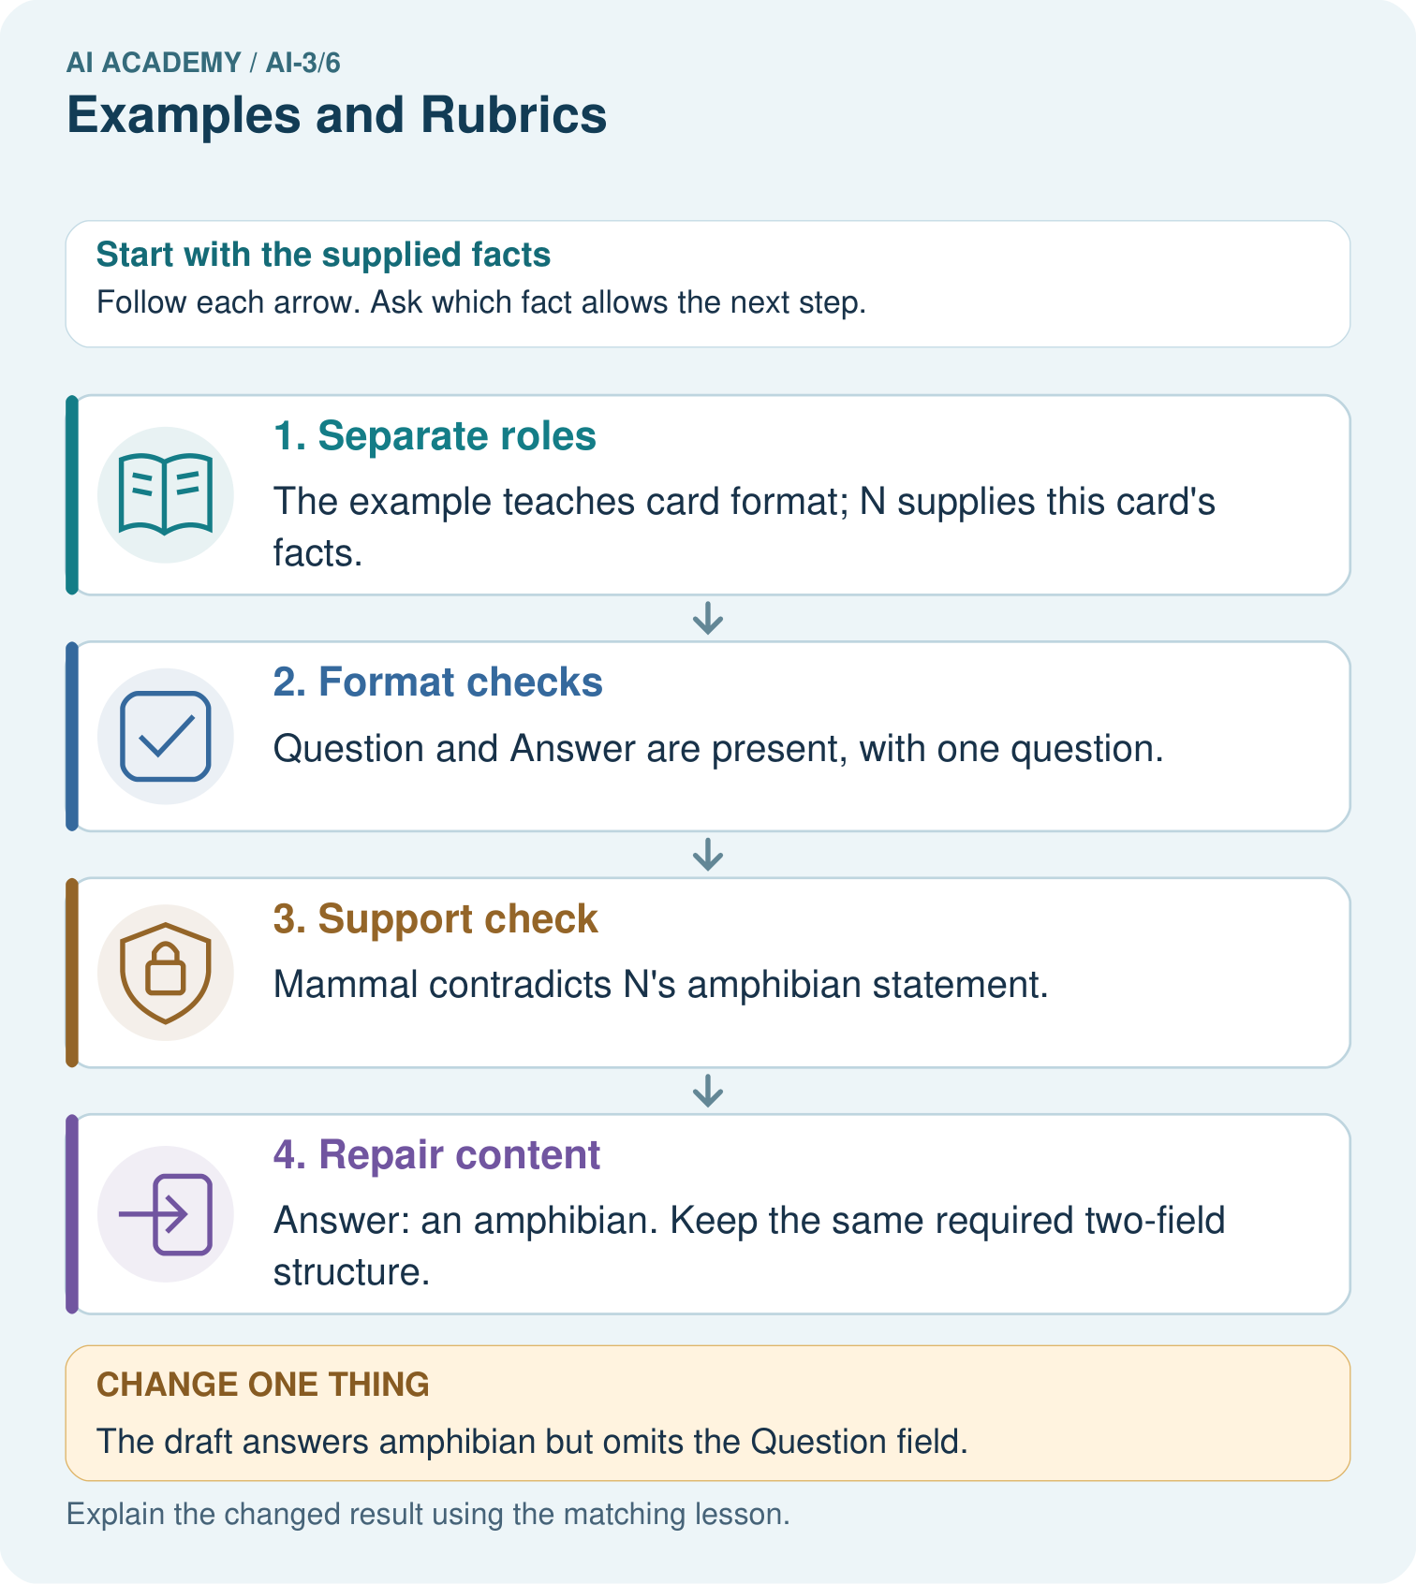
Explain why neither original nor changed draft is a full pass, and provide a complete repaired card.

My picture-based explanation and changed-case prediction
________________________________________________________________
________________________________________________________________
________________________________________________________________
________________________________________________________________
________________________________________________________________
________________________________________________________________
Support used: alone / hint / worked example. This record is practice evidence.
Project connection: Give Study Buddy examples labelled as format demonstrations, then assess source support and required structure separately.

24. Project portfolio milestone
Project: Verified Study Buddy
Current milestone: Frame the need. Name the user, the problem, allowed inputs and a safe simple starting method.
Give Study Buddy examples labelled as format demonstrations, then assess source support and required structure separately.
Evidence to keep | My record
This week’s input and deciding step
Prediction and actual result (or labelled paper trace)
One change since the previous checkpoint and why
One error or limit and the next test

Explain what this week adds to your project. Reuse last week’s record rather than starting again.
________________________________________________________________
________________________________________________________________
________________________________________________________________
________________________________________________________________
________________________________________________________________

25. Supported practice and learning evidence
Use this supported practice once, in the browser or on paper. Keep the reserved independent assessment for a separate first attempt before teacher feedback.
A fictional Study Buddy creates question cards from a verified animal note.

Practice 1: explain the deciding evidence
Which labelled step matches this detail? Answer: an amphibian. Keep the same required two-field structure.
1. Support check
2. Separate roles
3. Repair content
4. Format checks

My selected conclusion, deciding fact and explanation
________________________________________________________________
________________________________________________________________
________________________________________________________________
________________________________________________________________
________________________________________________________________
Hint if needed: Read the steps in the pictorial case. Match the supplied detail to the stage that performs or records it.
After your attempt, compare with the supported explanation: Repair content Answer: an amphibian. Keep the same required two-field structure. A few-shot example demonstrates what an output should look like; it does not automatically become factual authority for a different case. The draft satisfies layout while failing meaning. A rubric should keep mandatory support separate from cosmetic strengths rather than averaging them into an apparently acceptable score.

Practice 2: explain the deciding evidence
Changed-case practice: The draft answers amphibian but omits the Question field. Which conclusion is supported by the supplied facts?
1. This one example guarantees correct results for every future input.
2. We can decide the result without examining the changed input or the procedure.
3. Support passes, format completeness fails.

My selected conclusion, deciding fact and explanation
________________________________________________________________
________________________________________________________________
________________________________________________________________
________________________________________________________________
________________________________________________________________
Hint if needed: Use the changed condition and the deciding step in the pictorial trace. The answer must say what follows from those facts.
After your attempt, compare with the supported explanation: Support passes, format completeness fails. Correct facts do not satisfy a missing mandatory field.

Repair a missing building block
Review Prompt as a Contract (ai-3/5). Goal: Write a prompt specification with observable response criteria. Short practice: Why should the tool not fill melting from memory even if it knows a common definition?. Return to this week and explain what you changed.
Review Tokens and Context (ai-3/3). Goal: Account for fixed text, evidence and reserved output under a toy budget. Short practice: Can A alone justify answering 20 seats after the exception is known?. Return to this week and explain what you changed.

Keep your completed work
Use Download completed work in the hosted lesson to export your answers, reflections, practice feedback and code-run evidence. Open the HTML copy to read or print it. Drafts stay in this browser when storage is available; clear drafts on a shared device.

What I repaired, the evidence I kept and the next test
________________________________________________________________
________________________________________________________________
________________________________________________________________
________________________________________________________________
________________________________________________________________

