AI ACADEMY · WORKBOOK · ai-3/7

Iterative Prompting
Project: Verified Study Buddy

01. Recall and choose your starting point
Try the recall before opening notes. Then use a different colour or a labelled second line to correct your explanation.

Examples and Rubrics
Without opening the old lesson, explain one key idea from Examples and Rubrics. Give an example and a mistake that the idea helps you avoid.

My remembered idea, example and correction
________________________________________________________________
________________________________________________________________
________________________________________________________________

Sampling and Variability
Without opening the old lesson, explain one key idea from Sampling and Variability. Give an example and a mistake that the idea helps you avoid.

My remembered idea, example and correction
________________________________________________________________
________________________________________________________________
________________________________________________________________

Predictive and Generative AI
Without opening the old lesson, explain one key idea from Predictive and Generative AI. Give an example and a mistake that the idea helps you avoid.

My remembered idea, example and correction
________________________________________________________________
________________________________________________________________
________________________________________________________________

02. Practise with fading help
Use W2: Trace the worked case for Controlled prompt experiments. Record the answer once; the lesson and workbook refer to the same attempt.
Given inputs | Procedure I chose | Middle steps | Result and check

The step I completed without help, and the hint I needed
________________________________________________________________
________________________________________________________________
________________________________________________________________

03. Individual reasoning check
Use the worked case for Controlled prompt experiments. Proposed explanation: “The worked result establishes every future case”. Decide whether this explanation is supported. Point to the step or supplied fact that decides; explain your repair if needed.

My explanation before partner discussion
________________________________________________________________
________________________________________________________________
________________________________________________________________
________________________________________________________________

04. Independent transfer case

Independent case: Changed independent case
A factual response uses four paragraphs when the contract requires three bullets. Design a controlled prompt revision and evaluation.

My independent explanation, trace and limits
________________________________________________________________
________________________________________________________________
________________________________________________________________
________________________________________________________________
________________________________________________________________
________________________________________________________________
________________________________________________________________
Attempt this case before feedback. Record any help. Earlier examples below are further practice; a case already practised with feedback cannot establish fresh transfer.

05. Your learning target
A summary has accurate facts but uses unexplained terms. Propose one prompt change and a comparison that checks both accessibility and factual preservation.

06. Solve the given case
A factually correct explanation is too difficult for a nine-year-old.
Make and test one focused revision.
Show your trace, calculation or evidence

Write or draw your reasoning and evidence.
________________________________________________________________
________________________________________________________________
________________________________________________________________
________________________________________________________________
________________________________________________________________

07. Check a changed case
You change a prompt's audience, length and source rules together; the result improves. What can you conclude, and how would you investigate the cause?
My independent answer and reason

Write or draw your reasoning and evidence.
________________________________________________________________
________________________________________________________________
________________________________________________________________
________________________________________________________________
________________________________________________________________

Week 7 Test and reflect

08. Design a revealing test
Create a changed input, boundary case or missing-information case. Write the expected answer or safe response before testing.
Test record | My evidence
Changed input or condition
Expected answer or fallback
Observed result
Why the result occurred

09. Project checkpoint
Maintain prompt version, diagnosed failure, change, and before/after rubric scores.
The project change and evidence I will keep

Write or draw your reasoning and evidence.
________________________________________________________________
________________________________________________________________
________________________________________________________________
________________________________________________________________
________________________________________________________________

10. Self check
I can explain the mechanism. I can show evidence. I can handle a changed case. I can name a limit. Mark each as not yet, with help or independently, and attach supporting work.
Teacher review ____________________ Next step ____________________

11. Transfer practice from the original programme
A summary has accurate facts but uses unexplained terms. Propose one prompt change and a comparison that checks both accessibility and factual preservation.

My independently reasoned answer
________________________________________________________________
________________________________________________________________
________________________________________________________________
________________________________________________________________
________________________________________________________________
________________________________________________________________
________________________________________________________________
Record support used: none, hint or teacher explanation.

12. W1 Explain the mechanism
Explain the weekly mechanism in your own words. Use the worked scenario to name its input, decision rule and output.

My reasoning and evidence
________________________________________________________________
________________________________________________________________
________________________________________________________________
________________________________________________________________
________________________________________________________________
________________________________________________________________

13. W2 Trace the worked case
On six development cases P passes cases 1, 2, 3, 4; Q passes 1, 2, 3, 5, 6. Missing-approval cases are 4 and 6. Compare totals and condition results. Show the intermediate steps and give the conclusion with its scope.

My reasoning and evidence
________________________________________________________________
________________________________________________________________
________________________________________________________________
________________________________________________________________
________________________________________________________________
________________________________________________________________
________________________________________________________________

14. W3 Audit the limit
A report omits this qualification: Prompt selection on development cases cannot be reported as independent final performance. Explain how omitting it could change a reader's interpretation, and write an accurate replacement.

My reasoning and evidence
________________________________________________________________
________________________________________________________________
________________________________________________________________
________________________________________________________________
________________________________________________________________
________________________________________________________________

15. W4 Apply a new case independently
On eight paired cases A passes 1–5; B passes 1–4, 6, 7. Special cases are 5 and 8. Compare overall and special-case results; select by total passes.

My reasoning and evidence
________________________________________________________________
________________________________________________________________
________________________________________________________________
________________________________________________________________
________________________________________________________________
________________________________________________________________
________________________________________________________________
________________________________________________________________

16. W5 Design a revealing follow-up
For the worked scenario, propose one additional case that could reveal a failure, describe its expected outcome before running it, and explain what would need to remain fixed for a fair comparison. Do not reuse W4 as a new final test after receiving feedback.

My reasoning and evidence
________________________________________________________________
________________________________________________________________
________________________________________________________________
________________________________________________________________
________________________________________________________________
________________________________________________________________
________________________________________________________________

17. Feedback, return check and learning record
Evidence | My record
Worked alone / hint / model
First step I repaired and why
New case checked later; date and result
What I can now explain without notes
One remaining question
Revisit this idea with your teacher after a delay. Familiarity is different from explaining and using it on a changed case.

18. Pictorial case practice: Iterative Prompting
A fictional Study Buddy prompt invents a definition when approved notes omit it.
P asks “answer helpfully”. Revision Q adds “if approved notes lack the answer, say not supplied”.
Hold model settings and four development questions fixed. P passes 1,2; Q passes 1,2,3. Case 4 still fails.
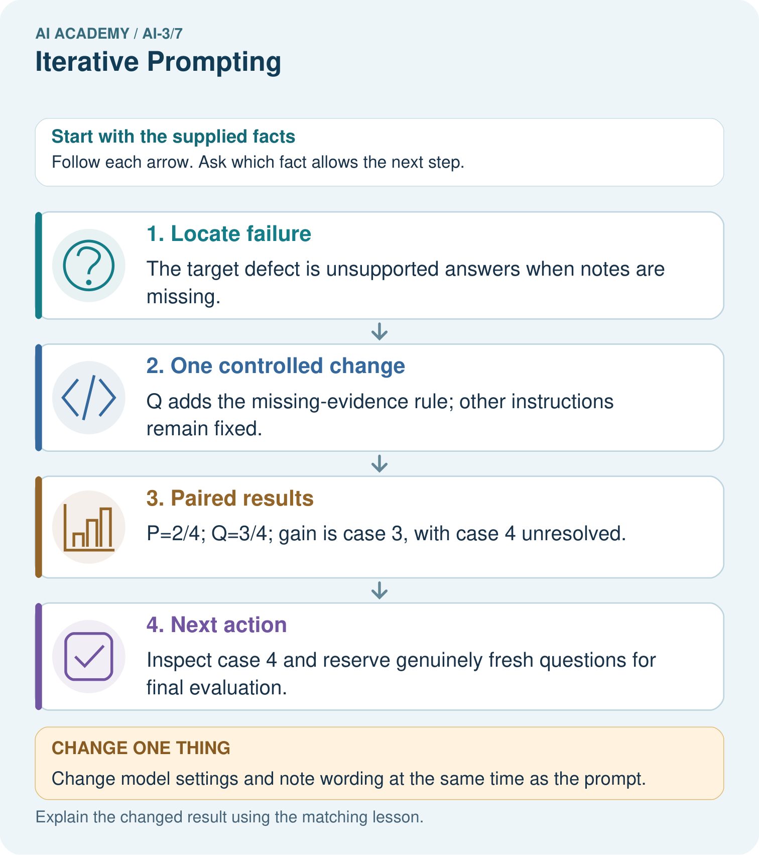
What evidence supports improvement here, and what remains unproven?

My picture-based explanation and changed-case prediction
________________________________________________________________
________________________________________________________________
________________________________________________________________
________________________________________________________________
________________________________________________________________
________________________________________________________________
Support used: alone / hint / worked example. This record is practice evidence.
Project connection: Maintain a Study Buddy experiment log linking failure, single revision and paired rubric results.

19. Project portfolio milestone
Project: Verified Study Buddy
Current milestone: Make a transparent first version. Keep a trace of how one input becomes an output; explain the rule or learned component.
Maintain a Study Buddy experiment log linking failure, single revision and paired rubric results.
Evidence to keep | My record
This week’s input and deciding step
Prediction and actual result (or labelled paper trace)
One change since the previous checkpoint and why
One error or limit and the next test

Explain what this week adds to your project. Reuse last week’s record rather than starting again.
________________________________________________________________
________________________________________________________________
________________________________________________________________
________________________________________________________________
________________________________________________________________

20. Supported practice and learning evidence
Use this supported practice once, in the browser or on paper. Keep the reserved independent assessment for a separate first attempt before teacher feedback.
A fictional Study Buddy prompt invents a definition when approved notes omit it.

Practice 1: explain the deciding evidence
Which labelled step matches this detail? Inspect case 4 and reserve genuinely fresh questions for final evaluation.
1. Locate failure
2. Next action
3. One controlled change
4. Paired results

My selected conclusion, deciding fact and explanation
________________________________________________________________
________________________________________________________________
________________________________________________________________
________________________________________________________________
________________________________________________________________
Hint if needed: Read the steps in the pictorial case. Match the supplied detail to the stage that performs or records it.
After your attempt, compare with the supported explanation: Next action Inspect case 4 and reserve genuinely fresh questions for final evaluation. An iteration should respond to a recorded failure with a precise change. Comparing the same questions reveals whether other behavior changed too. The invented results show a development gain of one case, not a guarantee that the new instruction always works. Save prompt text, settings, source notes and case-level outcomes.

Practice 2: explain the deciding evidence
Changed-case practice: Change model settings and note wording at the same time as the prompt. Which conclusion is supported by the supplied facts?
1. We can decide the result without examining the changed input or the procedure.
2. This one example guarantees correct results for every future input.
3. The comparison no longer isolates the prompt revision.

My selected conclusion, deciding fact and explanation
________________________________________________________________
________________________________________________________________
________________________________________________________________
________________________________________________________________
________________________________________________________________
Hint if needed: Use the changed condition and the deciding step in the pictorial trace. The answer must say what follows from those facts.
After your attempt, compare with the supported explanation: The comparison no longer isolates the prompt revision. Several changes could explain the altered outputs; record them or run separate controlled comparisons.

Repair a missing building block
Review Examples and Rubrics (ai-3/6). Goal: Write a prompt specification with observable response criteria. Short practice: Explain why neither original nor changed draft is a full pass, and provide a complete repaired card.. Return to this week and explain what you changed.
Review Sampling and Variability (ai-3/4). Goal: Sample from a distribution using explicit cumulative intervals. Short practice: Does T=0.5 make B impossible, and does choosing A guarantee factual accuracy?. Return to this week and explain what you changed.
Review Predictive and Generative AI (ai-3/1). Goal: Distinguish discriminative prediction from generation by inspecting the requested output. Short practice: Identify the first unsupported claim and explain what source would be needed before asserting it.. Return to this week and explain what you changed.

Keep your completed work
Use Download completed work in the hosted lesson to export your answers, reflections, practice feedback and code-run evidence. Open the HTML copy to read or print it. Drafts stay in this browser when storage is available; clear drafts on a shared device.

What I repaired, the evidence I kept and the next test
________________________________________________________________
________________________________________________________________
________________________________________________________________
________________________________________________________________
________________________________________________________________

