AI ACADEMY · WORKBOOK · ai-3/9

Prompt Evaluation
Project: Verified Study Buddy

01. Recall and choose your starting point
Try the recall before opening notes. Then use a different colour or a labelled second line to correct your explanation.

Structured Output and Schemas
Without opening the old lesson, explain one key idea from Structured Output and Schemas. Give an example and a mistake that the idea helps you avoid.

My remembered idea, example and correction
________________________________________________________________
________________________________________________________________
________________________________________________________________

Examples and Rubrics
Without opening the old lesson, explain one key idea from Examples and Rubrics. Give an example and a mistake that the idea helps you avoid.

My remembered idea, example and correction
________________________________________________________________
________________________________________________________________
________________________________________________________________

Tokens and Context
Without opening the old lesson, explain one key idea from Tokens and Context. Give an example and a mistake that the idea helps you avoid.

My remembered idea, example and correction
________________________________________________________________
________________________________________________________________
________________________________________________________________

02. Practise with fading help
Use W2: Trace the worked case for Controlled prompt experiments. Record the answer once; the lesson and workbook refer to the same attempt.
Given inputs | Procedure I chose | Middle steps | Result and check

The step I completed without help, and the hint I needed
________________________________________________________________
________________________________________________________________
________________________________________________________________

03. Individual reasoning check
Use the worked case for Controlled prompt experiments. Proposed explanation: “The worked result establishes every future case”. Decide whether this explanation is supported. Point to the step or supplied fact that decides; explain your repair if needed.

My explanation before partner discussion
________________________________________________________________
________________________________________________________________
________________________________________________________________
________________________________________________________________

04. Independent transfer case

Independent case: Changed independent case
Five validation tasks have pass results A:1,1,1,0,0 and B:0,1,0,1,1. Compare performance and explain what is required before choosing a prompt.

My independent explanation, trace and limits
________________________________________________________________
________________________________________________________________
________________________________________________________________
________________________________________________________________
________________________________________________________________
________________________________________________________________
________________________________________________________________
Attempt this case before feedback. Record any help. Earlier examples below are further practice; a case already practised with feedback cannot establish fresh transfer.

05. Your learning target
On four shared tasks, A scores 1,1,0,1 and B scores 1,0,1,1. Their totals tie. What should you inspect before choosing? Define a final evaluation step.

06. Solve the given case
On five fixed questions, A passes four and B passes three; B looks more attractive.
What conclusion is supported?
Show your trace, calculation or evidence

Write or draw your reasoning and evidence.
________________________________________________________________
________________________________________________________________
________________________________________________________________
________________________________________________________________
________________________________________________________________

07. Check a changed case
Prompt A passes 8 of 10 tasks; B passes 9 of 10 but fails the only source-checking task. A source check is mandatory. Which can be accepted as-is?
My independent answer and reason

Write or draw your reasoning and evidence.
________________________________________________________________
________________________________________________________________
________________________________________________________________
________________________________________________________________
________________________________________________________________

Week 9 Test and reflect

08. Design a revealing test
Create a changed input, boundary case or missing-information case. Write the expected answer or safe response before testing.
Test record | My evidence
Changed input or condition
Expected answer or fallback
Observed result
Why the result occurred

09. Project checkpoint
Evaluate Study Buddy prompts on factual, ambiguous, missing-source, and adversarial questions.
The project change and evidence I will keep

Write or draw your reasoning and evidence.
________________________________________________________________
________________________________________________________________
________________________________________________________________
________________________________________________________________
________________________________________________________________

10. Self check
I can explain the mechanism. I can show evidence. I can handle a changed case. I can name a limit. Mark each as not yet, with help or independently, and attach supporting work.
Teacher review ____________________ Next step ____________________

11. Transfer practice from the original programme
On four shared tasks, A scores 1,1,0,1 and B scores 1,0,1,1. Their totals tie. What should you inspect before choosing? Define a final evaluation step.

My independently reasoned answer
________________________________________________________________
________________________________________________________________
________________________________________________________________
________________________________________________________________
________________________________________________________________
________________________________________________________________
________________________________________________________________
Record support used: none, hint or teacher explanation.

12. W1 Explain the mechanism
Explain the weekly mechanism in your own words. Use the worked scenario to name its input, decision rule and output.

My reasoning and evidence
________________________________________________________________
________________________________________________________________
________________________________________________________________
________________________________________________________________
________________________________________________________________
________________________________________________________________

13. W2 Trace the worked case
On six development cases P passes cases 1, 2, 3, 4; Q passes 1, 2, 3, 5, 6. Missing-approval cases are 4 and 6. Compare totals and condition results. Show the intermediate steps and give the conclusion with its scope.

My reasoning and evidence
________________________________________________________________
________________________________________________________________
________________________________________________________________
________________________________________________________________
________________________________________________________________
________________________________________________________________
________________________________________________________________

14. W3 Audit the limit
A report omits this qualification: Prompt selection on development cases cannot be reported as independent final performance. Explain how omitting it could change a reader's interpretation, and write an accurate replacement.

My reasoning and evidence
________________________________________________________________
________________________________________________________________
________________________________________________________________
________________________________________________________________
________________________________________________________________
________________________________________________________________

15. W4 Apply a new case independently
On eight paired cases A passes 1–5; B passes 1–4, 6, 7. Special cases are 5 and 8. Compare overall and special-case results; select by total passes.

My reasoning and evidence
________________________________________________________________
________________________________________________________________
________________________________________________________________
________________________________________________________________
________________________________________________________________
________________________________________________________________
________________________________________________________________
________________________________________________________________

16. W5 Design a revealing follow-up
For the worked scenario, propose one additional case that could reveal a failure, describe its expected outcome before running it, and explain what would need to remain fixed for a fair comparison. Do not reuse W4 as a new final test after receiving feedback.

My reasoning and evidence
________________________________________________________________
________________________________________________________________
________________________________________________________________
________________________________________________________________
________________________________________________________________
________________________________________________________________
________________________________________________________________

17. Feedback, return check and learning record
Evidence | My record
Worked alone / hint / model
First step I repaired and why
New case checked later; date and result
What I can now explain without notes
One remaining question
Revisit this idea with your teacher after a delay. Familiarity is different from explaining and using it on a changed case.

18. Pictorial case practice: Prompt Evaluation
A fictional Study Buddy compares two prompts across six development questions.
A passes cases 1,2,3,4. B passes 1,2,5,6. Cases 5 and 6 require refusing unsupported claims.
Mandatory selection gate: pass both refusal cases. All cases use fixed sources and one common rubric.
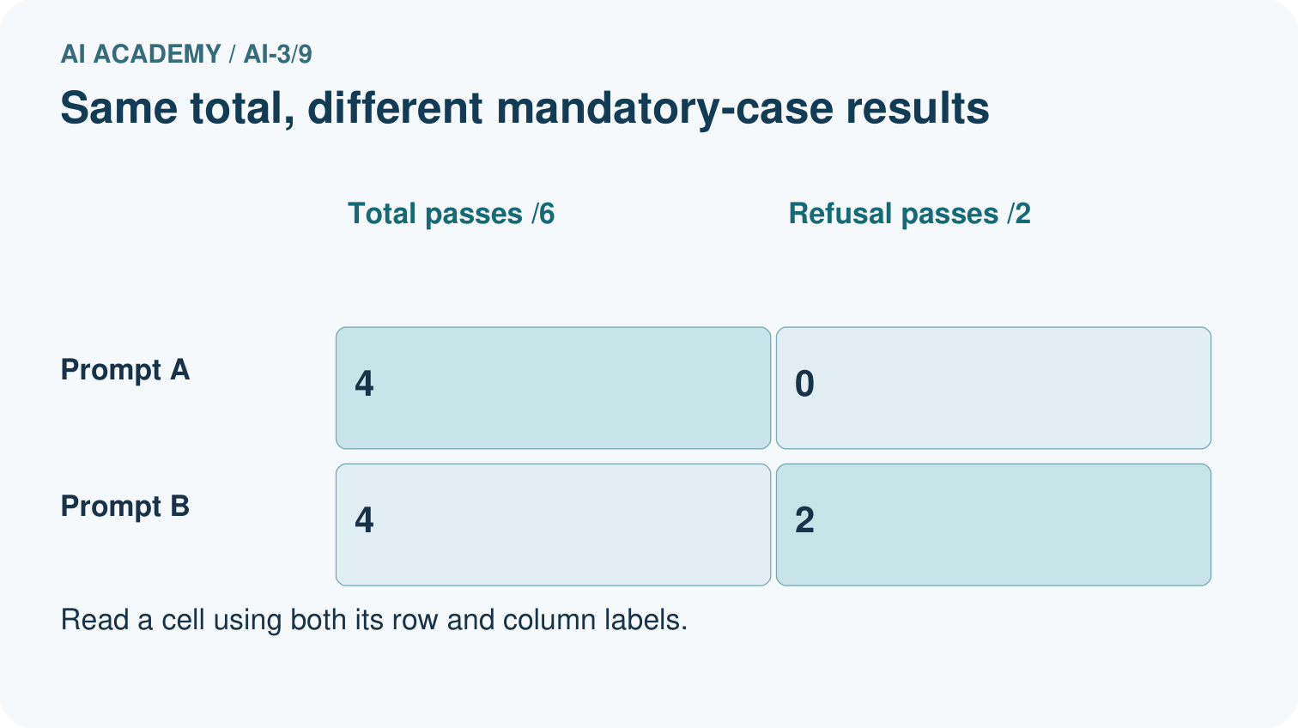
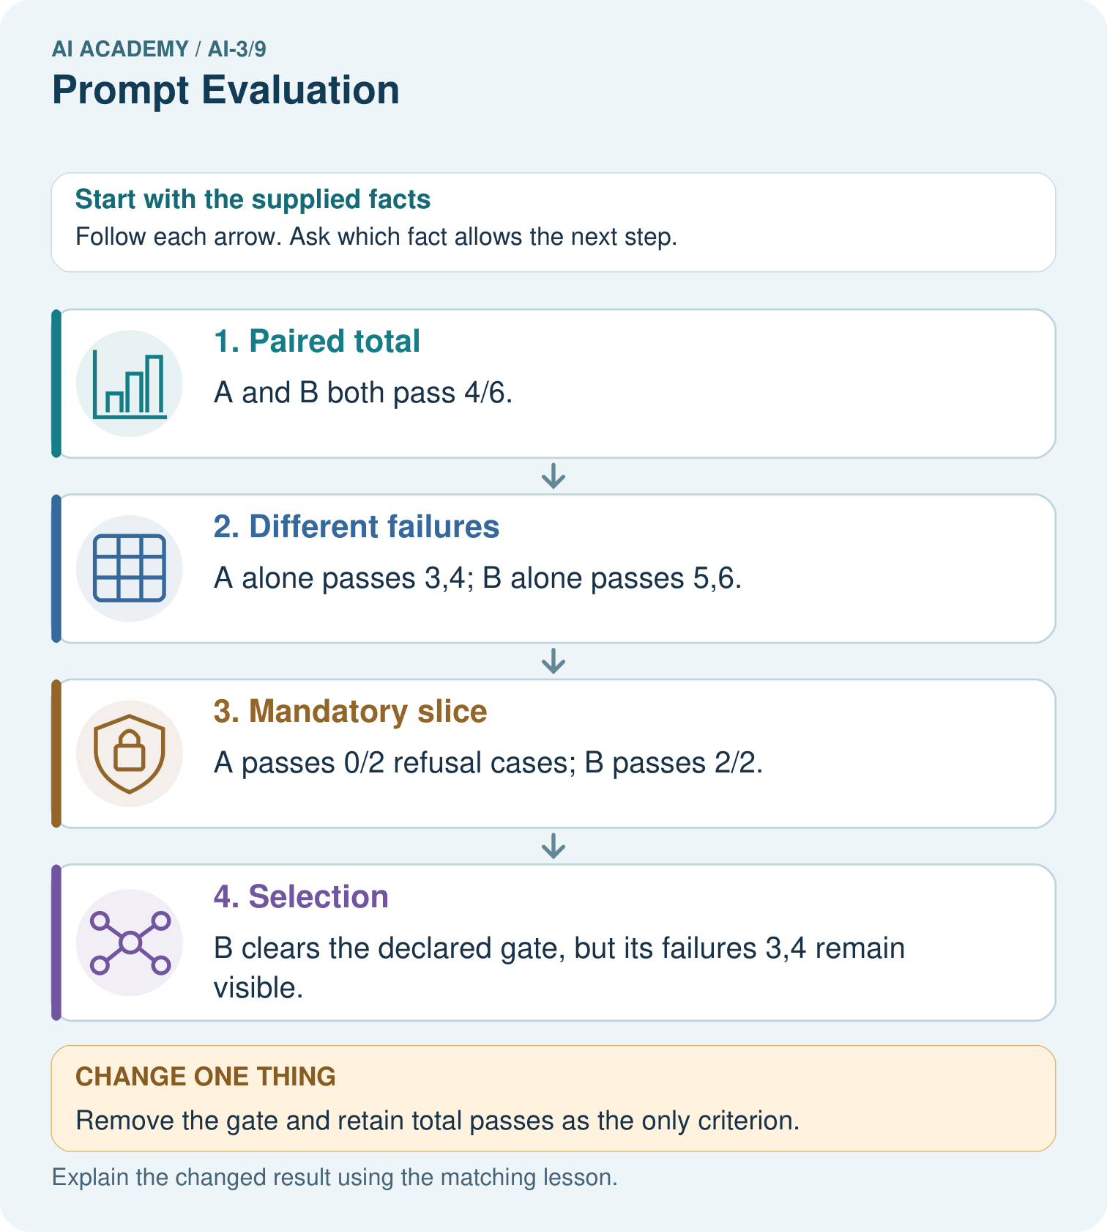
Why is B’s selection defensible here without calling it universally superior?

My picture-based explanation and changed-case prediction
________________________________________________________________
________________________________________________________________
________________________________________________________________
________________________________________________________________
________________________________________________________________
________________________________________________________________
Support used: alone / hint / worked example. This record is practice evidence.
Project connection: Use Study Buddy case matrices with explicit priorities, source support gates and fresh final questions.

19. Project portfolio milestone
Project: Verified Study Buddy
Current milestone: Make a transparent first version. Keep a trace of how one input becomes an output; explain the rule or learned component.
Use Study Buddy case matrices with explicit priorities, source support gates and fresh final questions.
Evidence to keep | My record
This week’s input and deciding step
Prediction and actual result (or labelled paper trace)
One change since the previous checkpoint and why
One error or limit and the next test

Explain what this week adds to your project. Reuse last week’s record rather than starting again.
________________________________________________________________
________________________________________________________________
________________________________________________________________
________________________________________________________________
________________________________________________________________

20. Supported practice and learning evidence
Use this supported practice once, in the browser or on paper. Keep the reserved independent assessment for a separate first attempt before teacher feedback.
A fictional Study Buddy compares two prompts across six development questions.

Practice 1: explain the deciding evidence
Which labelled step matches this detail? B clears the declared gate, but its failures 3,4 remain visible.
1. Different failures
2. Paired total
3. Mandatory slice
4. Selection

My selected conclusion, deciding fact and explanation
________________________________________________________________
________________________________________________________________
________________________________________________________________
________________________________________________________________
________________________________________________________________
Hint if needed: Read the steps in the pictorial case. Match the supplied detail to the stage that performs or records it.
After your attempt, compare with the supported explanation: Selection B clears the declared gate, but its failures 3,4 remain visible. Equal totals do not imply equal behavior. The predeclared gate expresses an important requirement instead of choosing a criterion after seeing the result. Selecting B is justified under that rule, not by claiming it is best on every question. After development, freeze the chosen prompt and test new questions, including both ordinary and unsupported cases.

Practice 2: explain the deciding evidence
Changed-case practice: Remove the gate and retain total passes as the only criterion. Which conclusion is supported by the supplied facts?
1. We can decide the result without examining the changed input or the procedure.
2. This one example guarantees correct results for every future input.
3. The record is a tie; another predeclared tie policy or further development evidence is needed.

My selected conclusion, deciding fact and explanation
________________________________________________________________
________________________________________________________________
________________________________________________________________
________________________________________________________________
________________________________________________________________
Hint if needed: Use the changed condition and the deciding step in the pictorial trace. The answer must say what follows from those facts.
After your attempt, compare with the supported explanation: The record is a tie; another predeclared tie policy or further development evidence is needed. Both prompts have four passes on six questions.

Repair a missing building block
Review Structured Output and Schemas (ai-3/8). Goal: Separate JSON parsing, schema validation and source support checks. Short practice: Which object demonstrates that valid JSON and valid types are insufficient for truth?. Return to this week and explain what you changed.
Review Examples and Rubrics (ai-3/6). Goal: Write a prompt specification with observable response criteria. Short practice: Explain why neither original nor changed draft is a full pass, and provide a complete repaired card.. Return to this week and explain what you changed.
Review Tokens and Context (ai-3/3). Goal: Account for fixed text, evidence and reserved output under a toy budget. Short practice: Can A alone justify answering 20 seats after the exception is known?. Return to this week and explain what you changed.

Keep your completed work
Use Download completed work in the hosted lesson to export your answers, reflections, practice feedback and code-run evidence. Open the HTML copy to read or print it. Drafts stay in this browser when storage is available; clear drafts on a shared device.

What I repaired, the evidence I kept and the next test
________________________________________________________________
________________________________________________________________
________________________________________________________________
________________________________________________________________
________________________________________________________________

