AI ACADEMY · WORKBOOK · ai-3/17

Model Memory vs Retrieval
Project: Verified Study Buddy

01. Recall and choose your starting point
Try the recall before opening notes. Then use a different colour or a labelled second line to correct your explanation.

Verify Numbers and Dates
Without opening the old lesson, explain one key idea from Verify Numbers and Dates. Give an example and a mistake that the idea helps you avoid.

My remembered idea, example and correction
________________________________________________________________
________________________________________________________________
________________________________________________________________

Hallucination Failure Types
Without opening the old lesson, explain one key idea from Hallucination Failure Types. Give an example and a mistake that the idea helps you avoid.

My remembered idea, example and correction
________________________________________________________________
________________________________________________________________
________________________________________________________________

Visual Composition
Without opening the old lesson, explain one key idea from Visual Composition. Give an example and a mistake that the idea helps you avoid.

My remembered idea, example and correction
________________________________________________________________
________________________________________________________________
________________________________________________________________

02. Practise with fading help
Use W2: Trace the worked case for Retrieval and indexing. Record the answer once; the lesson and workbook refer to the same attempt.
Given inputs | Procedure I chose | Middle steps | Result and check

The step I completed without help, and the hint I needed
________________________________________________________________
________________________________________________________________
________________________________________________________________

03. Individual reasoning check
Use the worked case for Retrieval and indexing. Proposed explanation: “The worked result establishes every future case”. Decide whether this explanation is supported. Point to the step or supplied fact that decides; explain your repair if needed.

My explanation before partner discussion
________________________________________________________________
________________________________________________________________
________________________________________________________________
________________________________________________________________

04. Independent transfer case

Independent case: Apply a new case independently
Corpus has public P, teacher-only T and withdrawn W. A student search returns all three. Identify the filtering defect and whether hiding T after generation is sufficient.

My independent explanation, trace and limits
________________________________________________________________
________________________________________________________________
________________________________________________________________
________________________________________________________________
________________________________________________________________
________________________________________________________________
________________________________________________________________
Attempt this case before feedback. Record any help. Earlier examples below are further practice; a case already practised with feedback cannot establish fresh transfer.

05. Your learning target
A model states the library opens at 8 from learned patterns. A supplied current notice says 9. Explain the stronger answer and one remaining check.

06. Solve the given case
One assistant answers without search; another retrieves a handbook paragraph.
Compare evidence trails.
Show your trace, calculation or evidence

Write or draw your reasoning and evidence.
________________________________________________________________
________________________________________________________________
________________________________________________________________
________________________________________________________________
________________________________________________________________

07. Check a changed case
A model recalls last year's opening hours; a retrieved current notice gives different hours. How should the answer use this evidence?
My independent answer and reason

Write or draw your reasoning and evidence.
________________________________________________________________
________________________________________________________________
________________________________________________________________
________________________________________________________________
________________________________________________________________

Week 17 Test and reflect

08. Design a revealing test
Create a changed input, boundary case or missing-information case. Write the expected answer or safe response before testing.
Test record | My evidence
Changed input or condition
Expected answer or fallback
Observed result
Why the result occurred

09. Project checkpoint
The Study Buddy retrieves course passages and never presents model memory as a citation.
The project change and evidence I will keep

Write or draw your reasoning and evidence.
________________________________________________________________
________________________________________________________________
________________________________________________________________
________________________________________________________________
________________________________________________________________

10. Self check
I can explain the mechanism. I can show evidence. I can handle a changed case. I can name a limit. Mark each as not yet, with help or independently, and attach supporting work.
Teacher review ____________________ Next step ____________________

11. Transfer practice from the original programme
A model states the library opens at 8 from learned patterns. A supplied current notice says 9. Explain the stronger answer and one remaining check.

My independently reasoned answer
________________________________________________________________
________________________________________________________________
________________________________________________________________
________________________________________________________________
________________________________________________________________
________________________________________________________________
________________________________________________________________
Record support used: none, hint or teacher explanation.

12. W1 Explain the mechanism
Explain the weekly mechanism in your own words. Use the worked scenario to name its input, decision rule and output.

My reasoning and evidence
________________________________________________________________
________________________________________________________________
________________________________________________________________
________________________________________________________________
________________________________________________________________
________________________________________________________________

13. W2 Trace the worked case
Index v1 contains notice N1 for room A. Corpus v2 supersedes it with N2 for room B, but the query still returns N1. What can be reported? Show the intermediate steps and give the conclusion with its scope.

My reasoning and evidence
________________________________________________________________
________________________________________________________________
________________________________________________________________
________________________________________________________________
________________________________________________________________
________________________________________________________________
________________________________________________________________

14. W3 Audit the limit
A report omits this qualification: High retrieval similarity does not override permissions or make an obsolete source current. Explain how omitting it could change a reader's interpretation, and write an accurate replacement.

My reasoning and evidence
________________________________________________________________
________________________________________________________________
________________________________________________________________
________________________________________________________________
________________________________________________________________
________________________________________________________________

15. W4 Apply a new case independently
Corpus has public P, teacher-only T and withdrawn W. A student search returns all three. Identify the filtering defect and whether hiding T after generation is sufficient.

My reasoning and evidence
________________________________________________________________
________________________________________________________________
________________________________________________________________
________________________________________________________________
________________________________________________________________
________________________________________________________________
________________________________________________________________
________________________________________________________________

16. W5 Design a revealing follow-up
For the worked scenario, propose one additional case that could reveal a failure, describe its expected outcome before running it, and explain what would need to remain fixed for a fair comparison. Do not reuse W4 as a new final test after receiving feedback.

My reasoning and evidence
________________________________________________________________
________________________________________________________________
________________________________________________________________
________________________________________________________________
________________________________________________________________
________________________________________________________________
________________________________________________________________

17. Feedback, return check and learning record
Evidence | My record
Worked alone / hint / model
First step I repaired and why
New case checked later; date and result
What I can now explain without notes
One remaining question
Revisit this idea with your teacher after a delay. Familiarity is different from explaining and using it on a changed case.

18. Pictorial case practice: Model Memory vs Retrieval
The library assistant remembers an old opening time, but a current notice can be retrieved.
Approved notice LIB-v = 2 says Wednesday closes at 16: 00; the model previously produced 15: 00. The question asks the current Wednesday closing time.
All inputs and outcomes in this worked example are invented classroom data; no real model run is claimed.
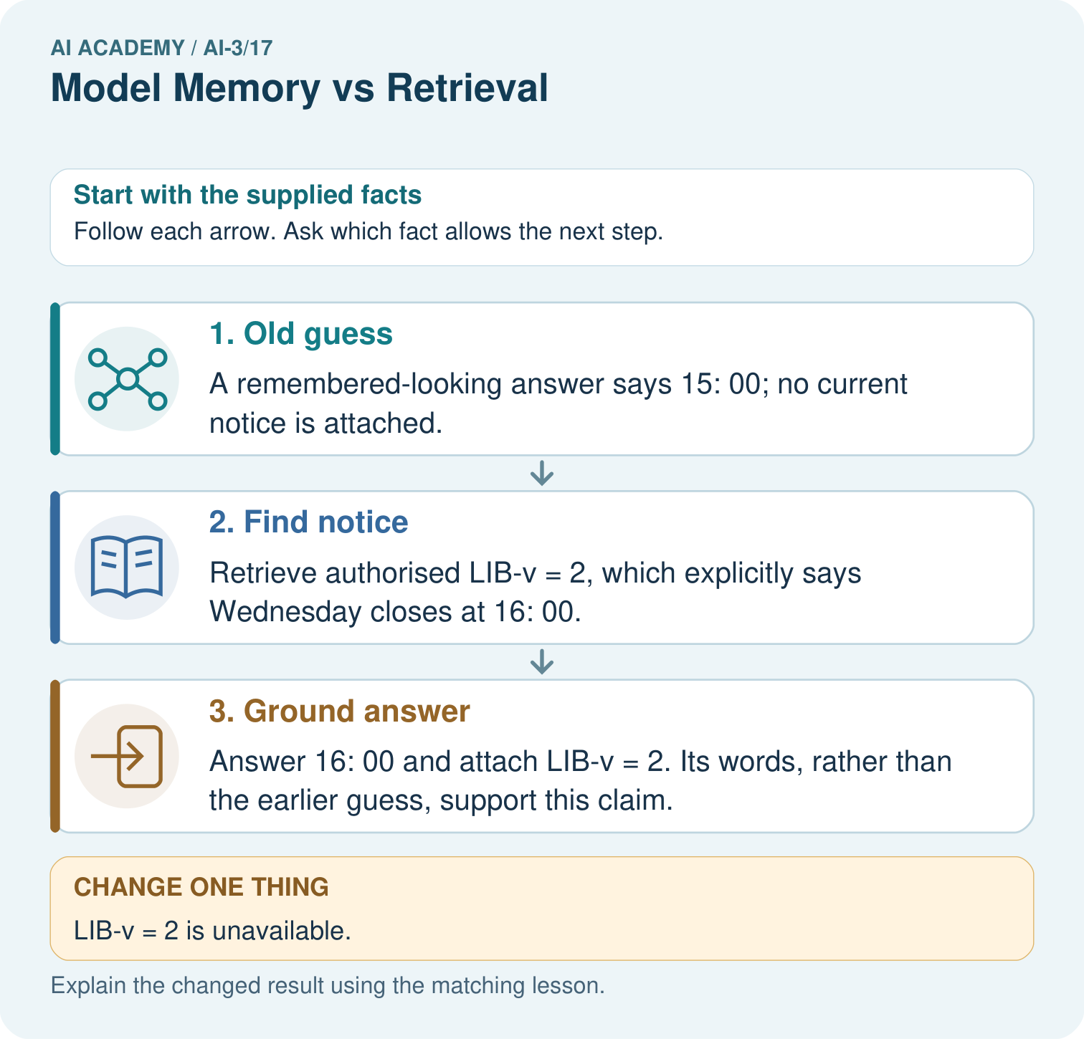
Why can the assistant not certify 15: 00 when the notice is missing? Point to the relevant step in the picture, then write the changed result and the rule or evidence that supports it.

My picture-based explanation and changed-case prediction
________________________________________________________________
________________________________________________________________
________________________________________________________________
________________________________________________________________
________________________________________________________________
________________________________________________________________
Support used: alone / hint / worked example. This record is practice evidence.
Project connection: For your Verified Study Buddy, save the input, procedure, observed result and limitation of this check. Label this worked example as practice; use a different, previously unreviewed case when checking independent understanding.

19. Project portfolio milestone
Project: Verified Study Buddy
Current milestone: Test changed cases. Keep normal, boundary and failure cases; compare expected and observed results.
For your Verified Study Buddy, save the input, procedure, observed result and limitation of this check. Label this worked example as practice; use a different, previously unreviewed case when checking independent understanding.
Evidence to keep | My record
This week’s input and deciding step
Prediction and actual result (or labelled paper trace)
One change since the previous checkpoint and why
One error or limit and the next test

Explain what this week adds to your project. Reuse last week’s record rather than starting again.
________________________________________________________________
________________________________________________________________
________________________________________________________________
________________________________________________________________
________________________________________________________________

20. Supported practice and learning evidence
Use this supported practice once, in the browser or on paper. Keep the reserved independent assessment for a separate first attempt before teacher feedback.
The library assistant remembers an old opening time, but a current notice can be retrieved.

Practice 1: explain the deciding evidence
Which labelled step matches this detail? Answer 16: 00 and attach LIB-v = 2. Its words, rather than the earlier guess, support this claim.
1. Old guess
2. Find notice
3. Ground answer

My selected conclusion, deciding fact and explanation
________________________________________________________________
________________________________________________________________
________________________________________________________________
________________________________________________________________
________________________________________________________________
Hint if needed: Read the steps in the pictorial case. Match the supplied detail to the stage that performs or records it.
After your attempt, compare with the supported explanation: Ground answer Answer 16: 00 and attach LIB-v = 2. Its words, rather than the earlier guess, support this claim. Read the picture in order. Answer 16: 00 and attach LIB-v = 2. Its words, rather than the earlier guess, support this claim. The arrows show which recorded input or intermediate result each decision uses. Explain the deciding step aloud before checking the changed case; pointing to the final answer alone does not show how it follows.

Practice 2: explain the deciding evidence
Changed-case practice: LIB-v = 2 is unavailable. Which conclusion is supported by the supplied facts?
1. We can decide the result without examining the changed input or the procedure.
2. This one example guarantees correct results for every future input.
3. Report that the current time cannot be verified.

My selected conclusion, deciding fact and explanation
________________________________________________________________
________________________________________________________________
________________________________________________________________
________________________________________________________________
________________________________________________________________
Hint if needed: Use the changed condition and the deciding step in the pictorial trace. The answer must say what follows from those facts.
After your attempt, compare with the supported explanation: Report that the current time cannot be verified. The unsupported old guess does not become current evidence when retrieval fails.

Repair a missing building block
Review Verify Numbers and Dates (ai-3/16). Goal: Explain the mechanism and terminology of claim support and citation evaluation. Short practice: Which part can be corrected immediately from existing evidence, and which needs follow-up?. Return to this week and explain what you changed.
Review Hallucination Failure Types (ai-3/14). Goal: Explain the mechanism and terminology of generation failures and verification. Short practice: Can we conclude there will definitely be no lunch from S alone?. Return to this week and explain what you changed.
Review Visual Composition (ai-3/11). Goal: Explain the mechanism and terminology of image generation and provenance. Short practice: Which checks pass after that single change, and what still needs repair?. Return to this week and explain what you changed.

Keep your completed work
Use Download completed work in the hosted lesson to export your answers, reflections, practice feedback and code-run evidence. Open the HTML copy to read or print it. Drafts stay in this browser when storage is available; clear drafts on a shared device.

What I repaired, the evidence I kept and the next test
________________________________________________________________
________________________________________________________________
________________________________________________________________
________________________________________________________________
________________________________________________________________

