AI ACADEMY · WORKBOOK · ai-3/20

Conversation State and Memory
Project: Verified Study Buddy

01. Recall and choose your starting point
Try the recall before opening notes. Then use a different colour or a labelled second line to correct your explanation.

User Need and AI Contribution
Without opening the old lesson, explain one key idea from User Need and AI Contribution. Give an example and a mistake that the idea helps you avoid.

My remembered idea, example and correction
________________________________________________________________
________________________________________________________________
________________________________________________________________

Model Memory vs Retrieval
Without opening the old lesson, explain one key idea from Model Memory vs Retrieval. Give an example and a mistake that the idea helps you avoid.

My remembered idea, example and correction
________________________________________________________________
________________________________________________________________
________________________________________________________________

Hallucination Failure Types
Without opening the old lesson, explain one key idea from Hallucination Failure Types. Give an example and a mistake that the idea helps you avoid.

My remembered idea, example and correction
________________________________________________________________
________________________________________________________________
________________________________________________________________

02. Practise with fading help
Use W2: Trace the worked case for Conversation state and retention. Record the answer once; the lesson and workbook refer to the same attempt.
Given inputs | Procedure I chose | Middle steps | Result and check

The step I completed without help, and the hint I needed
________________________________________________________________
________________________________________________________________
________________________________________________________________

03. Individual reasoning check
Use the worked case for Conversation state and retention. Proposed explanation: “The worked result establishes every future case”. Decide whether this explanation is supported. Point to the step or supplied fact that decides; explain your repair if needed.

My explanation before partner discussion
________________________________________________________________
________________________________________________________________
________________________________________________________________
________________________________________________________________

04. Independent transfer case

Independent case: Apply a new case independently
A session stores lab L1 then corrects to L2; session ends. A new session has no room input. State the active values at each stage.

My independent explanation, trace and limits
________________________________________________________________
________________________________________________________________
________________________________________________________________
________________________________________________________________
________________________________________________________________
________________________________________________________________
________________________________________________________________
Attempt this case before feedback. Record any help. Earlier examples below are further practice; a case already practised with feedback cannot establish fresh transfer.

05. Your learning target
The conversation state is topic=plants, level=Grade 8. The user says 'Keep the topic, explain for Grade 6'. Write the updated state and a reset behaviour.

06. Solve the given case
State stores topic=plants and reading_level=beginner. User requests advanced explanation.
What changes?
Show your trace, calculation or evidence

Write or draw your reasoning and evidence.
________________________________________________________________
________________________________________________________________
________________________________________________________________
________________________________________________________________
________________________________________________________________

07. Check a changed case
A learner corrects their project topic from oceans to forests. The next reply still uses oceans. What state should change, and what should not be saved unnecessarily?
My independent answer and reason

Write or draw your reasoning and evidence.
________________________________________________________________
________________________________________________________________
________________________________________________________________
________________________________________________________________
________________________________________________________________

Week 20 Test and reflect

08. Design a revealing test
Create a changed input, boundary case or missing-information case. Write the expected answer or safe response before testing.
Test record | My evidence
Changed input or condition
Expected answer or fallback
Observed result
Why the result occurred

09. Project checkpoint
Store minimal session state and make persistent memory optional, visible, and erasable.
The project change and evidence I will keep

Write or draw your reasoning and evidence.
________________________________________________________________
________________________________________________________________
________________________________________________________________
________________________________________________________________
________________________________________________________________

10. Self check
I can explain the mechanism. I can show evidence. I can handle a changed case. I can name a limit. Mark each as not yet, with help or independently, and attach supporting work.
Teacher review ____________________ Next step ____________________

11. Transfer practice from the original programme
The conversation state is topic=plants, level=Grade 8. The user says 'Keep the topic, explain for Grade 6'. Write the updated state and a reset behaviour.

My independently reasoned answer
________________________________________________________________
________________________________________________________________
________________________________________________________________
________________________________________________________________
________________________________________________________________
________________________________________________________________
________________________________________________________________
Record support used: none, hint or teacher explanation.

12. W1 Explain the mechanism
Explain the weekly mechanism in your own words. Use the worked scenario to name its input, decision rule and output.

My reasoning and evidence
________________________________________________________________
________________________________________________________________
________________________________________________________________
________________________________________________________________
________________________________________________________________
________________________________________________________________

13. W2 Trace the worked case
Turn 1 selects room A; turn 2 corrects to room B. A later answer uses A from an older summary. Show the intermediate steps and give the conclusion with its scope.

My reasoning and evidence
________________________________________________________________
________________________________________________________________
________________________________________________________________
________________________________________________________________
________________________________________________________________
________________________________________________________________
________________________________________________________________

14. W3 Audit the limit
A report omits this qualification: Remembered statements are not automatically current or verified; retention should follow the stated purpose and policy. Explain how omitting it could change a reader's interpretation, and write an accurate replacement.

My reasoning and evidence
________________________________________________________________
________________________________________________________________
________________________________________________________________
________________________________________________________________
________________________________________________________________
________________________________________________________________

15. W4 Apply a new case independently
A session stores lab L1 then corrects to L2; session ends. A new session has no room input. State the active values at each stage.

My reasoning and evidence
________________________________________________________________
________________________________________________________________
________________________________________________________________
________________________________________________________________
________________________________________________________________
________________________________________________________________
________________________________________________________________
________________________________________________________________

16. W5 Design a revealing follow-up
For the worked scenario, propose one additional case that could reveal a failure, describe its expected outcome before running it, and explain what would need to remain fixed for a fair comparison. Do not reuse W4 as a new final test after receiving feedback.

My reasoning and evidence
________________________________________________________________
________________________________________________________________
________________________________________________________________
________________________________________________________________
________________________________________________________________
________________________________________________________________
________________________________________________________________

17. Feedback, return check and learning record
Evidence | My record
Worked alone / hint / model
First step I repaired and why
New case checked later; date and result
What I can now explain without notes
One remaining question
Revisit this idea with your teacher after a delay. Familiarity is different from explaining and using it on a changed case.

18. Pictorial case practice: Conversation State and Memory
Keep a reading conversation consistent when the learner changes the selected book.
In this toy session, “choose Cedar” sets selected_book=Cedar; “change to Maple” replaces it. Session state is cleared on exit.
All inputs and outcomes in this worked example are invented classroom data; no real model run is claimed.
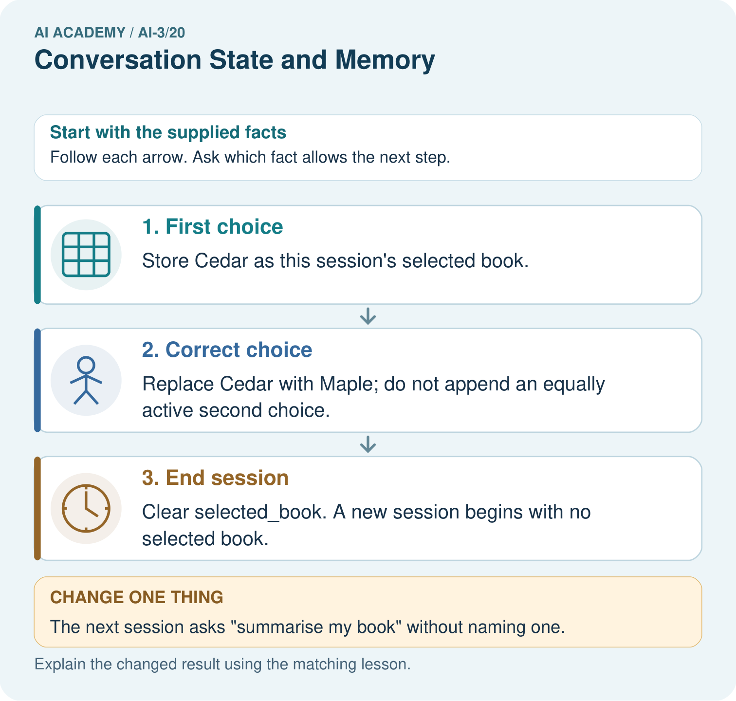
What is selected_book after the correction and after exit? Point to the relevant step in the picture, then write the changed result and the rule or evidence that supports it.

My picture-based explanation and changed-case prediction
________________________________________________________________
________________________________________________________________
________________________________________________________________
________________________________________________________________
________________________________________________________________
________________________________________________________________
Support used: alone / hint / worked example. This record is practice evidence.
Project connection: For your Verified Study Buddy, save the input, procedure, observed result and limitation of this check. Label this worked example as practice; use a different, previously unreviewed case when checking independent understanding.

19. Project portfolio milestone
Project: Verified Study Buddy
Current milestone: Evaluate and revise. Compare with your starting method, explain errors and record a justified revision.
For your Verified Study Buddy, save the input, procedure, observed result and limitation of this check. Label this worked example as practice; use a different, previously unreviewed case when checking independent understanding.
Evidence to keep | My record
This week’s input and deciding step
Prediction and actual result (or labelled paper trace)
One change since the previous checkpoint and why
One error or limit and the next test

Explain what this week adds to your project. Reuse last week’s record rather than starting again.
________________________________________________________________
________________________________________________________________
________________________________________________________________
________________________________________________________________
________________________________________________________________

20. Supported practice and learning evidence
Use this supported practice once, in the browser or on paper. Keep the reserved independent assessment for a separate first attempt before teacher feedback.
Keep a reading conversation consistent when the learner changes the selected book.

Practice 1: explain the deciding evidence
Which labelled step matches this detail? Clear selected_book. A new session begins with no selected book.
1. First choice
2. Correct choice
3. End session

My selected conclusion, deciding fact and explanation
________________________________________________________________
________________________________________________________________
________________________________________________________________
________________________________________________________________
________________________________________________________________
Hint if needed: Read the steps in the pictorial case. Match the supplied detail to the stage that performs or records it.
After your attempt, compare with the supported explanation: End session Clear selected_book. A new session begins with no selected book. Read the picture in order. Clear selected_book. A new session begins with no selected book. The arrows show which recorded input or intermediate result each decision uses. Explain the deciding step aloud before checking the changed case; pointing to the final answer alone does not show how it follows.

Practice 2: explain the deciding evidence
Changed-case practice: The next session asks “summarise my book” without naming one. Which conclusion is supported by the supplied facts?
1. Ask which book the learner wants.
2. We can decide the result without examining the changed input or the procedure.
3. This one example guarantees correct results for every future input.

My selected conclusion, deciding fact and explanation
________________________________________________________________
________________________________________________________________
________________________________________________________________
________________________________________________________________
________________________________________________________________
Hint if needed: Use the changed condition and the deciding step in the pictorial trace. The answer must say what follows from those facts.
After your attempt, compare with the supported explanation: Ask which book the learner wants. The declared policy clears session state, so yesterday’s choice is unavailable.

Repair a missing building block
Review User Need and AI Contribution (ai-3/19). Goal: Explain the mechanism and terminology of capstone requirements and corpus. Short practice: What non-AI baseline would reveal whether this helper adds value? Point to the relevant step in the picture, then write the changed result and the rule or evidence that supports it.. Return to this week and explain what you changed.
Review Model Memory vs Retrieval (ai-3/17). Goal: Explain the mechanism and terminology of retrieval and indexing. Short practice: Why can the assistant not certify 15: 00 when the notice is missing? Point to the relevant step in the picture, then write the changed result and the rule or evidence that supports it.. Return to this week and explain what you changed.
Review Hallucination Failure Types (ai-3/14). Goal: Explain the mechanism and terminology of generation failures and verification. Short practice: Can we conclude there will definitely be no lunch from S alone?. Return to this week and explain what you changed.

Keep your completed work
Use Download completed work in the hosted lesson to export your answers, reflections, practice feedback and code-run evidence. Open the HTML copy to read or print it. Drafts stay in this browser when storage is available; clear drafts on a shared device.

What I repaired, the evidence I kept and the next test
________________________________________________________________
________________________________________________________________
________________________________________________________________
________________________________________________________________
________________________________________________________________

