AI ACADEMY · WORKBOOK · ai-3/23

Block to Python Bridge
Project: Verified Study Buddy

01. Recall and choose your starting point
Try the recall before opening notes. Then use a different colour or a labelled second line to correct your explanation.

Requests Responses and JSON
Without opening the old lesson, explain one key idea from Requests Responses and JSON. Give an example and a mistake that the idea helps you avoid.

My remembered idea, example and correction
________________________________________________________________
________________________________________________________________
________________________________________________________________

Conversation State and Memory
Without opening the old lesson, explain one key idea from Conversation State and Memory. Give an example and a mistake that the idea helps you avoid.

My remembered idea, example and correction
________________________________________________________________
________________________________________________________________
________________________________________________________________

Model Memory vs Retrieval
Without opening the old lesson, explain one key idea from Model Memory vs Retrieval. Give an example and a mistake that the idea helps you avoid.

My remembered idea, example and correction
________________________________________________________________
________________________________________________________________
________________________________________________________________

02. Practise with fading help
Use W2: Predict then observe for From a paper algorithm to Python. Record the answer once; the lesson and workbook refer to the same attempt.
Given inputs | Procedure I chose | Middle steps | Result and check

The step I completed without help, and the hint I needed
________________________________________________________________
________________________________________________________________
________________________________________________________________

03. Individual reasoning check
Use the worked case for From a paper algorithm to Python. Proposed explanation: “An equals sign displays the answer”. Decide whether this explanation is supported. Point to the step or supplied fact that decides; explain your repair if needed.

My explanation before partner discussion
________________________________________________________________
________________________________________________________________
________________________________________________________________
________________________________________________________________

04. Independent transfer case

Independent case: Changed independent case
Set total=0, then for values2,4,9 perform total=total+value. Trace the result. What changes if total=0 moves inside the loop before that addition?

My independent explanation, trace and limits
________________________________________________________________
________________________________________________________________
________________________________________________________________
________________________________________________________________
________________________________________________________________
________________________________________________________________
________________________________________________________________
Attempt this case before feedback. Record any help. Earlier examples below are further practice; a case already practised with feedback cannot establish fresh transfer.

05. Your learning target
Write Python that totals [3,5,7], then trace each total. Explain how indenting 'total=0' inside the loop changes the result.

06. Solve the given case
A block program sets total=0 and adds each value in [2,4,6].
Translate and trace.
Show your trace, calculation or evidence

Write or draw your reasoning and evidence.
________________________________________________________________
________________________________________________________________
________________________________________________________________
________________________________________________________________
________________________________________________________________

07. Check a changed case
Trace this Python: score = 2; then if score >= 2: score = score + 3. What is the final value, and what changes if the condition becomes score > 2?
My independent answer and reason

Write or draw your reasoning and evidence.
________________________________________________________________
________________________________________________________________
________________________________________________________________
________________________________________________________________
________________________________________________________________

Week 23 Test and reflect

08. Design a revealing test
Create a changed input, boundary case or missing-information case. Write the expected answer or safe response before testing.
Test record | My evidence
Changed input or condition
Expected answer or fallback
Observed result
Why the result occurred

09. Project checkpoint
Implement small transparent functions for selection, validation, and citation formatting.
The project change and evidence I will keep

Write or draw your reasoning and evidence.
________________________________________________________________
________________________________________________________________
________________________________________________________________
________________________________________________________________
________________________________________________________________

10. Self check
I can explain the mechanism. I can show evidence. I can handle a changed case. I can name a limit. Mark each as not yet, with help or independently, and attach supporting work.
Teacher review ____________________ Next step ____________________

11. Transfer practice from the original programme
Write Python that totals [3,5,7], then trace each total. Explain how indenting 'total=0' inside the loop changes the result.

My independently reasoned answer
________________________________________________________________
________________________________________________________________
________________________________________________________________
________________________________________________________________
________________________________________________________________
________________________________________________________________
________________________________________________________________
Record support used: none, hint or teacher explanation.

12. W1 Connect the paper steps to Python
Write the complete four-line script for 4 packs of 6. Beside each line explain what it does. Which line displays information?

My reasoning and evidence
________________________________________________________________
________________________________________________________________
________________________________________________________________
________________________________________________________________
________________________________________________________________
________________________________________________________________

13. W2 Predict then observe
Make records for 4 packs of 6, then 5 packs of 6. Predict before running. Record actual output, any error and what changed. If working on paper, label both results as traces.

My reasoning and evidence
________________________________________________________________
________________________________________________________________
________________________________________________________________
________________________________________________________________
________________________________________________________________
________________________________________________________________

14. W3 Explain an order error
Move print(total) to the first line of a fresh script. Predict what happens and why. Put the lines back into an order that meets the requirement.

My reasoning and evidence
________________________________________________________________
________________________________________________________________
________________________________________________________________
________________________________________________________________
________________________________________________________________
________________________________________________________________

15. W4 Transfer the procedure independently
A fictional shelf has 3 trays of 7 tiles each. Write a four-line Python script using trays, per_tray and tiles. Predict its output. Then change only trays to 0 and predict again. Explain why adding the two quantities is wrong.

My reasoning and evidence
________________________________________________________________
________________________________________________________________
________________________________________________________________
________________________________________________________________
________________________________________________________________
________________________________________________________________
________________________________________________________________

16. W5 Keep an honest conclusion
Explain the difference between a successful run and a correct calculation. State one limit of this program and what you would keep so another person can check your work.

My reasoning and evidence
________________________________________________________________
________________________________________________________________
________________________________________________________________
________________________________________________________________
________________________________________________________________
________________________________________________________________

17. Feedback, return check and learning record
Evidence | My record
Worked alone / hint / model
First step I repaired and why
New case checked later; date and result
What I can now explain without notes
One remaining question
Revisit this idea with your teacher after a delay. Familiarity is different from explaining and using it on a changed case.

18. Pictorial case practice: Block to Python Bridge
Translate a “count qualifying books” paper procedure into a Python-style trace.
Page counts are [80, 150, 90]. Start count=0; for each pages value, add 1 only when pages<100.
All inputs and outcomes in this worked example are invented classroom data; no real model run is claimed.
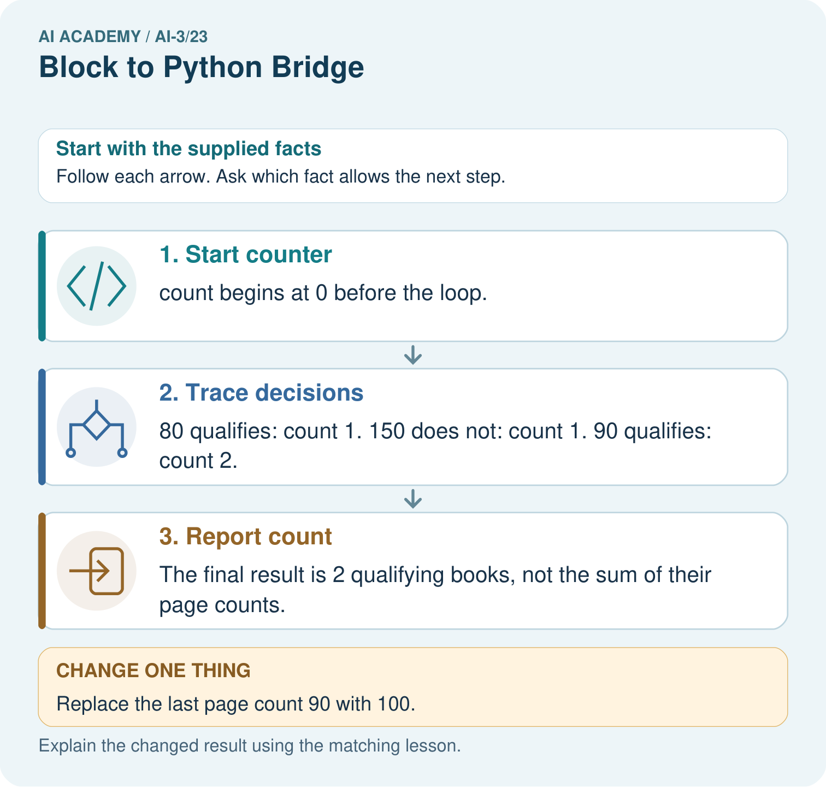
Trace the changed list and identify where the result differs. Point to the relevant step in the picture, then write the changed result and the rule or evidence that supports it.

My picture-based explanation and changed-case prediction
________________________________________________________________
________________________________________________________________
________________________________________________________________
________________________________________________________________
________________________________________________________________
________________________________________________________________
Support used: alone / hint / worked example. This record is practice evidence.
Project connection: For your Verified Study Buddy, save the input, procedure, observed result and limitation of this check. Label this worked example as practice; use a different, previously unreviewed case when checking independent understanding.

19. Project portfolio milestone
Project: Verified Study Buddy
Current milestone: Evaluate and revise. Compare with your starting method, explain errors and record a justified revision.
For your Verified Study Buddy, save the input, procedure, observed result and limitation of this check. Label this worked example as practice; use a different, previously unreviewed case when checking independent understanding.
Evidence to keep | My record
This week’s input and deciding step
Prediction and actual result (or labelled paper trace)
One change since the previous checkpoint and why
One error or limit and the next test

Explain what this week adds to your project. Reuse last week’s record rather than starting again.
________________________________________________________________
________________________________________________________________
________________________________________________________________
________________________________________________________________
________________________________________________________________

20. Supported practice and learning evidence
Use this supported practice once, in the browser or on paper. Keep the reserved independent assessment for a separate first attempt before teacher feedback.
Translate a “count qualifying books” paper procedure into a Python-style trace.

Practice 1: explain the deciding evidence
Which labelled step matches this detail? The final result is 2 qualifying books, not the sum of their page counts.
1. Trace decisions
2. Start counter
3. Report count

My selected conclusion, deciding fact and explanation
________________________________________________________________
________________________________________________________________
________________________________________________________________
________________________________________________________________
________________________________________________________________
Hint if needed: Read the steps in the pictorial case. Match the supplied detail to the stage that performs or records it.
After your attempt, compare with the supported explanation: Report count The final result is 2 qualifying books, not the sum of their page counts. Read the picture in order. The final result is 2 qualifying books, not the sum of their page counts. The arrows show which recorded input or intermediate result each decision uses. Explain the deciding step aloud before checking the changed case; pointing to the final answer alone does not show how it follows.

Practice 2: explain the deciding evidence
Changed-case practice: Replace the last page count 90 with 100. Which conclusion is supported by the supplied facts?
1. This one example guarantees correct results for every future input.
2. We can decide the result without examining the changed input or the procedure.
3. The final count becomes 1.

My selected conclusion, deciding fact and explanation
________________________________________________________________
________________________________________________________________
________________________________________________________________
________________________________________________________________
________________________________________________________________
Hint if needed: Use the changed condition and the deciding step in the pictorial trace. The answer must say what follows from those facts.
After your attempt, compare with the supported explanation: The final count becomes 1. The comparison is strictly less than 100, so the boundary value does not qualify.

Repair a missing building block
Review Requests Responses and JSON (ai-3/22). Goal: Parse JSON into Python records. Short practice: Would converting the text silently prove the source count is correct? Point to the relevant step in the picture, then write the changed result and the rule or evidence that supports it.. Return to this week and explain what you changed.
Review Conversation State and Memory (ai-3/20). Goal: Explain the mechanism and terminology of conversation state and retention. Short practice: What is selected_book after the correction and after exit? Point to the relevant step in the picture, then write the changed result and the rule or evidence that supports it.. Return to this week and explain what you changed.
Review Model Memory vs Retrieval (ai-3/17). Goal: Explain the mechanism and terminology of retrieval and indexing. Short practice: Why can the assistant not certify 15: 00 when the notice is missing? Point to the relevant step in the picture, then write the changed result and the rule or evidence that supports it.. Return to this week and explain what you changed.

Predict, run and debug
The browser lab lets you edit the supported Python examples already included in this lesson. Predict first, run, inspect the actual output or error, change one input, then run again. Keep code, predictions, actual results and a reasoned revision together. On paper, label your result as a trace rather than an execution.

Keep your completed work
Use Download completed work in the hosted lesson to export your answers, reflections, practice feedback and code-run evidence. Open the HTML copy to read or print it. Drafts stay in this browser when storage is available; clear drafts on a shared device.

What I repaired, the evidence I kept and the next test
________________________________________________________________
________________________________________________________________
________________________________________________________________
________________________________________________________________
________________________________________________________________

