AI ACADEMY · WORKBOOK · ai-3/29

Copyright and Provenance
Project: Verified Study Buddy

01. Recall and choose your starting point
Try the recall before opening notes. Then use a different colour or a labelled second line to correct your explanation.

Privacy by Design
Without opening the old lesson, explain one key idea from Privacy by Design. Give an example and a mistake that the idea helps you avoid.

My remembered idea, example and correction
________________________________________________________________
________________________________________________________________
________________________________________________________________

Evaluation Sets
Without opening the old lesson, explain one key idea from Evaluation Sets. Give an example and a mistake that the idea helps you avoid.

My remembered idea, example and correction
________________________________________________________________
________________________________________________________________
________________________________________________________________

Block to Python Bridge
Without opening the old lesson, explain one key idea from Block to Python Bridge. Give an example and a mistake that the idea helps you avoid.

My remembered idea, example and correction
________________________________________________________________
________________________________________________________________
________________________________________________________________

02. Practise with fading help
Use W2: Trace the worked case for Copyright and permitted sources. Record the answer once; the lesson and workbook refer to the same attempt.
Given inputs | Procedure I chose | Middle steps | Result and check

The step I completed without help, and the hint I needed
________________________________________________________________
________________________________________________________________
________________________________________________________________

03. Individual reasoning check
Use the worked case for Copyright and permitted sources. Proposed explanation: “The worked result establishes every future case”. Decide whether this explanation is supported. Point to the step or supplied fact that decides; explain your repair if needed.

My explanation before partner discussion
________________________________________________________________
________________________________________________________________
________________________________________________________________
________________________________________________________________

04. Independent transfer case

Independent case: Apply a new case independently
Text C permits internal reading only; D permits public quotation up to 30 words with attribution. Proposed public handout reproduces 40 words. Apply the fictional terms.

My independent explanation, trace and limits
________________________________________________________________
________________________________________________________________
________________________________________________________________
________________________________________________________________
________________________________________________________________
________________________________________________________________
________________________________________________________________
Attempt this case before feedback. Record any help. Earlier examples below are further practice; a case already practised with feedback cannot establish fresh transfer.

05. Your learning target
A project uses an image found through search. Its author is known but its licence is missing. Is naming the author enough to establish reuse permission? Describe a provenance record and next action.

06. Solve the given case
A slide reuses an online photograph and textbook paragraph.
What provenance and reuse checks are needed?
Show your trace, calculation or evidence

Write or draw your reasoning and evidence.
________________________________________________________________
________________________________________________________________
________________________________________________________________
________________________________________________________________
________________________________________________________________

07. Check a changed case
You find an attractive illustration online with no license information. What should you record and check before reusing it in a public project?
My independent answer and reason

Write or draw your reasoning and evidence.
________________________________________________________________
________________________________________________________________
________________________________________________________________
________________________________________________________________
________________________________________________________________

Week 29 Test and reflect

08. Design a revealing test
Create a changed input, boundary case or missing-information case. Write the expected answer or safe response before testing.
Test record | My evidence
Changed input or condition
Expected answer or fallback
Observed result
Why the result occurred

09. Project checkpoint
Attach citations and provenance metadata to every Study Buddy learning asset.
The project change and evidence I will keep

Write or draw your reasoning and evidence.
________________________________________________________________
________________________________________________________________
________________________________________________________________
________________________________________________________________
________________________________________________________________

10. Self check
I can explain the mechanism. I can show evidence. I can handle a changed case. I can name a limit. Mark each as not yet, with help or independently, and attach supporting work.
Teacher review ____________________ Next step ____________________

11. Transfer practice from the original programme
A project uses an image found through search. Its author is known but its licence is missing. Is naming the author enough to establish reuse permission? Describe a provenance record and next action.

My independently reasoned answer
________________________________________________________________
________________________________________________________________
________________________________________________________________
________________________________________________________________
________________________________________________________________
________________________________________________________________
________________________________________________________________
Record support used: none, hint or teacher explanation.

12. W1 Explain the mechanism
Explain the weekly mechanism in your own words. Use the worked scenario to name its input, decision rule and output.

My reasoning and evidence
________________________________________________________________
________________________________________________________________
________________________________________________________________
________________________________________________________________
________________________________________________________________
________________________________________________________________

13. W2 Trace the worked case
Image A has L; image B has M. The project is a publicly downloadable adapted poster. Show the intermediate steps and give the conclusion with its scope.

My reasoning and evidence
________________________________________________________________
________________________________________________________________
________________________________________________________________
________________________________________________________________
________________________________________________________________
________________________________________________________________
________________________________________________________________

14. W3 Audit the limit
A report omits this qualification: Real legal outcomes depend on jurisdiction and facts; supplied licence terms define this classroom exercise, not universal copyright law. Explain how omitting it could change a reader's interpretation, and write an accurate replacement.

My reasoning and evidence
________________________________________________________________
________________________________________________________________
________________________________________________________________
________________________________________________________________
________________________________________________________________
________________________________________________________________

15. W4 Apply a new case independently
Text C permits internal reading only; D permits public quotation up to 30 words with attribution. Proposed public handout reproduces 40 words. Apply the fictional terms.

My reasoning and evidence
________________________________________________________________
________________________________________________________________
________________________________________________________________
________________________________________________________________
________________________________________________________________
________________________________________________________________
________________________________________________________________
________________________________________________________________

16. W5 Design a revealing follow-up
For the worked scenario, propose one additional case that could reveal a failure, describe its expected outcome before running it, and explain what would need to remain fixed for a fair comparison. Do not reuse W4 as a new final test after receiving feedback.

My reasoning and evidence
________________________________________________________________
________________________________________________________________
________________________________________________________________
________________________________________________________________
________________________________________________________________
________________________________________________________________
________________________________________________________________

17. Feedback, return check and learning record
Evidence | My record
Worked alone / hint / model
First step I repaired and why
New case checked later; date and result
What I can now explain without notes
One remaining question
Revisit this idea with your teacher after a delay. Familiarity is different from explaining and using it on a changed case.

18. Pictorial case practice: Copyright and Provenance
Read fictional reuse terms before decorating a public study guide.
Image Fern allows public redistribution with attribution but no alteration. Image Moss allows alteration and public redistribution with attribution. The plan crops an image.
All inputs and outcomes in this worked example are invented classroom data; no real model run is claimed.
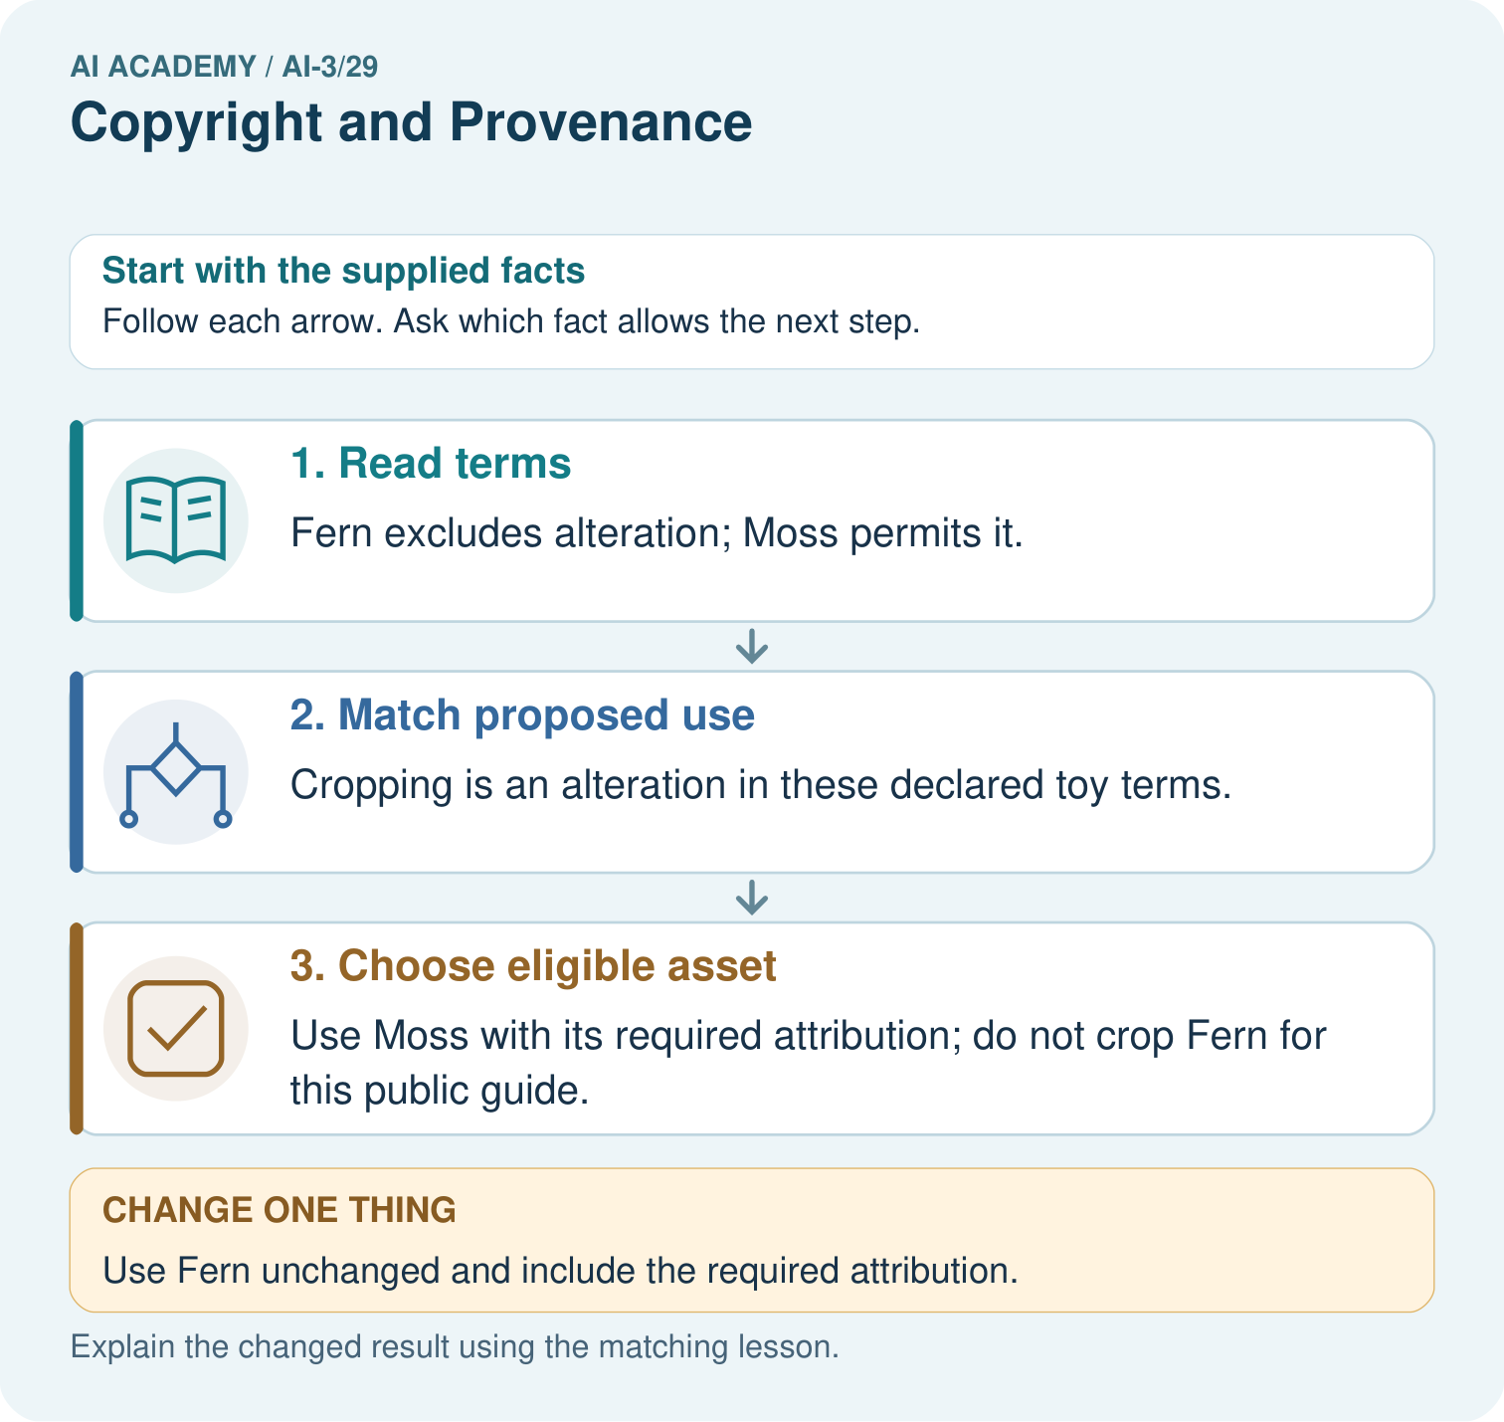
Does acknowledging Fern make a cropped version permitted? Point to the relevant step in the picture, then write the changed result and the rule or evidence that supports it.

My picture-based explanation and changed-case prediction
________________________________________________________________
________________________________________________________________
________________________________________________________________
________________________________________________________________
________________________________________________________________
________________________________________________________________
Support used: alone / hint / worked example. This record is practice evidence.
Project connection: For your Verified Study Buddy, save the input, procedure, observed result and limitation of this check. Label this worked example as practice; use a different, previously unreviewed case when checking independent understanding.

19. Project portfolio milestone
Project: Verified Study Buddy
Current milestone: Prepare the demonstration. Gather reproducible instructions, evidence, access checks and remaining limitations.
For your Verified Study Buddy, save the input, procedure, observed result and limitation of this check. Label this worked example as practice; use a different, previously unreviewed case when checking independent understanding.
Evidence to keep | My record
This week’s input and deciding step
Prediction and actual result (or labelled paper trace)
One change since the previous checkpoint and why
One error or limit and the next test

Explain what this week adds to your project. Reuse last week’s record rather than starting again.
________________________________________________________________
________________________________________________________________
________________________________________________________________
________________________________________________________________
________________________________________________________________

20. Supported practice and learning evidence
Use this supported practice once, in the browser or on paper. Keep the reserved independent assessment for a separate first attempt before teacher feedback.
Read fictional reuse terms before decorating a public study guide.

Practice 1: explain the deciding evidence
Which labelled step matches this detail? Use Moss with its required attribution; do not crop Fern for this public guide.
1. Choose eligible asset
2. Read terms
3. Match proposed use

My selected conclusion, deciding fact and explanation
________________________________________________________________
________________________________________________________________
________________________________________________________________
________________________________________________________________
________________________________________________________________
Hint if needed: Read the steps in the pictorial case. Match the supplied detail to the stage that performs or records it.
After your attempt, compare with the supported explanation: Choose eligible asset Use Moss with its required attribution; do not crop Fern for this public guide. Read the picture in order. Use Moss with its required attribution; do not crop Fern for this public guide. The arrows show which recorded input or intermediate result each decision uses. Explain the deciding step aloud before checking the changed case; pointing to the final answer alone does not show how it follows.

Practice 2: explain the deciding evidence
Changed-case practice: Use Fern unchanged and include the required attribution. Which conclusion is supported by the supplied facts?
1. That use satisfies the stated fictional permission conditions.
2. This one example guarantees correct results for every future input.
3. We can decide the result without examining the changed input or the procedure.

My selected conclusion, deciding fact and explanation
________________________________________________________________
________________________________________________________________
________________________________________________________________
________________________________________________________________
________________________________________________________________
Hint if needed: Use the changed condition and the deciding step in the pictorial trace. The answer must say what follows from those facts.
After your attempt, compare with the supported explanation: That use satisfies the stated fictional permission conditions. Its public redistribution is permitted when there is no alteration and attribution is included.

Repair a missing building block
Review Privacy by Design (ai-3/28). Goal: Explain the mechanism and terminology of data retention and deletion. Short practice: Which IDs and locations must appear in the deletion evidence? Point to the relevant step in the picture, then write the changed result and the rule or evidence that supports it.. Return to this week and explain what you changed.
Review Evaluation Sets (ai-3/26). Goal: Explain the mechanism and terminology of system evaluation sets. Short practice: Did the added cases demonstrate better answering? Point to the relevant step in the picture, then write the changed result and the rule or evidence that supports it.. Return to this week and explain what you changed.
Review Block to Python Bridge (ai-3/23). Goal: Translate a short paper calculation into a Python script. Short practice: Trace the changed list and identify where the result differs. Point to the relevant step in the picture, then write the changed result and the rule or evidence that supports it.. Return to this week and explain what you changed.

Keep your completed work
Use Download completed work in the hosted lesson to export your answers, reflections, practice feedback and code-run evidence. Open the HTML copy to read or print it. Drafts stay in this browser when storage is available; clear drafts on a shared device.

What I repaired, the evidence I kept and the next test
________________________________________________________________
________________________________________________________________
________________________________________________________________
________________________________________________________________
________________________________________________________________

