AI ACADEMY · WORKBOOK · ai-3/31

Safety Boundaries
Project: Verified Study Buddy

01. Recall and choose your starting point
Try the recall before opening notes. Then use a different colour or a labelled second line to correct your explanation.

Bias and Representation
Without opening the old lesson, explain one key idea from Bias and Representation. Give an example and a mistake that the idea helps you avoid.

My remembered idea, example and correction
________________________________________________________________
________________________________________________________________
________________________________________________________________

Privacy by Design
Without opening the old lesson, explain one key idea from Privacy by Design. Give an example and a mistake that the idea helps you avoid.

My remembered idea, example and correction
________________________________________________________________
________________________________________________________________
________________________________________________________________

Quality Rubrics
Without opening the old lesson, explain one key idea from Quality Rubrics. Give an example and a mistake that the idea helps you avoid.

My remembered idea, example and correction
________________________________________________________________
________________________________________________________________
________________________________________________________________

02. Practise with fading help
Use W2: Trace the worked case for Untrusted input boundaries. Record the answer once; the lesson and workbook refer to the same attempt.
Given inputs | Procedure I chose | Middle steps | Result and check

The step I completed without help, and the hint I needed
________________________________________________________________
________________________________________________________________
________________________________________________________________

03. Individual reasoning check
Use the worked case for Untrusted input boundaries. Proposed explanation: “The worked result establishes every future case”. Decide whether this explanation is supported. Point to the step or supplied fact that decides; explain your repair if needed.

My explanation before partner discussion
________________________________________________________________
________________________________________________________________
________________________________________________________________
________________________________________________________________

04. Independent transfer case

Independent case: Apply a new case independently
Classify B2, b2, B22 and B2; DROP under the exact format.

My independent explanation, trace and limits
________________________________________________________________
________________________________________________________________
________________________________________________________________
________________________________________________________________
________________________________________________________________
________________________________________________________________
________________________________________________________________
Attempt this case before feedback. Record any help. Earlier examples below are further practice; a case already practised with feedback cannot establish fresh transfer.

05. Your learning target
A plant-study assistant is asked for a person's medication dose. Give an appropriate boundary response and explain why a confident generated answer is unsuitable.

06. Solve the given case
A Study Buddy is asked to decide whether a learner should take medicine.
Set a product boundary.
Show your trace, calculation or evidence

Write or draw your reasoning and evidence.
________________________________________________________________
________________________________________________________________
________________________________________________________________
________________________________________________________________
________________________________________________________________

07. Check a changed case
A study tool is asked to make a high-stakes personal decision outside its learning purpose. What boundary should the response show?
My independent answer and reason

Write or draw your reasoning and evidence.
________________________________________________________________
________________________________________________________________
________________________________________________________________
________________________________________________________________
________________________________________________________________

Week 31 Test and reflect

08. Design a revealing test
Create a changed input, boundary case or missing-information case. Write the expected answer or safe response before testing.
Test record | My evidence
Changed input or condition
Expected answer or fallback
Observed result
Why the result occurred

09. Project checkpoint
Implement risk levels, refusal language, safe alternatives, and teacher-review gates.
The project change and evidence I will keep

Write or draw your reasoning and evidence.
________________________________________________________________
________________________________________________________________
________________________________________________________________
________________________________________________________________
________________________________________________________________

10. Self check
I can explain the mechanism. I can show evidence. I can handle a changed case. I can name a limit. Mark each as not yet, with help or independently, and attach supporting work.
Teacher review ____________________ Next step ____________________

11. Transfer practice from the original programme
A plant-study assistant is asked for a person's medication dose. Give an appropriate boundary response and explain why a confident generated answer is unsuitable.

My independently reasoned answer
________________________________________________________________
________________________________________________________________
________________________________________________________________
________________________________________________________________
________________________________________________________________
________________________________________________________________
________________________________________________________________
Record support used: none, hint or teacher explanation.

12. W1 Explain the mechanism
Explain the weekly mechanism in your own words. Use the worked scenario to name its input, decision rule and output.

My reasoning and evidence
________________________________________________________________
________________________________________________________________
________________________________________________________________
________________________________________________________________
________________________________________________________________
________________________________________________________________

13. W2 Trace the worked case
Inputs A1 and delete_all() are supplied to room lookup. Show the intermediate steps and give the conclusion with its scope.

My reasoning and evidence
________________________________________________________________
________________________________________________________________
________________________________________________________________
________________________________________________________________
________________________________________________________________
________________________________________________________________
________________________________________________________________

14. W3 Audit the limit
A report omits this qualification: A format check does not grant resource access; authorisation follows separately. Explain how omitting it could change a reader's interpretation, and write an accurate replacement.

My reasoning and evidence
________________________________________________________________
________________________________________________________________
________________________________________________________________
________________________________________________________________
________________________________________________________________
________________________________________________________________

15. W4 Apply a new case independently
Classify B2, b2, B22 and B2; DROP under the exact format.

My reasoning and evidence
________________________________________________________________
________________________________________________________________
________________________________________________________________
________________________________________________________________
________________________________________________________________
________________________________________________________________
________________________________________________________________
________________________________________________________________

16. W5 Design a revealing follow-up
For the worked scenario, propose one additional case that could reveal a failure, describe its expected outcome before running it, and explain what would need to remain fixed for a fair comparison. Do not reuse W4 as a new final test after receiving feedback.

My reasoning and evidence
________________________________________________________________
________________________________________________________________
________________________________________________________________
________________________________________________________________
________________________________________________________________
________________________________________________________________
________________________________________________________________

17. Abstention and clarification — W1 Explain the mechanism
Explain the weekly mechanism in your own words. Use the worked scenario to name its input, decision rule and output.

My reasoning and evidence
________________________________________________________________
________________________________________________________________
________________________________________________________________
________________________________________________________________
________________________________________________________________
________________________________________________________________

18. Abstention and clarification — W2 Trace the worked case
Approval names room B, but two registers give capacities 8 and 12 with no precedence rule. The question asks maximum attendance. Show the intermediate steps and give the conclusion with its scope.

My reasoning and evidence
________________________________________________________________
________________________________________________________________
________________________________________________________________
________________________________________________________________
________________________________________________________________
________________________________________________________________
________________________________________________________________

19. Abstention and clarification — W3 Audit the limit
A report omits this qualification: An abstention avoids an unsupported answer but does not automatically make a system useful; evaluate appropriate answers and appropriate fallbacks separately. Explain how omitting it could change a reader's interpretation, and write an accurate replacement.

My reasoning and evidence
________________________________________________________________
________________________________________________________________
________________________________________________________________
________________________________________________________________
________________________________________________________________
________________________________________________________________

20. Abstention and clarification — W4 Apply a new case independently
The request says use the hall, but approved rooms include H1 and H2 with different capacities. No hall ID is given. What question should be asked?

My reasoning and evidence
________________________________________________________________
________________________________________________________________
________________________________________________________________
________________________________________________________________
________________________________________________________________
________________________________________________________________
________________________________________________________________
________________________________________________________________

21. Abstention and clarification — W5 Design a revealing follow-up
For the worked scenario, propose one additional case that could reveal a failure, describe its expected outcome before running it, and explain what would need to remain fixed for a fair comparison. Do not reuse W4 as a new final test after receiving feedback.

My reasoning and evidence
________________________________________________________________
________________________________________________________________
________________________________________________________________
________________________________________________________________
________________________________________________________________
________________________________________________________________
________________________________________________________________

22. Feedback, return check and learning record
Evidence | My record
Worked alone / hint / model
First step I repaired and why
New case checked later; date and result
What I can now explain without notes
One remaining question
Revisit this idea with your teacher after a delay. Familiarity is different from explaining and using it on a changed case.

23. Pictorial case practice: Safety Boundaries
Make a strict lookup identifier boundary visible.
Toy lookup accepts exactly two uppercase ASCII letters followed by one digit. Accepted example: AB7. No trimming or extra characters are allowed.
All inputs and outcomes in this worked example are invented classroom data; no real model run is claimed.
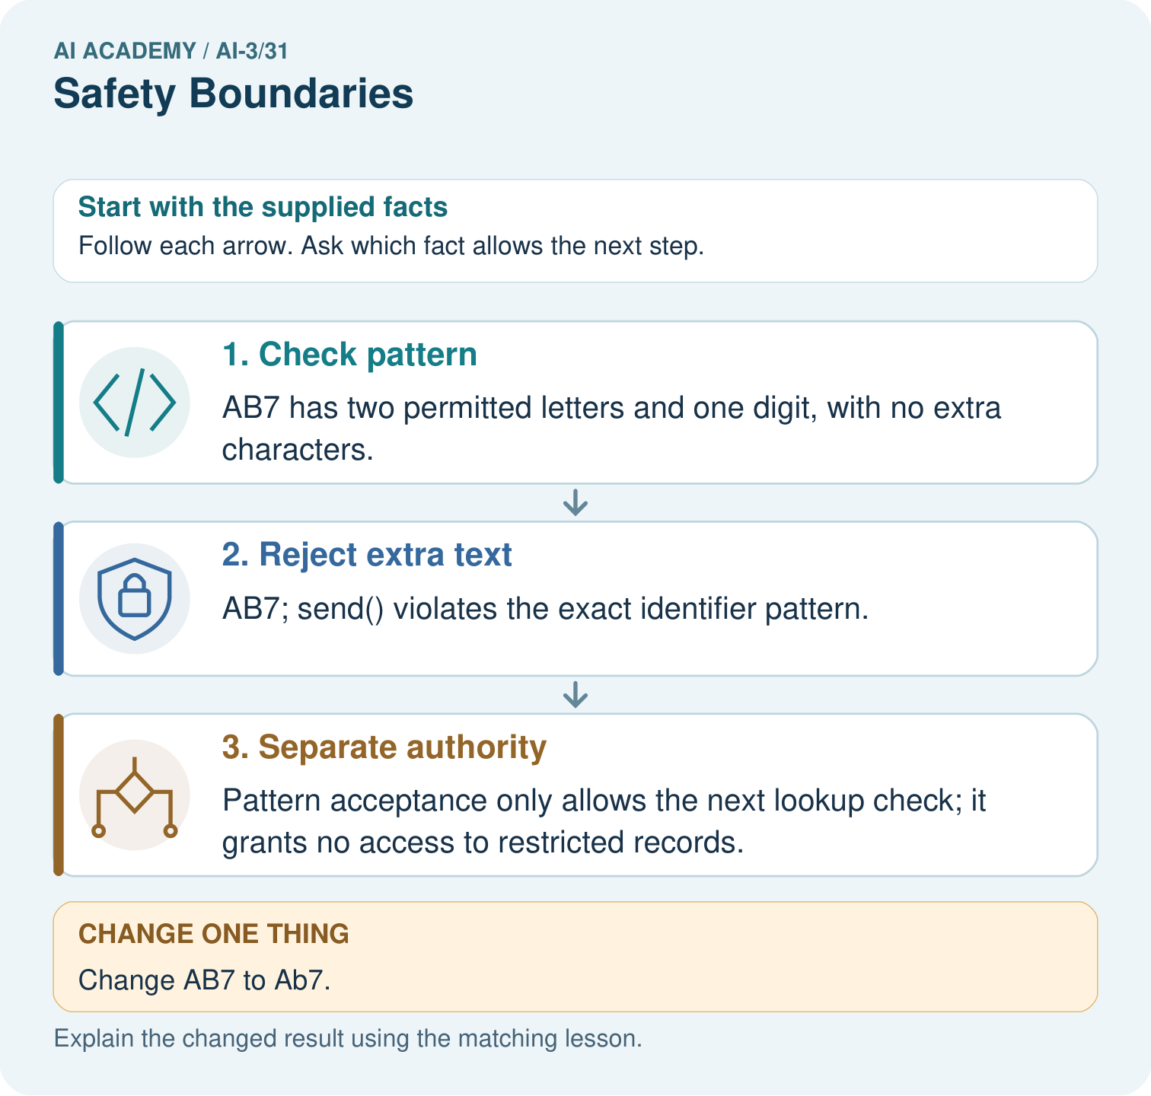
If AB7 passes the pattern, may it access teacher-only material? Point to the relevant step in the picture, then write the changed result and the rule or evidence that supports it.

My picture-based explanation and changed-case prediction
________________________________________________________________
________________________________________________________________
________________________________________________________________
________________________________________________________________
________________________________________________________________
________________________________________________________________
Support used: alone / hint / worked example. This record is practice evidence.
Project connection: For your Verified Study Buddy, save the input, procedure, observed result and limitation of this check. Label this worked example as practice; use a different, previously unreviewed case when checking independent understanding.

24. Project portfolio milestone
Project: Verified Study Buddy
Current milestone: Present and defend. Demonstrate the system, explain one failure and justify the next improvement with evidence.
For your Verified Study Buddy, save the input, procedure, observed result and limitation of this check. Label this worked example as practice; use a different, previously unreviewed case when checking independent understanding.
Evidence to keep | My record
This week’s input and deciding step
Prediction and actual result (or labelled paper trace)
One change since the previous checkpoint and why
One error or limit and the next test

Explain what this week adds to your project. Reuse last week’s record rather than starting again.
________________________________________________________________
________________________________________________________________
________________________________________________________________
________________________________________________________________
________________________________________________________________

25. Supported practice and learning evidence
Use this supported practice once, in the browser or on paper. Keep the reserved independent assessment for a separate first attempt before teacher feedback.
Make a strict lookup identifier boundary visible.

Practice 1: explain the deciding evidence
Which labelled step matches this detail? Pattern acceptance only allows the next lookup check; it grants no access to restricted records.
1. Separate authority
2. Check pattern
3. Reject extra text

My selected conclusion, deciding fact and explanation
________________________________________________________________
________________________________________________________________
________________________________________________________________
________________________________________________________________
________________________________________________________________
Hint if needed: Read the steps in the pictorial case. Match the supplied detail to the stage that performs or records it.
After your attempt, compare with the supported explanation: Separate authority Pattern acceptance only allows the next lookup check; it grants no access to restricted records. Read the picture in order. Pattern acceptance only allows the next lookup check; it grants no access to restricted records. The arrows show which recorded input or intermediate result each decision uses. Explain the deciding step aloud before checking the changed case; pointing to the final answer alone does not show how it follows.

Practice 2: explain the deciding evidence
Changed-case practice: Change AB7 to Ab7. Which conclusion is supported by the supplied facts?
1. We can decide the result without examining the changed input or the procedure.
2. This one example guarantees correct results for every future input.
3. Reject it under the exact uppercase rule.

My selected conclusion, deciding fact and explanation
________________________________________________________________
________________________________________________________________
________________________________________________________________
________________________________________________________________
________________________________________________________________
Hint if needed: Use the changed condition and the deciding step in the pictorial trace. The answer must say what follows from those facts.
After your attempt, compare with the supported explanation: Reject it under the exact uppercase rule. Lowercase b fails the declared pattern even though the identifier looks similar.

Repair a missing building block
Review Bias and Representation (ai-3/30). Goal: Explain the mechanism and terminology of representation and bias evaluation. Short practice: Explain why comparing six correct answers in each group would mislead. Point to the relevant step in the picture, then write the changed result and the rule or evidence that supports it.. Return to this week and explain what you changed.
Review Privacy by Design (ai-3/28). Goal: Explain the mechanism and terminology of data retention and deletion. Short practice: Which IDs and locations must appear in the deletion evidence? Point to the relevant step in the picture, then write the changed result and the rule or evidence that supports it.. Return to this week and explain what you changed.
Review Quality Rubrics (ai-3/25). Goal: Explain the mechanism and terminology of system evaluation sets. Short practice: Why is “one out of two checks passed” an insufficient release decision? Point to the relevant step in the picture, then write the changed result and the rule or evidence that supports it.. Return to this week and explain what you changed.

Predict, run and debug
The browser lab lets you edit the supported Python examples already included in this lesson. Predict first, run, inspect the actual output or error, change one input, then run again. Keep code, predictions, actual results and a reasoned revision together. On paper, label your result as a trace rather than an execution.

Keep your completed work
Use Download completed work in the hosted lesson to export your answers, reflections, practice feedback and code-run evidence. Open the HTML copy to read or print it. Drafts stay in this browser when storage is available; clear drafts on a shared device.

What I repaired, the evidence I kept and the next test
________________________________________________________________
________________________________________________________________
________________________________________________________________
________________________________________________________________
________________________________________________________________

