AI ACADEMY · WORKBOOK · ai-3/34

Capstone Build
Project: Verified Study Buddy

01. Recall and choose your starting point
Try the recall before opening notes. Then use a different colour or a labelled second line to correct your explanation.

Capstone Design
Without opening the old lesson, explain one key idea from Capstone Design. Give an example and a mistake that the idea helps you avoid.

My remembered idea, example and correction
________________________________________________________________
________________________________________________________________
________________________________________________________________

Safety Boundaries
Without opening the old lesson, explain one key idea from Safety Boundaries. Give an example and a mistake that the idea helps you avoid.

My remembered idea, example and correction
________________________________________________________________
________________________________________________________________
________________________________________________________________

Privacy by Design
Without opening the old lesson, explain one key idea from Privacy by Design. Give an example and a mistake that the idea helps you avoid.

My remembered idea, example and correction
________________________________________________________________
________________________________________________________________
________________________________________________________________

02. Practise with fading help
Use W2: Trace the worked case for Capstone grounded assistant. Record the answer once; the lesson and workbook refer to the same attempt.
Given inputs | Procedure I chose | Middle steps | Result and check

The step I completed without help, and the hint I needed
________________________________________________________________
________________________________________________________________
________________________________________________________________

03. Individual reasoning check
Use the worked case for Capstone grounded assistant. Proposed explanation: “The worked result establishes every future case”. Decide whether this explanation is supported. Point to the step or supplied fact that decides; explain your repair if needed.

My explanation before partner discussion
________________________________________________________________
________________________________________________________________
________________________________________________________________
________________________________________________________________

04. Independent transfer case

Independent case: Changed independent case
An experiment note records four fictional seeds observed for six days but supplies no growth results. A generated draft says all four sprouted and the method always works in any soil. Repair it.

My independent explanation, trace and limits
________________________________________________________________
________________________________________________________________
________________________________________________________________
________________________________________________________________
________________________________________________________________
________________________________________________________________
________________________________________________________________
Attempt this case before feedback. Record any help. Earlier examples below are further practice; a case already practised with feedback cannot establish fresh transfer.

05. Your learning target
A prototype cites note A but its answer adds a detail found nowhere in A. What should the final validation stage check and do?

06. Solve the given case
A pipeline retrieves passages, drafts and displays without checking citations.
What step is missing?
Show your trace, calculation or evidence

Write or draw your reasoning and evidence.
________________________________________________________________
________________________________________________________________
________________________________________________________________
________________________________________________________________
________________________________________________________________

07. Check a changed case
The interface looks complete, but its answer button returns the same saved sentence for every question. What capability is still missing, and how can you expose it?
My independent answer and reason

Write or draw your reasoning and evidence.
________________________________________________________________
________________________________________________________________
________________________________________________________________
________________________________________________________________
________________________________________________________________

Week 34 Test and reflect

08. Design a revealing test
Create a changed input, boundary case or missing-information case. Write the expected answer or safe response before testing.
Test record | My evidence
Changed input or condition
Expected answer or fallback
Observed result
Why the result occurred

09. Project checkpoint
Assemble interface, retrieval, prompt, model/tool, validation, evidence display, and fallback.
The project change and evidence I will keep

Write or draw your reasoning and evidence.
________________________________________________________________
________________________________________________________________
________________________________________________________________
________________________________________________________________
________________________________________________________________

10. Self check
I can explain the mechanism. I can show evidence. I can handle a changed case. I can name a limit. Mark each as not yet, with help or independently, and attach supporting work.
Teacher review ____________________ Next step ____________________

11. Transfer practice from the original programme
A prototype cites note A but its answer adds a detail found nowhere in A. What should the final validation stage check and do?

My independently reasoned answer
________________________________________________________________
________________________________________________________________
________________________________________________________________
________________________________________________________________
________________________________________________________________
________________________________________________________________
________________________________________________________________
Record support used: none, hint or teacher explanation.

12. W1 Explain the mechanism
Explain the weekly mechanism in your own words. Use the worked scenario to name its input, decision rule and output.

My reasoning and evidence
________________________________________________________________
________________________________________________________________
________________________________________________________________
________________________________________________________________
________________________________________________________________
________________________________________________________________

13. W2 Trace the worked case
Request room B; retrieved approval names B but register names C. Draft gives capacity 10 from C. Show the intermediate steps and give the conclusion with its scope.

My reasoning and evidence
________________________________________________________________
________________________________________________________________
________________________________________________________________
________________________________________________________________
________________________________________________________________
________________________________________________________________
________________________________________________________________

14. W3 Audit the limit
A report omits this qualification: A correct happy path does not establish fallback, access control or side-effect safety. Explain how omitting it could change a reader's interpretation, and write an accurate replacement.

My reasoning and evidence
________________________________________________________________
________________________________________________________________
________________________________________________________________
________________________________________________________________
________________________________________________________________
________________________________________________________________

15. W4 Apply a new case independently
Request room J; approval and register both J capacity 0. Draft is well-formed with J/0 and correct sources. Trace stages and distinguish zero from missing.

My reasoning and evidence
________________________________________________________________
________________________________________________________________
________________________________________________________________
________________________________________________________________
________________________________________________________________
________________________________________________________________
________________________________________________________________
________________________________________________________________

16. W5 Design a revealing follow-up
For the worked scenario, propose one additional case that could reveal a failure, describe its expected outcome before running it, and explain what would need to remain fixed for a fair comparison. Do not reuse W4 as a new final test after receiving feedback.

My reasoning and evidence
________________________________________________________________
________________________________________________________________
________________________________________________________________
________________________________________________________________
________________________________________________________________
________________________________________________________________
________________________________________________________________

17. Feedback, return check and learning record
Evidence | My record
Worked alone / hint / model
First step I repaired and why
New case checked later; date and result
What I can now explain without notes
One remaining question
Revisit this idea with your teacher after a delay. Familiarity is different from explaining and using it on a changed case.

18. Pictorial case practice: Capstone Build
Build a claim checker for a draft summary of a fictional class investigation.
Approved record E2: three cups were observed for four days. No measured water loss is provided. Draft says “three cups were observed for four days and all lost half their water”.
All inputs and outcomes in this worked example are invented classroom data; no real model run is claimed.
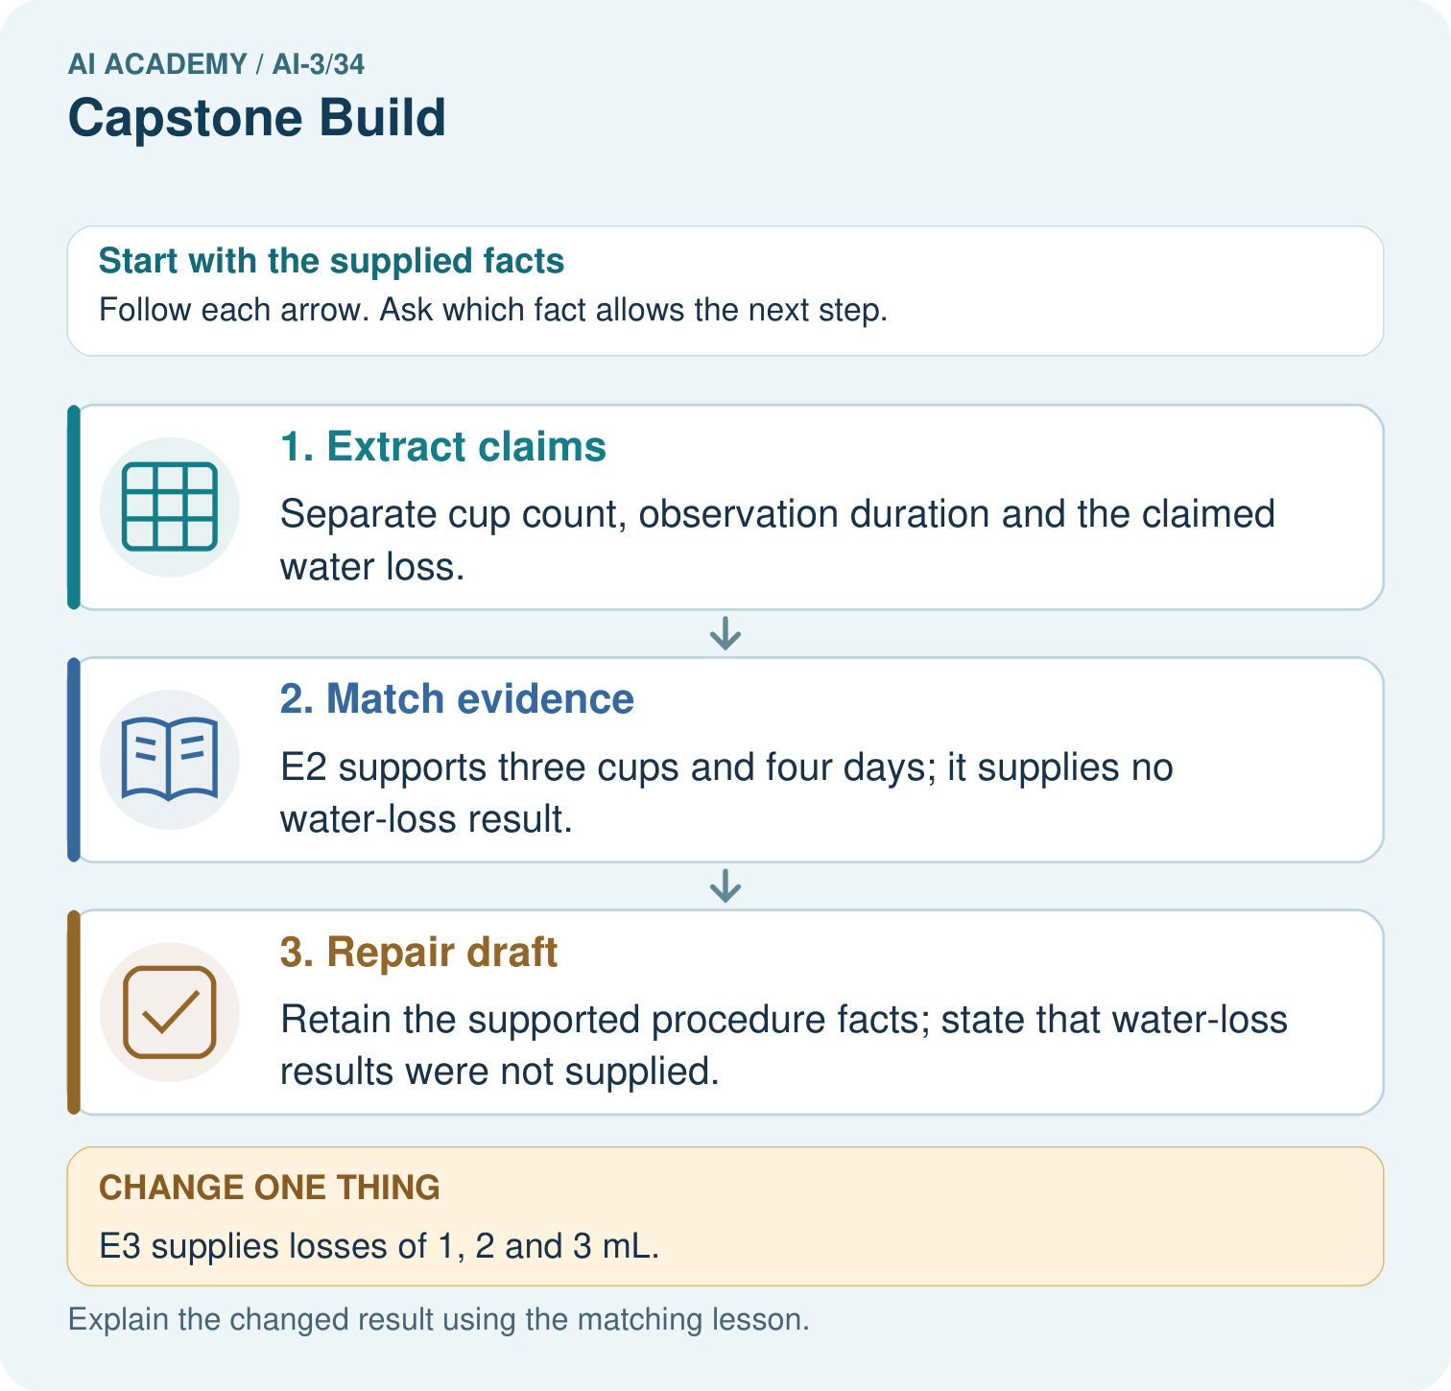
What additional numbers would a half-water claim require? Point to the relevant step in the picture, then write the changed result and the rule or evidence that supports it.

My picture-based explanation and changed-case prediction
________________________________________________________________
________________________________________________________________
________________________________________________________________
________________________________________________________________
________________________________________________________________
________________________________________________________________
Support used: alone / hint / worked example. This record is practice evidence.
Project connection: For your Verified Study Buddy, save the input, procedure, observed result and limitation of this check. Label this worked example as practice; use a different, previously unreviewed case when checking independent understanding.

19. Project portfolio milestone
Project: Verified Study Buddy
Current milestone: Present and defend. Demonstrate the system, explain one failure and justify the next improvement with evidence.
For your Verified Study Buddy, save the input, procedure, observed result and limitation of this check. Label this worked example as practice; use a different, previously unreviewed case when checking independent understanding.
Evidence to keep | My record
This week’s input and deciding step
Prediction and actual result (or labelled paper trace)
One change since the previous checkpoint and why
One error or limit and the next test

Explain what this week adds to your project. Reuse last week’s record rather than starting again.
________________________________________________________________
________________________________________________________________
________________________________________________________________
________________________________________________________________
________________________________________________________________

20. Supported practice and learning evidence
Use this supported practice once, in the browser or on paper. Keep the reserved independent assessment for a separate first attempt before teacher feedback.
Build a claim checker for a draft summary of a fictional class investigation.

Practice 1: explain the deciding evidence
Which labelled step matches this detail? Retain the supported procedure facts; state that water-loss results were not supplied.
1. Extract claims
2. Match evidence
3. Repair draft

My selected conclusion, deciding fact and explanation
________________________________________________________________
________________________________________________________________
________________________________________________________________
________________________________________________________________
________________________________________________________________
Hint if needed: Read the steps in the pictorial case. Match the supplied detail to the stage that performs or records it.
After your attempt, compare with the supported explanation: Repair draft Retain the supported procedure facts; state that water-loss results were not supplied. Read the picture in order. Retain the supported procedure facts; state that water-loss results were not supplied. The arrows show which recorded input or intermediate result each decision uses. Explain the deciding step aloud before checking the changed case; pointing to the final answer alone does not show how it follows.

Practice 2: explain the deciding evidence
Changed-case practice: E3 supplies losses of 1, 2 and 3 mL. Which conclusion is supported by the supplied facts?
1. We can decide the result without examining the changed input or the procedure.
2. Report those individual losses, not “half” unless starting volumes are also available.
3. This one example guarantees correct results for every future input.

My selected conclusion, deciding fact and explanation
________________________________________________________________
________________________________________________________________
________________________________________________________________
________________________________________________________________
________________________________________________________________
Hint if needed: Use the changed condition and the deciding step in the pictorial trace. The answer must say what follows from those facts.
After your attempt, compare with the supported explanation: Report those individual losses, not “half” unless starting volumes are also available. Absolute losses alone do not establish each cup’s fractional loss.

Repair a missing building block
Review Capstone Design (ai-3/33). Goal: Explain the mechanism and terminology of capstone requirements and corpus. Short practice: What should the project plan record before the new flower test? Point to the relevant step in the picture, then write the changed result and the rule or evidence that supports it.. Return to this week and explain what you changed.
Review Safety Boundaries (ai-3/31). Goal: Explain the mechanism and terminology of untrusted input boundaries. Short practice: If AB7 passes the pattern, may it access teacher-only material? Point to the relevant step in the picture, then write the changed result and the rule or evidence that supports it.. Return to this week and explain what you changed.
Review Privacy by Design (ai-3/28). Goal: Explain the mechanism and terminology of data retention and deletion. Short practice: Which IDs and locations must appear in the deletion evidence? Point to the relevant step in the picture, then write the changed result and the rule or evidence that supports it.. Return to this week and explain what you changed.

Keep your completed work
Use Download completed work in the hosted lesson to export your answers, reflections, practice feedback and code-run evidence. Open the HTML copy to read or print it. Drafts stay in this browser when storage is available; clear drafts on a shared device.

What I repaired, the evidence I kept and the next test
________________________________________________________________
________________________________________________________________
________________________________________________________________
________________________________________________________________
________________________________________________________________

