AI ACADEMY · WORKBOOK · ai-4/1

The ML Lifecycle
Project: Responsible Plant Classifier

01. Recall and choose your starting point
Try the recall before opening notes. Then use a different colour or a labelled second line to correct your explanation.

Creator Defense
Without opening the old lesson, explain one key idea from Creator Defense. Give an example and a mistake that the idea helps you avoid.

My remembered idea, example and correction
________________________________________________________________
________________________________________________________________
________________________________________________________________

02. Practise with fading help
Use W2: Trace one candidate for The machine learning lifecycle. Record the answer once; the lesson and workbook refer to the same attempt.
Given inputs | Procedure I chose | Middle steps | Result and check

The step I completed without help, and the hint I needed
________________________________________________________________
________________________________________________________________
________________________________________________________________

03. Individual reasoning check
Use the worked case for The machine learning lifecycle. Proposed explanation: “The model wrote its own task”. Decide whether this explanation is supported. Point to the step or supplied fact that decides; explain your repair if needed.

My explanation before partner discussion
________________________________________________________________
________________________________________________________________
________________________________________________________________
________________________________________________________________

04. Independent transfer case

Independent case: Fit and evaluate independently
New training cards are (width 2, label 0), (4, 0), (6, 1), (8, 1). Candidates are 3, 5 and 7. Predict 1 when width is at least the threshold. Count training mistakes, select the fewest with smaller threshold breaking ties, and record the choice before testing. Held out cards are (3, 0), (7, 1), (5, 0). Give each test prediction, the correct count and a limited conclusion.

My independent explanation, trace and limits
________________________________________________________________
________________________________________________________________
________________________________________________________________
________________________________________________________________
________________________________________________________________
________________________________________________________________
________________________________________________________________
Attempt this case before feedback. Record any help. Earlier examples below are further practice; a case already practised with feedback cannot establish fresh transfer.

05. Your learning target
A team labels photos, fits a model and celebrates one correct new photo. List the missing evaluation steps and define the intended use before testing.

06. Solve the given case
A team labels leaf photos, trains a healthy/spotted classifier and shows one correct prediction.
Order the lifecycle and identify missing evidence.
Show your trace, calculation or evidence

Write or draw your reasoning and evidence.
________________________________________________________________
________________________________________________________________
________________________________________________________________
________________________________________________________________
________________________________________________________________

07. Check a changed case
A team selects a model before deciding what outcome to predict or where the data comes from. Name two missing lifecycle decisions and their effect.
My independent answer and reason

Write or draw your reasoning and evidence.
________________________________________________________________
________________________________________________________________
________________________________________________________________
________________________________________________________________
________________________________________________________________

Week 1 Test and reflect

08. Design a revealing test
Create a changed input, boundary case or missing-information case. Write the expected answer or safe response before testing.
Test record | My evidence
Changed input or condition
Expected answer or fallback
Observed result
Why the result occurred

09. Project checkpoint
Write the Responsible Plant Classifier problem statement, intended user, prediction target, success measure, and human-review point.
The project change and evidence I will keep

Write or draw your reasoning and evidence.
________________________________________________________________
________________________________________________________________
________________________________________________________________
________________________________________________________________
________________________________________________________________

10. Self check
I can explain the mechanism. I can show evidence. I can handle a changed case. I can name a limit. Mark each as not yet, with help or independently, and attach supporting work.
Teacher review ____________________ Next step ____________________

11. Transfer practice from the original programme
A team labels photos, fits a model and celebrates one correct new photo. List the missing evaluation steps and define the intended use before testing.

My independently reasoned answer
________________________________________________________________
________________________________________________________________
________________________________________________________________
________________________________________________________________
________________________________________________________________
________________________________________________________________
________________________________________________________________
Record support used: none, hint or teacher explanation.

12. W1 Identify the learning decision
For the worked cards, name the input, label, three candidate thresholds and the information allowed to select a threshold.

My reasoning and evidence
________________________________________________________________
________________________________________________________________
________________________________________________________________
________________________________________________________________
________________________________________________________________
________________________________________________________________

13. W2 Trace one candidate
Use threshold 6 on the four training widths 1, 3, 5 and 7. Write all predictions, identify each error, and explain why threshold 4 is selected.

My reasoning and evidence
________________________________________________________________
________________________________________________________________
________________________________________________________________
________________________________________________________________
________________________________________________________________
________________________________________________________________

14. W3 Repair the report
A learner fits on all six worked cards and then reports 6 of 6 as independent test performance. Explain what is wrong and what evidence is needed.

My reasoning and evidence
________________________________________________________________
________________________________________________________________
________________________________________________________________
________________________________________________________________
________________________________________________________________
________________________________________________________________

15. W4 Fit and evaluate independently
New training cards are (width 2, label 0), (4, 0), (6, 1), (8, 1). Candidates are 3, 5 and 7. Predict 1 when width is at least the threshold. Count training mistakes, select the fewest with smaller threshold breaking ties, and record the choice before testing. Held out cards are (3, 0), (7, 1), (5, 0). Give each test prediction, the correct count and a limited conclusion.

My reasoning and evidence
________________________________________________________________
________________________________________________________________
________________________________________________________________
________________________________________________________________
________________________________________________________________
________________________________________________________________
________________________________________________________________
________________________________________________________________

16. W5 Decide the next step
After W4, a team changes its threshold because of the test error. Can the same three cards be an untouched final test for the changed model? Explain how to proceed.

My reasoning and evidence
________________________________________________________________
________________________________________________________________
________________________________________________________________
________________________________________________________________
________________________________________________________________
________________________________________________________________

17. Feedback, return check and learning record
Evidence | My record
Worked alone / hint / model
First step I repaired and why
New case checked later; date and result
What I can now explain without notes
One remaining question
Revisit this idea with your teacher after a delay. Familiarity is different from explaining and using it on a changed case.

18. Pictorial case practice: The ML Lifecycle
Follow one complete plant-classifier lifecycle without tuning on the final test.
Toy training leaves have widths 1 healthy, 3 healthy, 5 spotted, 7 spotted. Candidates predict spotted at width>=2 or >=4.
All inputs and outcomes in this worked example are invented classroom data; no real model run is claimed.
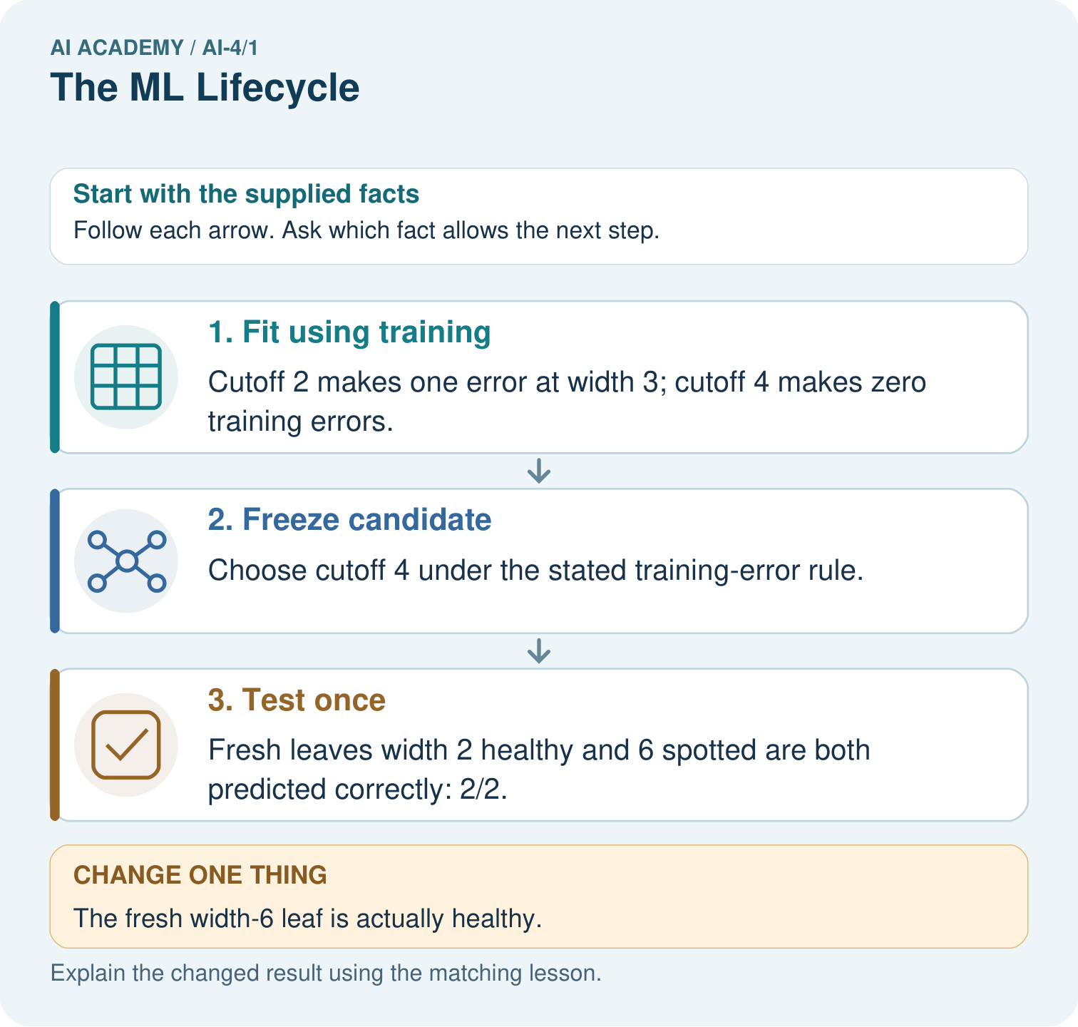
Should the team silently retune on the changed test? Point to the relevant step in the picture, then write the changed result and the rule or evidence that supports it.

My picture-based explanation and changed-case prediction
________________________________________________________________
________________________________________________________________
________________________________________________________________
________________________________________________________________
________________________________________________________________
________________________________________________________________
Support used: alone / hint / worked example. This record is practice evidence.
Project connection: For your Responsible Plant Classifier, save the input, procedure, observed result and limitation of this check. Label this worked example as practice; use a different, previously unreviewed case when checking independent understanding.

19. Project portfolio milestone
Project: Responsible Plant Classifier
Current milestone: Frame the need. Name the user, the problem, allowed inputs and a safe simple starting method.
For your Responsible Plant Classifier, save the input, procedure, observed result and limitation of this check. Label this worked example as practice; use a different, previously unreviewed case when checking independent understanding.
Evidence to keep | My record
This week’s input and deciding step
Prediction and actual result (or labelled paper trace)
One change since the previous checkpoint and why
One error or limit and the next test

Explain what this week adds to your project. Reuse last week’s record rather than starting again.
________________________________________________________________
________________________________________________________________
________________________________________________________________
________________________________________________________________
________________________________________________________________

20. Supported practice and learning evidence
Use this supported practice once, in the browser or on paper. Keep the reserved independent assessment for a separate first attempt before teacher feedback.
Follow one complete plant-classifier lifecycle without tuning on the final test.

Practice 1: explain the deciding evidence
Which labelled step matches this detail? Fresh leaves width 2 healthy and 6 spotted are both predicted correctly: 2/2.
1. Test once
2. Freeze candidate
3. Fit using training

My selected conclusion, deciding fact and explanation
________________________________________________________________
________________________________________________________________
________________________________________________________________
________________________________________________________________
________________________________________________________________
Hint if needed: Read the steps in the pictorial case. Match the supplied detail to the stage that performs or records it.
After your attempt, compare with the supported explanation: Test once Fresh leaves width 2 healthy and 6 spotted are both predicted correctly: 2/2. Read the picture in order. Fresh leaves width 2 healthy and 6 spotted are both predicted correctly: 2/2. The arrows show which recorded input or intermediate result each decision uses. Explain the deciding step aloud before checking the changed case; pointing to the final answer alone does not show how it follows.

Practice 2: explain the deciding evidence
Changed-case practice: The fresh width-6 leaf is actually healthy. Which conclusion is supported by the supplied facts?
1. We can decide the result without examining the changed input or the procedure.
2. This one example guarantees correct results for every future input.
3. The frozen model is correct on 1/2 test leaves.

My selected conclusion, deciding fact and explanation
________________________________________________________________
________________________________________________________________
________________________________________________________________
________________________________________________________________
________________________________________________________________
Hint if needed: Use the changed condition and the deciding step in the pictorial trace. The answer must say what follows from those facts.
After your attempt, compare with the supported explanation: The frozen model is correct on 1/2 test leaves. The supplied reference changed; moving the cutoff after seeing this test would reuse final evidence for development.

Repair a missing building block
Review Creator Defense (ai-3/36). Goal: Explain the mechanism and terminology of generative systems defense. Short practice: Which numbers would you display to make the defense honest? Point to the relevant step in the picture, then write the changed result and the rule or evidence that supports it.. Return to this week and explain what you changed.

Predict, run and debug
The browser lab lets you edit the supported Python examples already included in this lesson. Predict first, run, inspect the actual output or error, change one input, then run again. Keep code, predictions, actual results and a reasoned revision together. On paper, label your result as a trace rather than an execution.

Keep your completed work
Use Download completed work in the hosted lesson to export your answers, reflections, practice feedback and code-run evidence. Open the HTML copy to read or print it. Drafts stay in this browser when storage is available; clear drafts on a shared device.

What I repaired, the evidence I kept and the next test
________________________________________________________________
________________________________________________________________
________________________________________________________________
________________________________________________________________
________________________________________________________________

