AI ACADEMY · WORKBOOK · ai-4/9

Dataset Cards
Project: Responsible Plant Classifier

01. Recall and choose your starting point
Try the recall before opening notes. Then use a different colour or a labelled second line to correct your explanation.

Leakage
Without opening the old lesson, explain one key idea from Leakage. Give an example and a mistake that the idea helps you avoid.

My remembered idea, example and correction
________________________________________________________________
________________________________________________________________
________________________________________________________________

Label Quality
Without opening the old lesson, explain one key idea from Label Quality. Give an example and a mistake that the idea helps you avoid.

My remembered idea, example and correction
________________________________________________________________
________________________________________________________________
________________________________________________________________

Classification or Regression?
Without opening the old lesson, explain one key idea from Classification or Regression?. Give an example and a mistake that the idea helps you avoid.

My remembered idea, example and correction
________________________________________________________________
________________________________________________________________
________________________________________________________________

02. Practise with fading help
Use W2: Interpret the audit counts for Dataset inspection and cards. Record the answer once; the lesson and workbook refer to the same attempt.
Given inputs | Procedure I chose | Middle steps | Result and check

The step I completed without help, and the hint I needed
________________________________________________________________
________________________________________________________________
________________________________________________________________

03. Individual reasoning check
Use the worked case for Dataset inspection and cards. Proposed explanation: “A complete card certifies data quality”. Decide whether this explanation is supported. Point to the step or supplied fact that decides; explain your repair if needed.

My explanation before partner discussion
________________________________________________________________
________________________________________________________________
________________________________________________________________
________________________________________________________________

04. Independent transfer case

Independent case: Changed independent case
Write key dataset-card entries for20 photos: five plants, four views each, one phone, one indoor setting. Growth labels have not been supplied.

My independent explanation, trace and limits
________________________________________________________________
________________________________________________________________
________________________________________________________________
________________________________________________________________
________________________________________________________________
________________________________________________________________
________________________________________________________________
Attempt this case before feedback. Record any help. Earlier examples below are further practice; a case already practised with feedback cannot establish fresh transfer.

05. Your learning target
Write five dataset-card fields for a leaf dataset and explain why '1000 images' alone is insufficient.

06. Solve the given case
A dataset card lists fields but omits source and intended use.
Add information needed to assess suitability.
Show your trace, calculation or evidence

Write or draw your reasoning and evidence.
________________________________________________________________
________________________________________________________________
________________________________________________________________
________________________________________________________________
________________________________________________________________

07. Check a changed case
A dataset card lists 500 images but omits collection conditions and intended use. Add two essential entries and explain their value.
My independent answer and reason

Write or draw your reasoning and evidence.
________________________________________________________________
________________________________________________________________
________________________________________________________________
________________________________________________________________
________________________________________________________________

Week 9 Test and reflect

08. Design a revealing test
Create a changed input, boundary case or missing-information case. Write the expected answer or safe response before testing.
Test record | My evidence
Changed input or condition
Expected answer or fallback
Observed result
Why the result occurred

09. Project checkpoint
Publish the Plant Classifier dataset card before model experiments begin; update it when data changes.
The project change and evidence I will keep

Write or draw your reasoning and evidence.
________________________________________________________________
________________________________________________________________
________________________________________________________________
________________________________________________________________
________________________________________________________________

10. Self check
I can explain the mechanism. I can show evidence. I can handle a changed case. I can name a limit. Mark each as not yet, with help or independently, and attach supporting work.
Teacher review ____________________ Next step ____________________

11. Transfer practice from the original programme
Write five dataset-card fields for a leaf dataset and explain why '1000 images' alone is insufficient.

My independently reasoned answer
________________________________________________________________
________________________________________________________________
________________________________________________________________
________________________________________________________________
________________________________________________________________
________________________________________________________________
________________________________________________________________
Record support used: none, hint or teacher explanation.

12. W1 Define the row and source
For Robot practice v1, state what one row is intended to represent, the source, the unit and the meaning of None.

My reasoning and evidence
________________________________________________________________
________________________________________________________________
________________________________________________________________
________________________________________________________________
________________________________________________________________
________________________________________________________________

13. W2 Interpret the audit counts
Explain each number in 5 4 2 1. How many extra ID occurrences are there, and how many rows belong to a repeated-ID group?

My reasoning and evidence
________________________________________________________________
________________________________________________________________
________________________________________________________________
________________________________________________________________
________________________________________________________________
________________________________________________________________

14. W3 Reject an unsupported correction
A learner changes None to 0 and -2 to 2, then reports a clean dataset. Explain why this is not a justified repair and what record should be kept.

My reasoning and evidence
________________________________________________________________
________________________________________________________________
________________________________________________________________
________________________________________________________________
________________________________________________________________
________________________________________________________________

15. W4 Inspect and document independently
A new fictional indoor trip export has (P,4), (Q,None), (Q,None), (R,-1), (S,6), (T,0), with durations in minutes and the same schema. Count raw rows, distinct IDs, missing durations, negative durations and extra ID occurrences. Identify overlap. Draft a short dataset card stating source, row meaning, unit, findings, unchanged version and one excluded use.

My reasoning and evidence
________________________________________________________________
________________________________________________________________
________________________________________________________________
________________________________________________________________
________________________________________________________________
________________________________________________________________
________________________________________________________________
________________________________________________________________

16. W5 State an evidence gap
Someone duplicates each row ten times and claims the export now covers more kinds of trips. Explain what changed and what did not.

My reasoning and evidence
________________________________________________________________
________________________________________________________________
________________________________________________________________
________________________________________________________________
________________________________________________________________
________________________________________________________________

17. Feedback, return check and learning record
Evidence | My record
Worked alone / hint / model
First step I repaired and why
New case checked later; date and result
What I can now explain without notes
One remaining question
Revisit this idea with your teacher after a delay. Familiarity is different from explaining and using it on a changed case.

18. Pictorial case practice: Dataset Cards
Build a dataset card that reveals what the photo count hides.
Teacher-created dataset: 18 photos of 6 fictional plants, 3 views each, one tablet, indoor fluorescent light. Label rule is visible spot/no visible spot/review.
All inputs and outcomes in this worked example are invented classroom data; no real model run is claimed.
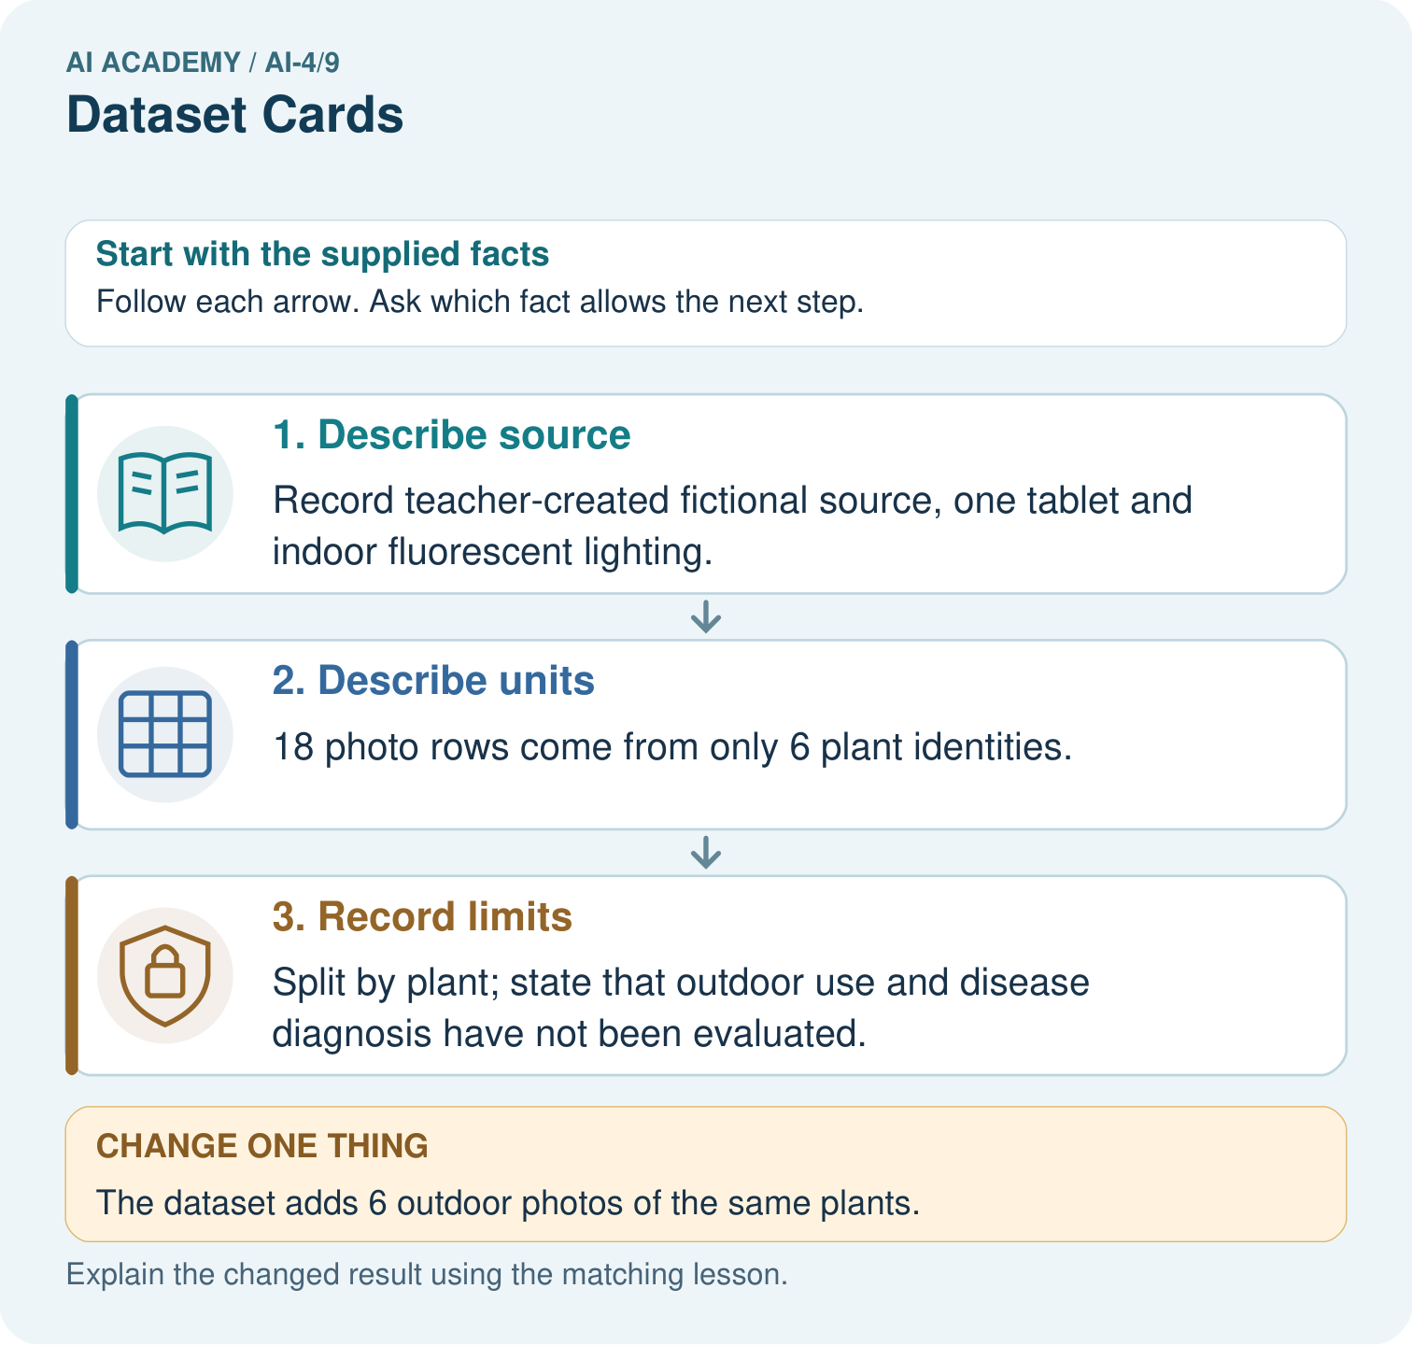
What two counts should the revised card show? Point to the relevant step in the picture, then write the changed result and the rule or evidence that supports it.

My picture-based explanation and changed-case prediction
________________________________________________________________
________________________________________________________________
________________________________________________________________
________________________________________________________________
________________________________________________________________
________________________________________________________________
Support used: alone / hint / worked example. This record is practice evidence.
Project connection: For your Responsible Plant Classifier, save the input, procedure, observed result and limitation of this check. Label this worked example as practice; use a different, previously unreviewed case when checking independent understanding.

19. Project portfolio milestone
Project: Responsible Plant Classifier
Current milestone: Make a transparent first version. Keep a trace of how one input becomes an output; explain the rule or learned component.
For your Responsible Plant Classifier, save the input, procedure, observed result and limitation of this check. Label this worked example as practice; use a different, previously unreviewed case when checking independent understanding.
Evidence to keep | My record
This week’s input and deciding step
Prediction and actual result (or labelled paper trace)
One change since the previous checkpoint and why
One error or limit and the next test

Explain what this week adds to your project. Reuse last week’s record rather than starting again.
________________________________________________________________
________________________________________________________________
________________________________________________________________
________________________________________________________________
________________________________________________________________

20. Supported practice and learning evidence
Use this supported practice once, in the browser or on paper. Keep the reserved independent assessment for a separate first attempt before teacher feedback.
Build a dataset card that reveals what the photo count hides.

Practice 1: explain the deciding evidence
Which labelled step matches this detail? Split by plant; state that outdoor use and disease diagnosis have not been evaluated.
1. Record limits
2. Describe units
3. Describe source

My selected conclusion, deciding fact and explanation
________________________________________________________________
________________________________________________________________
________________________________________________________________
________________________________________________________________
________________________________________________________________
Hint if needed: Read the steps in the pictorial case. Match the supplied detail to the stage that performs or records it.
After your attempt, compare with the supported explanation: Record limits Split by plant; state that outdoor use and disease diagnosis have not been evaluated. Read the picture in order. Split by plant; state that outdoor use and disease diagnosis have not been evaluated. The arrows show which recorded input or intermediate result each decision uses. Explain the deciding step aloud before checking the changed case; pointing to the final answer alone does not show how it follows.

Practice 2: explain the deciding evidence
Changed-case practice: The dataset adds 6 outdoor photos of the same plants. Which conclusion is supported by the supplied facts?
1. We can decide the result without examining the changed input or the procedure.
2. Photo count becomes 24, plant count remains 6; lighting coverage changes.
3. This one example guarantees correct results for every future input.

My selected conclusion, deciding fact and explanation
________________________________________________________________
________________________________________________________________
________________________________________________________________
________________________________________________________________
________________________________________________________________
Hint if needed: Use the changed condition and the deciding step in the pictorial trace. The answer must say what follows from those facts.
After your attempt, compare with the supported explanation: Photo count becomes 24, plant count remains 6; lighting coverage changes. Additional views broaden conditions without creating new independent plant identities.

Repair a missing building block
Review Leakage (ai-4/8). Goal: Choose a split unit that matches the intended prediction claim. Short practice: How many independently new plant identities are in the original test? Point to the relevant step in the picture, then write the changed result and the rule or evidence that supports it.. Return to this week and explain what you changed.
Review Label Quality (ai-4/6). Goal: Write an observable label rule with boundaries and a review option. Short practice: Why should two annotators not vote away Z’s missing evidence? Point to the relevant step in the picture, then write the changed result and the rule or evidence that supports it.. Return to this week and explain what you changed.
Review Classification or Regression? (ai-4/3). Goal: Identify a task from the meaning of its target. Short practice: Did regression MAE improve when the boundary changed? Point to the relevant step in the picture, then write the changed result and the rule or evidence that supports it.. Return to this week and explain what you changed.

Predict, run and debug
The browser lab lets you edit the supported Python examples already included in this lesson. Predict first, run, inspect the actual output or error, change one input, then run again. Keep code, predictions, actual results and a reasoned revision together. On paper, label your result as a trace rather than an execution.

Keep your completed work
Use Download completed work in the hosted lesson to export your answers, reflections, practice feedback and code-run evidence. Open the HTML copy to read or print it. Drafts stay in this browser when storage is available; clear drafts on a shared device.

What I repaired, the evidence I kept and the next test
________________________________________________________________
________________________________________________________________
________________________________________________________________
________________________________________________________________
________________________________________________________________

