AI ACADEMY · WORKBOOK · ai-4/16

Accuracy and Imbalance
Project: Responsible Plant Classifier

01. Recall and choose your starting point
Try the recall before opening notes. Then use a different colour or a labelled second line to correct your explanation.

Confusion Matrix
Without opening the old lesson, explain one key idea from Confusion Matrix. Give an example and a mistake that the idea helps you avoid.

My remembered idea, example and correction
________________________________________________________________
________________________________________________________________
________________________________________________________________

Train a Classifier
Without opening the old lesson, explain one key idea from Train a Classifier. Give an example and a mistake that the idea helps you avoid.

My remembered idea, example and correction
________________________________________________________________
________________________________________________________________
________________________________________________________________

Baselines First
Without opening the old lesson, explain one key idea from Baselines First. Give an example and a mistake that the idea helps you avoid.

My remembered idea, example and correction
________________________________________________________________
________________________________________________________________
________________________________________________________________

02. Practise with fading help
Use W2: Compare both class fractions for Accuracy and class imbalance. Record the answer once; the lesson and workbook refer to the same attempt.
Given inputs | Procedure I chose | Middle steps | Result and check

The step I completed without help, and the hint I needed
________________________________________________________________
________________________________________________________________
________________________________________________________________

03. Individual reasoning check
Use the worked case for Accuracy and class imbalance. Proposed explanation: “High accuracy means both classes work well”. Decide whether this explanation is supported. Point to the step or supplied fact that decides; explain your repair if needed.

My explanation before partner discussion
________________________________________________________________
________________________________________________________________
________________________________________________________________
________________________________________________________________

04. Independent transfer case

Independent case: Changed independent case
Validation has90 healthy and10 spotted cases. Always-healthy predicts all healthy. Another model has TP7,FN3,FP8,TN82. Compare accuracy and spotted recall.

My independent explanation, trace and limits
________________________________________________________________
________________________________________________________________
________________________________________________________________
________________________________________________________________
________________________________________________________________
________________________________________________________________
________________________________________________________________
Attempt this case before feedback. Record any help. Earlier examples below are further practice; a case already practised with feedback cannot establish fresh transfer.

05. Your learning target
Model A is always healthy on 96 healthy and 4 spotted leaves. Model B finds 3 spotted but falsely flags 5 healthy. Compare accuracy and spotted detection.

06. Solve the given case
A dataset has 95 healthy and 5 spotted. Model predicts healthy for all.
Calculate and critique accuracy.
Show your trace, calculation or evidence

Write or draw your reasoning and evidence.
________________________________________________________________
________________________________________________________________
________________________________________________________________
________________________________________________________________
________________________________________________________________

07. Check a changed case
A classifier predicts healthy for all 100 plants; 95 are healthy and 5 diseased. Compute accuracy and diseased recall.
My independent answer and reason

Write or draw your reasoning and evidence.
________________________________________________________________
________________________________________________________________
________________________________________________________________
________________________________________________________________
________________________________________________________________

Week 16 Test and reflect

08. Design a revealing test
Create a changed input, boundary case or missing-information case. Write the expected answer or safe response before testing.
Test record | My evidence
Changed input or condition
Expected answer or fallback
Observed result
Why the result occurred

09. Project checkpoint
Check Plant Classifier class balance and select metrics that keep the spotted-leaf class visible.
The project change and evidence I will keep

Write or draw your reasoning and evidence.
________________________________________________________________
________________________________________________________________
________________________________________________________________
________________________________________________________________
________________________________________________________________

10. Self check
I can explain the mechanism. I can show evidence. I can handle a changed case. I can name a limit. Mark each as not yet, with help or independently, and attach supporting work.
Teacher review ____________________ Next step ____________________

11. Transfer practice from the original programme
Model A is always healthy on 96 healthy and 4 spotted leaves. Model B finds 3 spotted but falsely flags 5 healthy. Compare accuracy and spotted detection.

My independently reasoned answer
________________________________________________________________
________________________________________________________________
________________________________________________________________
________________________________________________________________
________________________________________________________________
________________________________________________________________
________________________________________________________________
Record support used: none, hint or teacher explanation.

12. W1 Score the majority baseline
Training has 16 clear and 4 blocked labels. State the majority rule. On the worked evaluation, give its matrix, accuracy, false positives and false negatives with blocked positive. Explain why 80 percent is incomplete.

My reasoning and evidence
________________________________________________________________
________________________________________________________________
________________________________________________________________
________________________________________________________________
________________________________________________________________
________________________________________________________________

13. W2 Compare both class fractions
For the worked candidate [[12,4],[0,4]], give ordinary accuracy, both class-specific correct fractions, balanced accuracy, false positives and false negatives. Compare with the baseline.

My reasoning and evidence
________________________________________________________________
________________________________________________________________
________________________________________________________________
________________________________________________________________
________________________________________________________________
________________________________________________________________

14. W3 Explain a changed class mix
For the illustrative 8-clear 8-blocked set, use baseline [[8,0],[8,0]] and candidate [[6,2],[0,8]]. Calculate ordinary and balanced accuracy for each. Explain what stayed fixed and what this example does not prove.

My reasoning and evidence
________________________________________________________________
________________________________________________________________
________________________________________________________________
________________________________________________________________
________________________________________________________________
________________________________________________________________

15. W4 Assess a new comparison independently
New training labels have a clear majority. A separate evaluation has 18 clear and 2 blocked records. The always-clear baseline is [[18,0],[2,0]] and candidate is [[15,3],[1,1]], with reference rows and clear then blocked on both axes. Calculate ordinary accuracy, both class fractions and balanced accuracy for each. Give candidate FP and FN, then explain why the metrics do not choose an automatic winner.

My reasoning and evidence
________________________________________________________________
________________________________________________________________
________________________________________________________________
________________________________________________________________
________________________________________________________________
________________________________________________________________
________________________________________________________________
________________________________________________________________

16. W5 Limit claims from missing classes
An evaluation contains ten clear cases and no blocked cases. All predictions are clear. State ordinary accuracy, explain why blocked performance is unavailable, and describe how our code handles the missing class.

My reasoning and evidence
________________________________________________________________
________________________________________________________________
________________________________________________________________
________________________________________________________________
________________________________________________________________
________________________________________________________________

17. Feedback, return check and learning record
Evidence | My record
Worked alone / hint / model
First step I repaired and why
New case checked later; date and result
What I can now explain without notes
One remaining question
Revisit this idea with your teacher after a delay. Familiarity is different from explaining and using it on a changed case.

18. Pictorial case practice: Accuracy and Imbalance
Show how a common healthy class can hide complete failure to detect spotted leaves.
Toy evaluation has 18 healthy and 2 spotted leaves. Always-healthy predicts all healthy. A candidate hasTP2, FN 0, FP 3, TN 15.
All inputs and outcomes in this worked example are invented classroom data; no real model run is claimed.
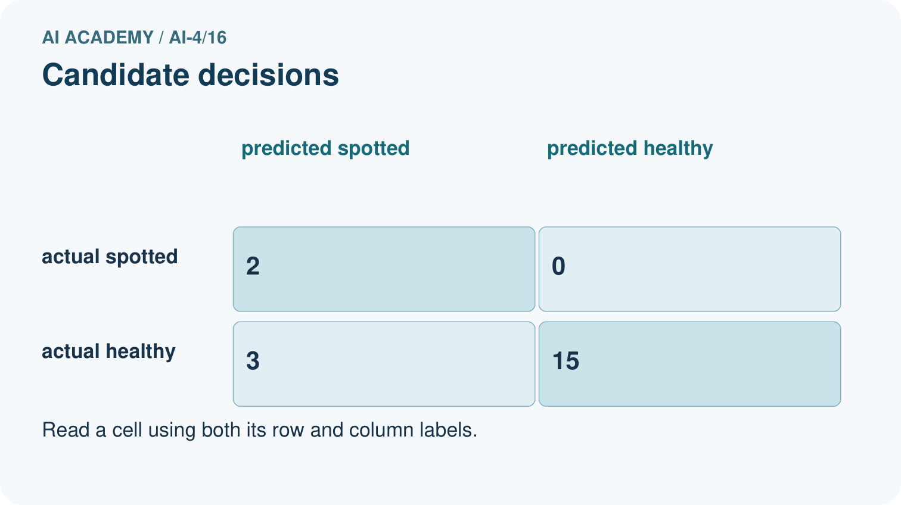
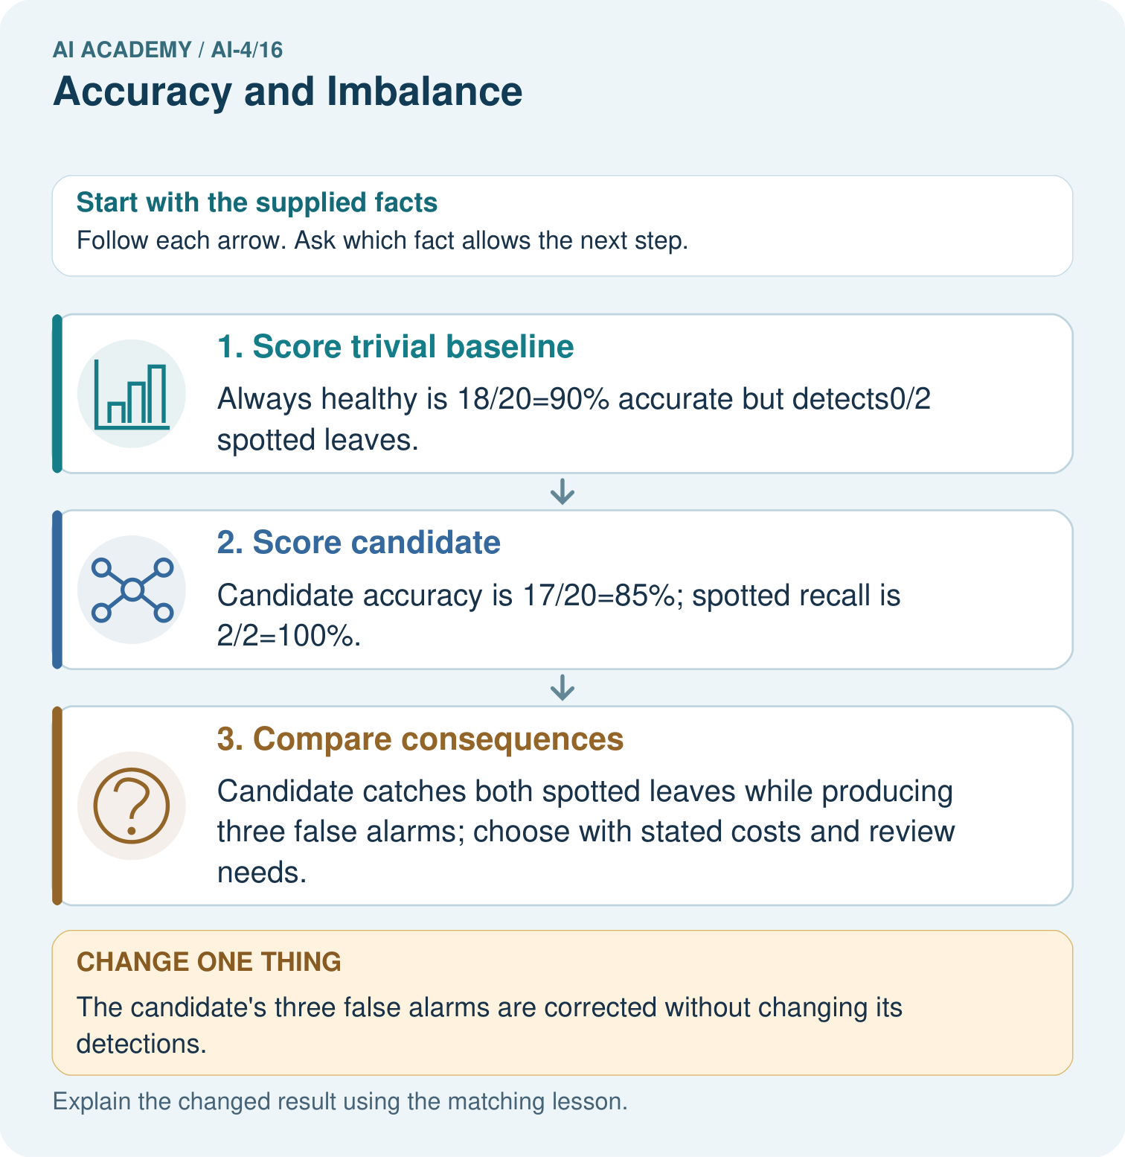
Why can the 90% baseline still be unsuitable for a detection task? Point to the relevant step in the picture, then write the changed result and the rule or evidence that supports it.

My picture-based explanation and changed-case prediction
________________________________________________________________
________________________________________________________________
________________________________________________________________
________________________________________________________________
________________________________________________________________
________________________________________________________________
Support used: alone / hint / worked example. This record is practice evidence.
Project connection: For your Responsible Plant Classifier, save the input, procedure, observed result and limitation of this check. Label this worked example as practice; use a different, previously unreviewed case when checking independent understanding.

19. Project portfolio milestone
Project: Responsible Plant Classifier
Current milestone: Test changed cases. Keep normal, boundary and failure cases; compare expected and observed results.
For your Responsible Plant Classifier, save the input, procedure, observed result and limitation of this check. Label this worked example as practice; use a different, previously unreviewed case when checking independent understanding.
Evidence to keep | My record
This week’s input and deciding step
Prediction and actual result (or labelled paper trace)
One change since the previous checkpoint and why
One error or limit and the next test

Explain what this week adds to your project. Reuse last week’s record rather than starting again.
________________________________________________________________
________________________________________________________________
________________________________________________________________
________________________________________________________________
________________________________________________________________

20. Supported practice and learning evidence
Use this supported practice once, in the browser or on paper. Keep the reserved independent assessment for a separate first attempt before teacher feedback.
Show how a common healthy class can hide complete failure to detect spotted leaves.

Practice 1: explain the deciding evidence
Which labelled step matches this detail? Candidate catches both spotted leaves while producing three false alarms; choose with stated costs and review needs.
1. Compare consequences
2. Score candidate
3. Score trivial baseline

My selected conclusion, deciding fact and explanation
________________________________________________________________
________________________________________________________________
________________________________________________________________
________________________________________________________________
________________________________________________________________
Hint if needed: Read the steps in the pictorial case. Match the supplied detail to the stage that performs or records it.
After your attempt, compare with the supported explanation: Compare consequences Candidate catches both spotted leaves while producing three false alarms; choose with stated costs and review needs. Read the picture in order. Candidate catches both spotted leaves while producing three false alarms; choose with stated costs and review needs. The arrows show which recorded input or intermediate result each decision uses. Explain the deciding step aloud before checking the changed case; pointing to the final answer alone does not show how it follows.

Practice 2: explain the deciding evidence
Changed-case practice: The candidate’s three false alarms are corrected without changing its detections. Which conclusion is supported by the supplied facts?
1. Candidate accuracy becomes20/20 with spotted recall still100% in this toy set.
2. This one example guarantees correct results for every future input.
3. We can decide the result without examining the changed input or the procedure.

My selected conclusion, deciding fact and explanation
________________________________________________________________
________________________________________________________________
________________________________________________________________
________________________________________________________________
________________________________________________________________
Hint if needed: Use the changed condition and the deciding step in the pictorial trace. The answer must say what follows from those facts.
After your attempt, compare with the supported explanation: Candidate accuracy becomes20/20 with spotted recall still100% in this toy set. False alarms move from FP to TN; neither TP nor FN changes.

Repair a missing building block
Review Confusion Matrix (ai-4/15). Goal: Build a labelled confusion matrix from matched reference and prediction pairs. Short practice: Why is adding TP alone without reducing FN an incorrect revision? Point to the relevant step in the picture, then write the changed result and the rule or evidence that supports it.. Return to this week and explain what you changed.
Review Train a Classifier (ai-4/13). Goal: Connect training-only scaling and neighbour prediction in one pipeline. Short practice: Which pipeline record would help another team reproduce the result? Point to the relevant step in the picture, then write the changed result and the rule or evidence that supports it.. Return to this week and explain what you changed.
Review Baselines First (ai-4/10). Goal: Fit a majority label baseline using training labels only. Short practice: Can the candidate’s training accuracy replace this validation comparison? Point to the relevant step in the picture, then write the changed result and the rule or evidence that supports it.. Return to this week and explain what you changed.

Predict, run and debug
The browser lab lets you edit the supported Python examples already included in this lesson. Predict first, run, inspect the actual output or error, change one input, then run again. Keep code, predictions, actual results and a reasoned revision together. On paper, label your result as a trace rather than an execution.

Keep your completed work
Use Download completed work in the hosted lesson to export your answers, reflections, practice feedback and code-run evidence. Open the HTML copy to read or print it. Drafts stay in this browser when storage is available; clear drafts on a shared device.

What I repaired, the evidence I kept and the next test
________________________________________________________________
________________________________________________________________
________________________________________________________________
________________________________________________________________
________________________________________________________________

