AI ACADEMY · WORKBOOK · ai-4/18

Error Analysis
Project: Responsible Plant Classifier

01. Recall and choose your starting point
Try the recall before opening notes. Then use a different colour or a labelled second line to correct your explanation.

Precision and Recall
Without opening the old lesson, explain one key idea from Precision and Recall. Give an example and a mistake that the idea helps you avoid.

My remembered idea, example and correction
________________________________________________________________
________________________________________________________________
________________________________________________________________

Confusion Matrix
Without opening the old lesson, explain one key idea from Confusion Matrix. Give an example and a mistake that the idea helps you avoid.

My remembered idea, example and correction
________________________________________________________________
________________________________________________________________
________________________________________________________________

Nearest Neighbors
Without opening the old lesson, explain one key idea from Nearest Neighbors. Give an example and a mistake that the idea helps you avoid.

My remembered idea, example and correction
________________________________________________________________
________________________________________________________________
________________________________________________________________

02. Practise with fading help
Use W2: Explain the limit for Error analysis and controlled follow-up. Record the answer once; the lesson and workbook refer to the same attempt.
Given inputs | Procedure I chose | Middle steps | Result and check

The step I completed without help, and the hint I needed
________________________________________________________________
________________________________________________________________
________________________________________________________________

03. Individual reasoning check
Use the worked case for Error analysis and controlled follow-up. Proposed explanation: “A final answer is enough”. Decide whether this explanation is supported. Point to the step or supplied fact that decides; explain your repair if needed.

My explanation before partner discussion
________________________________________________________________
________________________________________________________________
________________________________________________________________
________________________________________________________________

04. Independent transfer case

Independent case: Apply independently
Old errors are 5/10 on route A and 2/20 on B. New errors are 3/10 and 5/20. State total and group changes and a justified next step.

My independent explanation, trace and limits
________________________________________________________________
________________________________________________________________
________________________________________________________________
________________________________________________________________
________________________________________________________________
________________________________________________________________
________________________________________________________________
Attempt this case before feedback. Record any help. Earlier examples below are further practice; a case already practised with feedback cannot establish fresh transfer.

05. Your learning target
A model fails 6/10 backlit and 2/20 front-lit photos. Compute error rates and design a follow-up that tests lighting rather than leaf identity.

06. Solve the given case
Four errors occur among five backlit photos; two among twenty ordinary photos.
Compare rates and investigate.
Show your trace, calculation or evidence

Write or draw your reasoning and evidence.
________________________________________________________________
________________________________________________________________
________________________________________________________________
________________________________________________________________
________________________________________________________________

07. Check a changed case
Of eight errors, six are on blurry images and two on clear images. Can you conclude blurry images have a higher error rate without group totals?
My independent answer and reason

Write or draw your reasoning and evidence.
________________________________________________________________
________________________________________________________________
________________________________________________________________
________________________________________________________________
________________________________________________________________

Week 18 Test and reflect

08. Design a revealing test
Create a changed input, boundary case or missing-information case. Write the expected answer or safe response before testing.
Test record | My evidence
Changed input or condition
Expected answer or fallback
Observed result
Why the result occurred

09. Project checkpoint
Create the Plant Classifier error log linking case ID, actual, predicted, confidence, condition, likely cause, and next action.
The project change and evidence I will keep

Write or draw your reasoning and evidence.
________________________________________________________________
________________________________________________________________
________________________________________________________________
________________________________________________________________
________________________________________________________________

10. Self check
I can explain the mechanism. I can show evidence. I can handle a changed case. I can name a limit. Mark each as not yet, with help or independently, and attach supporting work.
Teacher review ____________________ Next step ____________________

11. Transfer practice from the original programme
A model fails 6/10 backlit and 2/20 front-lit photos. Compute error rates and design a follow-up that tests lighting rather than leaf identity.

My independently reasoned answer
________________________________________________________________
________________________________________________________________
________________________________________________________________
________________________________________________________________
________________________________________________________________
________________________________________________________________
________________________________________________________________
Record support used: none, hint or teacher explanation.

12. W1 Find the rates
Calculate the original error rates by lighting condition.

My reasoning and evidence
________________________________________________________________
________________________________________________________________
________________________________________________________________
________________________________________________________________
________________________________________________________________
________________________________________________________________

13. W2 Explain the limit
Does the difference prove dim light causes model errors?

My reasoning and evidence
________________________________________________________________
________________________________________________________________
________________________________________________________________
________________________________________________________________
________________________________________________________________
________________________________________________________________

14. W3 Track regressions
Summarize the changed results without hiding a regression.

My reasoning and evidence
________________________________________________________________
________________________________________________________________
________________________________________________________________
________________________________________________________________
________________________________________________________________
________________________________________________________________

15. W4 Apply independently
Old errors are 5/10 on route A and 2/20 on B. New errors are 3/10 and 5/20. State total and group changes and a justified next step.

My reasoning and evidence
________________________________________________________________
________________________________________________________________
________________________________________________________________
________________________________________________________________
________________________________________________________________
________________________________________________________________
________________________________________________________________
________________________________________________________________

16. W5 Repair a misleading audit
A team removes all disputed records only from the new model report. Why is the comparison invalid?

My reasoning and evidence
________________________________________________________________
________________________________________________________________
________________________________________________________________
________________________________________________________________
________________________________________________________________
________________________________________________________________

17. Feedback, return check and learning record
Evidence | My record
Worked alone / hint / model
First step I repaired and why
New case checked later; date and result
What I can now explain without notes
One remaining question
Revisit this idea with your teacher after a delay. Familiarity is different from explaining and using it on a changed case.

18. Pictorial case practice: Error Analysis
Find an error cluster before choosing a controlled follow-up.
Candidate errors: bright-light photos1/8; dim-light photos3/6. Images and reference labels are fixed for this audit.
All inputs and outcomes in this worked example are invented classroom data; no real model run is claimed.
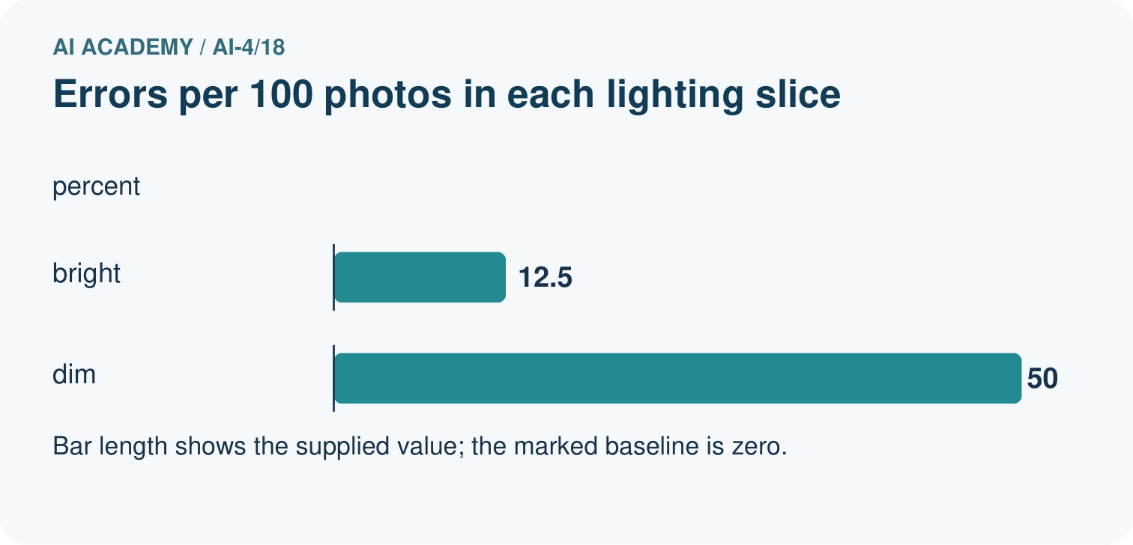
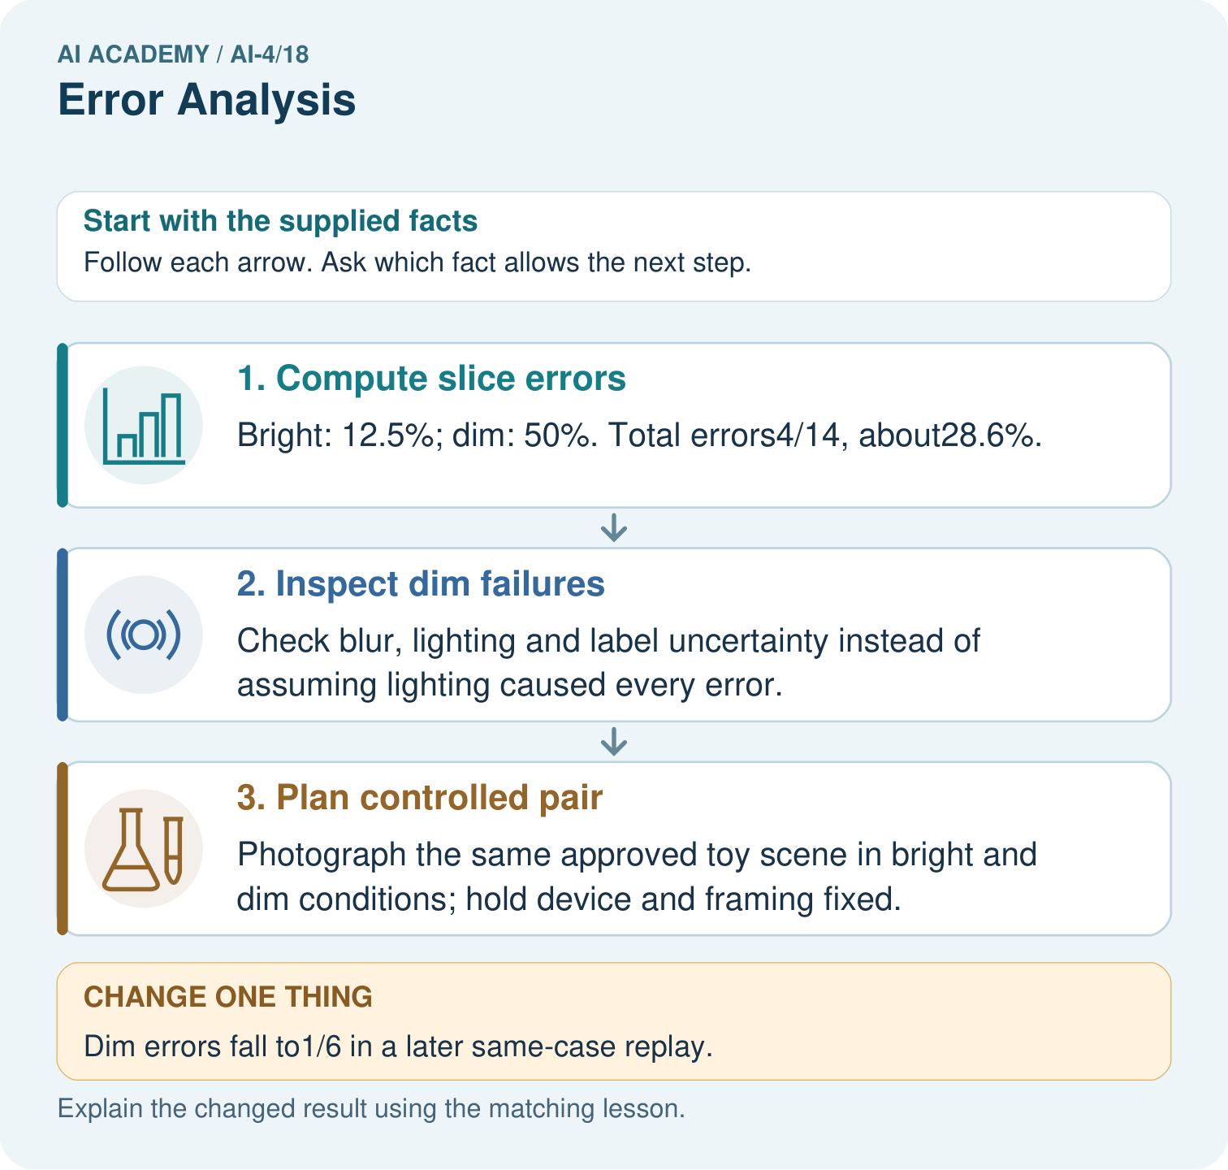
What evidence would support the claim that a change helps fresh dim-light images? Point to the relevant step in the picture, then write the changed result and the rule or evidence that supports it.

My picture-based explanation and changed-case prediction
________________________________________________________________
________________________________________________________________
________________________________________________________________
________________________________________________________________
________________________________________________________________
________________________________________________________________
Support used: alone / hint / worked example. This record is practice evidence.
Project connection: For your Responsible Plant Classifier, save the input, procedure, observed result and limitation of this check. Label this worked example as practice; use a different, previously unreviewed case when checking independent understanding.

19. Project portfolio milestone
Project: Responsible Plant Classifier
Current milestone: Test changed cases. Keep normal, boundary and failure cases; compare expected and observed results.
For your Responsible Plant Classifier, save the input, procedure, observed result and limitation of this check. Label this worked example as practice; use a different, previously unreviewed case when checking independent understanding.
Evidence to keep | My record
This week’s input and deciding step
Prediction and actual result (or labelled paper trace)
One change since the previous checkpoint and why
One error or limit and the next test

Explain what this week adds to your project. Reuse last week’s record rather than starting again.
________________________________________________________________
________________________________________________________________
________________________________________________________________
________________________________________________________________
________________________________________________________________

20. Supported practice and learning evidence
Use this supported practice once, in the browser or on paper. Keep the reserved independent assessment for a separate first attempt before teacher feedback.
Find an error cluster before choosing a controlled follow-up.

Practice 1: explain the deciding evidence
Which labelled step matches this detail? Photograph the same approved toy scene in bright and dim conditions; hold device and framing fixed.
1. Plan controlled pair
2. Compute slice errors
3. Inspect dim failures

My selected conclusion, deciding fact and explanation
________________________________________________________________
________________________________________________________________
________________________________________________________________
________________________________________________________________
________________________________________________________________
Hint if needed: Read the steps in the pictorial case. Match the supplied detail to the stage that performs or records it.
After your attempt, compare with the supported explanation: Plan controlled pair Photograph the same approved toy scene in bright and dim conditions; hold device and framing fixed. Read the picture in order. Photograph the same approved toy scene in bright and dim conditions; hold device and framing fixed. The arrows show which recorded input or intermediate result each decision uses. Explain the deciding step aloud before checking the changed case; pointing to the final answer alone does not show how it follows.

Practice 2: explain the deciding evidence
Changed-case practice: Dim errors fall to1/6 in a later same-case replay. Which conclusion is supported by the supplied facts?
1. The replay’s dim error rate is 16.7%; it is development evidence if those cases guided the revision.
2. We can decide the result without examining the changed input or the procedure.
3. This one example guarantees correct results for every future input.

My selected conclusion, deciding fact and explanation
________________________________________________________________
________________________________________________________________
________________________________________________________________
________________________________________________________________
________________________________________________________________
Hint if needed: Use the changed condition and the deciding step in the pictorial trace. The answer must say what follows from those facts.
After your attempt, compare with the supported explanation: The replay’s dim error rate is 16.7%; it is development evidence if those cases guided the revision. Observed improvement on reused cases is not an untouched final generalisation test.

Repair a missing building block
Review Precision and Recall (ai-4/17). Goal: Choose the denominator that answers the question. Short practice: Were the original precision and recall denominators the same? Point to the relevant step in the picture, then write the changed result and the rule or evidence that supports it.. Return to this week and explain what you changed.
Review Confusion Matrix (ai-4/15). Goal: Build a labelled confusion matrix from matched reference and prediction pairs. Short practice: Why is adding TP alone without reducing FN an incorrect revision? Point to the relevant step in the picture, then write the changed result and the rule or evidence that supports it.. Return to this week and explain what you changed.
Review Nearest Neighbors (ai-4/12). Goal: Compute absolute distances and rank training neighbours. Short practice: Why is the k=1 outcome at length5 not uniquely determined without a tie rule? Point to the relevant step in the picture, then write the changed result and the rule or evidence that supports it.. Return to this week and explain what you changed.

Predict, run and debug
The browser lab lets you edit the supported Python examples already included in this lesson. Predict first, run, inspect the actual output or error, change one input, then run again. Keep code, predictions, actual results and a reasoned revision together. On paper, label your result as a trace rather than an execution.

Keep your completed work
Use Download completed work in the hosted lesson to export your answers, reflections, practice feedback and code-run evidence. Open the HTML copy to read or print it. Drafts stay in this browser when storage is available; clear drafts on a shared device.

What I repaired, the evidence I kept and the next test
________________________________________________________________
________________________________________________________________
________________________________________________________________
________________________________________________________________
________________________________________________________________

