AI ACADEMY · WORKBOOK · ai-4/25

Metrics Match Consequences
Project: Responsible Plant Classifier

01. Recall and choose your starting point
Try the recall before opening notes. Then use a different colour or a labelled second line to correct your explanation.

Train, Validation, Test
Without opening the old lesson, explain one key idea from Train, Validation, Test. Give an example and a mistake that the idea helps you avoid.

My remembered idea, example and correction
________________________________________________________________
________________________________________________________________
________________________________________________________________

Train a Regression Model
Without opening the old lesson, explain one key idea from Train a Regression Model. Give an example and a mistake that the idea helps you avoid.

My remembered idea, example and correction
________________________________________________________________
________________________________________________________________
________________________________________________________________

Regression and Residuals
Without opening the old lesson, explain one key idea from Regression and Residuals. Give an example and a mistake that the idea helps you avoid.

My remembered idea, example and correction
________________________________________________________________
________________________________________________________________
________________________________________________________________

02. Practise with fading help
Use W2: Count the consequences for Thresholds and consequences. Record the answer once; the lesson and workbook refer to the same attempt.
Given inputs | Procedure I chose | Middle steps | Result and check

The step I completed without help, and the hint I needed
________________________________________________________________
________________________________________________________________
________________________________________________________________

03. Individual reasoning check
Use the worked case for Thresholds and consequences. Proposed explanation: “A final answer is enough”. Decide whether this explanation is supported. Point to the step or supplied fact that decides; explain your repair if needed.

My explanation before partner discussion
________________________________________________________________
________________________________________________________________
________________________________________________________________
________________________________________________________________

04. Independent transfer case

Independent case: Apply independently
Scores/references are .8/blocked,.5/clear,.2/blocked,.1/clear. Compare thresholds .5 and .2 using the same cost.

My independent explanation, trace and limits
________________________________________________________________
________________________________________________________________
________________________________________________________________
________________________________________________________________
________________________________________________________________
________________________________________________________________
________________________________________________________________
Attempt this case before feedback. Record any help. Earlier examples below are further practice; a case already practised with feedback cannot establish fresh transfer.

05. Your learning target
A reviewer can inspect at most 10 alerts daily. Model A flags 20 cases with higher recall; B flags 8 with lower recall. What evidence is needed before choosing a threshold?

06. Solve the given case
Spotting alerts can miss disease signs or create unnecessary healthy-leaf reviews.
Connect metrics to consequences.
Show your trace, calculation or evidence

Write or draw your reasoning and evidence.
________________________________________________________________
________________________________________________________________
________________________________________________________________
________________________________________________________________
________________________________________________________________

07. Check a changed case
Missing a diseased plant is considered more costly than a false alarm, but staff can review only ten alerts daily. Which evaluation trade-off should be discussed?
My independent answer and reason

Write or draw your reasoning and evidence.
________________________________________________________________
________________________________________________________________
________________________________________________________________
________________________________________________________________
________________________________________________________________

Week 25 Test and reflect

08. Design a revealing test
Create a changed input, boundary case or missing-information case. Write the expected answer or safe response before testing.
Test record | My evidence
Changed input or condition
Expected answer or fallback
Observed result
Why the result occurred

09. Project checkpoint
Approve the Plant Classifier metric suite: accuracy for context, spotted precision/recall, confusion matrix, and subgroup slices.
The project change and evidence I will keep

Write or draw your reasoning and evidence.
________________________________________________________________
________________________________________________________________
________________________________________________________________
________________________________________________________________
________________________________________________________________

10. Self check
I can explain the mechanism. I can show evidence. I can handle a changed case. I can name a limit. Mark each as not yet, with help or independently, and attach supporting work.
Teacher review ____________________ Next step ____________________

11. Transfer practice from the original programme
A reviewer can inspect at most 10 alerts daily. Model A flags 20 cases with higher recall; B flags 8 with lower recall. What evidence is needed before choosing a threshold?

My independently reasoned answer
________________________________________________________________
________________________________________________________________
________________________________________________________________
________________________________________________________________
________________________________________________________________
________________________________________________________________
________________________________________________________________
Record support used: none, hint or teacher explanation.

12. W1 Apply the boundary
Which IDs are positive at .5 and .3?

My reasoning and evidence
________________________________________________________________
________________________________________________________________
________________________________________________________________
________________________________________________________________
________________________________________________________________
________________________________________________________________

13. W2 Count the consequences
Give TP, FP, FN, TN at both thresholds.

My reasoning and evidence
________________________________________________________________
________________________________________________________________
________________________________________________________________
________________________________________________________________
________________________________________________________________
________________________________________________________________

14. W3 Use the declared cost
Calculate costs with FP cost 1 and FN cost 4.

My reasoning and evidence
________________________________________________________________
________________________________________________________________
________________________________________________________________
________________________________________________________________
________________________________________________________________
________________________________________________________________

15. W4 Apply independently
Scores/references are .8/blocked,.5/clear,.2/blocked,.1/clear. Compare thresholds .5 and .2 using the same cost.

My reasoning and evidence
________________________________________________________________
________________________________________________________________
________________________________________________________________
________________________________________________________________
________________________________________________________________
________________________________________________________________
________________________________________________________________
________________________________________________________________

16. W5 Protect the final test
Why not select the threshold with the lowest final-test cost?

My reasoning and evidence
________________________________________________________________
________________________________________________________________
________________________________________________________________
________________________________________________________________
________________________________________________________________
________________________________________________________________

17. Feedback, return check and learning record
Evidence | My record
Worked alone / hint / model
First step I repaired and why
New case checked later; date and result
What I can now explain without notes
One remaining question
Revisit this idea with your teacher after a delay. Familiarity is different from explaining and using it on a changed case.

18. Pictorial case practice: Metrics Match Consequences
Translate a threshold choice into missed-leaf and false-alarm costs.
Scores/reference: 0.9 spotted, 0.6 healthy, 0.4 spotted, 0.1 healthy. Predict spotted at score>=threshold. Miss cost5; false-alarm cost1.
All inputs and outcomes in this worked example are invented classroom data; no real model run is claimed.
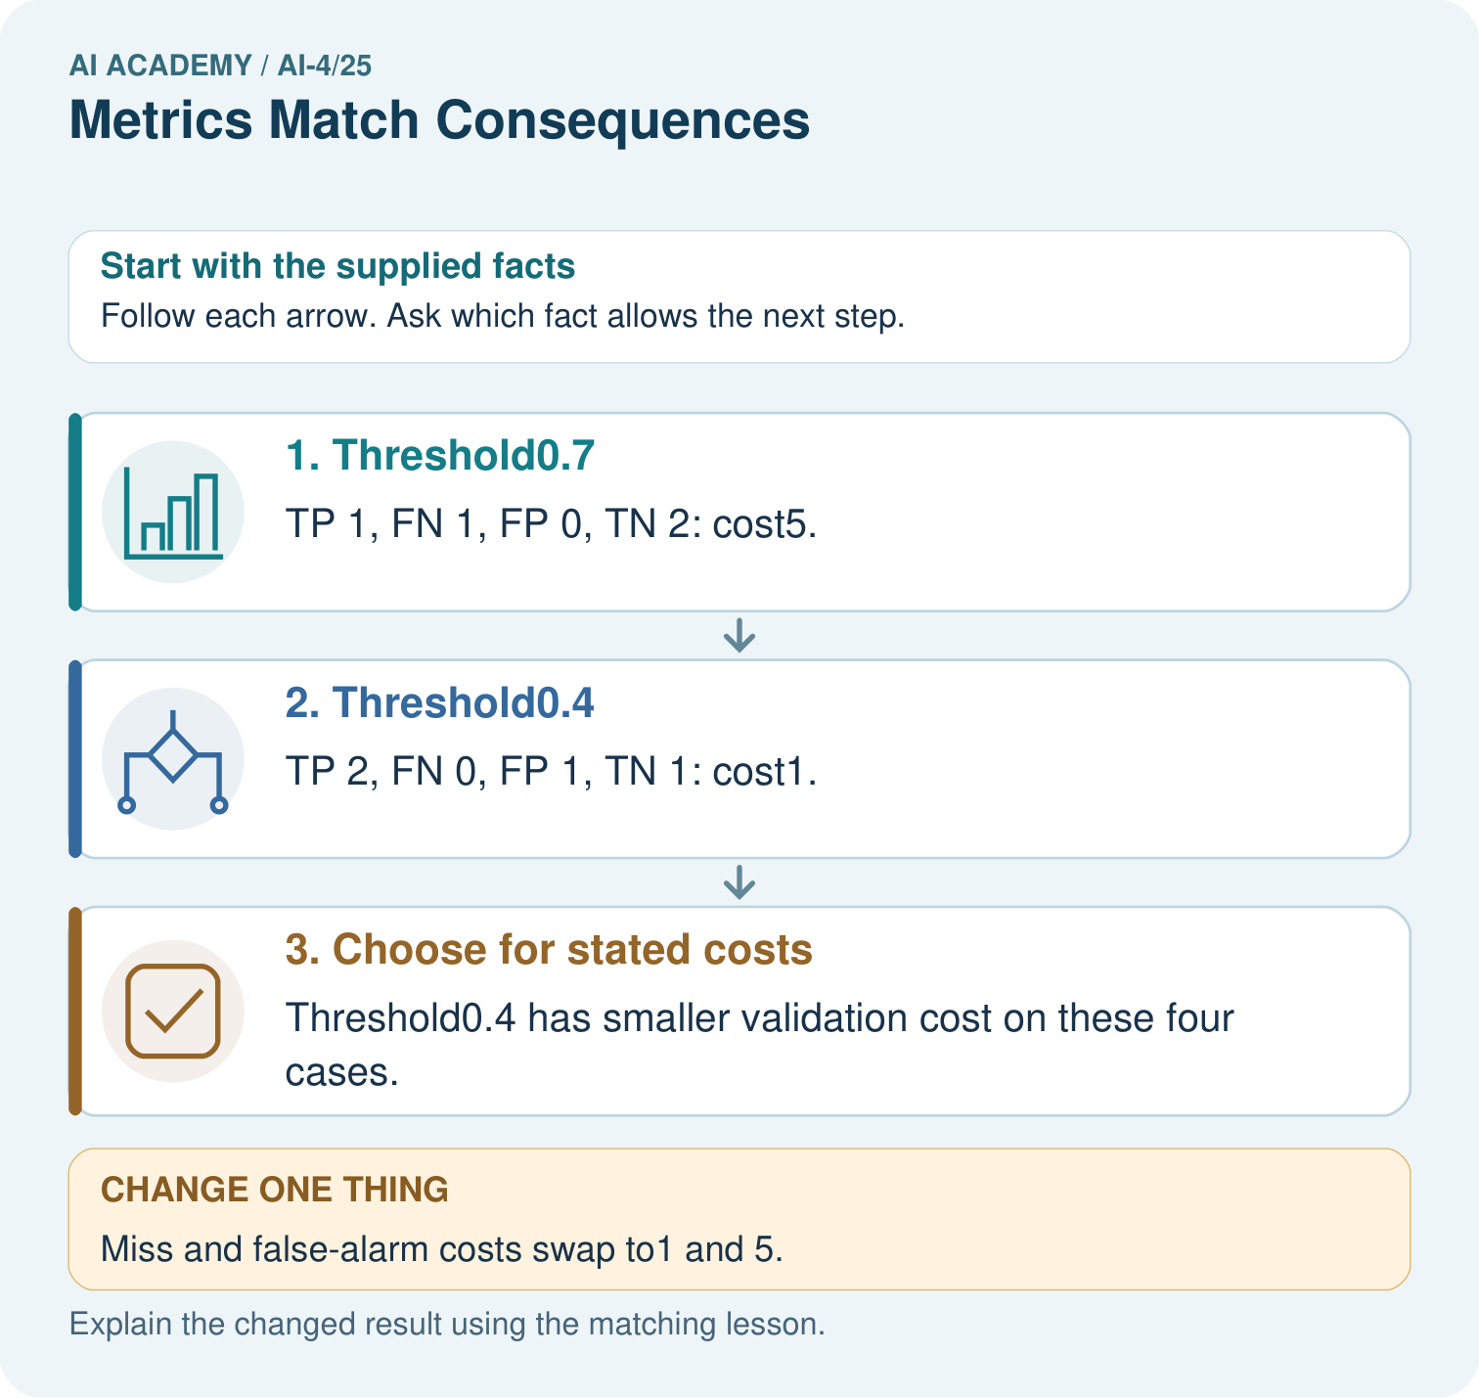
Which labels determine the false-alarm count at threshold 0.4? Point to the relevant step in the picture, then write the changed result and the rule or evidence that supports it.

My picture-based explanation and changed-case prediction
________________________________________________________________
________________________________________________________________
________________________________________________________________
________________________________________________________________
________________________________________________________________
________________________________________________________________
Support used: alone / hint / worked example. This record is practice evidence.
Project connection: For your Responsible Plant Classifier, save the input, procedure, observed result and limitation of this check. Label this worked example as practice; use a different, previously unreviewed case when checking independent understanding.

19. Project portfolio milestone
Project: Responsible Plant Classifier
Current milestone: Prepare the demonstration. Gather reproducible instructions, evidence, access checks and remaining limitations.
For your Responsible Plant Classifier, save the input, procedure, observed result and limitation of this check. Label this worked example as practice; use a different, previously unreviewed case when checking independent understanding.
Evidence to keep | My record
This week’s input and deciding step
Prediction and actual result (or labelled paper trace)
One change since the previous checkpoint and why
One error or limit and the next test

Explain what this week adds to your project. Reuse last week’s record rather than starting again.
________________________________________________________________
________________________________________________________________
________________________________________________________________
________________________________________________________________
________________________________________________________________

20. Supported practice and learning evidence
Use this supported practice once, in the browser or on paper. Keep the reserved independent assessment for a separate first attempt before teacher feedback.
Translate a threshold choice into missed-leaf and false-alarm costs.

Practice 1: explain the deciding evidence
Which labelled step matches this detail? Threshold0.4 has smaller validation cost on these four cases.
1. Threshold0.4
2. Choose for stated costs
3. Threshold0.7

My selected conclusion, deciding fact and explanation
________________________________________________________________
________________________________________________________________
________________________________________________________________
________________________________________________________________
________________________________________________________________
Hint if needed: Read the steps in the pictorial case. Match the supplied detail to the stage that performs or records it.
After your attempt, compare with the supported explanation: Choose for stated costs Threshold0.4 has smaller validation cost on these four cases. Read the picture in order. Threshold0.4 has smaller validation cost on these four cases. The arrows show which recorded input or intermediate result each decision uses. Explain the deciding step aloud before checking the changed case; pointing to the final answer alone does not show how it follows.

Practice 2: explain the deciding evidence
Changed-case practice: Miss and false-alarm costs swap to1 and 5. Which conclusion is supported by the supplied facts?
1. This one example guarantees correct results for every future input.
2. We can decide the result without examining the changed input or the procedure.
3. Threshold0.7 costs1 while0.4 costs5; preferred threshold switches.

My selected conclusion, deciding fact and explanation
________________________________________________________________
________________________________________________________________
________________________________________________________________
________________________________________________________________
________________________________________________________________
Hint if needed: Use the changed condition and the deciding step in the pictorial trace. The answer must say what follows from those facts.
After your attempt, compare with the supported explanation: Threshold0.7 costs1 while0.4 costs5; preferred threshold switches. Metric choice encodes the declared consequences, not a universal best threshold.

Repair a missing building block
Review Train, Validation, Test (ai-4/24). Goal: Select a model using a declared validation rule. Short practice: Why does B’s zero training MAE not settle the original choice? Point to the relevant step in the picture, then write the changed result and the rule or evidence that supports it.. Return to this week and explain what you changed.
Review Train a Regression Model (ai-4/22). Goal: Fit a line from a declared training candidate set. Short practice: May day3’s evaluation label choose the candidate line? Point to the relevant step in the picture, then write the changed result and the rule or evidence that supports it.. Return to this week and explain what you changed.
Review Regression and Residuals (ai-4/19). Goal: Distinguish numeric prediction from classification. Short practice: Which statistic reveals the size of errors without cancellation? Point to the relevant step in the picture, then write the changed result and the rule or evidence that supports it.. Return to this week and explain what you changed.

Predict, run and debug
The browser lab lets you edit the supported Python examples already included in this lesson. Predict first, run, inspect the actual output or error, change one input, then run again. Keep code, predictions, actual results and a reasoned revision together. On paper, label your result as a trace rather than an execution.

Keep your completed work
Use Download completed work in the hosted lesson to export your answers, reflections, practice feedback and code-run evidence. Open the HTML copy to read or print it. Drafts stay in this browser when storage is available; clear drafts on a shared device.

What I repaired, the evidence I kept and the next test
________________________________________________________________
________________________________________________________________
________________________________________________________________
________________________________________________________________
________________________________________________________________

