AI ACADEMY · WORKBOOK · ai-4/26

Reproducible Experiments
Project: Responsible Plant Classifier

01. Recall and choose your starting point
Try the recall before opening notes. Then use a different colour or a labelled second line to correct your explanation.

Metrics Match Consequences
Without opening the old lesson, explain one key idea from Metrics Match Consequences. Give an example and a mistake that the idea helps you avoid.

My remembered idea, example and correction
________________________________________________________________
________________________________________________________________
________________________________________________________________

Hold Out Test Data
Without opening the old lesson, explain one key idea from Hold Out Test Data. Give an example and a mistake that the idea helps you avoid.

My remembered idea, example and correction
________________________________________________________________
________________________________________________________________
________________________________________________________________

Mean, Median, and Baselines
Without opening the old lesson, explain one key idea from Mean, Median, and Baselines. Give an example and a mistake that the idea helps you avoid.

My remembered idea, example and correction
________________________________________________________________
________________________________________________________________
________________________________________________________________

02. Practise with fading help
Use W2: Improve a record for Experimental records and seeds. Record the answer once; the lesson and workbook refer to the same attempt.
Given inputs | Procedure I chose | Middle steps | Result and check

The step I completed without help, and the hint I needed
________________________________________________________________
________________________________________________________________
________________________________________________________________

03. Individual reasoning check
Use the worked case for Experimental records and seeds. Proposed explanation: “A final answer is enough”. Decide whether this explanation is supported. Point to the step or supplied fact that decides; explain your repair if needed.

My explanation before partner discussion
________________________________________________________________
________________________________________________________________
________________________________________________________________
________________________________________________________________

04. Independent transfer case

Independent case: Apply independently
Declared seeds 1, 2, 3 produce 9/12, 8/12, 10/12 correct. Compute the mean accuracy and range.

My independent explanation, trace and limits
________________________________________________________________
________________________________________________________________
________________________________________________________________
________________________________________________________________
________________________________________________________________
________________________________________________________________
________________________________________________________________
Attempt this case before feedback. Record any help. Earlier examples below are further practice; a case already practised with feedback cannot establish fresh transfer.

05. Your learning target
Two teams use the same random seed but different label files. Their results differ. List the records needed to reproduce the experiment.

06. Solve the given case
A report says accuracy85% without data split, code version, seed or preprocessing.
Specify reproducibility records.
Show your trace, calculation or evidence

Write or draw your reasoning and evidence.
________________________________________________________________
________________________________________________________________
________________________________________________________________
________________________________________________________________
________________________________________________________________

07. Check a changed case
Two runs use different random splits and different feature sets. Their scores differ. What must be recorded, and why is the cause unclear?
My independent answer and reason

Write or draw your reasoning and evidence.
________________________________________________________________
________________________________________________________________
________________________________________________________________
________________________________________________________________
________________________________________________________________

Week 26 Test and reflect

08. Design a revealing test
Create a changed input, boundary case or missing-information case. Write the expected answer or safe response before testing.
Test record | My evidence
Changed input or condition
Expected answer or fallback
Observed result
Why the result occurred

09. Project checkpoint
Give every Plant Classifier experiment an ID and immutable record linking dataset, split, code, settings, predictions, and metrics.
The project change and evidence I will keep

Write or draw your reasoning and evidence.
________________________________________________________________
________________________________________________________________
________________________________________________________________
________________________________________________________________
________________________________________________________________

10. Self check
I can explain the mechanism. I can show evidence. I can handle a changed case. I can name a limit. Mark each as not yet, with help or independently, and attach supporting work.
Teacher review ____________________ Next step ____________________

11. Transfer practice from the original programme
Two teams use the same random seed but different label files. Their results differ. List the records needed to reproduce the experiment.

My independently reasoned answer
________________________________________________________________
________________________________________________________________
________________________________________________________________
________________________________________________________________
________________________________________________________________
________________________________________________________________
________________________________________________________________
Record support used: none, hint or teacher explanation.

12. W1 Summarize all runs
Calculate the worked mean and range in percentage points.

My reasoning and evidence
________________________________________________________________
________________________________________________________________
________________________________________________________________
________________________________________________________________
________________________________________________________________
________________________________________________________________

13. W2 Improve a record
A file contains only seed 22 and 80 percent. Name four missing items.

My reasoning and evidence
________________________________________________________________
________________________________________________________________
________________________________________________________________
________________________________________________________________
________________________________________________________________
________________________________________________________________

14. W3 Separate two ideas
Does identical output prove a valid experiment?

My reasoning and evidence
________________________________________________________________
________________________________________________________________
________________________________________________________________
________________________________________________________________
________________________________________________________________
________________________________________________________________

15. W4 Apply independently
Declared seeds 1, 2, 3 produce 9/12, 8/12, 10/12 correct. Compute the mean accuracy and range.

My reasoning and evidence
________________________________________________________________
________________________________________________________________
________________________________________________________________
________________________________________________________________
________________________________________________________________
________________________________________________________________
________________________________________________________________
________________________________________________________________

16. W5 Handle a failed run
One planned seed fails before prediction. How should it appear in the record?

My reasoning and evidence
________________________________________________________________
________________________________________________________________
________________________________________________________________
________________________________________________________________
________________________________________________________________
________________________________________________________________

17. Versioned experiments — W1 Record a run
List five items needed to reproduce a scoring run.

My reasoning and evidence
________________________________________________________________
________________________________________________________________
________________________________________________________________
________________________________________________________________
________________________________________________________________
________________________________________________________________

18. Versioned experiments — W2 Compute a comparison
A has fun 3 and learning 2. Score it under weights (2,1) and (1,2).

My reasoning and evidence
________________________________________________________________
________________________________________________________________
________________________________________________________________
________________________________________________________________
________________________________________________________________
________________________________________________________________

19. Versioned experiments — W3 Repair an experiment
A learner changes weights, input ratings and the time limit together. Why is attribution difficult?

My reasoning and evidence
________________________________________________________________
________________________________________________________________
________________________________________________________________
________________________________________________________________
________________________________________________________________
________________________________________________________________

20. Versioned experiments — W4 Design independently
Plan two versions for C (fun 5, learning 1) and D (fun 2, learning 5), using weights (2,1) and (1,2). Record expected scores, ranks, fixed data and a separate final-case plan.

My reasoning and evidence
________________________________________________________________
________________________________________________________________
________________________________________________________________
________________________________________________________________
________________________________________________________________
________________________________________________________________
________________________________________________________________
________________________________________________________________

21. Versioned experiments — W5 Protect evaluation
You revise the policy after reading final-case failures. Are those cases still untouched holdout evidence?

My reasoning and evidence
________________________________________________________________
________________________________________________________________
________________________________________________________________
________________________________________________________________
________________________________________________________________
________________________________________________________________

22. Feedback, return check and learning record
Evidence | My record
Worked alone / hint / model
First step I repaired and why
New case checked later; date and result
What I can now explain without notes
One remaining question
Revisit this idea with your teacher after a delay. Familiarity is different from explaining and using it on a changed case.

23. Pictorial case practice: Reproducible Experiments
Record variation across declared seeds instead of selecting the prettiest run.
Same fixed validation set of10 cases; declared runs seed 4=6 correct, seed 5=8, seed 6=7. All three are reported.
All inputs and outcomes in this worked example are invented classroom data; no real model run is claimed.
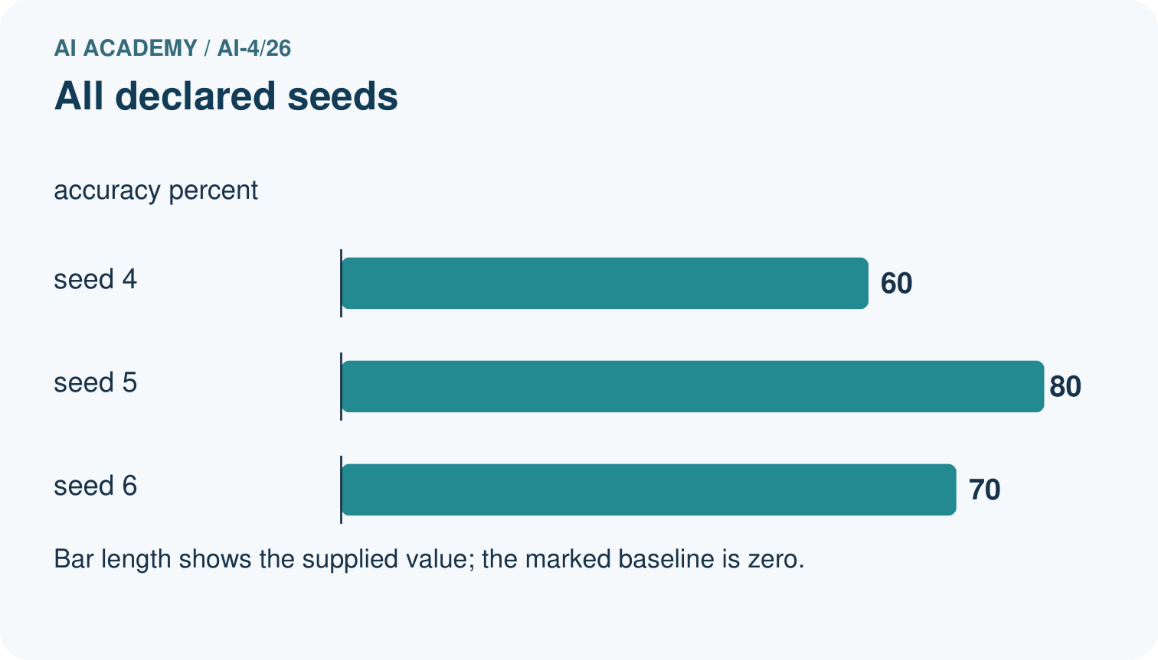
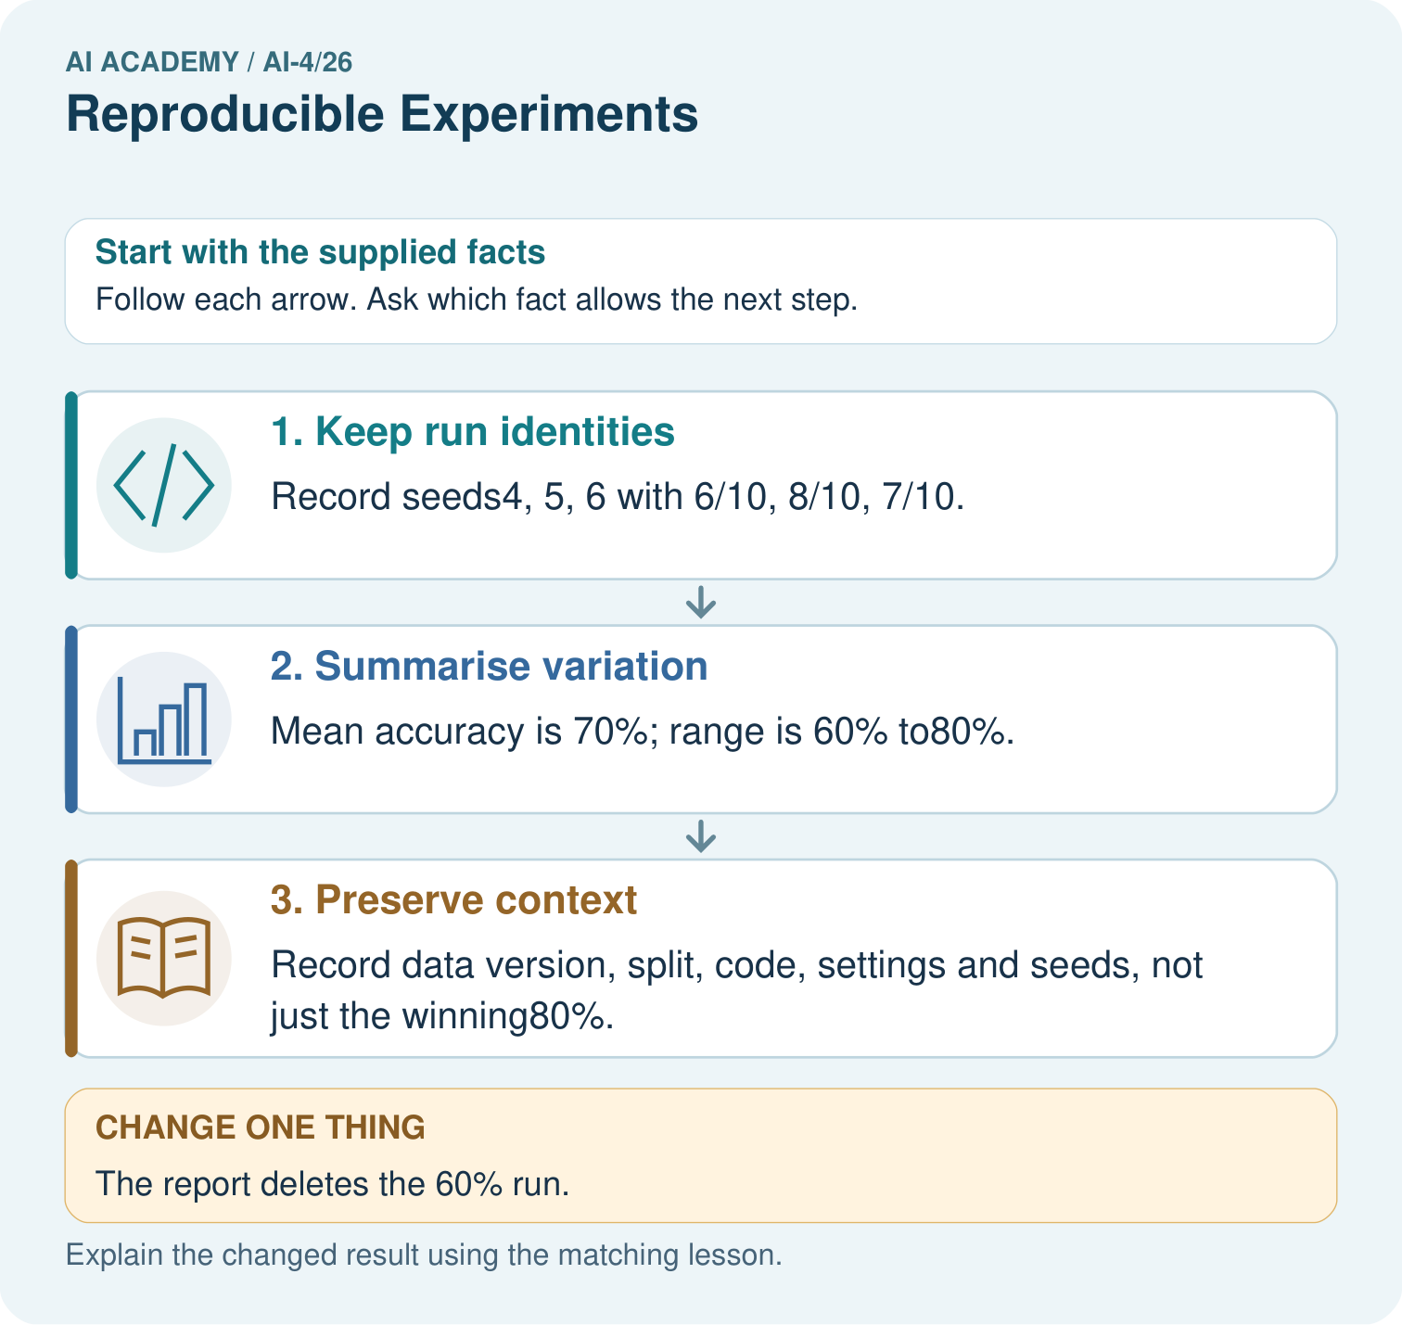
What should accompany the mean 70%? Point to the relevant step in the picture, then write the changed result and the rule or evidence that supports it.

My picture-based explanation and changed-case prediction
________________________________________________________________
________________________________________________________________
________________________________________________________________
________________________________________________________________
________________________________________________________________
________________________________________________________________
Support used: alone / hint / worked example. This record is practice evidence.
Project connection: For your Responsible Plant Classifier, save the input, procedure, observed result and limitation of this check. Label this worked example as practice; use a different, previously unreviewed case when checking independent understanding.

24. Project portfolio milestone
Project: Responsible Plant Classifier
Current milestone: Prepare the demonstration. Gather reproducible instructions, evidence, access checks and remaining limitations.
For your Responsible Plant Classifier, save the input, procedure, observed result and limitation of this check. Label this worked example as practice; use a different, previously unreviewed case when checking independent understanding.
Evidence to keep | My record
This week’s input and deciding step
Prediction and actual result (or labelled paper trace)
One change since the previous checkpoint and why
One error or limit and the next test

Explain what this week adds to your project. Reuse last week’s record rather than starting again.
________________________________________________________________
________________________________________________________________
________________________________________________________________
________________________________________________________________
________________________________________________________________

25. Supported practice and learning evidence
Use this supported practice once, in the browser or on paper. Keep the reserved independent assessment for a separate first attempt before teacher feedback.
Record variation across declared seeds instead of selecting the prettiest run.

Practice 1: explain the deciding evidence
Which labelled step matches this detail? Record data version, split, code, settings and seeds, not just the winning80%.
1. Preserve context
2. Keep run identities
3. Summarise variation

My selected conclusion, deciding fact and explanation
________________________________________________________________
________________________________________________________________
________________________________________________________________
________________________________________________________________
________________________________________________________________
Hint if needed: Read the steps in the pictorial case. Match the supplied detail to the stage that performs or records it.
After your attempt, compare with the supported explanation: Preserve context Record data version, split, code, settings and seeds, not just the winning80%. Read the picture in order. Record data version, split, code, settings and seeds, not just the winning80%. The arrows show which recorded input or intermediate result each decision uses. Explain the deciding step aloud before checking the changed case; pointing to the final answer alone does not show how it follows.

Practice 2: explain the deciding evidence
Changed-case practice: The report deletes the 60% run. Which conclusion is supported by the supplied facts?
1. The remaining mean rises to75%, but the reported comparison becomes selectively incomplete.
2. This one example guarantees correct results for every future input.
3. We can decide the result without examining the changed input or the procedure.

My selected conclusion, deciding fact and explanation
________________________________________________________________
________________________________________________________________
________________________________________________________________
________________________________________________________________
________________________________________________________________
Hint if needed: Use the changed condition and the deciding step in the pictorial trace. The answer must say what follows from those facts.
After your attempt, compare with the supported explanation: The remaining mean rises to75%, but the reported comparison becomes selectively incomplete. Removing an unfavourable declared run changes the evidence rather than improving the method.

Repair a missing building block
Review Metrics Match Consequences (ai-4/25). Goal: Apply a declared score threshold including equality. Short practice: Which labels determine the false-alarm count at threshold 0.4? Point to the relevant step in the picture, then write the changed result and the rule or evidence that supports it.. Return to this week and explain what you changed.
Review Hold Out Test Data (ai-4/23). Goal: Freeze the full evaluation procedure before testing. Short practice: What is needed for an honest final claim about the revised version? Point to the relevant step in the picture, then write the changed result and the rule or evidence that supports it.. Return to this week and explain what you changed.
Review Mean, Median, and Baselines (ai-4/20). Goal: Fit mean and median constant baselines on training targets. Short practice: Does either original baseline win under evaluation MAE? Point to the relevant step in the picture, then write the changed result and the rule or evidence that supports it.. Return to this week and explain what you changed.

Predict, run and debug
The browser lab lets you edit the supported Python examples already included in this lesson. Predict first, run, inspect the actual output or error, change one input, then run again. Keep code, predictions, actual results and a reasoned revision together. On paper, label your result as a trace rather than an execution.

Keep your completed work
Use Download completed work in the hosted lesson to export your answers, reflections, practice feedback and code-run evidence. Open the HTML copy to read or print it. Drafts stay in this browser when storage is available; clear drafts on a shared device.

What I repaired, the evidence I kept and the next test
________________________________________________________________
________________________________________________________________
________________________________________________________________
________________________________________________________________
________________________________________________________________

