AI ACADEMY · WORKBOOK · ai-4/27

Overfitting
Project: Responsible Plant Classifier

01. Recall and choose your starting point
Try the recall before opening notes. Then use a different colour or a labelled second line to correct your explanation.

Reproducible Experiments
Without opening the old lesson, explain one key idea from Reproducible Experiments. Give an example and a mistake that the idea helps you avoid.

My remembered idea, example and correction
________________________________________________________________
________________________________________________________________
________________________________________________________________

Train, Validation, Test
Without opening the old lesson, explain one key idea from Train, Validation, Test. Give an example and a mistake that the idea helps you avoid.

My remembered idea, example and correction
________________________________________________________________
________________________________________________________________
________________________________________________________________

Absolute Error and MAE
Without opening the old lesson, explain one key idea from Absolute Error and MAE. Give an example and a mistake that the idea helps you avoid.

My remembered idea, example and correction
________________________________________________________________
________________________________________________________________
________________________________________________________________

02. Practise with fading help
Use W2: Interpret a gap for Overfitting and model capacity. Record the answer once; the lesson and workbook refer to the same attempt.
Given inputs | Procedure I chose | Middle steps | Result and check

The step I completed without help, and the hint I needed
________________________________________________________________
________________________________________________________________
________________________________________________________________

03. Individual reasoning check
Use the worked case for Overfitting and model capacity. Proposed explanation: “A final answer is enough”. Decide whether this explanation is supported. Point to the step or supplied fact that decides; explain your repair if needed.

My explanation before partner discussion
________________________________________________________________
________________________________________________________________
________________________________________________________________
________________________________________________________________

04. Independent transfer case

Independent case: Changed independent case
Model A training96%, validation62%; model B training88%, validation79%. Compare gaps and choose a development candidate, assuming the same valid evaluation conditions.

My independent explanation, trace and limits
________________________________________________________________
________________________________________________________________
________________________________________________________________
________________________________________________________________
________________________________________________________________
________________________________________________________________
________________________________________________________________
Attempt this case before feedback. Record any help. Earlier examples below are further practice; a case already practised with feedback cannot establish fresh transfer.

05. Your learning target
A has training 98%, validation 58%; B has training 86%, validation 81%. Compute gaps and select a candidate with a qualification.

06. Solve the given case
A scores100% train,60% validation; B scores85%,80% on the same sets.
Compute gaps and select by validation accuracy.
Show your trace, calculation or evidence

Write or draw your reasoning and evidence.
________________________________________________________________
________________________________________________________________
________________________________________________________________
________________________________________________________________
________________________________________________________________

07. Check a changed case
Model A has training accuracy 99% and validation accuracy 70%; B has 88% and 84%. Compute each gap and discuss the evidence.
My independent answer and reason

Write or draw your reasoning and evidence.
________________________________________________________________
________________________________________________________________
________________________________________________________________
________________________________________________________________
________________________________________________________________

Week 27 Test and reflect

08. Design a revealing test
Create a changed input, boundary case or missing-information case. Write the expected answer or safe response before testing.
Test record | My evidence
Changed input or condition
Expected answer or fallback
Observed result
Why the result occurred

09. Project checkpoint
Check Plant Classifier train-validation gaps and limit complexity before final test release.
The project change and evidence I will keep

Write or draw your reasoning and evidence.
________________________________________________________________
________________________________________________________________
________________________________________________________________
________________________________________________________________
________________________________________________________________

10. Self check
I can explain the mechanism. I can show evidence. I can handle a changed case. I can name a limit. Mark each as not yet, with help or independently, and attach supporting work.
Teacher review ____________________ Next step ____________________

11. Transfer practice from the original programme
A has training 98%, validation 58%; B has training 86%, validation 81%. Compute gaps and select a candidate with a qualification.

My independently reasoned answer
________________________________________________________________
________________________________________________________________
________________________________________________________________
________________________________________________________________
________________________________________________________________
________________________________________________________________
________________________________________________________________
Record support used: none, hint or teacher explanation.

12. W1 Select from evidence
Choose among the three worked candidates and explain the training trap.

My reasoning and evidence
________________________________________________________________
________________________________________________________________
________________________________________________________________
________________________________________________________________
________________________________________________________________
________________________________________________________________

13. W2 Interpret a gap
Does a training-validation gap alone prove overfitting?

My reasoning and evidence
________________________________________________________________
________________________________________________________________
________________________________________________________________
________________________________________________________________
________________________________________________________________
________________________________________________________________

14. W3 Propose a controlled change
Describe one fair next development comparison.

My reasoning and evidence
________________________________________________________________
________________________________________________________________
________________________________________________________________
________________________________________________________________
________________________________________________________________
________________________________________________________________

15. W4 Apply independently
Models A training 4 validation 5, B training 1 validation 2, C training 0 validation 2. Lowest validation MAE then simpler; B is simpler than C. Choose and justify.

My reasoning and evidence
________________________________________________________________
________________________________________________________________
________________________________________________________________
________________________________________________________________
________________________________________________________________
________________________________________________________________
________________________________________________________________
________________________________________________________________

16. W5 Limit a diagnosis
What extra evidence would you inspect before concluding a model memorized noise?

My reasoning and evidence
________________________________________________________________
________________________________________________________________
________________________________________________________________
________________________________________________________________
________________________________________________________________
________________________________________________________________

17. Feedback, return check and learning record
Evidence | My record
Worked alone / hint / model
First step I repaired and why
New case checked later; date and result
What I can now explain without notes
One remaining question
Revisit this idea with your teacher after a delay. Familiarity is different from explaining and using it on a changed case.

18. Pictorial case practice: Overfitting
See overfitting as a gap requiring investigation, not a label based only on model size.
Toy model Small: training 85%, validation 80%. Large: training 100%, validation 60%. Same split and scoring rule.
All inputs and outcomes in this worked example are invented classroom data; no real model run is claimed.
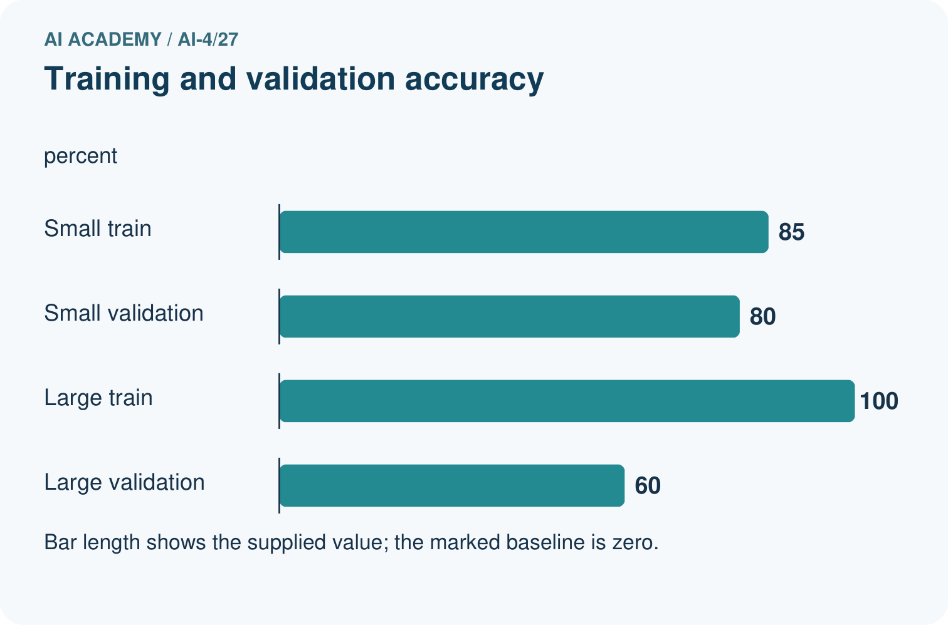
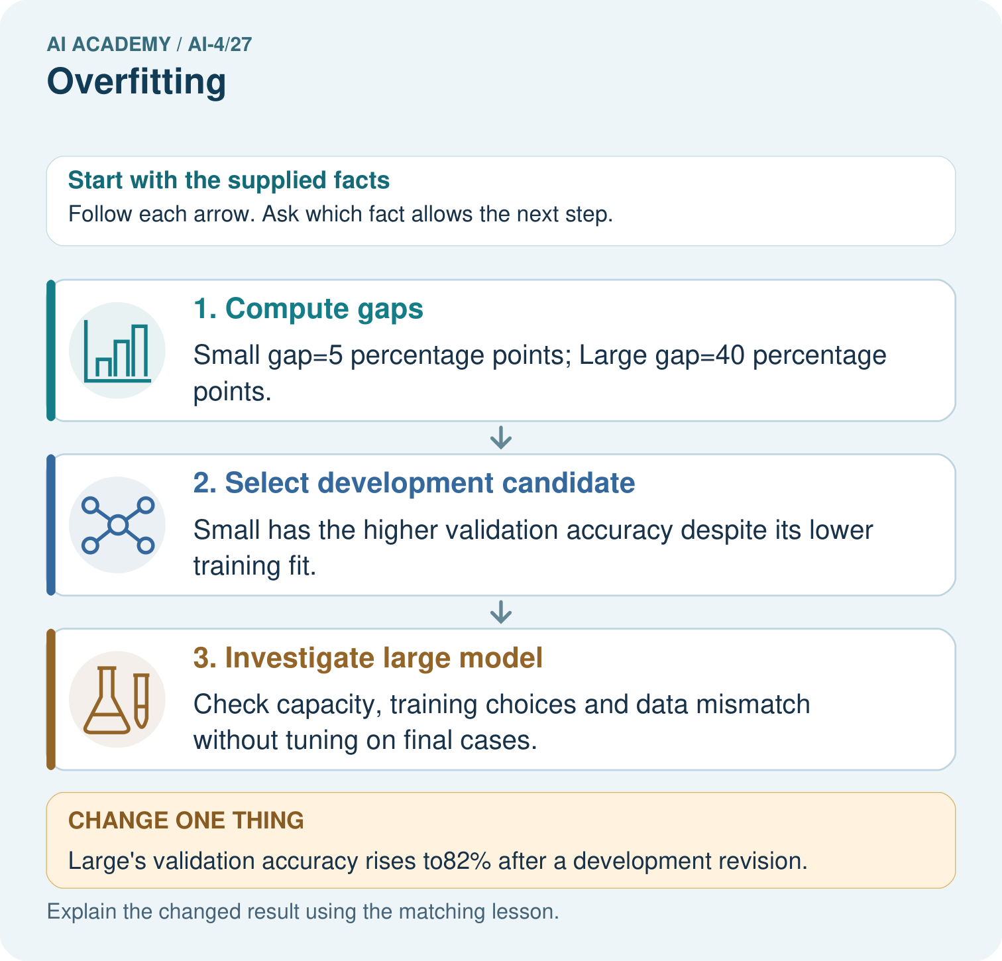
Does100% training accuracy prove Large was always best? Point to the relevant step in the picture, then write the changed result and the rule or evidence that supports it.

My picture-based explanation and changed-case prediction
________________________________________________________________
________________________________________________________________
________________________________________________________________
________________________________________________________________
________________________________________________________________
________________________________________________________________
Support used: alone / hint / worked example. This record is practice evidence.
Project connection: For your Responsible Plant Classifier, save the input, procedure, observed result and limitation of this check. Label this worked example as practice; use a different, previously unreviewed case when checking independent understanding.

19. Project portfolio milestone
Project: Responsible Plant Classifier
Current milestone: Prepare the demonstration. Gather reproducible instructions, evidence, access checks and remaining limitations.
For your Responsible Plant Classifier, save the input, procedure, observed result and limitation of this check. Label this worked example as practice; use a different, previously unreviewed case when checking independent understanding.
Evidence to keep | My record
This week’s input and deciding step
Prediction and actual result (or labelled paper trace)
One change since the previous checkpoint and why
One error or limit and the next test

Explain what this week adds to your project. Reuse last week’s record rather than starting again.
________________________________________________________________
________________________________________________________________
________________________________________________________________
________________________________________________________________
________________________________________________________________

20. Supported practice and learning evidence
Use this supported practice once, in the browser or on paper. Keep the reserved independent assessment for a separate first attempt before teacher feedback.
See overfitting as a gap requiring investigation, not a label based only on model size.

Practice 1: explain the deciding evidence
Which labelled step matches this detail? Check capacity, training choices and data mismatch without tuning on final cases.
1. Select development candidate
2. Compute gaps
3. Investigate large model

My selected conclusion, deciding fact and explanation
________________________________________________________________
________________________________________________________________
________________________________________________________________
________________________________________________________________
________________________________________________________________
Hint if needed: Read the steps in the pictorial case. Match the supplied detail to the stage that performs or records it.
After your attempt, compare with the supported explanation: Investigate large model Check capacity, training choices and data mismatch without tuning on final cases. Read the picture in order. Check capacity, training choices and data mismatch without tuning on final cases. The arrows show which recorded input or intermediate result each decision uses. Explain the deciding step aloud before checking the changed case; pointing to the final answer alone does not show how it follows.

Practice 2: explain the deciding evidence
Changed-case practice: Large’s validation accuracy rises to82% after a development revision. Which conclusion is supported by the supplied facts?
1. We can decide the result without examining the changed input or the procedure.
2. This one example guarantees correct results for every future input.
3. Its gap is 18 percentage points; it now beats Small on this validation set.

My selected conclusion, deciding fact and explanation
________________________________________________________________
________________________________________________________________
________________________________________________________________
________________________________________________________________
________________________________________________________________
Hint if needed: Use the changed condition and the deciding step in the pictorial trace. The answer must say what follows from those facts.
After your attempt, compare with the supported explanation: Its gap is 18 percentage points; it now beats Small on this validation set. Validation performance improved, but the training-validation gap is not a complete release rule.

Repair a missing building block
Review Reproducible Experiments (ai-4/26). Goal: Record enough detail to reproduce a run. Short practice: What should accompany the mean 70%? Point to the relevant step in the picture, then write the changed result and the rule or evidence that supports it.. Return to this week and explain what you changed.
Review Train, Validation, Test (ai-4/24). Goal: Select a model using a declared validation rule. Short practice: Why does B’s zero training MAE not settle the original choice? Point to the relevant step in the picture, then write the changed result and the rule or evidence that supports it.. Return to this week and explain what you changed.
Review Absolute Error and MAE (ai-4/21). Goal: Calculate MAE MSE and RMSE. Short practice: Why is quoting MSE as4.67 cm misleading? Point to the relevant step in the picture, then write the changed result and the rule or evidence that supports it.. Return to this week and explain what you changed.

Keep your completed work
Use Download completed work in the hosted lesson to export your answers, reflections, practice feedback and code-run evidence. Open the HTML copy to read or print it. Drafts stay in this browser when storage is available; clear drafts on a shared device.

What I repaired, the evidence I kept and the next test
________________________________________________________________
________________________________________________________________
________________________________________________________________
________________________________________________________________
________________________________________________________________

