AI ACADEMY · WORKBOOK · ai-4/32

Proxy Features and Fairness
Project: Responsible Plant Classifier

01. Recall and choose your starting point
Try the recall before opening notes. Then use a different colour or a labelled second line to correct your explanation.

Subgroup Performance
Without opening the old lesson, explain one key idea from Subgroup Performance. Give an example and a mistake that the idea helps you avoid.

My remembered idea, example and correction
________________________________________________________________
________________________________________________________________
________________________________________________________________

Feature Engineering
Without opening the old lesson, explain one key idea from Feature Engineering. Give an example and a mistake that the idea helps you avoid.

My remembered idea, example and correction
________________________________________________________________
________________________________________________________________
________________________________________________________________

Reproducible Experiments
Without opening the old lesson, explain one key idea from Reproducible Experiments. Give an example and a mistake that the idea helps you avoid.

My remembered idea, example and correction
________________________________________________________________
________________________________________________________________
________________________________________________________________

02. Practise with fading help
Use W2: Find a proxy risk for Proxy features and fairness. Record the answer once; the lesson and workbook refer to the same attempt.
Given inputs | Procedure I chose | Middle steps | Result and check

The step I completed without help, and the hint I needed
________________________________________________________________
________________________________________________________________
________________________________________________________________

03. Individual reasoning check
Use the worked case for Proxy features and fairness. Proposed explanation: “A final answer is enough”. Decide whether this explanation is supported. Point to the step or supplied fact that decides; explain your repair if needed.

My explanation before partner discussion
________________________________________________________________
________________________________________________________________
________________________________________________________________
________________________________________________________________

04. Independent transfer case

Independent case: Apply independently
A team removes postcode but retains school code and claims all location-related information is gone. Evaluate the claim and request evidence.

My independent explanation, trace and limits
________________________________________________________________
________________________________________________________________
________________________________________________________________
________________________________________________________________
________________________________________________________________
________________________________________________________________
________________________________________________________________
Attempt this case before feedback. Record any help. Earlier examples below are further practice; a case already practised with feedback cannot establish fresh transfer.

05. Your learning target
A leaf model performs well using location ID alone. Explain a possible proxy problem and design a diagnostic evaluation.

06. Solve the given case
Background colour tracks collection location, associated with plant types.
Explain proxy risk and test.
Show your trace, calculation or evidence

Write or draw your reasoning and evidence.
________________________________________________________________
________________________________________________________________
________________________________________________________________
________________________________________________________________
________________________________________________________________

07. Check a changed case
A plant classifier uses camera_model, and one species was photographed mostly on a single camera. What shortcut might it learn and how could you investigate?
My independent answer and reason

Write or draw your reasoning and evidence.
________________________________________________________________
________________________________________________________________
________________________________________________________________
________________________________________________________________
________________________________________________________________

Week 32 Test and reflect

08. Design a revealing test
Create a changed input, boundary case or missing-information case. Write the expected answer or safe response before testing.
Test record | My evidence
Changed input or condition
Expected answer or fallback
Observed result
Why the result occurred

09. Project checkpoint
Document Plant Classifier proxy risks, paired-test evidence, mitigation, and remaining fairness limitation.
The project change and evidence I will keep

Write or draw your reasoning and evidence.
________________________________________________________________
________________________________________________________________
________________________________________________________________
________________________________________________________________
________________________________________________________________

10. Self check
I can explain the mechanism. I can show evidence. I can handle a changed case. I can name a limit. Mark each as not yet, with help or independently, and attach supporting work.
Teacher review ____________________ Next step ____________________

11. Transfer practice from the original programme
A leaf model performs well using location ID alone. Explain a possible proxy problem and design a diagnostic evaluation.

My independently reasoned answer
________________________________________________________________
________________________________________________________________
________________________________________________________________
________________________________________________________________
________________________________________________________________
________________________________________________________________
________________________________________________________________
Record support used: none, hint or teacher explanation.

12. W1 Read an association
What do the device counts support, and what do they not support?

My reasoning and evidence
________________________________________________________________
________________________________________________________________
________________________________________________________________
________________________________________________________________
________________________________________________________________
________________________________________________________________

13. W2 Find a proxy risk
Why might removing building but keeping device code leave related information?

My reasoning and evidence
________________________________________________________________
________________________________________________________________
________________________________________________________________
________________________________________________________________
________________________________________________________________
________________________________________________________________

14. W3 Plan an ablation
Describe a controlled with/without-code comparison.

My reasoning and evidence
________________________________________________________________
________________________________________________________________
________________________________________________________________
________________________________________________________________
________________________________________________________________
________________________________________________________________

15. W4 Apply independently
A team removes postcode but retains school code and claims all location-related information is gone. Evaluate the claim and request evidence.

My reasoning and evidence
________________________________________________________________
________________________________________________________________
________________________________________________________________
________________________________________________________________
________________________________________________________________
________________________________________________________________
________________________________________________________________
________________________________________________________________

16. W5 Limit the result
Does unchanged accuracy after removing a proxy prove fairness?

My reasoning and evidence
________________________________________________________________
________________________________________________________________
________________________________________________________________
________________________________________________________________
________________________________________________________________
________________________________________________________________

17. Feedback, return check and learning record
Evidence | My record
Worked alone / hint / model
First step I repaired and why
New case checked later; date and result
What I can now explain without notes
One remaining question
Revisit this idea with your teacher after a delay. Familiarity is different from explaining and using it on a changed case.

18. Pictorial case practice: Proxy Features and Fairness
Removing an obvious setting field may leave another field that carries the same information.
Toy table has location=greenhouse/desk and camera_code=G/D. Every G record is greenhouse; every D record is desk. The team drops location.
All inputs and outcomes in this worked example are invented classroom data; no real model run is claimed.
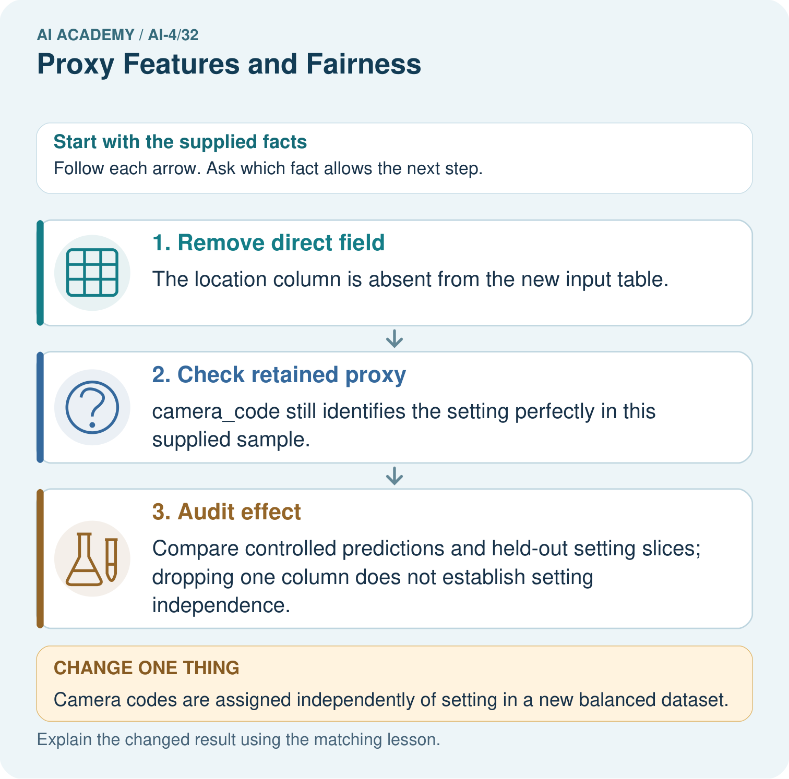
What evidence contradicts the original “all setting information removed” claim? Point to the relevant step in the picture, then write the changed result and the rule or evidence that supports it.

My picture-based explanation and changed-case prediction
________________________________________________________________
________________________________________________________________
________________________________________________________________
________________________________________________________________
________________________________________________________________
________________________________________________________________
Support used: alone / hint / worked example. This record is practice evidence.
Project connection: For your Responsible Plant Classifier, save the input, procedure, observed result and limitation of this check. Label this worked example as practice; use a different, previously unreviewed case when checking independent understanding.

19. Project portfolio milestone
Project: Responsible Plant Classifier
Current milestone: Present and defend. Demonstrate the system, explain one failure and justify the next improvement with evidence.
For your Responsible Plant Classifier, save the input, procedure, observed result and limitation of this check. Label this worked example as practice; use a different, previously unreviewed case when checking independent understanding.
Evidence to keep | My record
This week’s input and deciding step
Prediction and actual result (or labelled paper trace)
One change since the previous checkpoint and why
One error or limit and the next test

Explain what this week adds to your project. Reuse last week’s record rather than starting again.
________________________________________________________________
________________________________________________________________
________________________________________________________________
________________________________________________________________
________________________________________________________________

20. Supported practice and learning evidence
Use this supported practice once, in the browser or on paper. Keep the reserved independent assessment for a separate first attempt before teacher feedback.
Removing an obvious setting field may leave another field that carries the same information.

Practice 1: explain the deciding evidence
Which labelled step matches this detail? Compare controlled predictions and held-out setting slices; dropping one column does not establish setting independence.
1. Remove direct field
2. Audit effect
3. Check retained proxy

My selected conclusion, deciding fact and explanation
________________________________________________________________
________________________________________________________________
________________________________________________________________
________________________________________________________________
________________________________________________________________
Hint if needed: Read the steps in the pictorial case. Match the supplied detail to the stage that performs or records it.
After your attempt, compare with the supported explanation: Audit effect Compare controlled predictions and held-out setting slices; dropping one column does not establish setting independence. Read the picture in order. Compare controlled predictions and held-out setting slices; dropping one column does not establish setting independence. The arrows show which recorded input or intermediate result each decision uses. Explain the deciding step aloud before checking the changed case; pointing to the final answer alone does not show how it follows.

Practice 2: explain the deciding evidence
Changed-case practice: Camera codes are assigned independently of setting in a new balanced dataset. Which conclusion is supported by the supplied facts?
1. camera_code no longer perfectly identifies setting in that dataset.
2. We can decide the result without examining the changed input or the procedure.
3. This one example guarantees correct results for every future input.

My selected conclusion, deciding fact and explanation
________________________________________________________________
________________________________________________________________
________________________________________________________________
________________________________________________________________
________________________________________________________________
Hint if needed: Use the changed condition and the deciding step in the pictorial trace. The answer must say what follows from those facts.
After your attempt, compare with the supported explanation: camera_code no longer perfectly identifies setting in that dataset. The observed mapping changed; other retained fields may still contain setting information.

Repair a missing building block
Review Subgroup Performance (ai-4/31). Goal: Calculate subgroup results with sample sizes. Short practice: Why should the report retain subgroup rates alongside the total? Point to the relevant step in the picture, then write the changed result and the rule or evidence that supports it.. Return to this week and explain what you changed.
Review Feature Engineering (ai-4/29). Goal: Create features available at prediction time. Short practice: What should be saved so another group transforms the query identically? Point to the relevant step in the picture, then write the changed result and the rule or evidence that supports it.. Return to this week and explain what you changed.
Review Reproducible Experiments (ai-4/26). Goal: Record enough detail to reproduce a run. Short practice: What should accompany the mean 70%? Point to the relevant step in the picture, then write the changed result and the rule or evidence that supports it.. Return to this week and explain what you changed.

Keep your completed work
Use Download completed work in the hosted lesson to export your answers, reflections, practice feedback and code-run evidence. Open the HTML copy to read or print it. Drafts stay in this browser when storage is available; clear drafts on a shared device.

What I repaired, the evidence I kept and the next test
________________________________________________________________
________________________________________________________________
________________________________________________________________
________________________________________________________________
________________________________________________________________

