AI ACADEMY · WORKBOOK · ai-5/1

Representing inputs as vectors
Project: Image-pattern Network Investigation

01. Recall and choose your starting point
Try the recall before opening notes. Then use a different colour or a labelled second line to correct your explanation.

ML Builder Expo
Without opening the old lesson, explain one key idea from ML Builder Expo. Give an example and a mistake that the idea helps you avoid.

My remembered idea, example and correction
________________________________________________________________
________________________________________________________________
________________________________________________________________

02. Practise with fading help
Use W2: Convert before encoding for Representing inputs as vectors. Record the answer once; the lesson and workbook refer to the same attempt.
Given inputs | Procedure I chose | Middle steps | Result and check

The step I completed without help, and the hint I needed
________________________________________________________________
________________________________________________________________
________________________________________________________________

03. Individual reasoning check
Use the worked case for Representing inputs as vectors. Proposed explanation: “Order does not matter”. Decide whether this explanation is supported. Point to the step or supplied fact that decides; explain your repair if needed.

My explanation before partner discussion
________________________________________________________________
________________________________________________________________
________________________________________________________________
________________________________________________________________

04. Independent transfer case

Independent case: Apply a new schema independently
A new toy battery task uses [temperature in degrees C, voltage in V, age in days]. Record K has voltage 5, age 12, temperature 18. Record L has temperature 20, voltage 4, age 0. Encode both; state the vector dimension and table shape. Age zero is valid. The future failure label is also supplied in the data file: should it be appended?

My independent explanation, trace and limits
________________________________________________________________
________________________________________________________________
________________________________________________________________
________________________________________________________________
________________________________________________________________
________________________________________________________________
________________________________________________________________
Attempt this case before feedback. Record any help. Earlier examples below are further practice; a case already practised with feedback cannot establish fresh transfer.

05. W1 Encode the records
Write A, B and C as ordered pairs from the lesson. State the dimension of each and the shape of the stacked table.

My reasoning and evidence
________________________________________________________________
________________________________________________________________
________________________________________________________________
________________________________________________________________
________________________________________________________________
________________________________________________________________

06. W2 Convert before encoding
A new record has width 60 mm and height 10 mm. Give its vector in the agreed cm schema, and name one error in [60, 10].

My reasoning and evidence
________________________________________________________________
________________________________________________________________
________________________________________________________________
________________________________________________________________
________________________________________________________________
________________________________________________________________

07. W3 Handle missing information
Width is 4 cm and height is missing. A teammate writes [4, 0]. Explain why this is invalid and give the action required by this schema.

My reasoning and evidence
________________________________________________________________
________________________________________________________________
________________________________________________________________
________________________________________________________________
________________________________________________________________
________________________________________________________________

08. W4 Apply a new schema independently
A new toy battery task uses [temperature in degrees C, voltage in V, age in days]. Record K has voltage 5, age 12, temperature 18. Record L has temperature 20, voltage 4, age 0. Encode both; state the vector dimension and table shape. Age zero is valid. The future failure label is also supplied in the data file: should it be appended?

My reasoning and evidence
________________________________________________________________
________________________________________________________________
________________________________________________________________
________________________________________________________________
________________________________________________________________
________________________________________________________________
________________________________________________________________
________________________________________________________________

09. W5 Explain a collision
Two parcels have the same width and height but different material and target class. Explain why adding more examples alone cannot let this deterministic two-feature model tell these two inputs apart.

My reasoning and evidence
________________________________________________________________
________________________________________________________________
________________________________________________________________
________________________________________________________________
________________________________________________________________
________________________________________________________________

10. Project checkpoint and reflection
Add a labelled representing inputs as vectors evidence sheet to Image-pattern Network Investigation. Show how you can encode a record using a fixed feature order and units. Use the supplied fictional case and keep its inputs, intermediate steps, calculation or prediction, and limitation. Connect this record to last week’s record; a matching answer without a trace is insufficient.

My project change, supporting evidence and remaining limit
________________________________________________________________
________________________________________________________________
________________________________________________________________
________________________________________________________________
________________________________________________________________
________________________________________________________________

11. Feedback, return check and learning record
Evidence | My record
Worked alone / hint / model
First step I repaired and why
New case checked later; date and result
What I can now explain without notes
One remaining question
Revisit this idea with your teacher after a delay. Familiarity is different from explaining and using it on a changed case.

12. Pictorial case practice: Representing inputs as vectors
Encode the same pixel measurements in a fixed vector order.
Toy image features are [left_brightness, right_brightness], each = 0..10. ImageA has left2, right7; imageB has left7, right2.
All inputs and outcomes in this worked example are invented classroom data; no real model run is claimed.
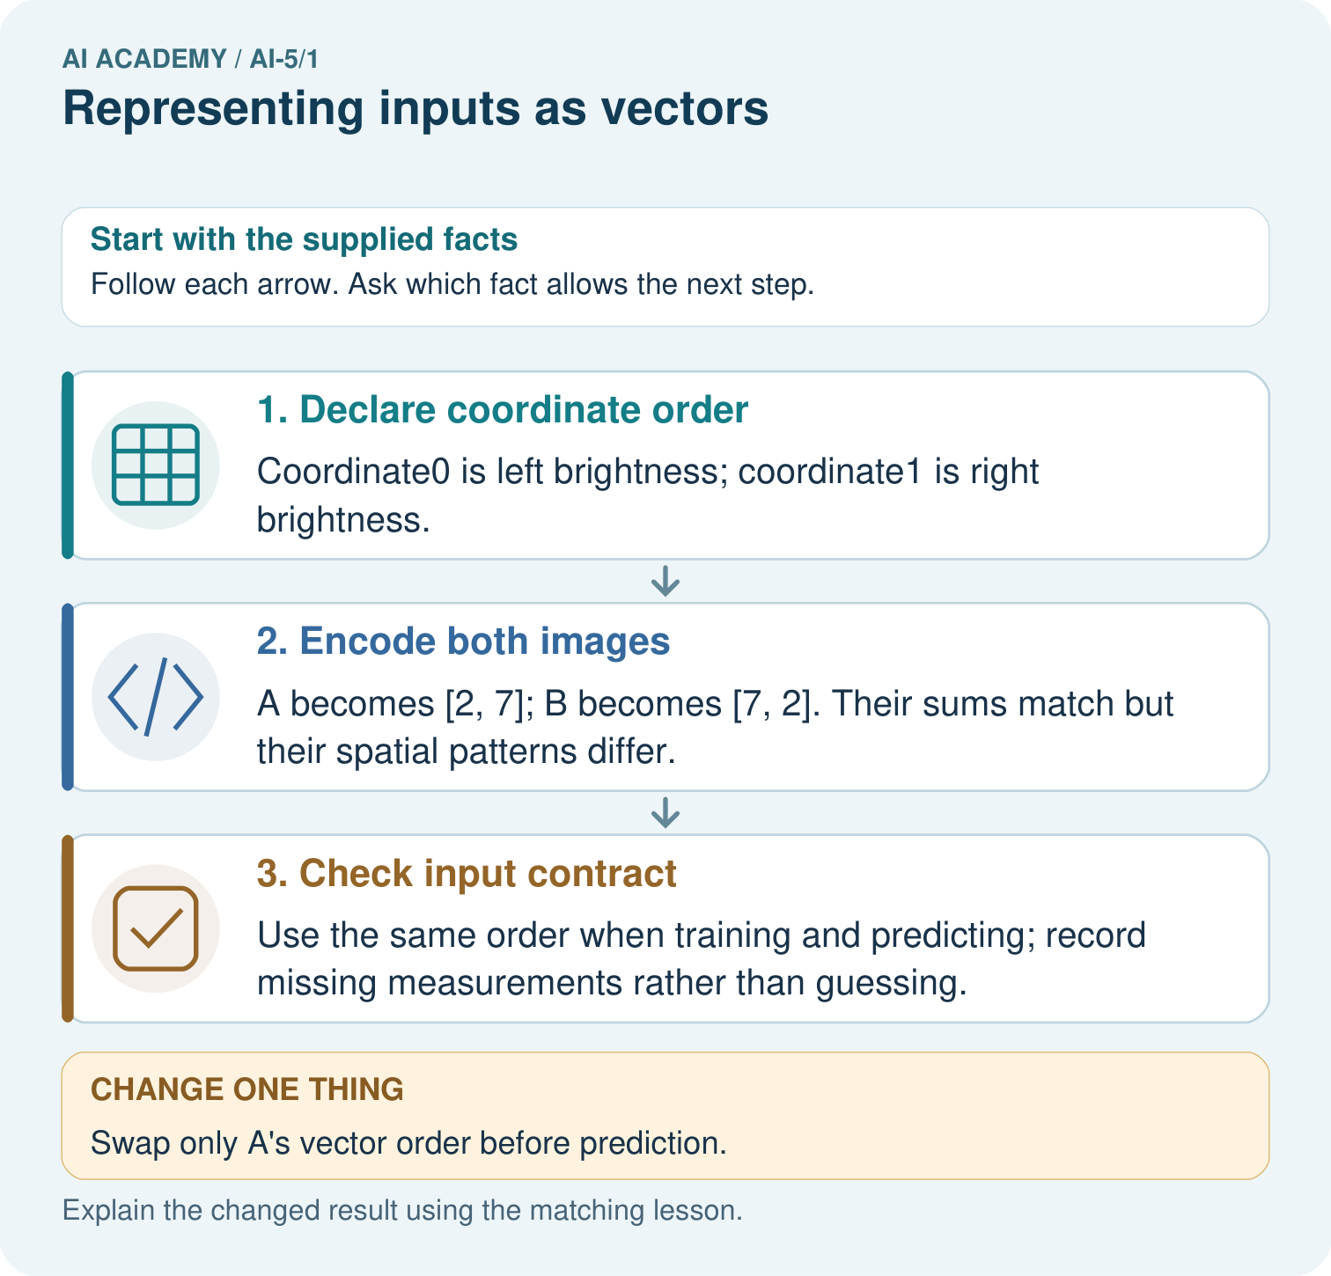
Why does equal total brightness not make A and B identical inputs? Point to the relevant step in the picture, then write the changed result and the rule or evidence that supports it.

My picture-based explanation and changed-case prediction
________________________________________________________________
________________________________________________________________
________________________________________________________________
________________________________________________________________
________________________________________________________________
________________________________________________________________
Support used: alone / hint / worked example. This record is practice evidence.
Project connection: For your Image-pattern Network Investigation, save the input, procedure, observed result and limitation of this check. Label this worked example as practice; use a different, previously unreviewed case when checking independent understanding.

13. Project portfolio milestone
Project: Image-pattern Network Investigation
Current milestone: Frame the need. Name the user, the problem, allowed inputs and a safe simple starting method.
For your Image-pattern Network Investigation, save the input, procedure, observed result and limitation of this check. Label this worked example as practice; use a different, previously unreviewed case when checking independent understanding.
Evidence to keep | My record
This week’s input and deciding step
Prediction and actual result (or labelled paper trace)
One change since the previous checkpoint and why
One error or limit and the next test

Explain what this week adds to your project. Reuse last week’s record rather than starting again.
________________________________________________________________
________________________________________________________________
________________________________________________________________
________________________________________________________________
________________________________________________________________

14. Supported practice and learning evidence
Use this supported practice once, in the browser or on paper. Keep the reserved independent assessment for a separate first attempt before teacher feedback.
Encode the same pixel measurements in a fixed vector order.

Practice 1: explain the deciding evidence
Which labelled step matches this detail? Use the same order when training and predicting; record missing measurements rather than guessing.
1. Declare coordinate order
2. Check input contract
3. Encode both images

My selected conclusion, deciding fact and explanation
________________________________________________________________
________________________________________________________________
________________________________________________________________
________________________________________________________________
________________________________________________________________
Hint if needed: Read the steps in the pictorial case. Match the supplied detail to the stage that performs or records it.
After your attempt, compare with the supported explanation: Check input contract Use the same order when training and predicting; record missing measurements rather than guessing. A vector is an ordered list, so the position of a number carries meaning. Here the first number always means left brightness. Adding the two measurements keeps total brightness but discards which side is brighter. A network receives the representation we give it; it cannot recover a lost distinction just because it has more layers.

Practice 2: explain the deciding evidence
Changed-case practice: Swap only A’s vector order before prediction. Which conclusion is supported by the supplied facts?
1. The encoded input becomes [7, 2], numerically identical to B’s original input.
2. We can decide the result without examining the changed input or the procedure.
3. This one example guarantees correct results for every future input.

My selected conclusion, deciding fact and explanation
________________________________________________________________
________________________________________________________________
________________________________________________________________
________________________________________________________________
________________________________________________________________
Hint if needed: Use the changed condition and the deciding step in the pictorial trace. The answer must say what follows from those facts.
After your attempt, compare with the supported explanation: The encoded input becomes [7, 2], numerically identical to B’s original input. Changing coordinate order changes feature meaning even if the numbers are unchanged.

Repair a missing building block
Review ML Builder Expo (ai-4/36). Goal: Defend the project using traceable evidence. Short practice: Which three supporting items should be visible at the expo? Point to the relevant step in the picture, then write the changed result and the rule or evidence that supports it.. Return to this week and explain what you changed.

Predict, run and debug
The browser lab lets you edit the supported Python examples already included in this lesson. Predict first, run, inspect the actual output or error, change one input, then run again. Keep code, predictions, actual results and a reasoned revision together. On paper, label your result as a trace rather than an execution.

Keep your completed work
Use Download completed work in the hosted lesson to export your answers, reflections, practice feedback and code-run evidence. Open the HTML copy to read or print it. Drafts stay in this browser when storage is available; clear drafts on a shared device.

What I repaired, the evidence I kept and the next test
________________________________________________________________
________________________________________________________________
________________________________________________________________
________________________________________________________________
________________________________________________________________

