AI ACADEMY · WORKBOOK · ai-5/2

Dot products and weighted sums
Project: Image-pattern Network Investigation

01. Recall and choose your starting point
Try the recall before opening notes. Then use a different colour or a labelled second line to correct your explanation.

Representing inputs as vectors
Without opening the old lesson, explain one key idea from Representing inputs as vectors. Give an example and a mistake that the idea helps you avoid.

My remembered idea, example and correction
________________________________________________________________
________________________________________________________________
________________________________________________________________

02. Practise with fading help
Use W2: Explain cancellation for Dot products and weighted sums. Record the answer once; the lesson and workbook refer to the same attempt.
Given inputs | Procedure I chose | Middle steps | Result and check

The step I completed without help, and the hint I needed
________________________________________________________________
________________________________________________________________
________________________________________________________________

03. Individual reasoning check
Use the worked case for Dot products and weighted sums. Proposed explanation: “Multiply the sums instead”. Decide whether this explanation is supported. Point to the step or supplied fact that decides; explain your repair if needed.

My explanation before partner discussion
________________________________________________________________
________________________________________________________________
________________________________________________________________
________________________________________________________________

04. Independent transfer case

Independent case: Compute a new dot product independently
Use x = [3, 1, 2] and w = [-2, 4, 0.5]. Give each contribution and the total. Increase only the second component from 1 to 2 and compute the new total. Explain why a two-weight list is invalid for this input.

My independent explanation, trace and limits
________________________________________________________________
________________________________________________________________
________________________________________________________________
________________________________________________________________
________________________________________________________________
________________________________________________________________
________________________________________________________________
Attempt this case before feedback. Record any help. Earlier examples below are further practice; a case already practised with feedback cannot establish fresh transfer.

05. W1 Calculate contributions
For w = [2, -1] and x = [3, 5], write both contributions and their sum.

My reasoning and evidence
________________________________________________________________
________________________________________________________________
________________________________________________________________
________________________________________________________________
________________________________________________________________
________________________________________________________________

06. W2 Explain cancellation
For w = [2, -1] and x = [2, 4], explain why score zero does not mean the input contains no information.

My reasoning and evidence
________________________________________________________________
________________________________________________________________
________________________________________________________________
________________________________________________________________
________________________________________________________________
________________________________________________________________

07. W3 Preserve a unit change
Width stays in cm and height changes to mm. For the worked parcel [4 cm, 20 mm], give the revised weights and score.

My reasoning and evidence
________________________________________________________________
________________________________________________________________
________________________________________________________________
________________________________________________________________
________________________________________________________________
________________________________________________________________

08. W4 Compute a new dot product independently
Use x = [3, 1, 2] and w = [-2, 4, 0.5]. Give each contribution and the total. Increase only the second component from 1 to 2 and compute the new total. Explain why a two-weight list is invalid for this input.

My reasoning and evidence
________________________________________________________________
________________________________________________________________
________________________________________________________________
________________________________________________________________
________________________________________________________________
________________________________________________________________
________________________________________________________________
________________________________________________________________

09. W5 Find lost information
Verify that [4, 2] and [5, 4] both score 6 with w = [2, -1]. Can a later step receiving only this score distinguish those two records?

My reasoning and evidence
________________________________________________________________
________________________________________________________________
________________________________________________________________
________________________________________________________________
________________________________________________________________
________________________________________________________________

10. Project checkpoint and reflection
Add a labelled dot products and weighted sums evidence sheet to Image-pattern Network Investigation. Show how you can calculate a dot product by matching feature positions. Use the supplied fictional case and keep its inputs, intermediate steps, calculation or prediction, and limitation. Connect this record to last week’s record; a matching answer without a trace is insufficient.

My project change, supporting evidence and remaining limit
________________________________________________________________
________________________________________________________________
________________________________________________________________
________________________________________________________________
________________________________________________________________
________________________________________________________________

11. Feedback, return check and learning record
Evidence | My record
Worked alone / hint / model
First step I repaired and why
New case checked later; date and result
What I can now explain without notes
One remaining question
Revisit this idea with your teacher after a delay. Familiarity is different from explaining and using it on a changed case.

12. Pictorial case practice: Dot products and weighted sums
Draw each input’s contribution to a toy weighted brightness score.
Inputs [2, 5]; weights [3,-1]; no bias. Score is 2×3+5×(-1).
All inputs and outcomes in this worked example are invented classroom data; no real model run is claimed.
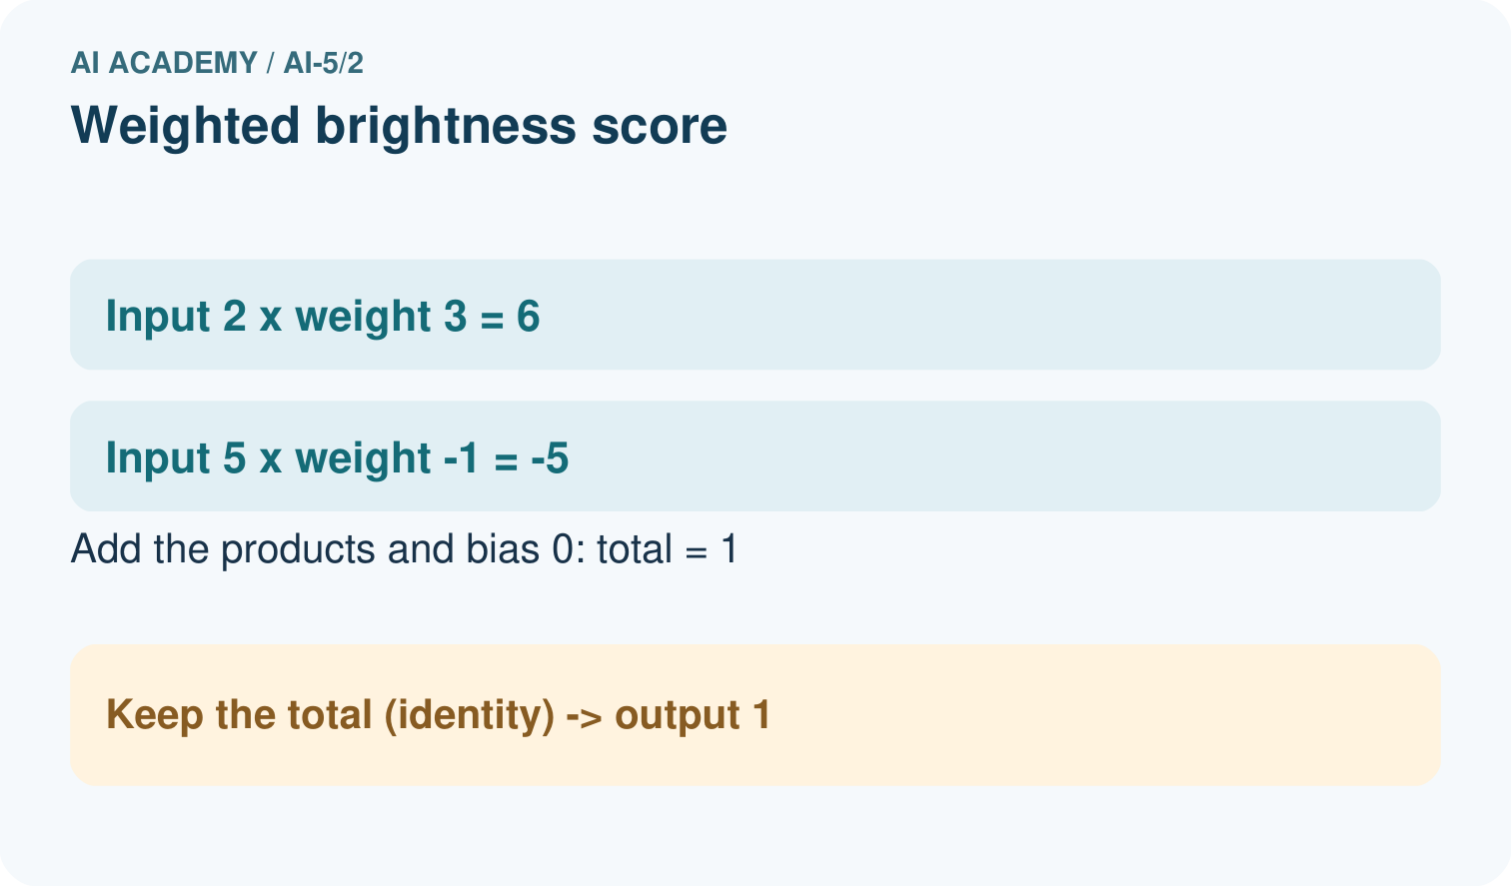
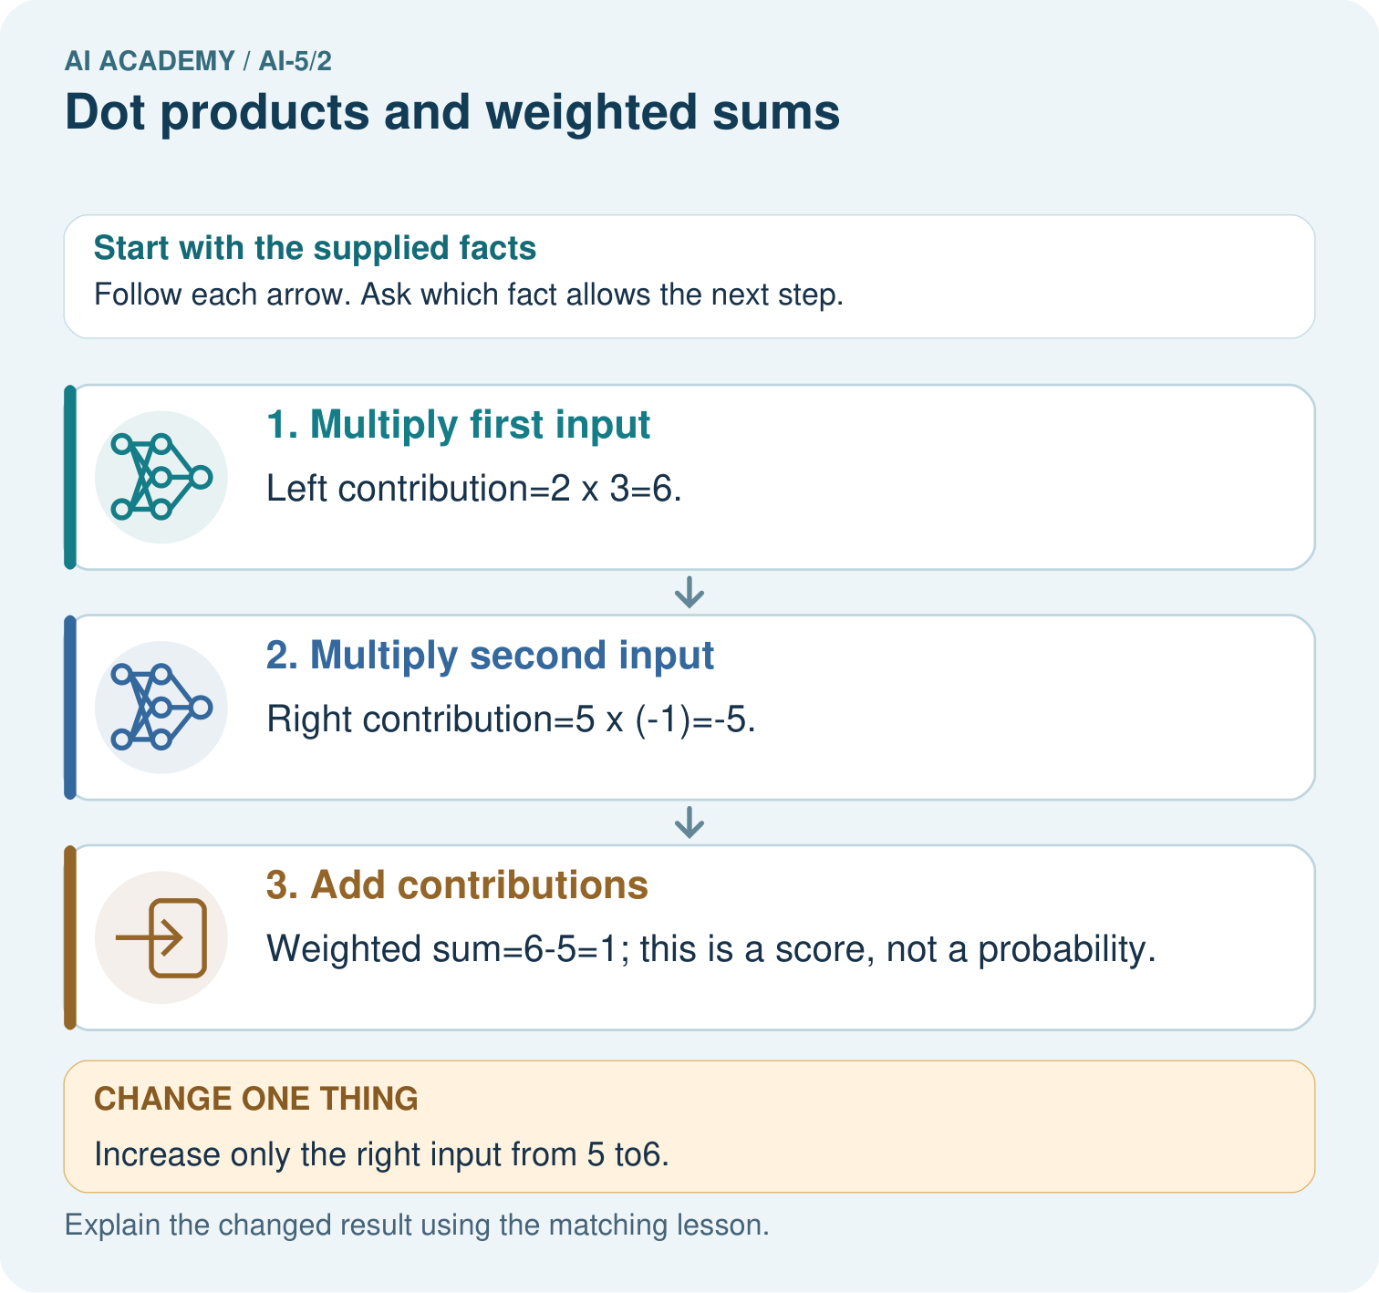
Which connection explains why more right brightness lowers this score? Point to the relevant step in the picture, then write the changed result and the rule or evidence that supports it.

My picture-based explanation and changed-case prediction
________________________________________________________________
________________________________________________________________
________________________________________________________________
________________________________________________________________
________________________________________________________________
________________________________________________________________
Support used: alone / hint / worked example. This record is practice evidence.
Project connection: For your Image-pattern Network Investigation, save the input, procedure, observed result and limitation of this check. Label this worked example as practice; use a different, previously unreviewed case when checking independent understanding.

13. Project portfolio milestone
Project: Image-pattern Network Investigation
Current milestone: Frame the need. Name the user, the problem, allowed inputs and a safe simple starting method.
For your Image-pattern Network Investigation, save the input, procedure, observed result and limitation of this check. Label this worked example as practice; use a different, previously unreviewed case when checking independent understanding.
Evidence to keep | My record
This week’s input and deciding step
Prediction and actual result (or labelled paper trace)
One change since the previous checkpoint and why
One error or limit and the next test

Explain what this week adds to your project. Reuse last week’s record rather than starting again.
________________________________________________________________
________________________________________________________________
________________________________________________________________
________________________________________________________________
________________________________________________________________

14. Supported practice and learning evidence
Use this supported practice once, in the browser or on paper. Keep the reserved independent assessment for a separate first attempt before teacher feedback.
Draw each input’s contribution to a toy weighted brightness score.

Practice 1: explain the deciding evidence
Which labelled step matches this detail? Weighted sum=6-5=1; this is a score, not a probability.
1. Multiply second input
2. Add contributions
3. Multiply first input

My selected conclusion, deciding fact and explanation
________________________________________________________________
________________________________________________________________
________________________________________________________________
________________________________________________________________
________________________________________________________________
Hint if needed: Read the steps in the pictorial case. Match the supplied detail to the stage that performs or records it.
After your attempt, compare with the supported explanation: Add contributions Weighted sum=6-5=1; this is a score, not a probability. A weight controls how strongly an input contributes to the score. The left connection adds three times its measurement; the negative right connection subtracts its measurement. Calculate each contribution before adding them. This dot product is a signed score; it becomes a probability only if a separate, justified transformation and interpretation are supplied.

Practice 2: explain the deciding evidence
Changed-case practice: Increase only the right input from 5 to6. Which conclusion is supported by the supplied facts?
1. The score becomes6-6=0.
2. We can decide the result without examining the changed input or the procedure.
3. This one example guarantees correct results for every future input.

My selected conclusion, deciding fact and explanation
________________________________________________________________
________________________________________________________________
________________________________________________________________
________________________________________________________________
________________________________________________________________
Hint if needed: Use the changed condition and the deciding step in the pictorial trace. The answer must say what follows from those facts.
After your attempt, compare with the supported explanation: The score becomes6-6=0. The right weight is-1, so adding1 to that input lowers the score by1.

Repair a missing building block
Review Representing inputs as vectors (ai-5/1). Goal: Encode a record using a fixed feature order and units. Short practice: Why does equal total brightness not make A and B identical inputs? Point to the relevant step in the picture, then write the changed result and the rule or evidence that supports it.. Return to this week and explain what you changed.

Predict, run and debug
The browser lab lets you edit the supported Python examples already included in this lesson. Predict first, run, inspect the actual output or error, change one input, then run again. Keep code, predictions, actual results and a reasoned revision together. On paper, label your result as a trace rather than an execution.

Keep your completed work
Use Download completed work in the hosted lesson to export your answers, reflections, practice feedback and code-run evidence. Open the HTML copy to read or print it. Drafts stay in this browser when storage is available; clear drafts on a shared device.

What I repaired, the evidence I kept and the next test
________________________________________________________________
________________________________________________________________
________________________________________________________________
________________________________________________________________
________________________________________________________________

